**Walkthrough - Publishing your web sites to GitHub**

1. Getting started

Download this zipped web site folder ([ch8.zip](https://1drv.ms/u/s!AmSGmNMljmbJhP4fJOSnC7n8nOyKzw?e=SkJSdh)) and extract it.

It should automatically store in your Downloads folder.

1. Open your web browser and Log in to your GitHub account
2. Click on new button (+)



1. Select New Repository

1. Give the repository a name

1. Click "Create Repository"

1. Click on your GitHub name at the top left to go back to your GitHub home page

1. Click on Repositories at the top and select the repository you just created.

1. Select uploading an existing file link from the Quick setup section in blue.

1. Drag your web site folder (ch8) from Step 0 to the Upload file section in GitHib

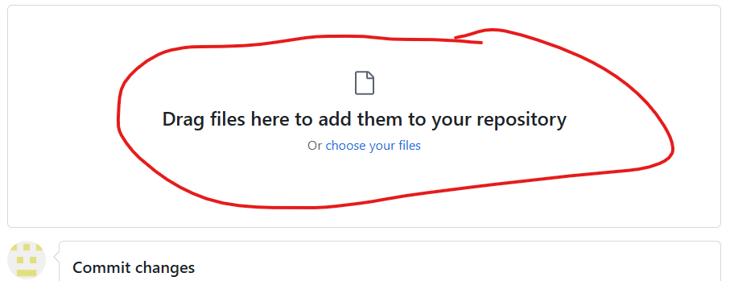

1. Click COMMIT changes
2. Congrats! You have uploaded your web site folder
3. Click on your repository name at the upper top left and Click on Settings

1. Click on Pages in the Code and automation section on the left

1. Make sure that Source is set to Deploy from a Branch and main is set to root

1. Copy your personal URL

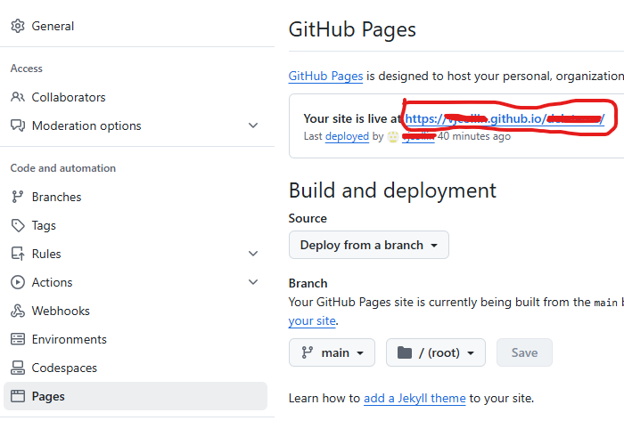

1. Return to your repository by clicking your repository name in the upper right corner.

1. Take note of your web site folder name

1. Paste your web site URL in a new web browser tab then type YourWebSiteFolderName at the end of your URL and press enter

Example: https://yourName.github.io/repositoryName/yourFolderName

Your web site page should load (see example below). If not, then check the contents of your folder. Make sure that you have an index.html page

1. You have published your web site!

