Suceava, 2024

Assist Tech Challenge 2024

Team Finder app - Team-der

Table of contents

PROJECT PURPOSE...................................................................................................................2

TECHNICAL SOLUTION........................................................................................................2

FUNCTIONAL AND NON-FUNCTIONAL REQUIREMENTS............................................2

HIGH-LEVEL ARCHITECTURE DIAGRAM........................................................................3

DATA MODEL DIAGRAM.....................................................................................................4

LIST OF TECHNOLOGIES......................................................................................................4

CONCLUSIONS........................................................................................................................5

## Project purpose

This project aims to facilitate the process of identifying and selecting team members for various projects within a company, taking into account the needs and requirements of each project individually. We have chosen "Team Finder - TeamDer" as the title for this project, as it is suggestive of its purpose. The manager seeks a simpler way to form teams for the company's projects, so we are trying to assist them with this endeavor.

Technical solution

The platform will be a web application that allows project managers to perform the following actions:

- Creating a new project, providing details such as the technologies used, project duration, team size, required roles, etc.

- Initiating team search, whereby the employee database will be analyzed to identify the most suitable candidates for the respective project.

- Adding selected candidates to the project team.

- Viewing and reviewing candidates based on established criteria.

Functional and non-functional requirements

Functional requirements:

- Creating a new project

-Adding project details

- Initiating team search for the project

- Viewing candidate suggestions and applied filters

- Selecting and adding candidates to the project team

- Updating project and team information

Non-functional requirements:

- Intuitive and user-friendly user interface

- High performance and fast response time of the application

- Data security

High-Level Architecture Diagram

This diagram below illustrates how the application functions.

<https://www.figma.com/file/IOrC9KumGNWr8ukJGeh8Z5/Workflow-(Copy)?type=whiteboard&node-id=0%3A1&t=YWT98flfB1tbJAaT-1>

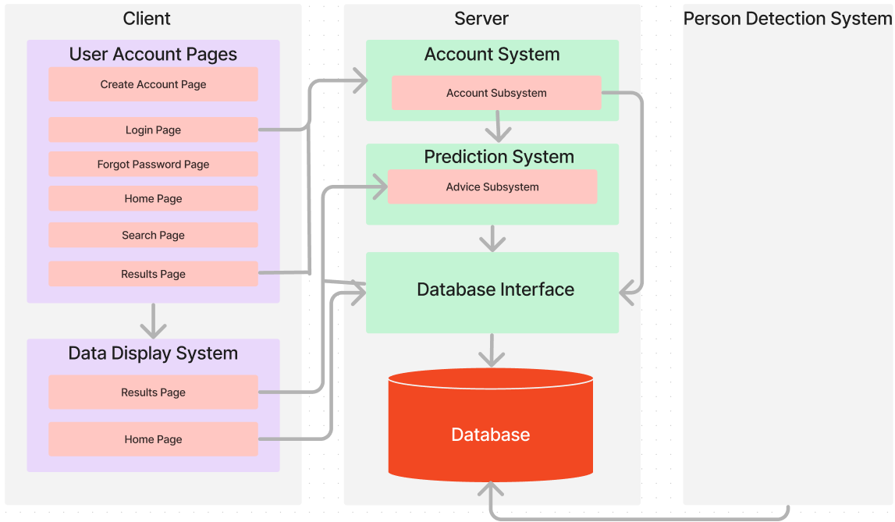

Data Model Diagram

Below, we have included the data model diagram that we will use for creating the database.

<https://drive.google.com/file/d/1Bi2KDQzwmbCU3Ab7ovyTD27hr3b6udUg/view?usp=sharing>

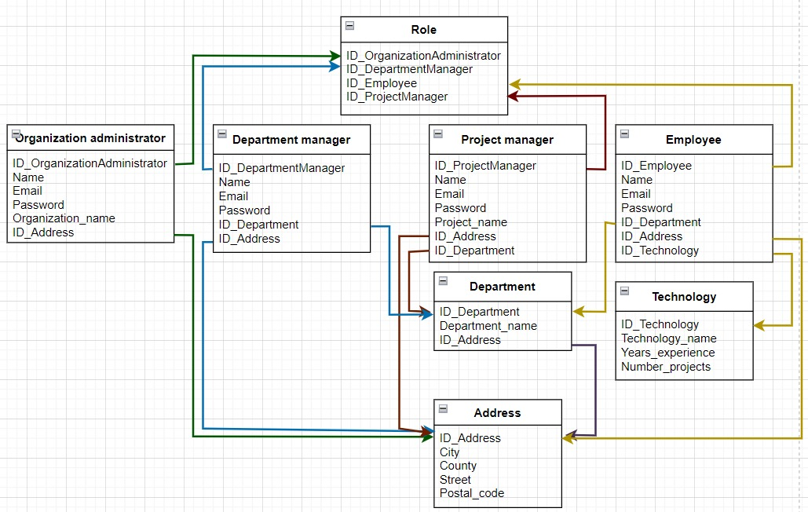

# List of technologies

|  |  |  |
| --- | --- | --- |
| **Technology name** | **Type** | **Purpose** |
| GitHub | Hosting service for software  development | Source control |
| ReactJS | Front-end JavaScript library | Develop Frontend |
| NodeJS | Back-end JavaScript  runtime environment | Develop Backend |
| MongoDB | NoSQL database program | Store & maintain  data. |
| HTML | Markup language | Develop WEB application |

# Conclusions

In conclusion, the "Team finder - TeamDer" application represents an opportunity for a company to assemble teams for the development and implementation of projects. The implementation of this project aims to facilitate the team formation process.