Planning Poker Device

About the project
In this project we imagined an easier and more playful way to plan a project. Especially how a team plans a task and estimate the workload of each task.
One way to estimate task is planning poker. With this method everyone lays a card on the table (from 1 to 10) with his estimate of the workload. If the numbers differ a lot it will be discussed as a team and a new round will start afterwards.
Our project would fit in the category Project planning or just general development.

Teammembers
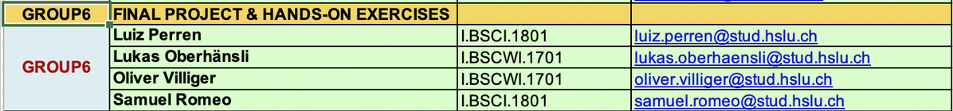

Vision
As a solution for these dreading task we propose a handheld device, which allows every participant to estimate the time of the current work-package.
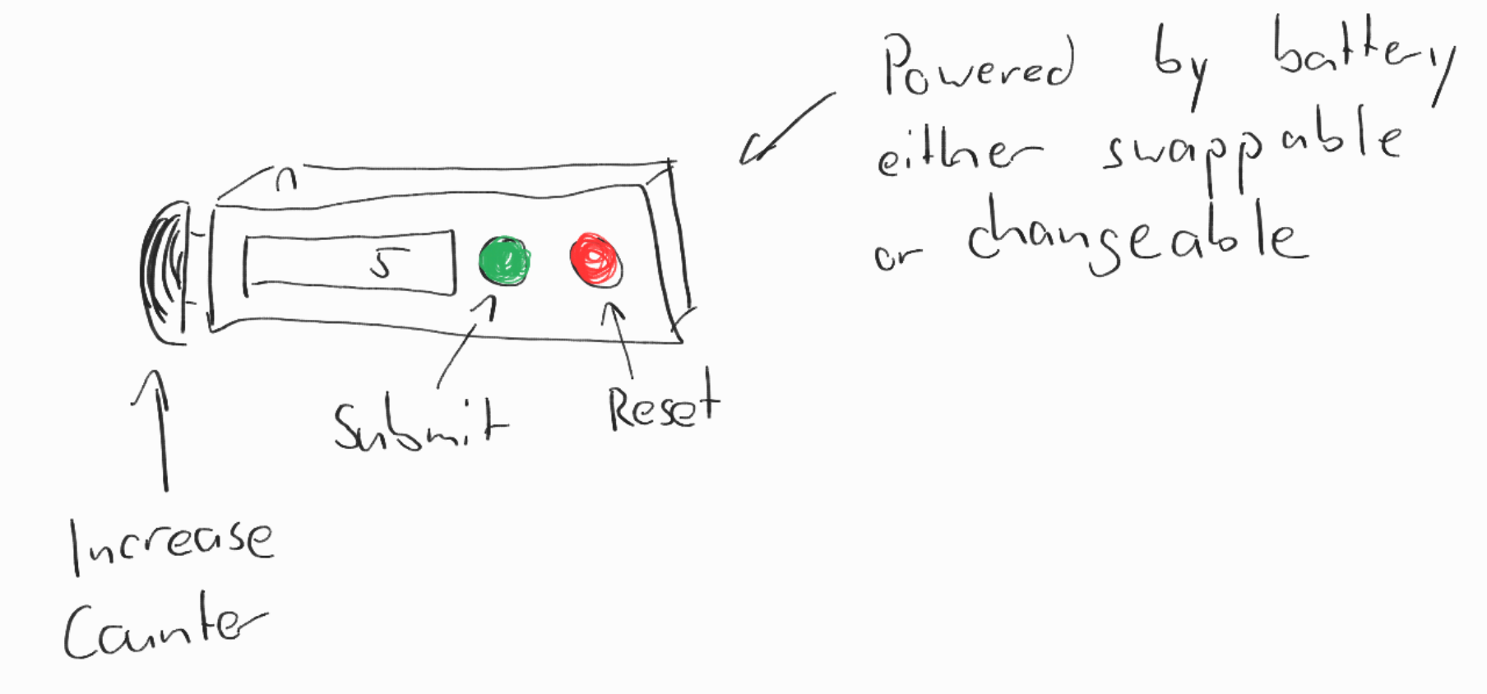
This device has 3 buttons.
- Increase the counter
- Submit the counter
- Reset the counter
With these simple functionalities it should be possible to easily use it and develop it in a certain budget.
The devices have to communicate with a base station like a Raspberry Pi.

Techniques
First off, we have to be able to recognize and temporarily store the input of a user. This will either be directly on the handheld device, or be sent to the Raspberry Pi directly.
This means we also have to have a main computer, who organizes the and stores the created information. We call this main computer the base station.
Handheld device – how do we built it?
We’ll exclusively use buttons on the handheld device. It makes the interaction extremely easy. We’ve also planned to have a small display that presents the current counter. The display will be discussed further in the project. We’re currently planning a simple solution. This device will need to be powered by battery. We’ve thought about 2 possibilities.
- Swappable battery
  - Is a hassle factor, requires the user to have spare batteries ready.
  - Does not need to be charged, have the environment and cables ready to charge multiple devices.
- Chargeable battery
  - Charging and usage has to be planned ahead.
  - Cheaper in the long run.
  - Need charging mechanism/station.
Base Station – What does it do?
Every Device will be communicating with the Raspberry Pi. The estimated numbers will be available to display in the preferred format or website. The base station also has to recognize if a participant resets the counter or finalizes his estimate.
If all the participants agree to the estimate. It will be possible to add the estimated work-package into the preferred planing application. We’ve not yet declared which API we’ll use.

Evaluation
To evaluate our project, we will create an example project. With the help of this our group will play a round of planning poker. This will show all weaknesses and possible problems that can be solved. A test protocol will be helpful too.

