NDC-01 Mission-Critical Data Center
Cooling Modernization
Engineering Project Management + Systems Engineering + Reproducible Evidence
Engineering Evidence Integrity Release Candidate v6.1
Independent simulated case study. All organizations, assets, operating data, costs and results are fictional.

1. Executive scenario
NovaTech Data Centers (NDC) is a fictional mid-sized colocation and digital-infrastructure provider. NDC-01 is a regional facility serving approximately 80 enterprise customers, with 420 installed racks, approximately 350 occupied racks and a modeled critical IT load up to 800 kW. The facility operates 24x7x365.
The cooling plant comprises three 400 kW chillers (1.2 MW nominal capacity), six pumps, field instrumentation, PLC-based control and a legacy BMS/SCADA layer. Under the defined design condition, two chillers support the critical cooling requirement while the third provides intended redundancy.

2. What was happening before the project
During the 2026 baseline period, Facilities Engineering identified progressive deterioration rather than one catastrophic outage. Repeated equipment events were consuming maintenance capacity, reducing redundancy margin, increasing thermal exposure and worsening operating economics. Equipment downtime is explicitly not treated as IT-service downtime.
Baseline evidence | Value
Equipment failures | 13
Equipment downtime | 121.75 h
Outside intended N+1 state | 66.75 h
Cooling-capacity deficit | 4.75 h
Cooling-service availability | 99.9458%
PM compliance | 72.22%
Weighted COP | 2.809
Modeled PUE | 1.551
Cooling O&M | EUR 425,432.79/year

3. Why the problem matters
A single cooling-asset failure can be absorbed by redundancy; however, the facility then operates with reduced resilience. A coincident event or high thermal demand can create a capacity deficit. The engineering problem is therefore not merely asset downtime, but the combination of reliability, available capacity, redundancy exposure, thermal margin, maintainability, energy performance and lifecycle cost.

4. Engineering assessment before project authorization
Management authorizes an engineering assessment before authorizing capital work. The assessment establishes baseline evidence, stakeholder needs, measurable requirements, alternatives, risk exposure and the business case. The project therefore begins with a problem and evidence, not with a predetermined technology purchase.

5. Stakeholder needs and Systems Engineering
Stakeholder | Need
Operations | Sufficient cooling capacity throughout required operation; visibility of redundancy and thermal margin.
Maintenance | Earlier degradation detection and restoration within maintainability limits.
Engineering | Reliable data for performance, degradation and energy analysis.
Finance | Measurable lifecycle value.
Service Management | Avoid cooling conditions that materially affect contracted IT services.
Cybersecurity | Logical separation and least privilege across control, supervisory and analytics functions.
Systems Engineering maintains the technical evidence chain: business concern -> stakeholder need -> system requirement -> architecture/interface -> verification evidence -> validation against intended use.

6. Key verifiable requirements
Requirement | Acceptance criterion
SYS-CAP-001 | Cooling-service availability >= 99.95%
SYS-RED-001 | Redundancy state and capacity margin visible for each 15-minute performance interval
SYS-MNT-001 | PM compliance >= 95%
SYS-ENE-001 | Weighted COP >= 3.30
SYS-PUE-001 | Modeled PUE <= 1.50 within declared boundary
SYS-MON-001 | Daily 1-minute monitoring completeness >= 95%
SYS-SEC-001 | Defined separation/access-control evidence accepted

7. Alternatives and decision
Alternative | Indicative CAPEX | Decision logic
Continue as-is | EUR 0 | Retains reliability, redundancy and cost exposure
Full plant replacement | ~EUR 900k | High renewal potential; high CAPEX/disruption
Controls/instrumentation only | ~EUR 130k | Improves visibility; limited reliability benefit
Targeted modernization | EUR 360k | Selected balance of reliability, controls, monitoring, energy and implementation risk

8. Project Management role
After the engineering alternative is selected, Project Management governs delivery: charter, scope/WBS, schedule, cost baseline, procurement, stakeholders, risks, resources, communications, change control, EVM, decision gates, transition and closure. Planned duration is 32 weeks and authorized funding is EUR 360,000.
At week 20, PV=EUR 210k, EV=EUR 195k and AC=EUR 205k, producing SPI 0.929 and CPI 0.951. A VFD supplier delay becomes an issue and is handled through CR-004, preserving assessment, approval and regression testing.

9. Integrated PM + SE execution
PM controls delivery of the change; SE controls technical integrity of the solution. Verification activities must appear in the schedule and budget; procurement must preserve technical requirements; changes must be evaluated for requirement/interface impact; and acceptance must be supported by evidence.

10. v6 physical and data model
The v6.1 model explicitly links time-varying IT load to cooling demand, available chiller capacity and redundancy state. It separates asset reliability from cooling-service availability and from any downstream IT-service consequence.
15-minute performance evidence contains IT load, cooling demand, cooling electrical energy, COP, modeled facility energy and PUE. A separate daily completeness file represents expected versus observed one-minute monitoring samples. Independent random-number streams reduce accidental coupling between load, failures, repair, maintenance, alarms, cost and data imperfections.

11. Post-modernization evidence
KPI | Baseline | Post
Failures | 13 | 5
Equipment downtime | 121.75 h | 20.08 h
Cooling-service availability | 99.9458% | 99.9943%
Outside intended N+1 | 66.75 h | 15.25 h
Capacity deficit | 4.75 h | 0.50 h
Weighted COP | 2.809 | 3.361
Modeled PUE | 1.551 | 1.489
PM compliance | 72.22% | 98.61%
Cooling O&M | EUR 425,432.79 | EUR 357,924.84

12. Benefit realization
The seeded reference realization produces direct annual cooling O&M savings of EUR 67,507.95, or 15.87%. With EUR 360,000 authorized CAPEX, simple payback based only on direct O&M savings is 5.33 years. Avoided customer outages and Expected Annual Loss reduction are intentionally excluded from the base payback to avoid unsupported monetization or double counting.

13. Visual evidence
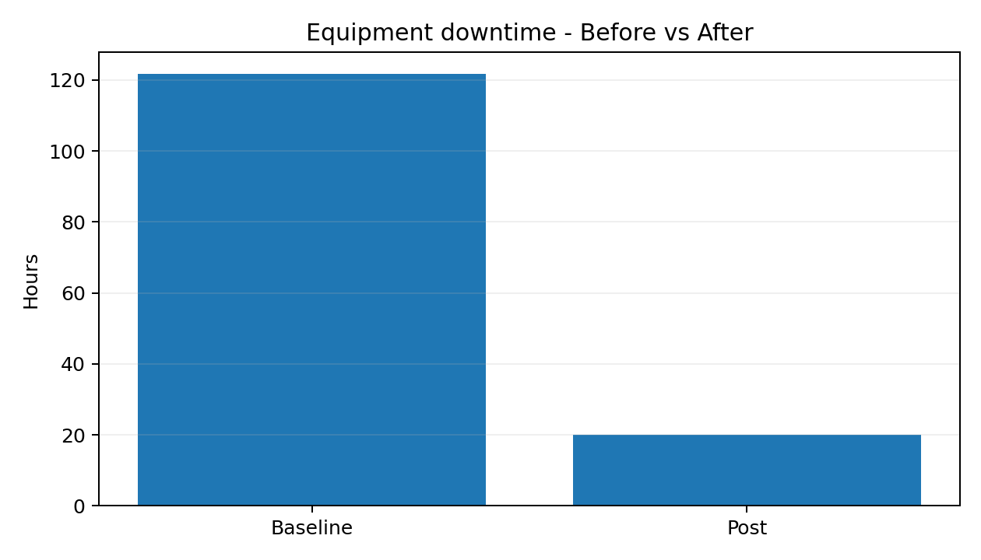
Equipment downtime
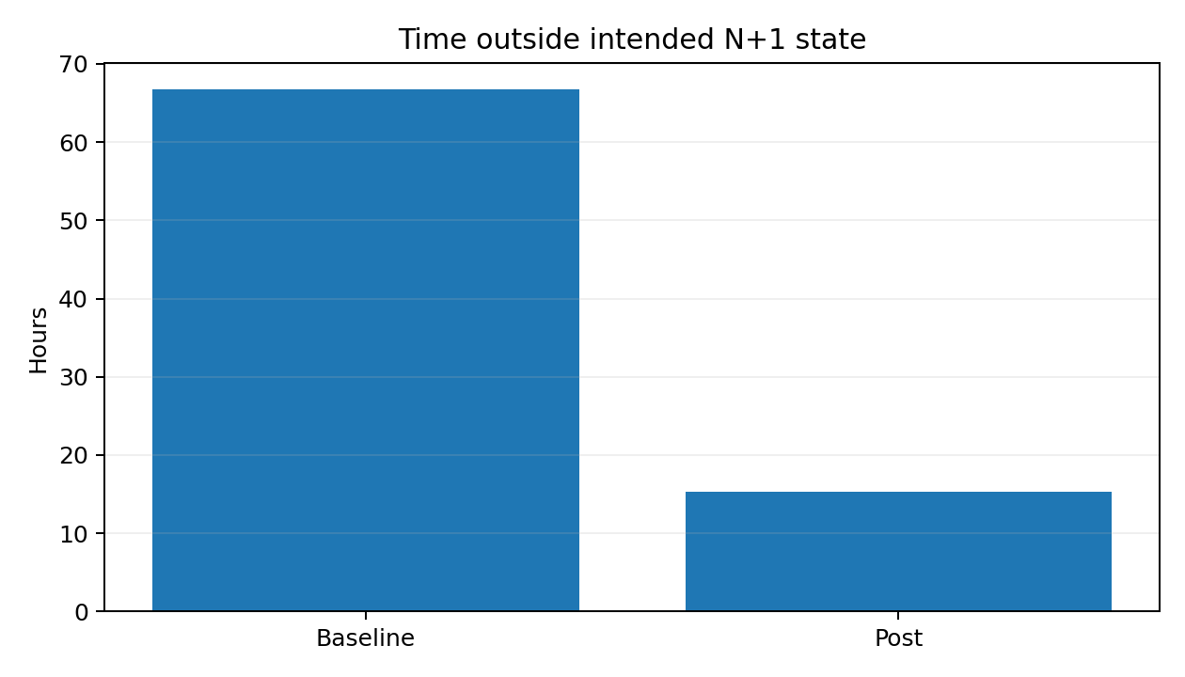
Redundancy exposure
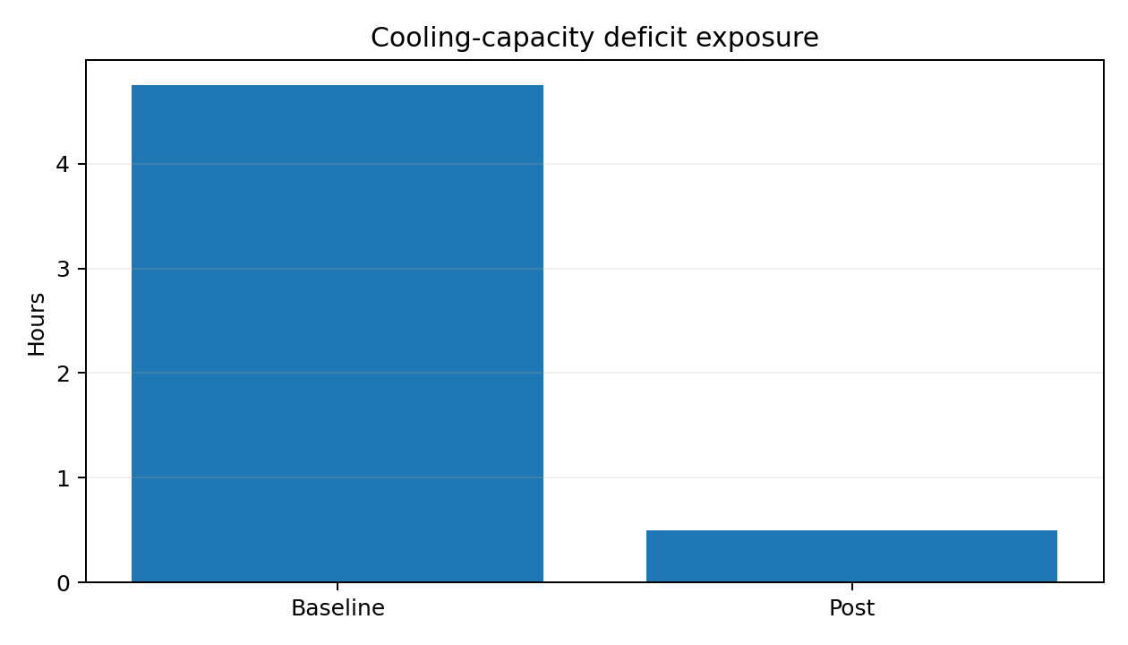
Cooling-capacity deficit
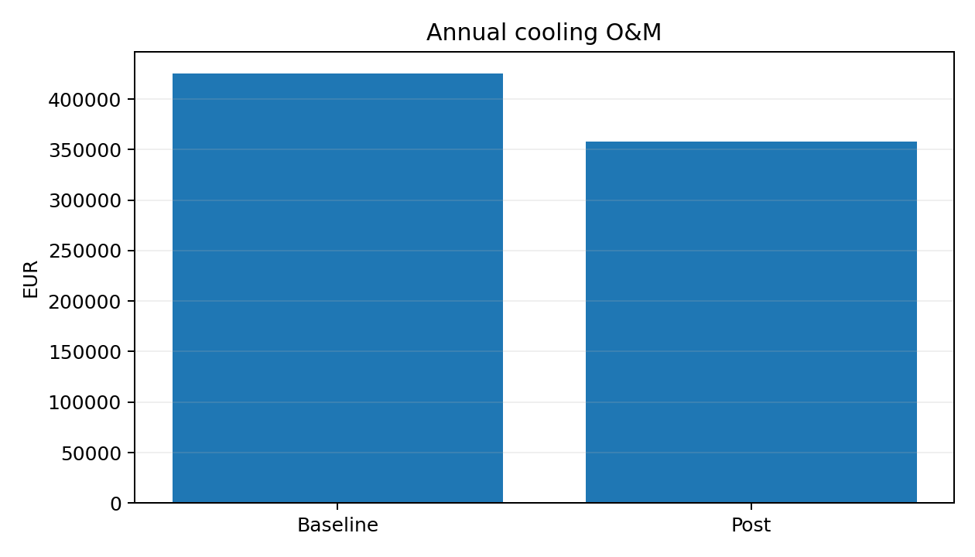
Annual cooling O&M

14. Reproducibility and acceptance discipline
Targets are inputs; outcomes are outputs. The model distinguishes a frozen baseline of assumptions, one seeded stochastic reference realization and downstream acceptance results. If evidence contradicts the intended story, the story changes - not the evidence.
The Python v6.1 pipeline has been executed successfully from current evidence: synthetic evidence generation, validation checks, automatic KPI regeneration, the complete pytest suite, requirement verification, benefit calculation, schedule Monte Carlo and chart generation. Weighted COP uses only paired, deduplicated 15-minute observations where both cooling-energy channels are present. PostgreSQL E2E remains the final release gate before a validated public v1.0 tag.

15. GitHub execution
In GitHub Codespaces: chmod +x scripts/*.sh, then run ./scripts/run_python_pipeline.sh. The pipeline deletes stale derived outputs and regenerates KPI, V&V, benefit, Monte Carlo and chart evidence. For the public release gate, run ./scripts/run_full_validation.sh with PostgreSQL/psql available. The SQL layer reloads the integrated PM+SE evidence model and independently recalculates mapped KPIs before Python-SQL comparison.

16. Portfolio narrative
This case demonstrates a chronological engineering story: operational deterioration -> evidence -> engineering assessment -> stakeholder needs -> verifiable requirements -> alternatives -> business case -> project authorization -> PM + SE integrated execution -> integration -> verification -> validation -> transition -> post evidence -> benefit realization.
The strongest message is not that every KPI improved. It is that the result is traceable to declared assumptions and reproducible evidence, and that asset-level events are not misrepresented as customer-service outages.

17. Evidence-integrity controls added in v6.1
The v6.1 revision closes the evidence-chain findings identified during independent rerun: weighted COP now uses paired 15-minute energy observations; Python KPI evidence is regenerated on every run; the complete test suite must pass; governed reporting periods are restored without driving service-availability arithmetic; PM+SE entities are restored to PostgreSQL; the legacy telemetry file is removed; and the validation manifest records hashes of generated evidence.
Seeded paired-COP evidence: baseline 2.8087 from 34,744 paired observations (99.155% coverage); post 3.3607 from 34,864 paired observations (99.226% coverage).

