**Configurando o Ambiente**

1. **update git to automatically set line ending to LF:**

git config --global core.eol lf

git config --global core.autocrlf input

1. **Adicionar no arquivo Gemfile:**

group :development, :test do

gem 'rspec-rails'

end

group :test do

gem 'cucumber-rails', :require => false

# database_cleaner is not required, but highly recommended

gem 'database_cleaner'

end

1. **Repositório adicionado no codeclimate:**

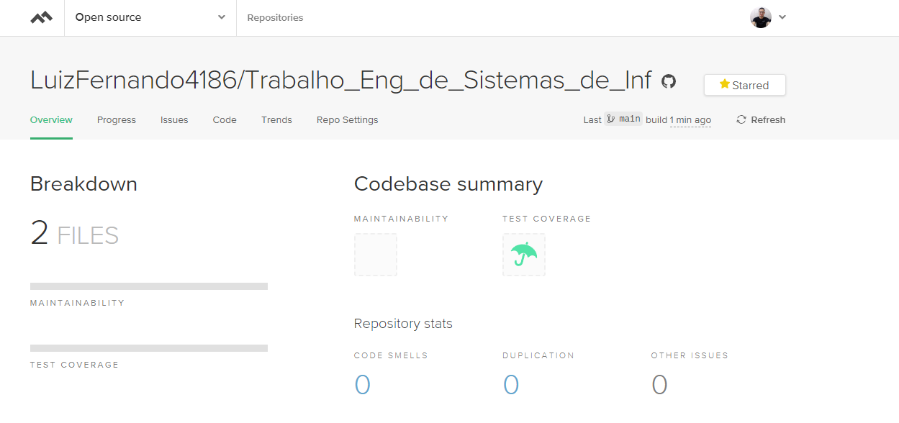

1. **Coverralls:**