Name: Luiz Mata Lopez

CMSC 104, CRN: 21473 Fall 2021

**CMSC140 Programming Classwork/Homework**

Screenshots:

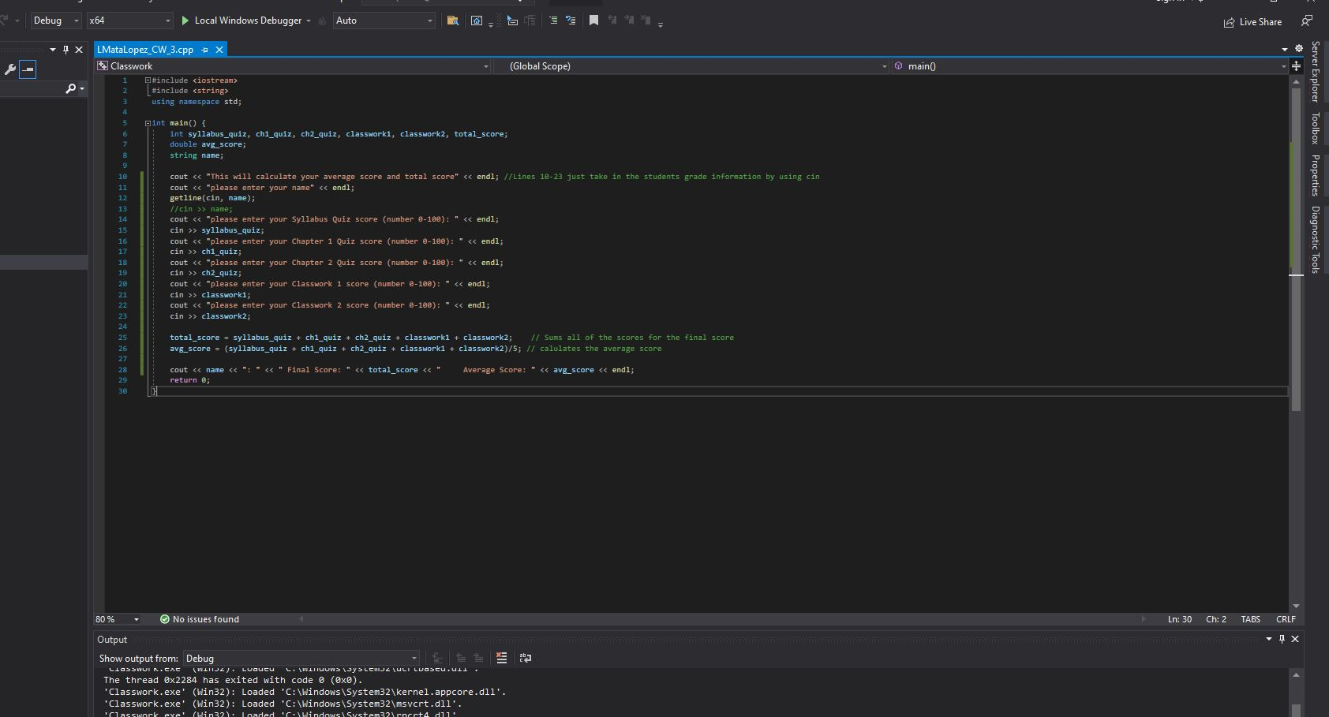

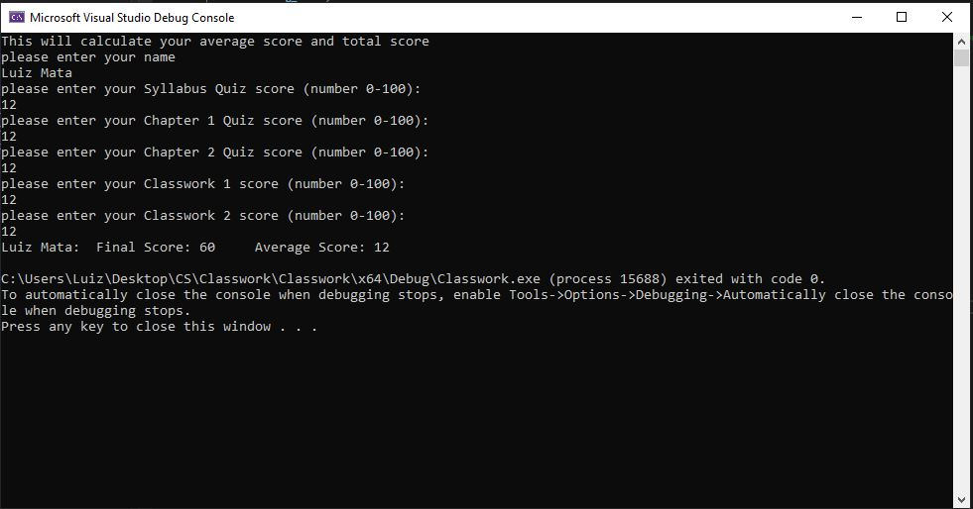

Pseudocode:

BEGIN

Main()

Declare all ints for assignments and score variables

syllabus_quiz, ch1_quiz, ch2_quiz, classwork1, classwork2, total_score

Declare precise average

Declare String name

Print desc: "This will calculate your average score and total score"

Prompt user for name

Input the name and store it in string name

Prompt user for score information

Input score in its respective int variable

Repeat 5x

.

.

.

.

//Sum all of the scores and store them in total_score

syllabus_quiz + ch1_quiz + ch2_quiz + classwork1 + classwork2

//Calculate the average score (a1+a2+a3)/n

(syllabus_quiz + ch1_quiz + ch2_quiz + classwork1 + classwork2)/5

Print final message which includes name, total and average score

END