Name:‌ ‌Luiz‌ ‌Mata‌ ‌Lopez‌ ‌

CMSC‌ ‌104,‌ ‌CRN:‌ ‌21473‌ ‌Fall‌ ‌2021‌ ‌

**CMSC140‌ ‌Programming‌ ‌Classwork/Homework‌**

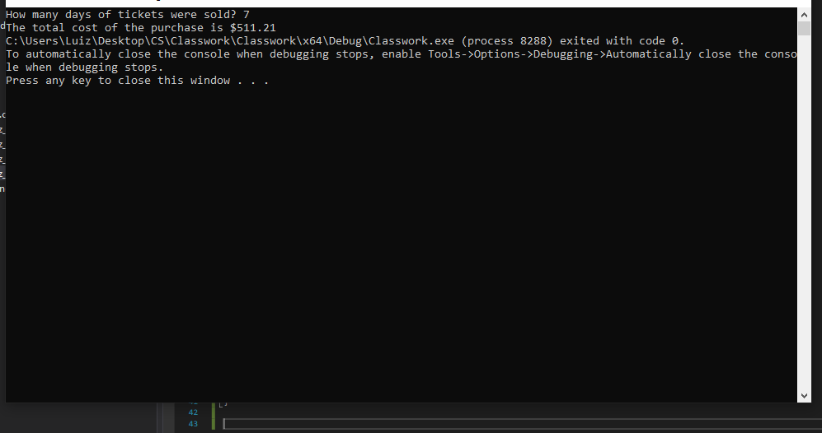

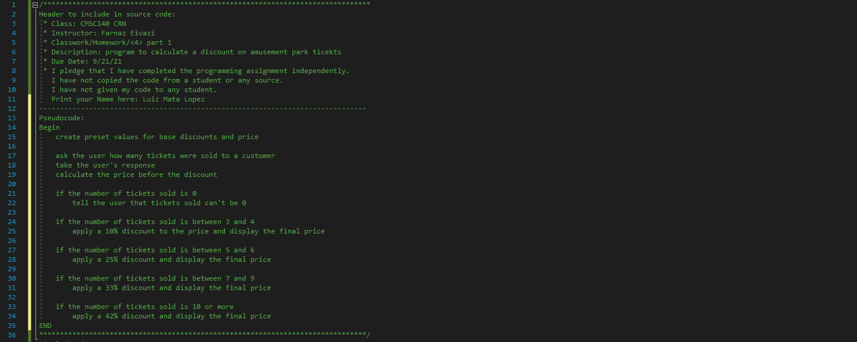

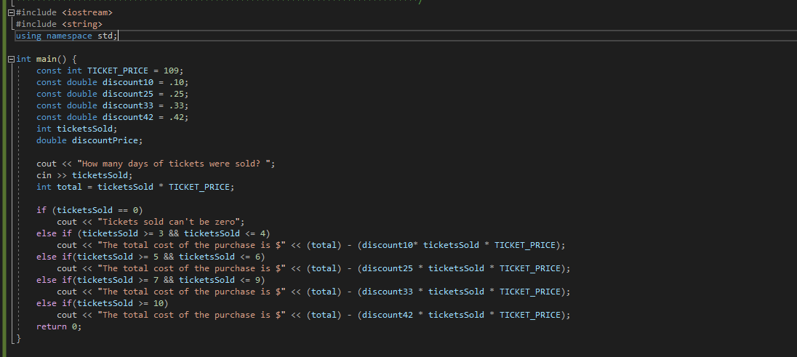

Pseudocode:

Begin

create preset values for base discounts and price

ask the user how many tickets were sold to a customer

take the user's response

calculate the price before the discount

if the number of tickets sold is 0

tell the user that tickets sold can't be 0

if the number of tickets sold is between 3 and 4

apply a 10% discount and display the final price

if the number of tickets sold is between 5 and 6

apply a 25% discount and display the final price

if the number of tickets sold is between 7 and 9

apply a 33% discount and display the final price

if the number of tickets sold is 10 or more

apply a 42% discount and display the final price

END