Name:‌ ‌Luiz‌ ‌Mata‌ ‌Lopez‌ ‌

CMSC‌ ‌104,‌ ‌CRN:‌ ‌21473‌ ‌Fall‌ ‌2021‌ ‌

**CMSC140‌ ‌Programming‌ ‌Classwork/Homework‌**

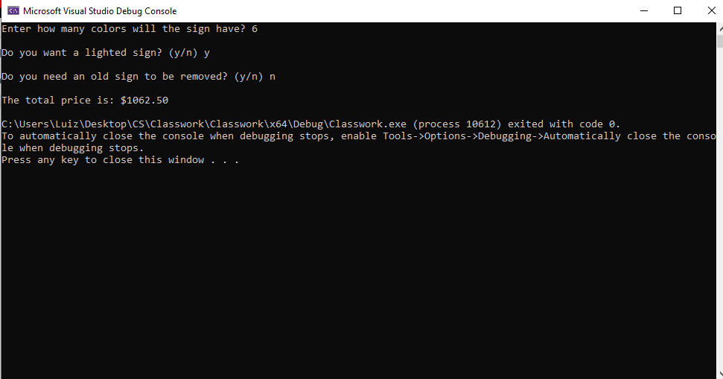

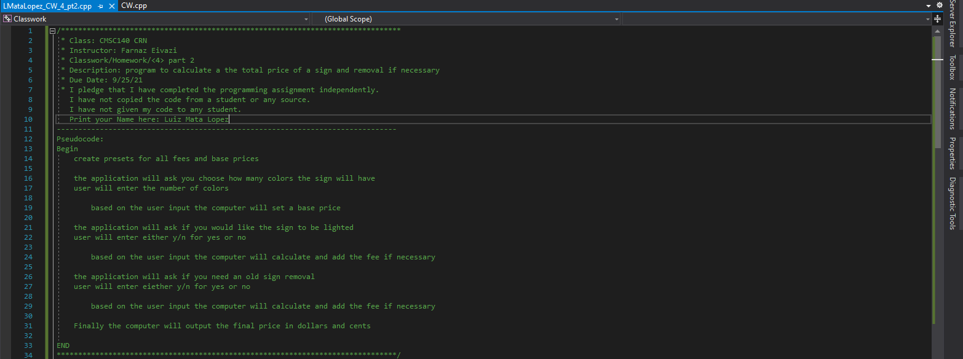

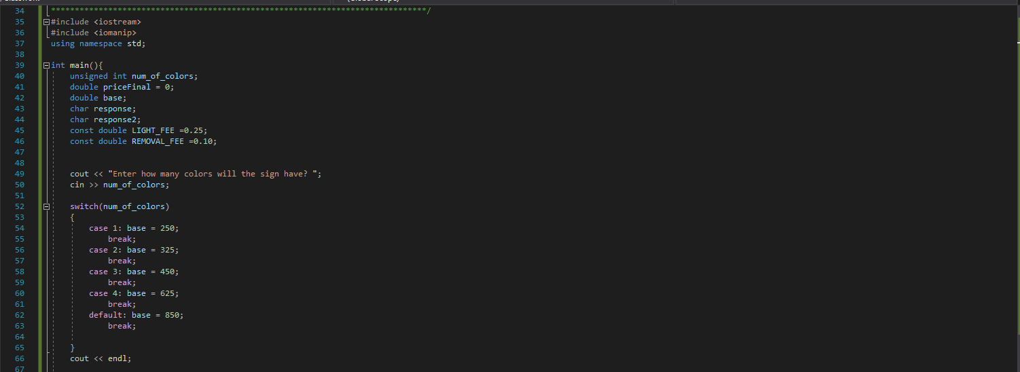

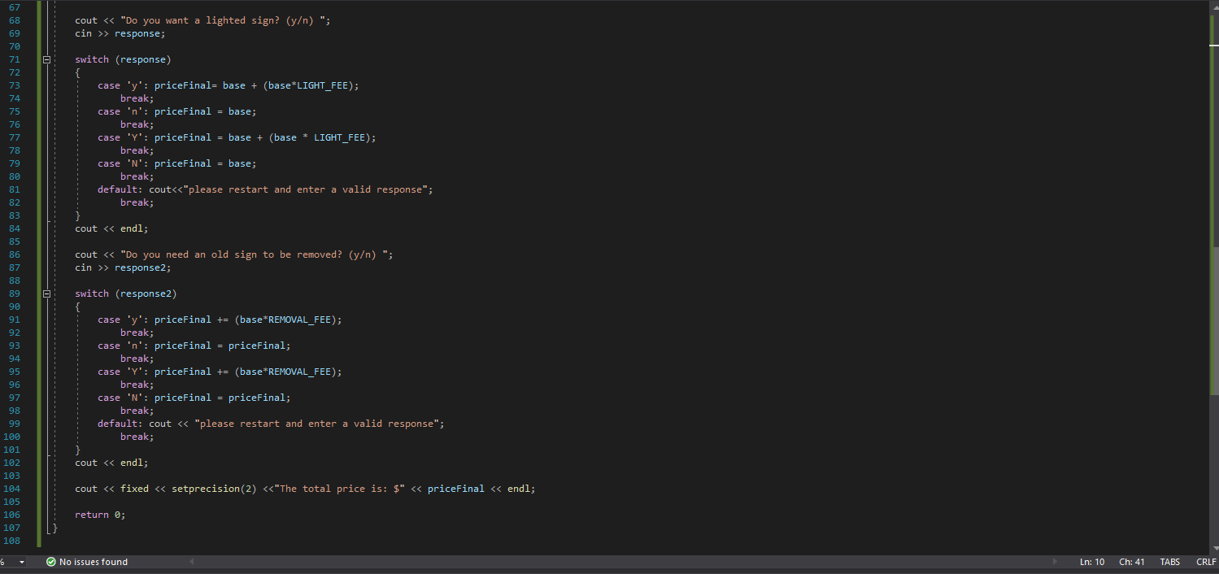

Pseudocode:

Pseudocode:

Begin

create presets for all fees and base prices

the application will ask you to choose how many colors the sign will have

user will enter the number of colors

based on the user input the computer will set a base price

the application will ask if you would like the sign to be lighted

user will enter either y/n for yes or no

based on the user input the computer will calculate and add the fee if necessary

the application will ask if you need an old sign removal

user will enter either y/n for yes or no

based on the user input the computer will calculate and add the fee if necessary

Finally, the computer will output the final price in dollars and cents

END