Name:‌ ‌Luiz‌ ‌Mata‌ ‌Lopez‌ ‌

CMSC‌ ‌104,‌ ‌CRN:‌ ‌21473‌ ‌Fall‌ ‌2021‌ ‌

**CMSC140‌ ‌Programming‌ ‌Classwork/Homework‌**

**Pseudocode:**

Begin

the application will print various patterns

END

**Output:**

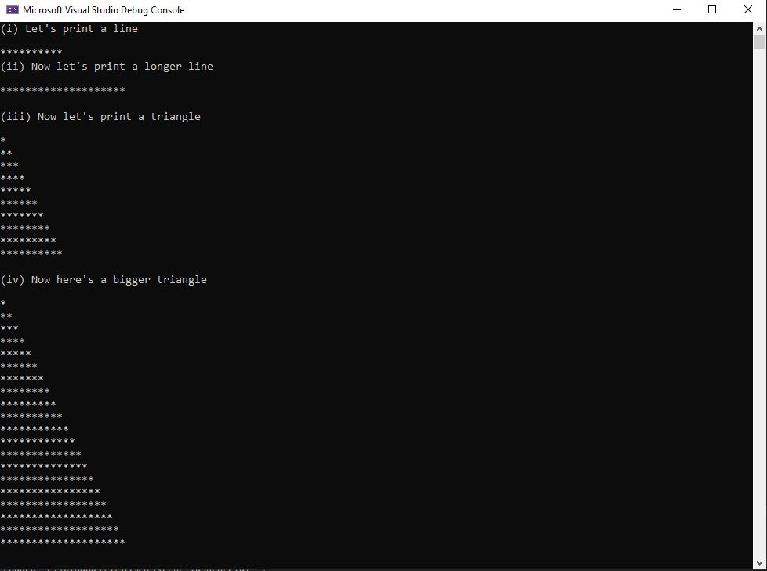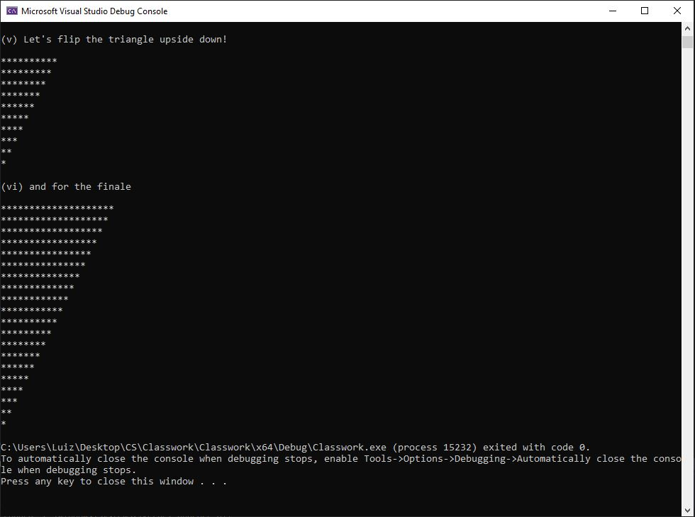

**Code:**

