Name:‌ ‌Luiz‌ ‌Mata‌ ‌Lopez‌ ‌

CMSC‌ ‌104,‌ ‌CRN:‌ ‌21473‌ ‌Fall‌ ‌2021‌ ‌

**CMSC140‌ ‌Programming‌ ‌Classwork/Homework‌**

**Pseudocode:**

Begin

1. The computer will ask the user to enter their information

2. The computer will save the info into a text file

3. The computer will reopen the file and extract the information

4. The user will have their info displayed

END

**Output:**

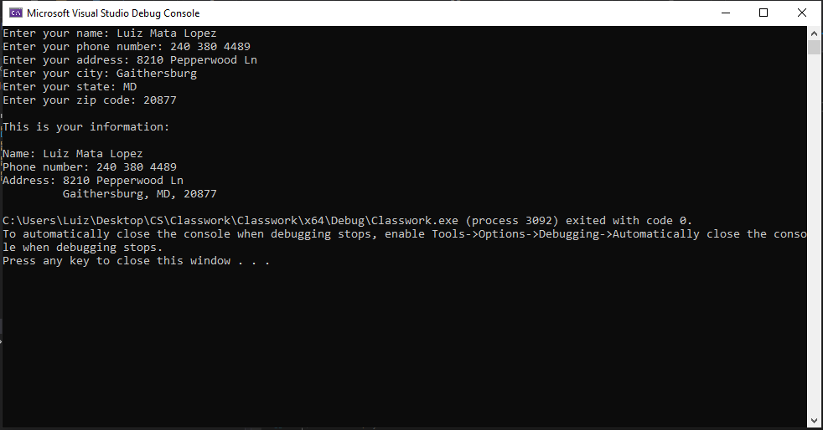

**Code:** 