Curso de Inglês

Interchange 1

Professor: Luis Felipe

Aluno: Luiz Perciliano

Programa: Class#9_2021

**Sumário**

1. Week 40 –October 03 at 9 – Unit 1 3

2. Week 39 – September 26 at October 02 – Unit 1 4

3. Tasks and Researchs 8

4. Bibliography 10

# **Week 40 –October 03 at 9 – Unit 1**

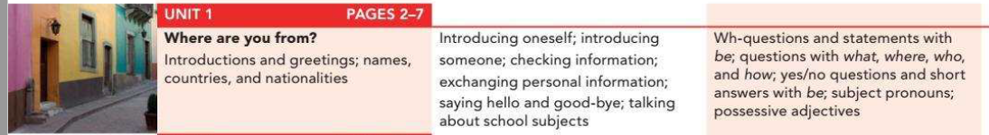

Unit 1 – Where are you from?

Video: <https://youtu.be/fs6gMj4zN3Q?list=PLrE-TRIPaiR7oqjITR7U-p4-pqwEJiWTJ>

Quiz: <https://quizlet.com/499050837/unit-1-interchange-book-1-flash-cards/>

* Book page 2 – 7 | pdf page 22 - 27

1. Conversation (initial 02/10/2021 at 09:32h a.m.)
2. Speaking
3. Conversation
4. Pronunciation
5. Grammar Focus (finish 02/10/2021 at 09:58h a.m.)

Countries and nationalities (see the appendix at the back of the book) – page pdf 187

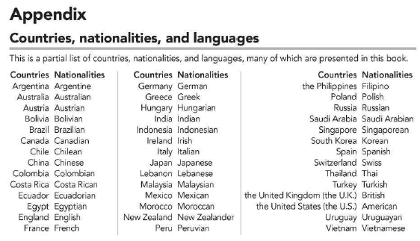

* 1. Grammar Plus page 132 – pdf page 152

1. Snapshot
2. Conversation
3. Grammar Focus
4. Word Power
5. Interchange 1
6. Listening
7. Reading

* Workbook page 1 a 6 | pdf 4 – 9

**Study day (06/10/2021)**

**Tasks**

* See video unit 1 – OK
* Criar uma planilha com lista de palavras desconhecidas do mestrado
* Workbook
  + Finished exercise xxx
* Ask Jackie: OK
* Drops – OK
* Elsa - NOK
* Duolingo Italy - OK
* Busuu – OK - Lição 53: Eu ligo para o meu pai dia sim, dia não

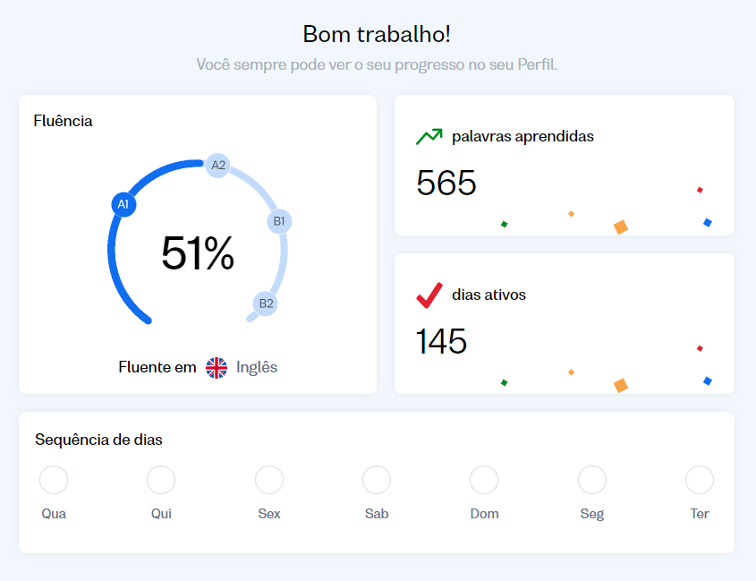

* News in levels – NOK

**Study day (05/10/2021)**

**Tasks**

* See video unit 1 – NOK
  + To see interchange ok.
* Criar uma planilha com lista de palavras desconhecidas do mestrado
* Workbook
  + Finished exercise xxx
* Ask Jackie and BBC: ok
* Drops – OK
* Elsa - NOK
* Duolingo Italy - NOK
* Busuu – NOK - Lição Lição xx
* News in levels – NOK

**Study day (04/10/2021 22:22h a)**

**Tasks**

* See video unit 1 – NOK
  + To see in 7:50’ minute.
* To see gramar plus page pdf 152
* Criar uma planilha com lista de palavras desconhecidas do mestrado
* Workbook
  + Finished exercise xxx
* Ask Jackie: https://youtu.be/teU-4_zNp9g
* Drops – OK
* Elsa - OK
* Duolingo Italy - OK
* Busuu – NOK - Lição Lição xx
* News in levels – NOK

**Study day (03/10/2021)**

**Tasks**

* Ask Jackie: <https://youtu.be/cDplQW8wcV4>

Help food an not

I’m fit

I have a question

I am working from home. Is not homeoofice

https://www.askjackie.com.br/ingles-fora-do-livro/

* See video unit 1 – NOK
  + Watching until 6. To see 7 in 5:46’ minute.
* To see gramar plus page pdf 152
* Criar uma planilha com lista de palavras desconhecidas do mestrado
* Workbook
  + Finished exercise xxx
* Drops – OK
* Elsa - OK
* Duolingo Italy - OK
* Busuu – NOK - Lição Lição xx
* News in levels – NOK

# **Week 39 – September 26 at October 02 – Unit 1**

**Study day (29/09/2021 26:45h a 30/09/2021 xx:33h):**



Unit 1 – Where are you from?

Video: <https://youtu.be/fs6gMj4zN3Q?list=PLrE-TRIPaiR7oqjITR7U-p4-pqwEJiWTJ>

Quiz: <https://quizlet.com/499050837/unit-1-interchange-book-1-flash-cards/>

* Book page 2 – 7 | pdf page 22 - 27

1. Conversation (initial 02/10/2021 at 09:32h a.m.)
2. Speaking
3. Conversation
4. Pronunciation
5. Grammar Focus (finish 02/10/2021 at 09:58h a.m.)

Countries and nationalities (see the appendix at the back of the book) – page pdf 187



* 1. Grammar Plus page 132 – pdf page 152

1. Snapshot
2. Conversation
3. Grammar Focus
4. Word Power
5. Interchange 1
6. Listening
7. Reading

* Workbook page 1 a 6 | pdf 4 – 9

**Tasks**

* Read introduction book – NOK
  + Read until page 14
* Hear video unit 1 – NOK
* Criar uma planilha com lista de palavras desconhecidas do mestrado
* Workbook
  + Finished exercise
* Drops - OK
* Duolingo Italy - OK
* Busuu – OK - Lição 51
* News in levels – NOK

**Study day (30/09/2021):**

**Tasks**

* Learn NBC News: <https://youtu.be/7rOWHevxZPw> (15:26h - 7.944 assistindo agora Transmissão iniciada há 4 horas)
* Kenya CitizenTV: <https://youtu.be/4l4ZJgTNvTg> (2.599 assistindo agoraTransmissão iniciada em 29 de set. de 2021)
* Newsmax TV: [https://youtu.be/39WrSskl3XE (18](https://youtu.be/39WrSskl3XE%20(18): 34 - 5.238 assistindo agoraTransmissão iniciada em 10 de jun. de 2019)
* Read introduction book – OK
* See video unit 1 – NOK
  + Vi até 4 - pronunciation
* Criar uma planilha com lista de palavras desconhecidas do mestrado
* Workbook
  + Finished exercise xxx
* Drops - OK
* Duolingo Italy - OK
* Busuu – OK - Lição 50
* News in levels – NOK

**Study day (01/10/2021):**

**Tasks**

* Learn NBC News: <https://youtu.be/7rOWHevxZPw>
* See video unit 1 – NOK
  + Watching 5
* To see gramar plus page pdf 152
* Criar uma planilha com lista de palavras desconhecidas do mestrado
* Workbook
  + Finished exercise xxx
* Drops - OK
* Duolingo Italy - OK
* Busuu – OK - Lição Lição 52: De tempos em tempos...

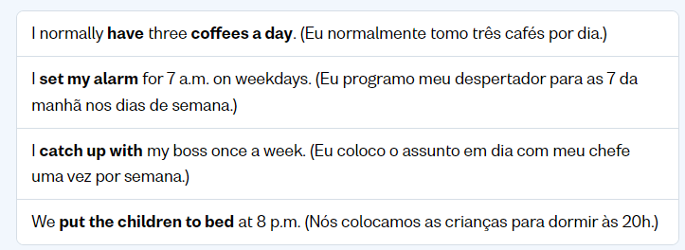

-

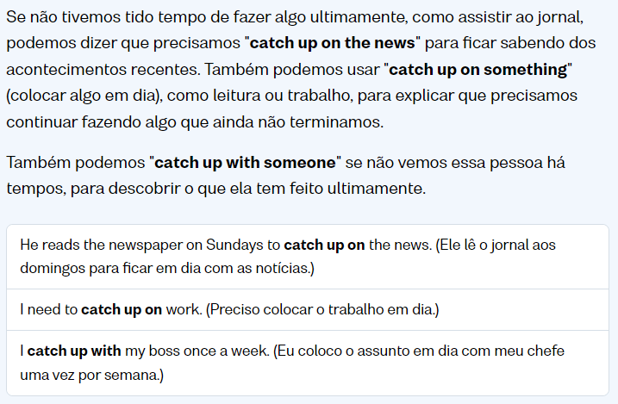

-

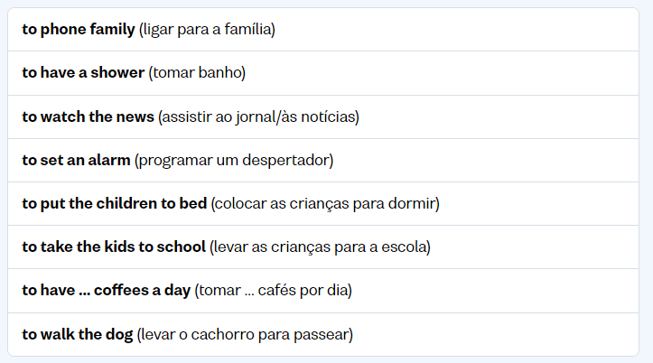

-

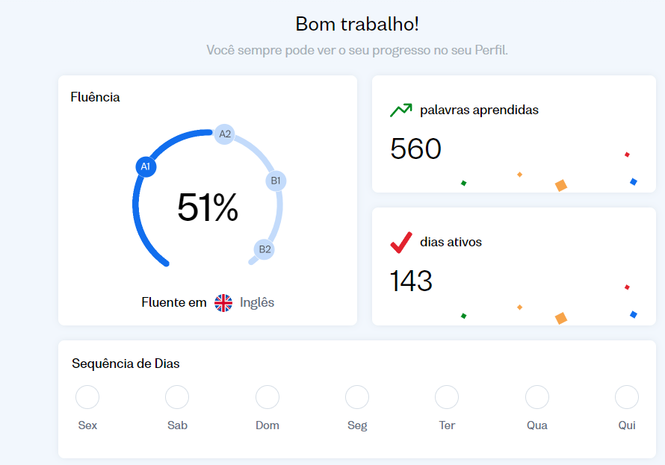

-

* News in levels – NOK

**Study day (02/10/2021) – class with teacher:**

***How as the class today?***

Very nice. We corrected workbook unit 14 and 15. We studied Book 1 unit 1 until part 5 grammar focus.

***For next class:***

1. To take workbook unit 16 – ok
2. Exercise part 5 grammar focus exercise 1, 2 and 3 - OK
3. Install app Elsa
4. To send link for class died. Link: how meeting
5. To pass my experience for friends (apps and sites)

**Tasks**

* Learn NBC News: <https://youtu.be/7rOWHevxZPw>
* Ask Jackie:
* See video unit 1 – NOK
  + Watching until 6. To see 7 in 5:46’ minute.
* To see gramar plus page pdf 152
* Criar uma planilha com lista de palavras desconhecidas do mestrado
* Workbook
  + Finished exercise xxx
* Drops - NOK
* Duolingo Italy - NOK
* Busuu – NOK - Lição Lição xx
* News in levels – NOK

Hello pessoAll,

Aproveita que o prof está em aula vou mandar uns bizus e link pra vcs deste book e depois apago.

Video – Playlist das aulas: <https://youtu.be/fs6gMj4zN3Q?list=PLrE-TRIPaiR7oqjITR7U-p4-pqwEJiWTJ>

Quiz: <https://quizlet.com/499050837/unit-1-interchange-book-1-flash-cards/>

<https://www.deepl.com/translator>

**Apps:**

<https://elsaspeak.com/pt/> (Android/Maçã)

<https://www.busuu.com/> (Android/Maçã)

<https://www.duolingo.com/> (Android/Maçã)

<https://www.newsinlevels.com/> (Android/Maçã)

# **Tasks and Researchs**

Vern a imagem abaixo se encontra estes materiais e se tem como comprar e tals

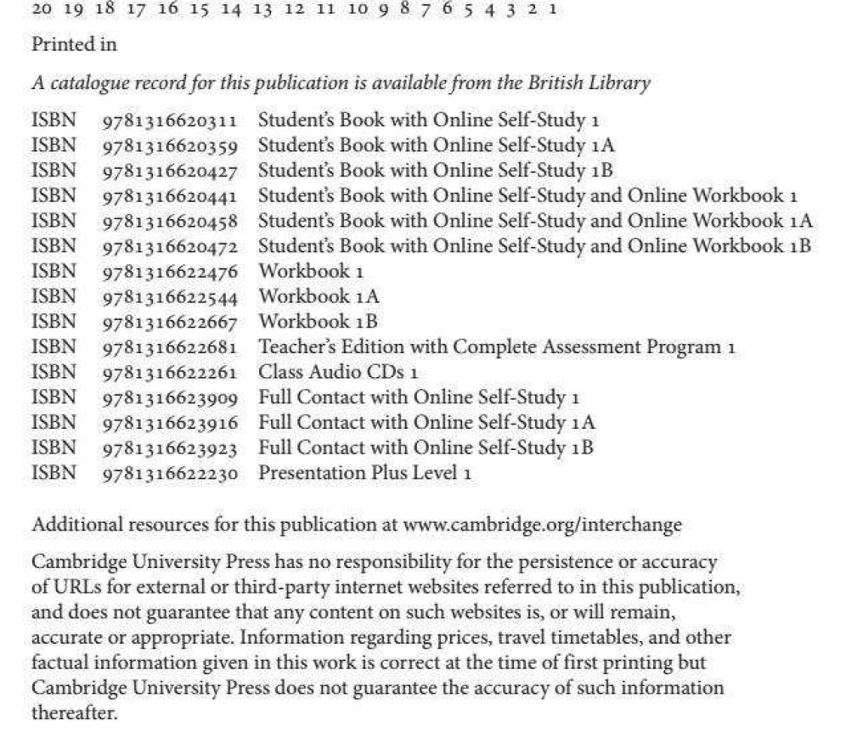

Pesquisar sobre o autor destes livros – Jack C. Richards

Read introduction book

News in english

Devotional in english

https://culturainglesapi.com.br/blog/7-melhores-jornais-para-aprender-ingles-com-noticias-3.html

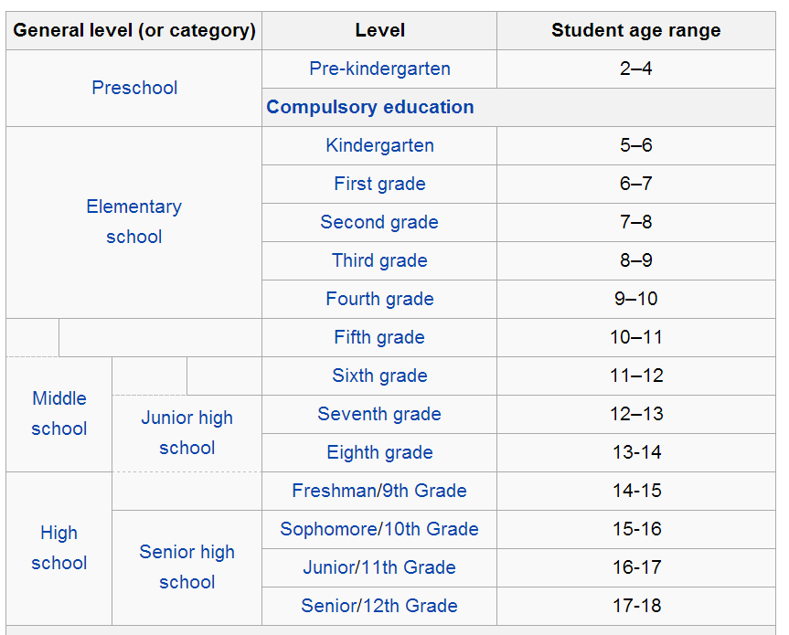

# **Bibliography**

Play list INTERCHANGE 5TH EDITION BOOK 1: <https://www.youtube.com/watch?v=fs6gMj4zN3Q&list=PLrE-TRIPaiR7oqjITR7U-p4-pqwEJiWTJ>

Lessons record: <https://1drv.ms/f/s!AvGAHmvAFyVsk88M532_fYJH79hWDA>

News

NBC News: <https://www.youtube.com/channel/UCeY0bbntWzzVIaj2z3QigXg>

<https://www.askjackie.com.br/ingles-fora-do-livro/>