Curso de Inglês

Professor: Luis Felipe

Aluno: Luiz Perciliano

Programa: Class#9_2021

**Sumário**

1. Semana 33 – de 16 de agosto a 22 de agosto 3

2. Semana 34 – de 22 de agosto a 28 de agosto 3

3. Referências 3

# **Semana 33 – de 16 de agosto a 22 de agosto**

Unit 10 = <https://www.youtube.com/watch?v=MpkVVksji4Y>

**Estudo dia (17/08/2021):** WorkBook, Unit 10, exercise 3.

**Estudo dia (18/08/2021 00:29h):** WorkBook, Unit 10, exercise 4 – OK

**Estudo dia (18/08/2021 22:38h a 23:12h):** WorkBook, Unit 10, exercise 5 at 10 – ok

**Unit 11**

I AM GOING TO HAVE A PARTY- INTERCHANGE INTRO 5TH EDITION UNIT 11 AUDIO PROGRAM

<https://www.youtube.com/watch?v=YQtXPmLAoEM&t=5s>

Listen unit eleven complete.

**Estudo dia (19/08/2021 23:14h a 00:20h):** WorkBook, Unit 11 exercise 1 at 2

**Estudo dia (20/08/2021 23:44h a 00x:37h):** WorkBook, Unit 11 exercise 3 at 5.1

Interchange INTRO 5th edition - Unit 11A 👉👉 SUBSCRIBE 👈👈

<https://www.youtube.com/watch?v=ngCd0g8QrEM&list=PL2eIVQX0_SVcB-neEUAK6OrN0z0Xf9FTS&index=21>

**Estudo dia (21/08/2021 08:00h a 10:00h):** Aula no Zoom com teacher e guys.

**Homework:** Lesson 10, 11 and 15 cap 7b em diante.

It made lesson 10 until 11 5.1

# **Semana 34 – de 22 de agosto a 28 de agosto**

**Study day (23/08/2021 22:31h a 23:27h):**

WorkBook: **: Unit** 11, exercice 5.2 at exercise 7

Book, Unit 15 exercise 7 B em diante (page)

Refazer toda a lição 7

**Study day (24/08/2021 22:47h a 23:16h):**

Drops - OK

Book, Unit 15 exercise 7 B em diante - OK

Refazer toda a lição 7 – OK

To make 8 – Word Power (vídeo 12:00minutes)

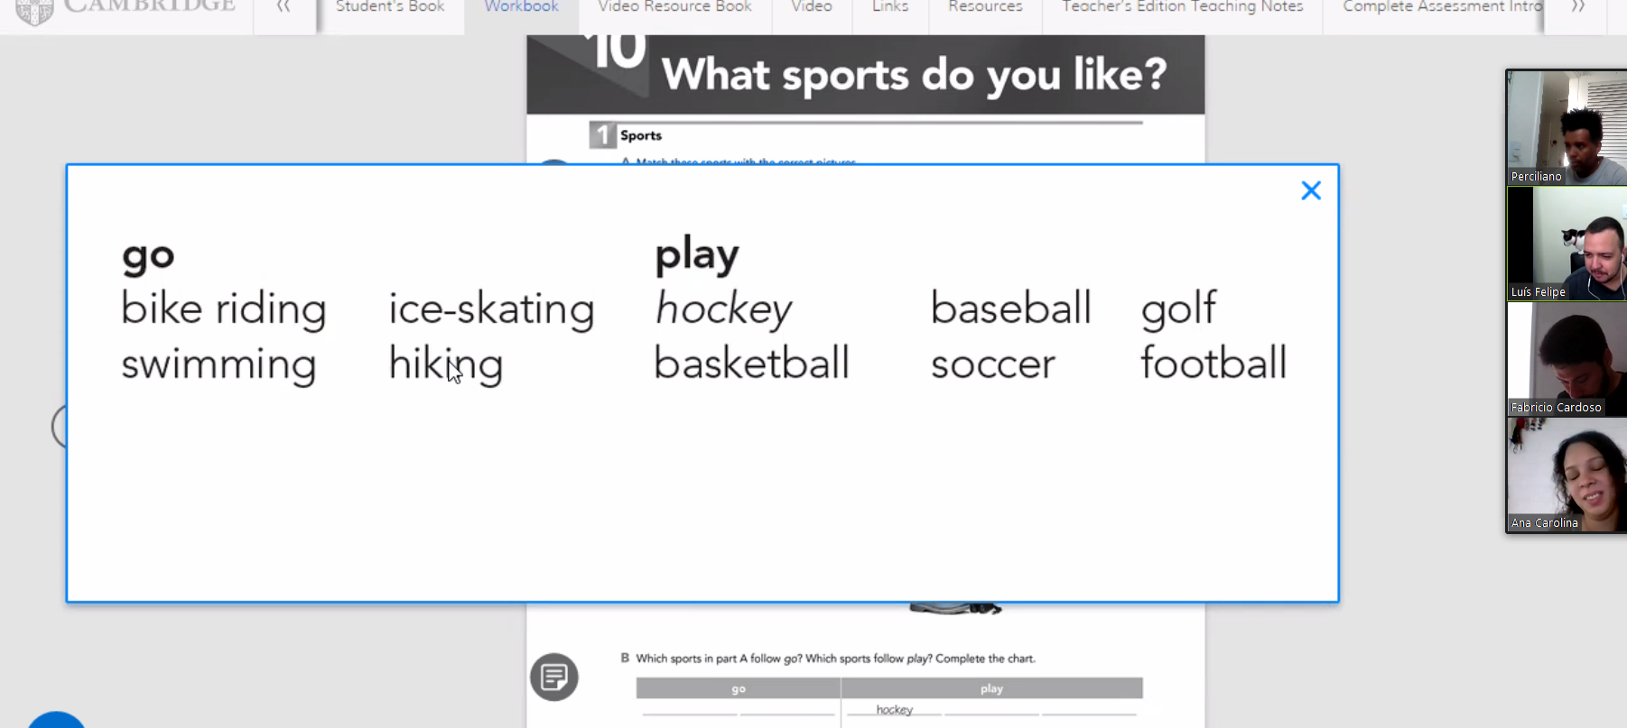

Unit 15 links

Interchange INTRO 5th edition WHERE WERE YOU BORN?

* WHERE WERE YOU BORN ?

<https://youtu.be/OI0vkiif5uI> (listen in 23/08/21)

listen again and to make exercise seven

* Unit 15A - <https://youtu.be/tSmaZdmrZ0U?list=PL2eIVQX0_SVcB-neEUAK6OrN0z0Xf9FTS>
* Unit 15B - <https://youtu.be/yLJ-kqkfsL8?list=PL2eIVQX0_SVcB-neEUAK6OrN0z0Xf9FTS>

Book, Unit 15 exercise 7 B (page) em diante

**Homework: Unit** 11, exercice 5.1 and study unit 15 book 7b em diante. (23/08/2021 = OK)

# **Semana 35 – de 28 de agosto a 04 de setembro – Unit 16**

**Study day (28/08/2021 08:13h a 10:02h) – Botafogo-RJ**



Correct Units workbook 10 and 11.

**Study day (30/08/2021 23:20h a 31/08/2021 00:50h) – Botafogo-RJ**

Workbook, unit 12, make until exercise 6.

To homework, to make workbook unit 11, 12 and 13

Unit 12 –

<https://www.youtube.com/watch?v=vEOuo1JC1aA> (listen 30/08/2021)

<https://www.youtube.com/watch?v=tIqNtQJGCEY&list=PL2eIVQX0_SVcB-neEUAK6OrN0z0Xf9FTS&index=24>

<https://www.youtube.com/watch?v=_FM3Ww-ZrbU&list=PL2eIVQX0_SVcB-neEUAK6OrN0z0Xf9FTS&index=25>

Unit 16

ESTARLING SILVESTRE

CAN I TAKE A MESSAGE ? interchange intro 5th edition unit 16 audio program

<https://www.youtube.com/watch?v=bbcjRqiyhnE>

Teacher Wilkins

<https://www.youtube.com/watch?v=YYQCuXjjvLg&list=PL2eIVQX0_SVcB-neEUAK6OrN0z0Xf9FTS&index=31>

<https://www.youtube.com/watch?v=rf5vDhOXkqI&list=PL2eIVQX0_SVcB-neEUAK6OrN0z0Xf9FTS&index=32>

Segue a lição 15 em dois canais do Youtube

* <https://youtu.be/OI0vkiif5uI>
* Unit 15A - <https://youtu.be/tSmaZdmrZ0U?list=PL2eIVQX0_SVcB-neEUAK6OrN0z0Xf9FTS>
* Unit 15B - <https://youtu.be/yLJ-kqkfsL8?list=PL2eIVQX0_SVcB-neEUAK6OrN0z0Xf9FTS>

**Study day (xx/08/2021 22:47h a 23:16h):**

# **Referências**

Teacher Wilkins -

<https://www.youtube.com/channel/UCtjDh5Cp7Va9qh3CMnsfLrA>