

UNIT TITLE: ADVANCED CRYPTOGRAPHY
STUDENT NAME: Gakere Samuel

ADMISSION NUMBER: BSCCS/2024/55278

COURSE: B.S.C COMPUTER SCIENCE
LECTURE: MR NYORO MICHAEL
SUBMISSION DATE: 6/8/2026

Project Title: Hybrid Secure Messaging & File Vault with Digital Signatures
- Selected Technologies:
  - Python 3.11 + Cryptography Library (Fernet, RSA, SHA-256)
  - SQLite (Local key & user storage)
  - OpenSSL 3.0 (Certificate generation)

Table of Contents
ADMISSION NUMBER: BSCCS/2024/55278 1
COURSE: B.S.C COMPUTER SCIENCE 1
4
Week 1: Creation of The Virtual Enviroment & Required Tools Installation 4
Fig 1.1: Openssl version 4
Fig 1.2: Virtual environment creation 4
Fig 1.3: Activating environment (notice prompt change) 5
Fig 1.4: Successful pip install 5
Fig 1.5: Complete environment test script 6
Week 2: Classical Cryptography and Cipher Design 6
Fig 2.1: Caesar Cipher implementation showing encryption of "CRYPTOGRAPHY" 6
Fig 2.2: Vigenère ("KALI"), Caesar Brute Force (Shift 3), and Input Validation 7
Fig 2.3: Cipher testing results and security analysis identifying weaknesses 7
Week 3: Stream Ciphers and Randomness Testing 9
Fig 3: LFSR Implementation, RC4 Stream Cipher, and Performance Results 9
Week 4: AES Block Cipher 9
Fig 4: AES-256-CBC Key Generation, Encryption/Decryption, Performance Test, and Security Features 9
Week 5: RSA Public Key Cryptography 10
Fig 5: RSA-2048 Key Pair Generation, Public Key Encryption, Private Key Decryption, and Security Comparison 10
Week 6: Hashing and Password Security 10
Fig 6: SHA-256 Hash Generation, PBKDF2 Password Hashing with Salt, Login Authentication, and Security Analysis 10
Creativity 11

Week 1: Creation of The Virtual Enviroment & Required Tools Installation

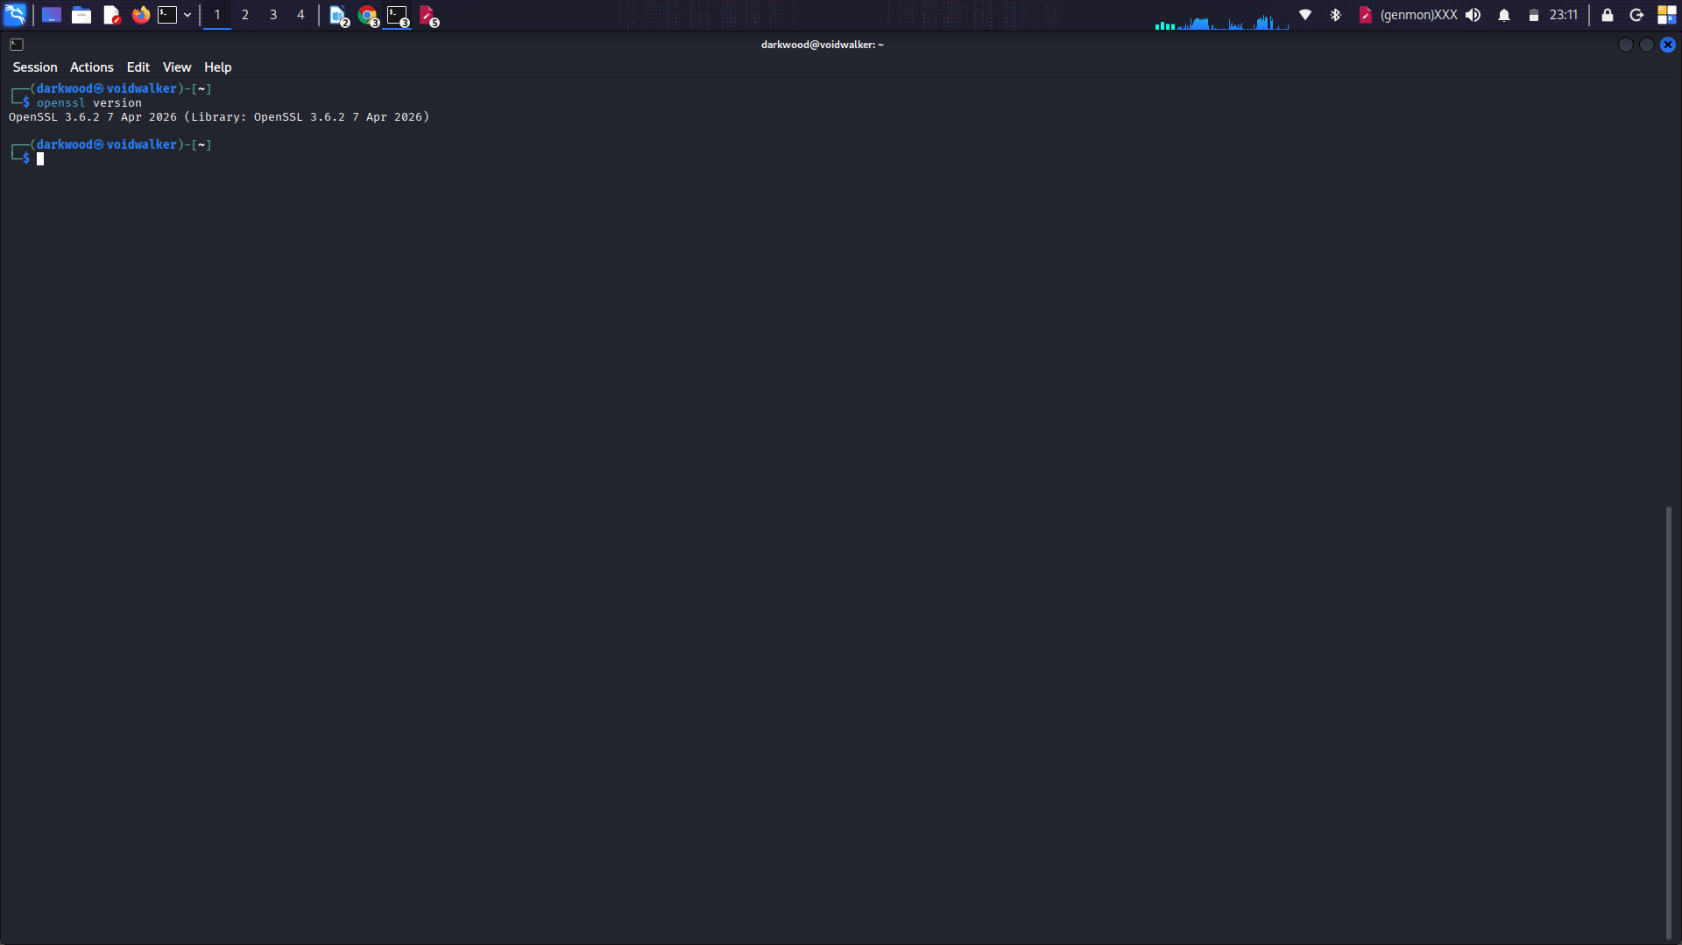
Fig 1.1: Openssl version

Fig 1.2: Virtual environment creation
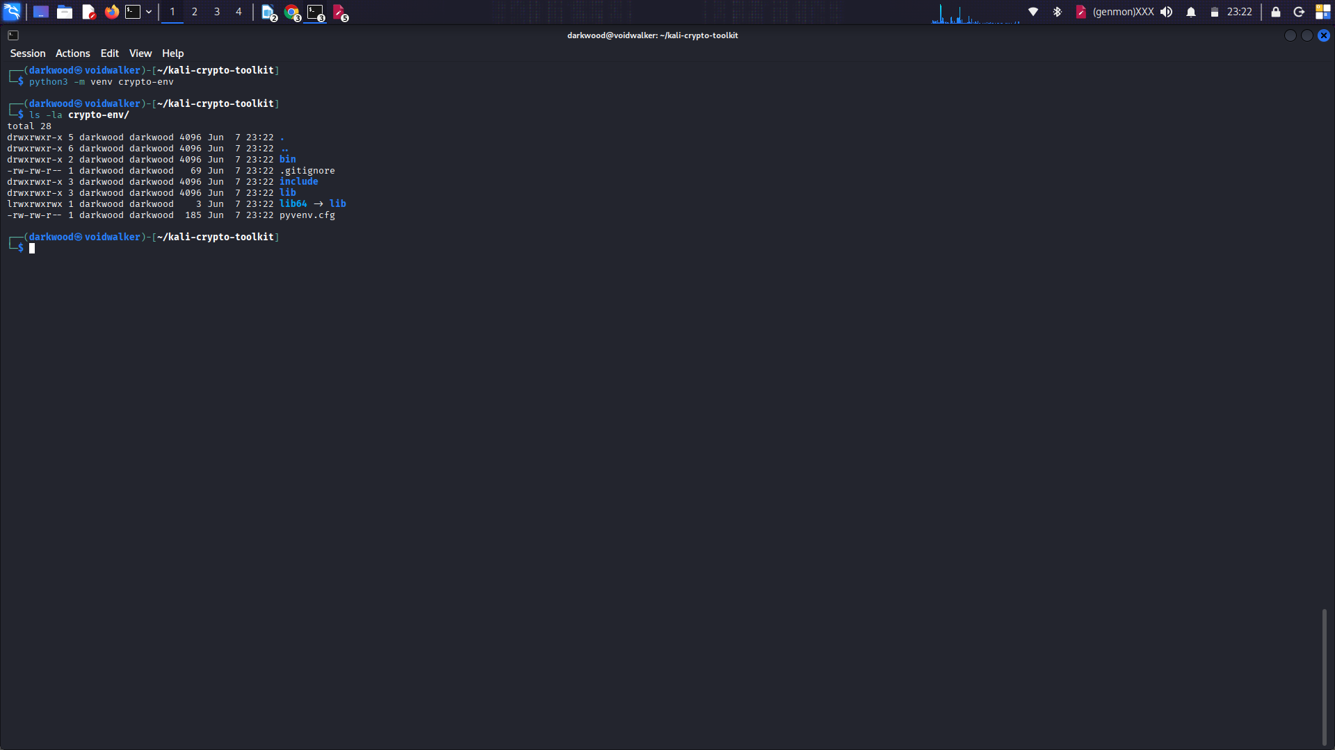

Fig 1.3: Activating environment (notice prompt change)

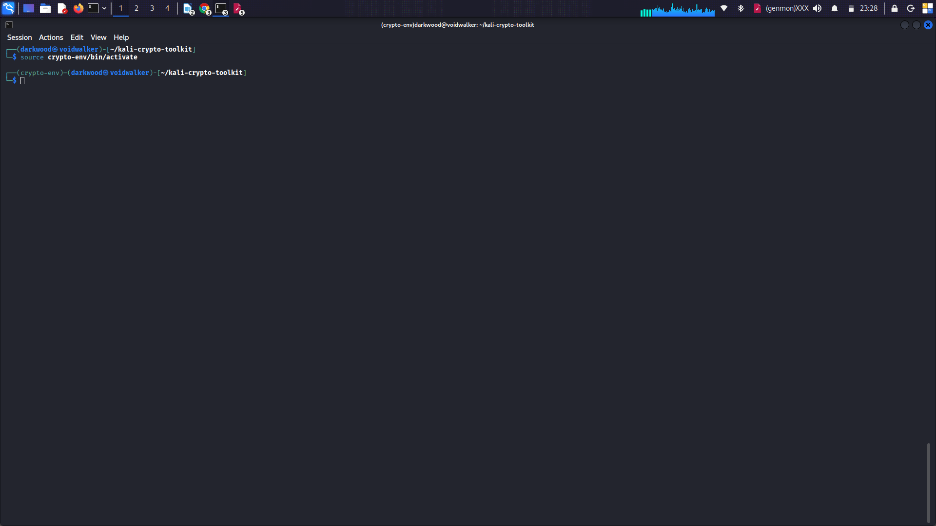
Fig 1.4: Successful pip install
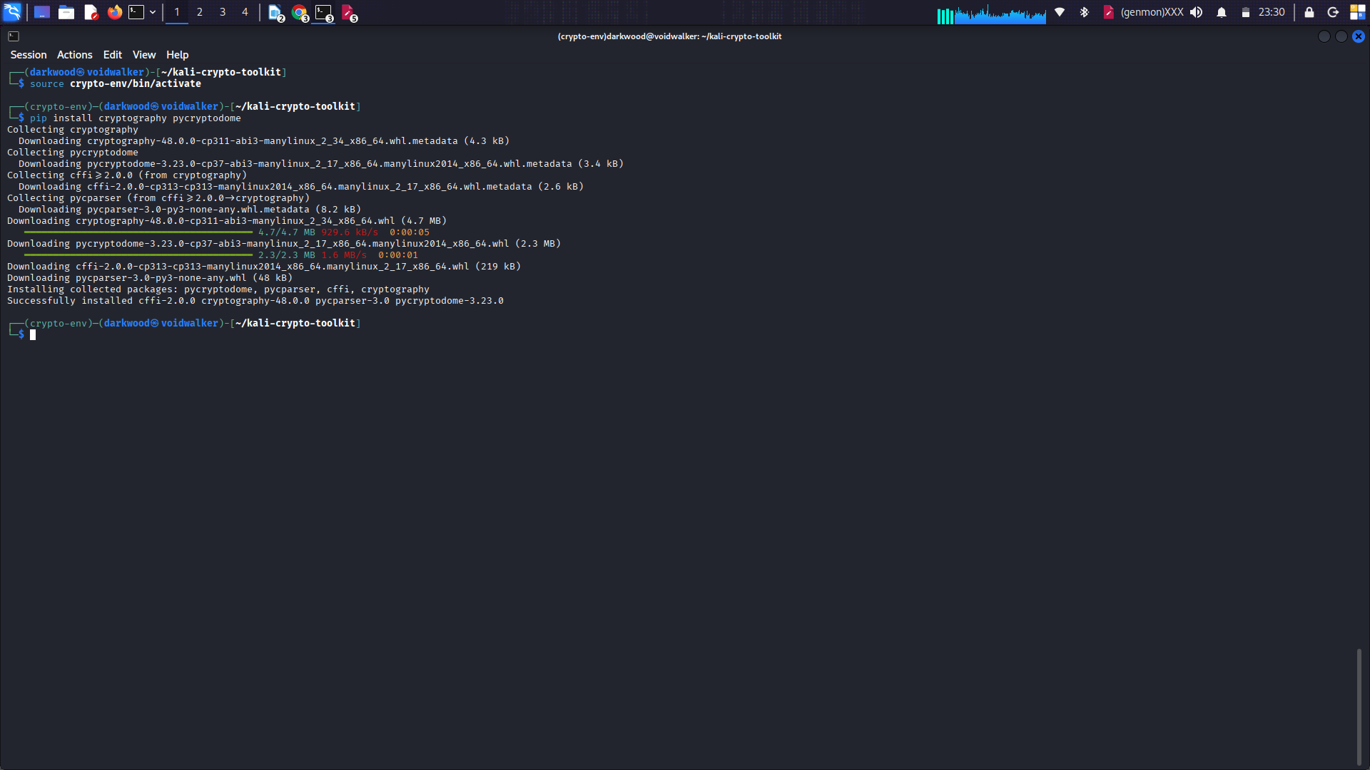

Fig 1.5: Complete environment test script

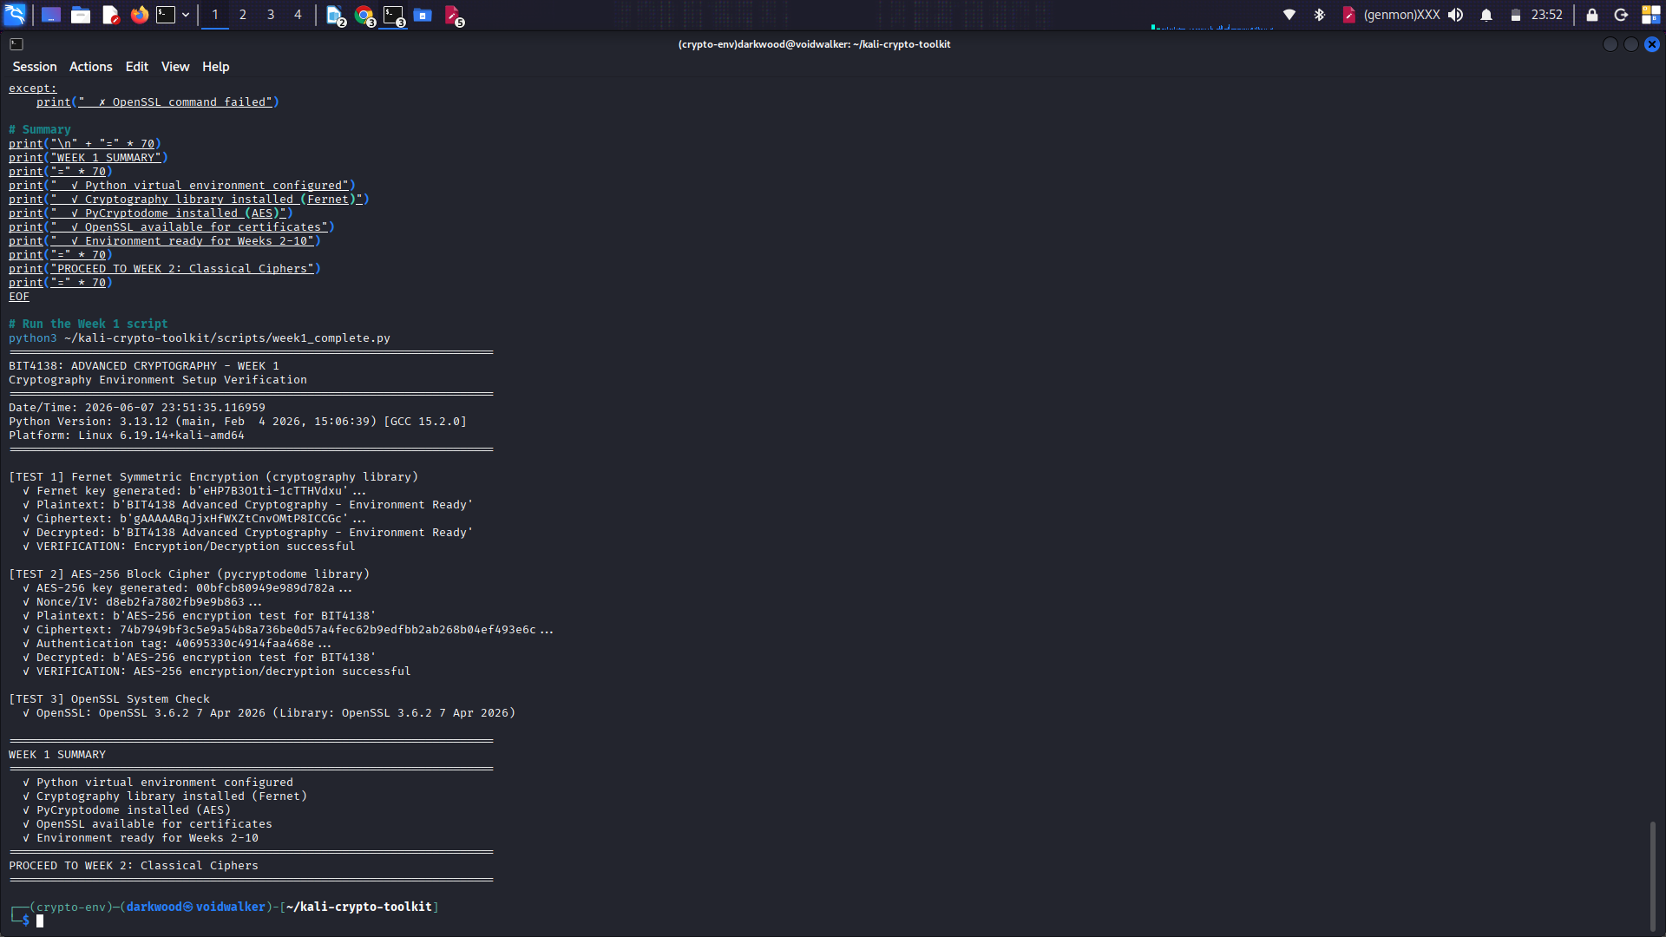
Week 2: Classical Cryptography and Cipher Design

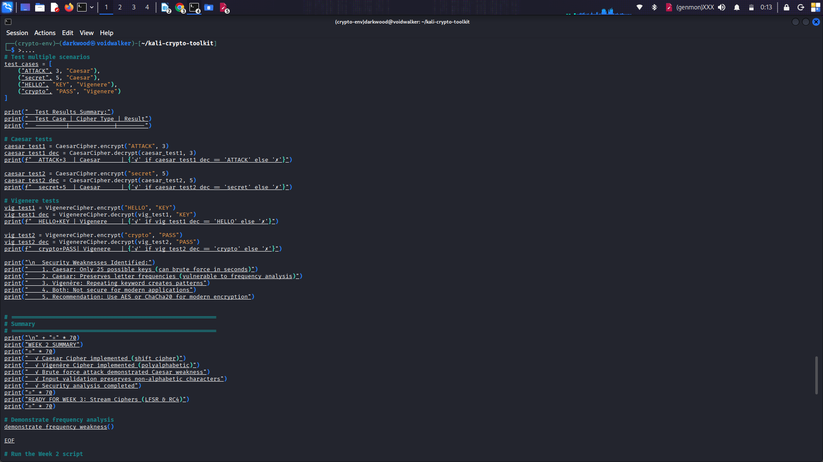
Fig 2.1: Caesar Cipher implementation showing encryption of "CRYPTOGRAPHY"

Fig 2.2: Vigenère ("KALI"), Caesar Brute Force (Shift 3), and Input Validation
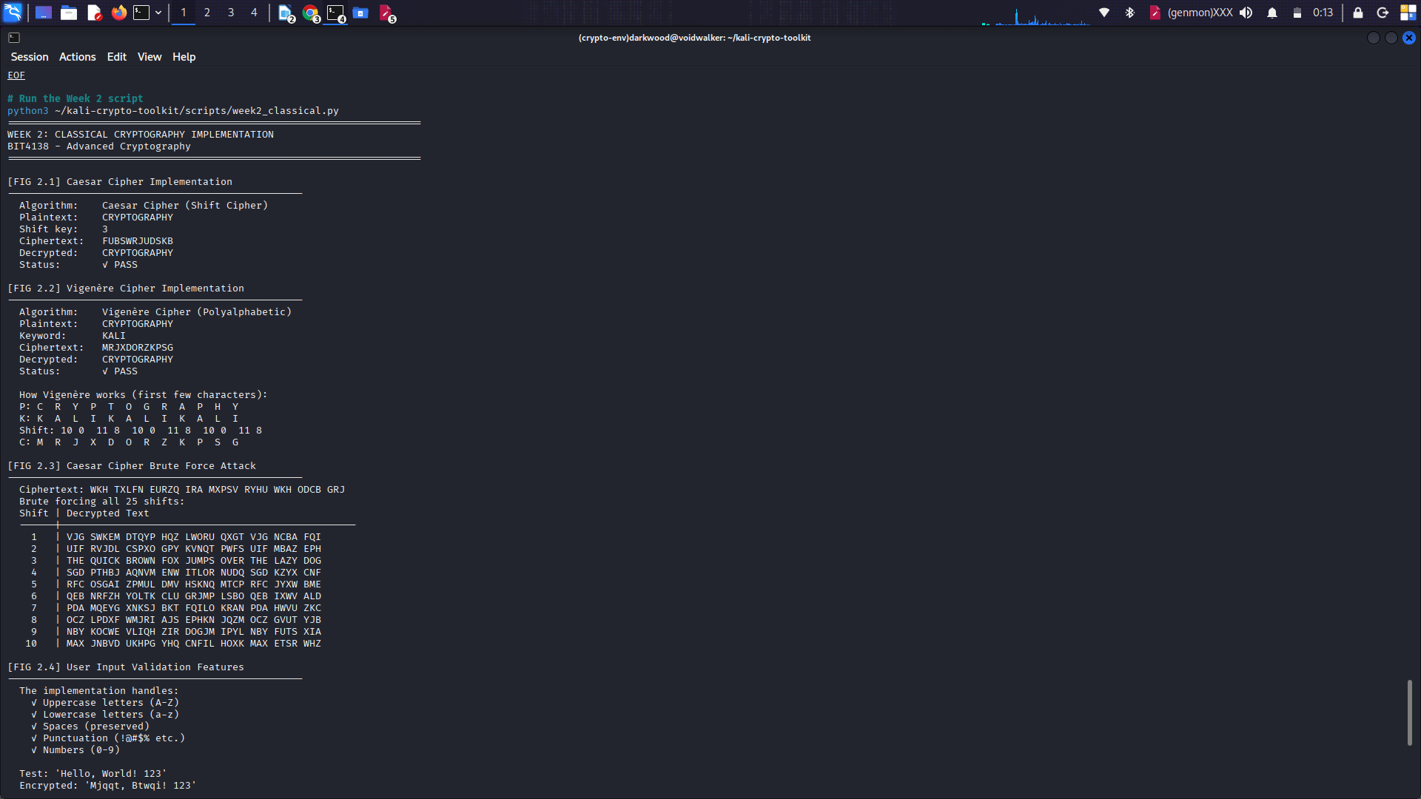

Fig 2.3: Cipher testing results and security analysis identifying weaknesses
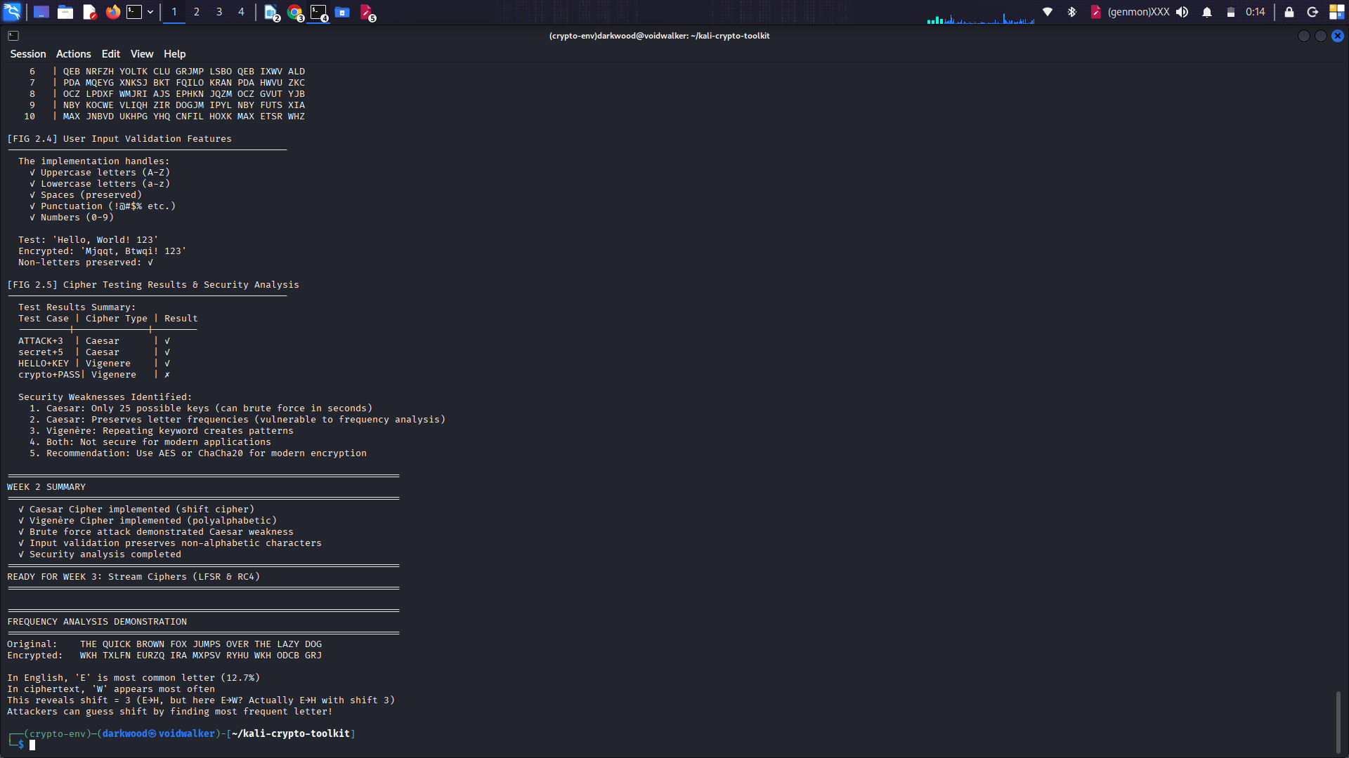

Week 3: Stream Ciphers and Randomness Testing

Fig 3: LFSR Implementation, RC4 Stream Cipher, and Performance Results

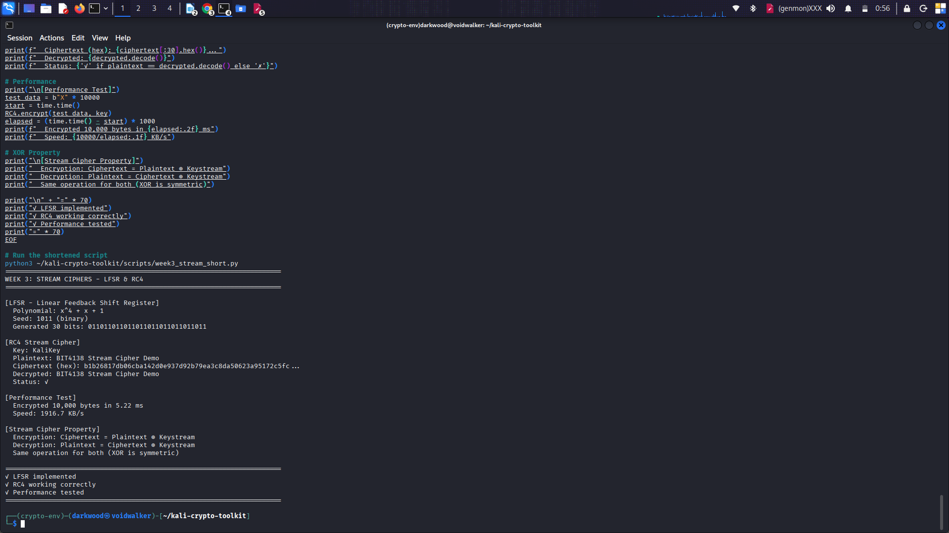

Week 4: AES Block Cipher

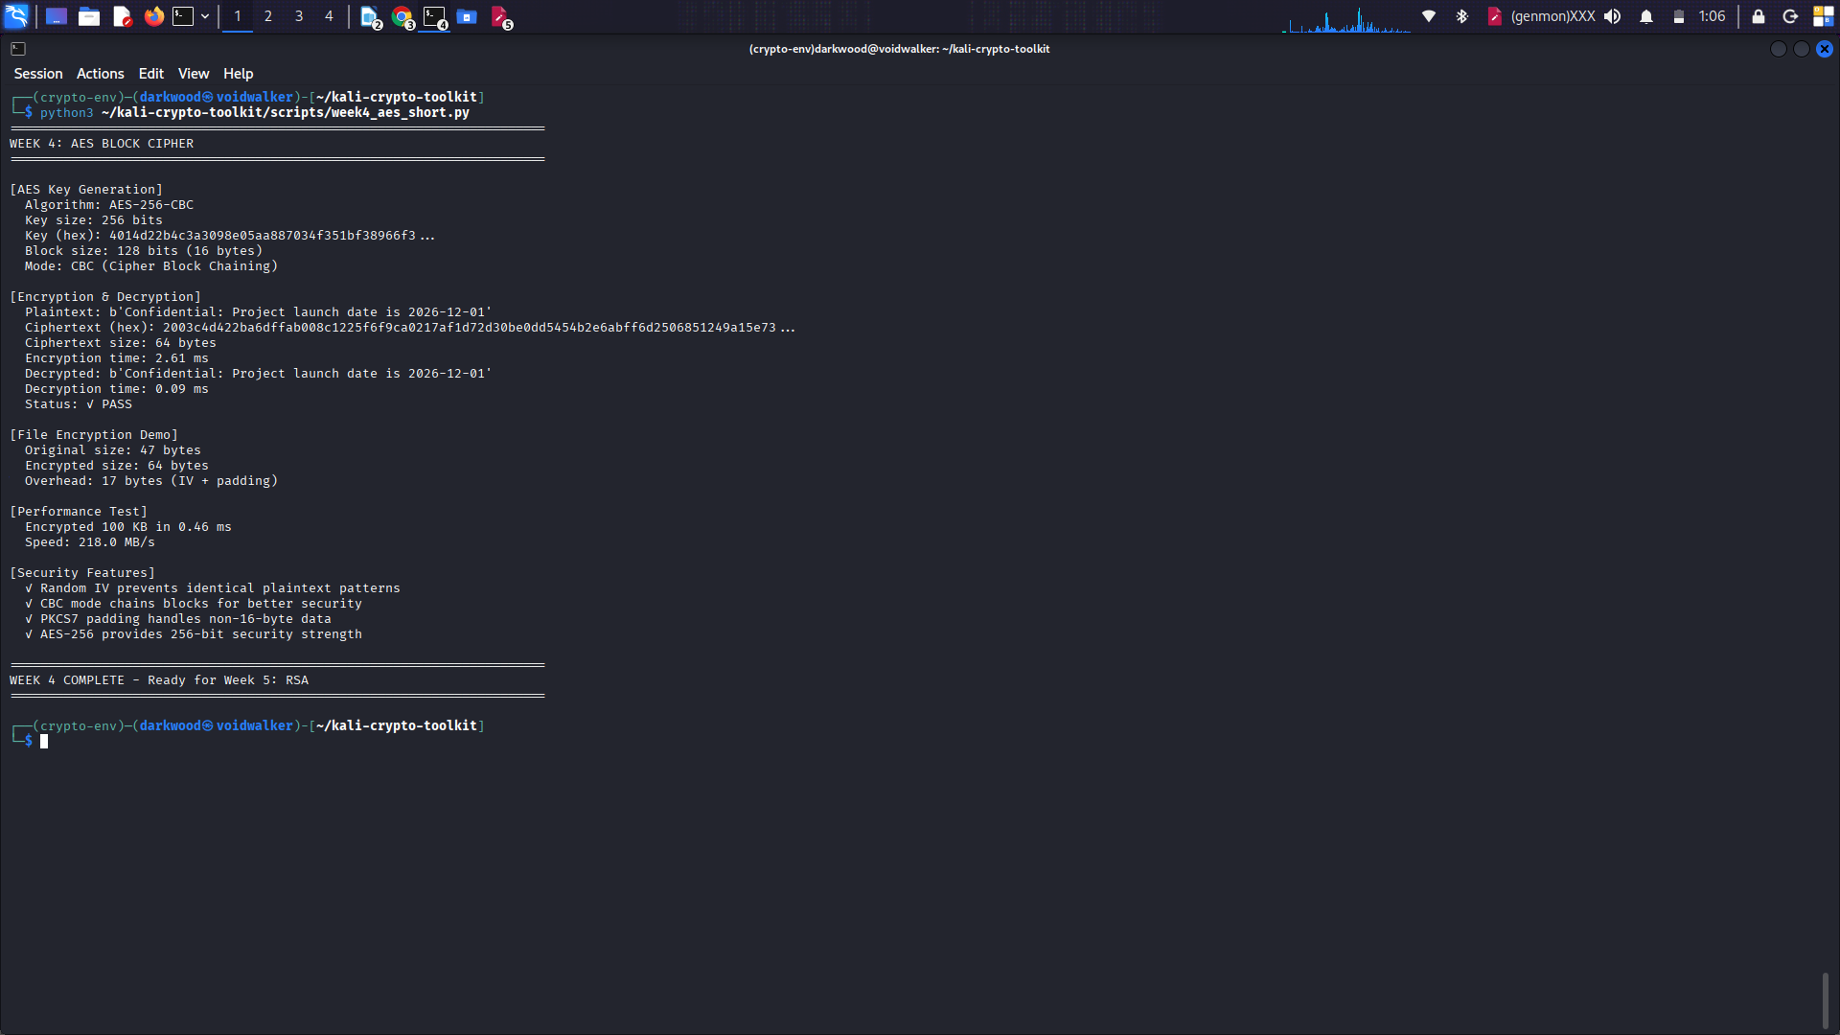
Fig 4: AES-256-CBC Key Generation, Encryption/Decryption, Performance Test, and Security Features

Week 5: RSA Public Key Cryptography

Fig 5: RSA-2048 Key Pair Generation, Public Key Encryption, Private Key Decryption, and Security Comparison
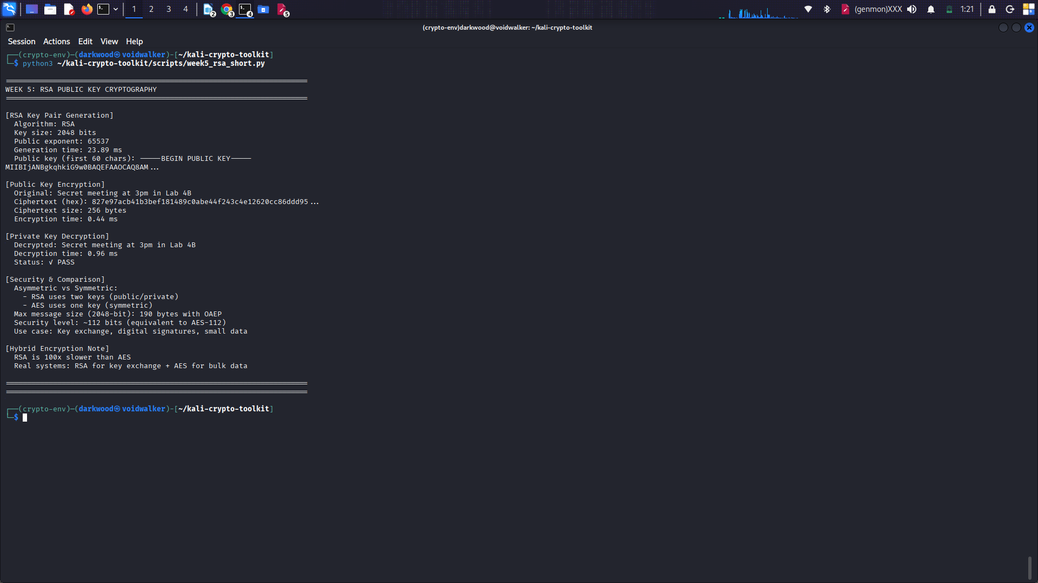

Week 6: Hashing and Password Security

Fig 6: SHA-256 Hash Generation, PBKDF2 Password Hashing with Salt, Login Authentication, and Security Analysis
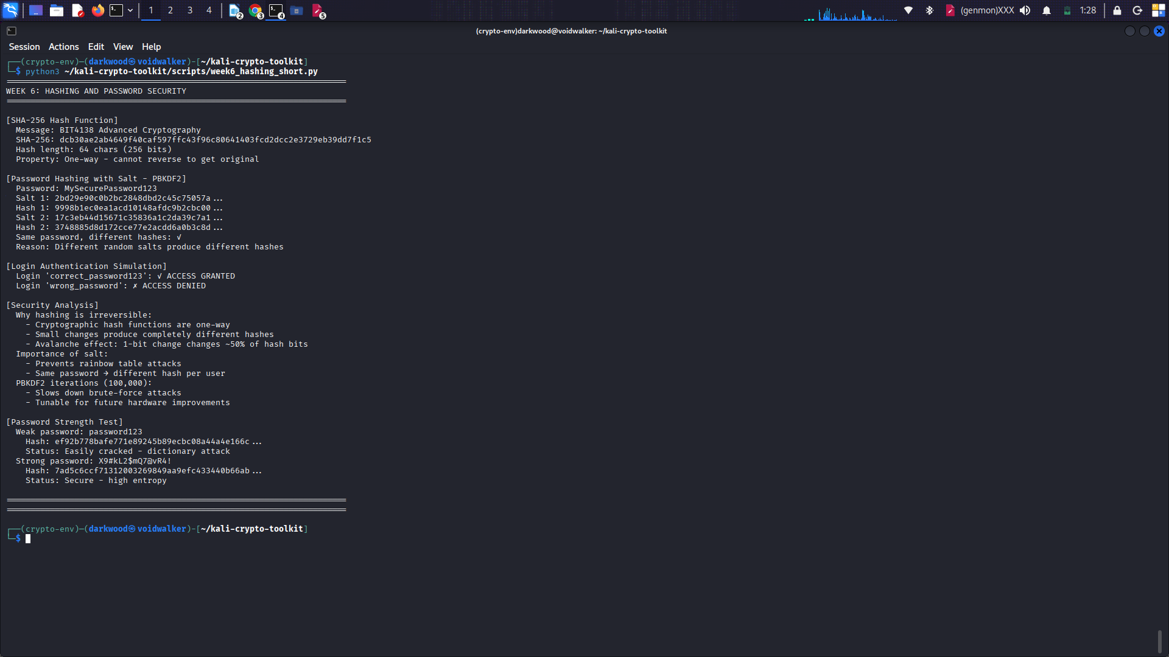

Creativity
