ABCD App Quick Start Guide

**This Quick Start Guide will help you complete the steps required to get started with ABCD app:**

Step 1. Set up your new iPad and create an Apple ID (needed to download ABCD app from App store).

Step 2. Install ABCD app from App store.

Step 3. Log in to ABCD and download a clinical trial.

**Before you get started, ensure you have:**

* a Wi-fi connection (and the Wi-fi password)
* your cell phone nearby
* an ABCD user account

**Allow approximately 1.5 hours to complete the steps.**

Set Up Your iPad and Create Apple ID

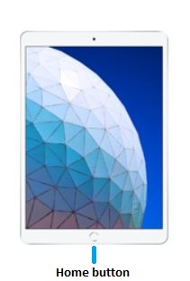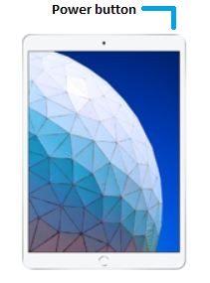

1. Press and hold the **power button** until you see the Apple logo.

If the iPad doesn’t wake, try charging the battery first (use the charger provided in the iPad box).

1. When you see **Hello** in many languages, press the **Home button** to continue, as indicated on the screen.

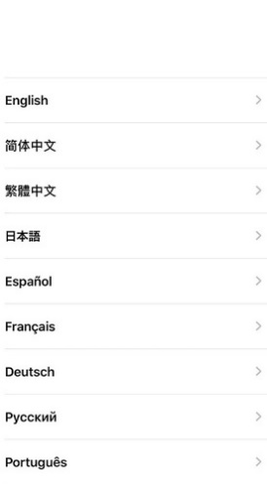

1. Select a language.
2. Scroll down to select your country or region. This affects how information looks on your device, including date, time, contacts, and more.
3. 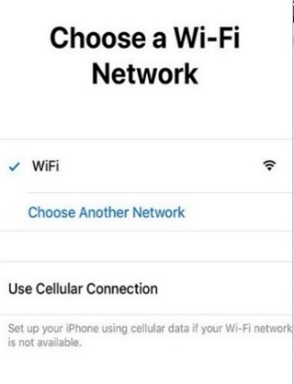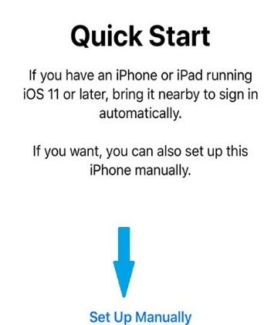On the Quick Start screen, tap **Set Up Manually** to continue.
4. Select a Wi-Fi network.
5. Enter the Wi-Fi password if required and tap **Join**.

Once connected, a tick sign will appear next to your Wi-Fi connection.

1. Tap **Next** to continue (top right corner).
2. Read the Data and Privacy information and tap **Continue** to go to the next screen.
3. Tap **Set Up Touch ID Later**.
4. On the Touch ID pop-up window, tap **Don’t Use** to continue.
5. On the Create Passcode screen, tap **Passcode Options**.
6. Select **Don’t Use Passcode**, so that the iPad can be easily shared between users.
7. On the pop-up window, tap **Don’t Use Passcode** to confirm you don’t want a passcode.
8. Select **Don’t transfer apps and data** to continue, as you are not transferring data from another device at the moment.
9. 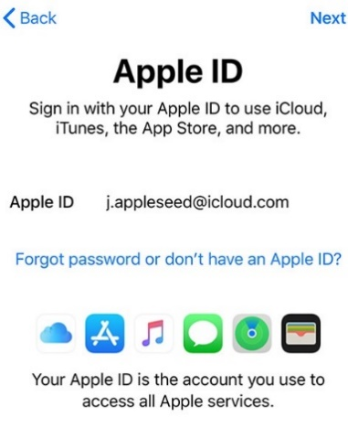If you don’t have an Apple ID, tap on the **Forgot password or don’t have an Apple ID?** link to create one.

If you already have an Apple ID, type it in the Apple ID text field and tap **Next** to enter your password. Tap **Next** after entering the password and go to step 24 to continue with authentication.

Note:

You will use the Apple ID to download the ABCD app from the App store.

You will only need one Apple ID for all users at your site.

1. 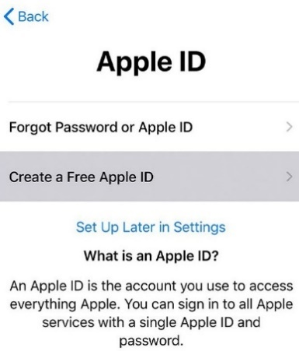Tap **Create a Free Apple ID**.
2. Enter required information: First Name, Last Name, Date of Birth.
3. Tap **Next** to continue.
4. Enter your contact email address and tap **Next**.
5. Enter a suitable password and re-type it to confirm.

Note:

Remember this password as you will use it to download the ABCD app from the App Store.

1. Tap **Next** to continue.
2. 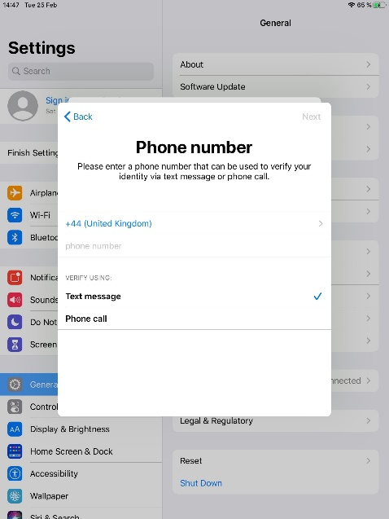Enter your mobile phone number and tap **Next** to receive the identity verification code.
3. Enter the 6-digit verification code received via SMS where indicated.
4. Tap **Agree** to the Terms and Conditions (bottom right corner).

Wait for a few minutes until your Apple ID is set up.

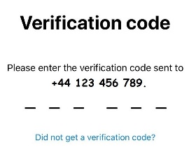

1. 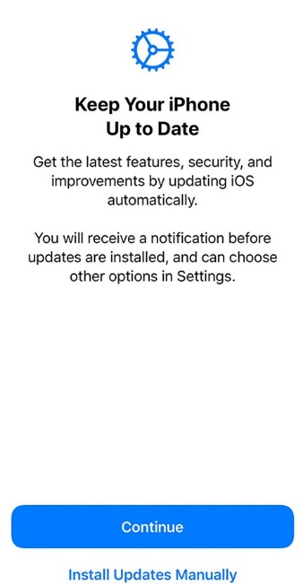Tap **Continue,** when you have read the information about regular updates that will be done on your device.
2. Tap **Enable** Location Services.
3. Tap **Set Up Later in Settings** if you don’t want to receive weekly reports about your screen time.
4. Tap **Don’t Share** if you don’t want to allow Apple to analyze your device usage and data.
5. Select a light or dark screen appearance and tap **Continue**.
6. Tap **Continue** when you have read each of the following:
   1. information about Quick Access to the Dock.
   2. information about how to Switch Between Recent Apps
   3. information about how to Quickly Access Controls
7. Tap **Get Started** to continue.
8. 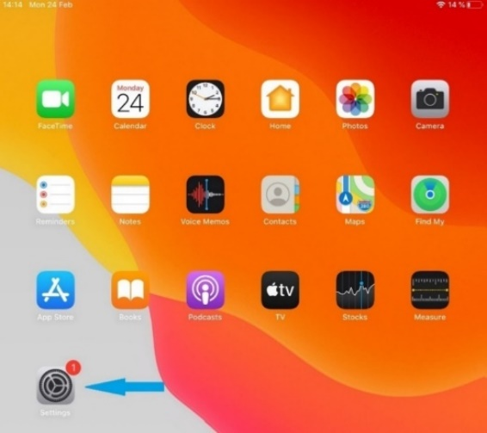Tap the **Settings** icon to finish setting up your Apple ID.

Note: The next steps apply only if you created your Apple ID during this iPad setup. You are not required to complete these steps if you already had an Apple ID set up beforehand.

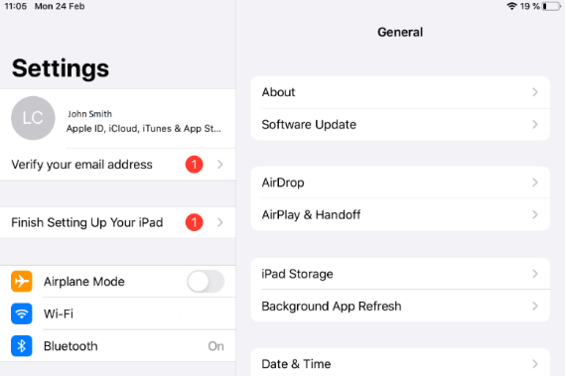

1. Tap **Verify your email address** on the Settings screen.
2. Tap the **Verify your email address** link.

A verification code will be sent to the email address you used to create the Apple ID.

1. Enter the 6-digit verification code on your iPad.
2. Under Settings, go to General > Date & Time and ensure that **Set Automatically** is enabled.
3. Tap the Home button to return to the Home screen.

*For security reasons, the rest of the steps cannot be disclosed.*