# Abstract

Paws Nepal is a web-based platform designed to streamline dog adoption processes in Nepal by connecting shelters, adopters, and pet care resources. Built using **HTML5, CSS3, JavaScript, jQuery, and AJAX**, the platform features dynamic dog listings loaded from a JSON file, responsive design for mobile/desktop compatibility, and interactive elements like adoption calculators and image galleries. The frontend-only architecture ensures easy deployment on static hosting services like GitHub Pages, making it accessible to shelters with limited technical infrastructure. Key functionalities include user registration forms with validation, filtered dog searches, and success story galleries.

**Keywords**: *Paws Nepal, Dog Adoption, HTML, JavaScript, jQuery, Responsive Design*

# Acknowledgements

We extend our sincere gratitude to our supervisor, **Arpan Acharya**, for their invaluable guidance. Special thanks to the **Department of BCSIT** and our peers for their feedback.

# Table of Contents

1. Abstract
2. Acknowledgements
3. List of Abbreviations
4. List of Figures
5. List of Tables
6. Chapter 1: Introduction
7. Chapter 2: Review of Literature
8. Chapter 3: System Analysis and Design
9. Chapter 4: Implementation and Testing
10. Chapter 5: Conclusion and Future Recommendations
11. Appendices
12. References

# List of Abbreviations

| **Abbreviation** | **Full Form** |
| --- | --- |
| UI | User Interface |
| JSON | JavaScript Object Notation |
| AJAX | Asynchronous JavaScript and XML |

# Chapter 1: Introduction

## 1.1 Background

Paws Nepal addresses the inefficiencies in traditional dog adoption methods by providing a centralized digital platform. The project leverages frontend technologies to create an intuitive interface for adopters and shelters.

## 1.2 Problem Statement

Manual adoption processes are time-consuming, lack transparency, and limit reach. Paws Nepal solves this with real-time dog listings, adoption filters, and educational resources.

## 1.3 Objectives

* Develop a responsive adoption portal.
* Implement dynamic content loading via JSON/AJAX.
* Ensure cross-device compatibility.

## 1.4 Scope

* Frontend-only (no backend).
* Dog listings with filters (breed, age, size).
* Adoption cost calculator.

## 1.5 Limitations

* No persistent user data storage.
* Manual JSON updates for new dogs.

# Chapter 2: Review of Literature

## 2.1 Fundamental Theories

The project uses **jQuery for DOM manipulation**, **CSS Grid/Flexbox for layouts**, and **AJAX for JSON data loading**. Reference: MDN Web Docs (2023).

## 2.2 Similar Projects

Compared to platforms like *Petfinder*, Paws Nepal focuses on Nepal’s context and minimizes backend dependencies.

# Chapter 3: System Analysis and Design

## 3.1 Methodology (Incremental Model)

1. **Increment 1**: HTML structure + basic CSS.
2. **Increment 2**: Responsive design + gallery.
3. **Increment 3**: Form validation + adoption calculator.
4. **Increment 4**: JSON/AJAX integration.

## 3.2 System Design

* **Wireframes**: Homepage, Adoption Listing, Contact Form.
* **Data Model**: JSON structure for dog profiles.

# Chapter 4: Implementation and Testing

## 4.1 Implementation

* **Tools**: VS Code, Chrome DevTools.
* **Modules**:
  + User Registration (localStorage).
  + Dog Listing (AJAX/JSON).
  + Gallery (jQuery Lightbox).

## 4.2 Testing

* **Unit Tests**: Form validation, filter logic.
* **System Tests**: Cross-browser compatibility.

## Tasks Completed (Mid-Term):

* Homepage, Adoption Page, Gallery, Contact Form.

## Tasks Remaining:

* User login persistence.
* Shelter dashboard prototype.

# Chapter 5: Conclusion and Future Recommendations

## 5.1 Lessons Learned

* Improved JSON data handling.
* Improved responsive design techniques.

## 5.2 Recommendations

* Backend integration for user accounts.
* Shelter-side dashboard for dog management

# Screenshots of UI.

* 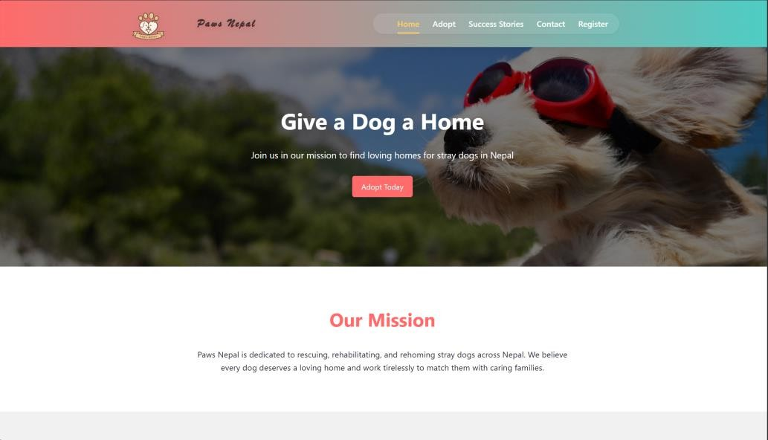Home page
* Adoption Page

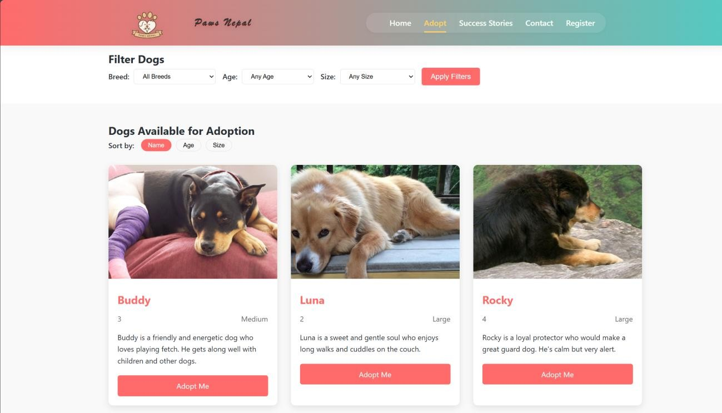

* Success Stories Page

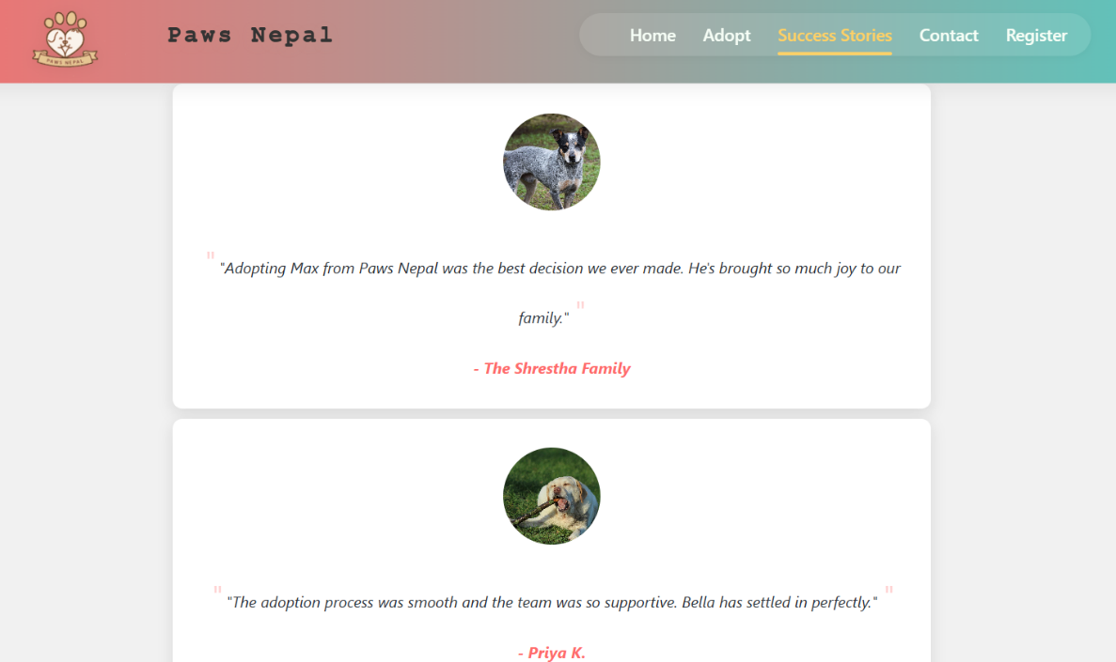

* 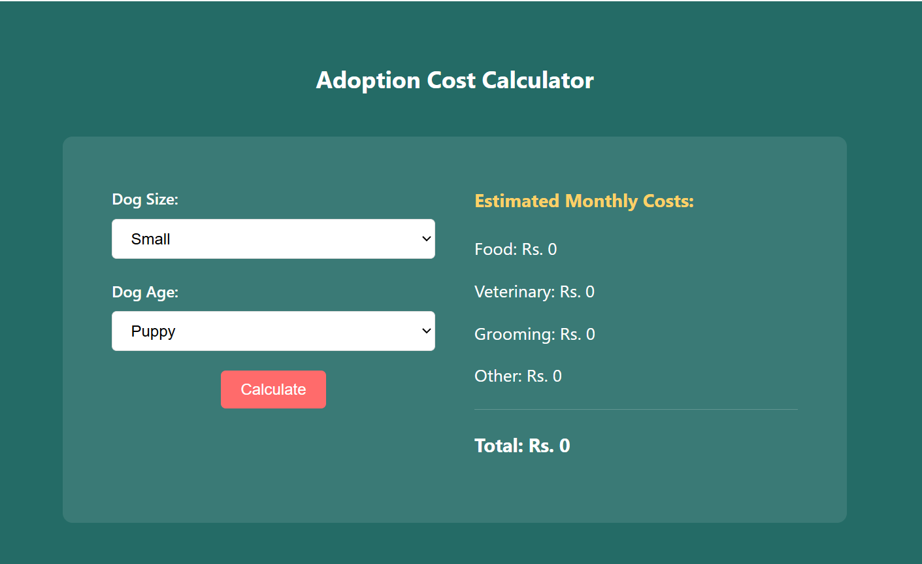Cost Calculator
* Registration Page

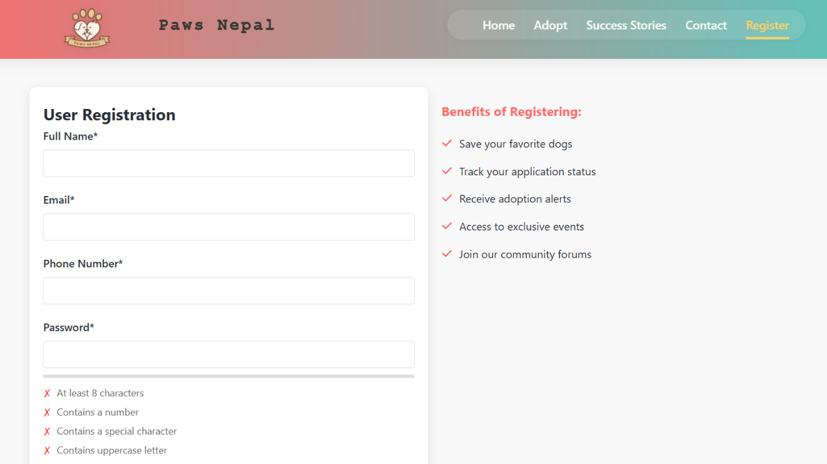

# Appendices

* Screenshots
* Source Code
* Gant Chart
* Sample JSON File

# References

1. W3Schools. "jQuery AJAX Tutorial." [Online]. Available: <https://www.w3schools.com/jquery/ajax_ajax.asp>