**Description of path planning for optic nerve decompression**

Path planning system for optic nerve decompression based on MITK. After decompressing “Preoperative planning”, find “MitkWorkbench.exe” in the “Preoperative planning software” folder, double-click to open it, and find the red square ”PreoperativePlan” in the function bar. Click to open the interface as follows:

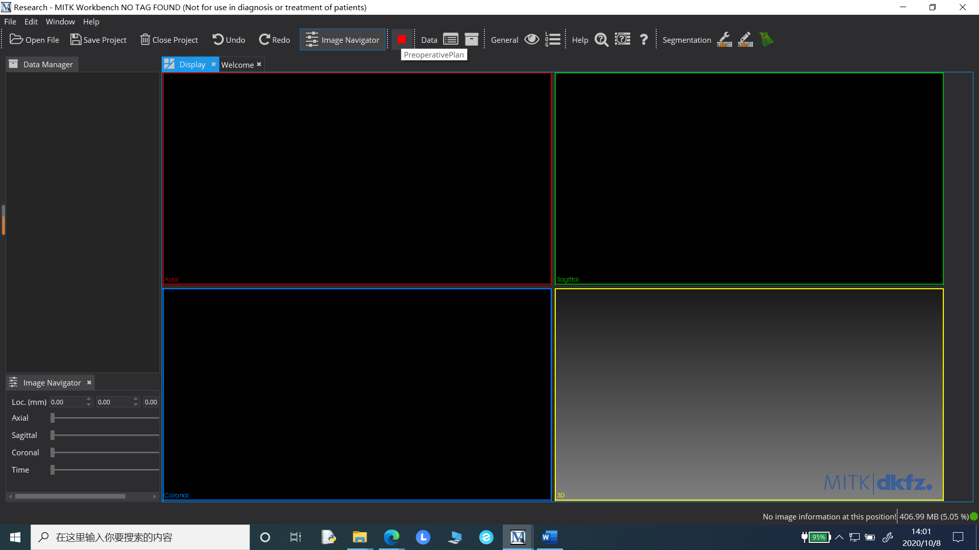

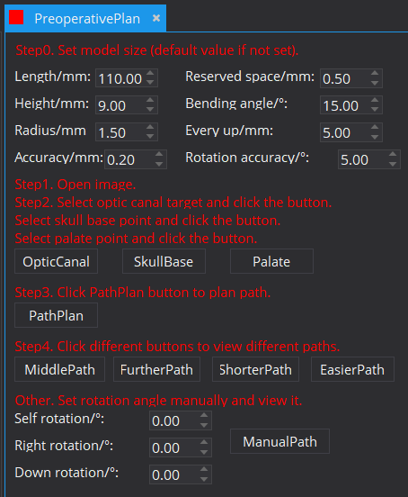

**Step0. Set surgical instrument size (optional)**

(1) Length/mm: Length of surgical instrument, unit: mm, default value: 110mm;

(2) Height/mm: Height of surgical instrument, unit: mm, default value: 9mm;

(3) Radius/mm: Radius of surgical instrument (half of the width), unit: mm, default value: 1.5mm;

(4) Accuracy/mm: Accuracy during modeling of surgical instruments, unit: mm, default value: 0.2mm;

(5) Reserved space/mm: Reserved operation space in all directions, unit: mm, default value: 0.5mm;

(6) Bending angle/mm: Bending angle of surgical instrument, unit: °, default value: 15 °;

(7) Every up/mm: The upward movement distance of surgical instruments is planned every time, in mm, and the default value is 5mm;

(8) Rotation accuracy/°: Single rotation angle when traversing the space, unit: °, and the default value is 5 °.

**Step1. Click "Open File " in the upper left corner of the main interface to open CT data and orbital segmentation results**

(1) CT data format needs to be nrrd format, and the name is " CT.nrrd ";

(2) The CT image should not be too skewed (the lower palate in sagittal position is close to the horizontal, and the optic canal in coronal position is clear, complete and symmetrical), otherwise it needs to be corrected (refer to the appendix, and other software can also be used)；

(3) Use the above CT data to segment the orbit (the medial wall of the orbit can be accurate), save the results in nrrd format, and name the left and right orbit as " Leftorbit.nrrd " and " Rightorbit.nrrd " (refer to the appendix, or use other software).

**Step2. Select the optic canal, skull base and inferior palatal point**

(1) Slide the mouse wheel, long press the right mouse button, drag to the upper right corner (lower left corner) and zoom in (out) for observation, find the optic canal in the horizontal position (coronal position), click the left mouse button so that the center point of the cross line is the inner wall point of the optic canal, and click " OpticCanal" to confirm. This is the target;

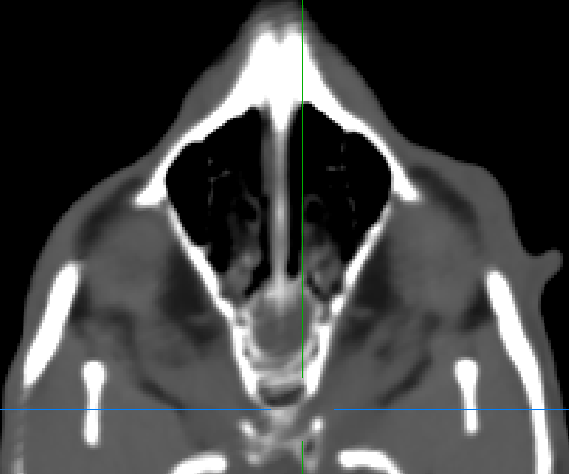 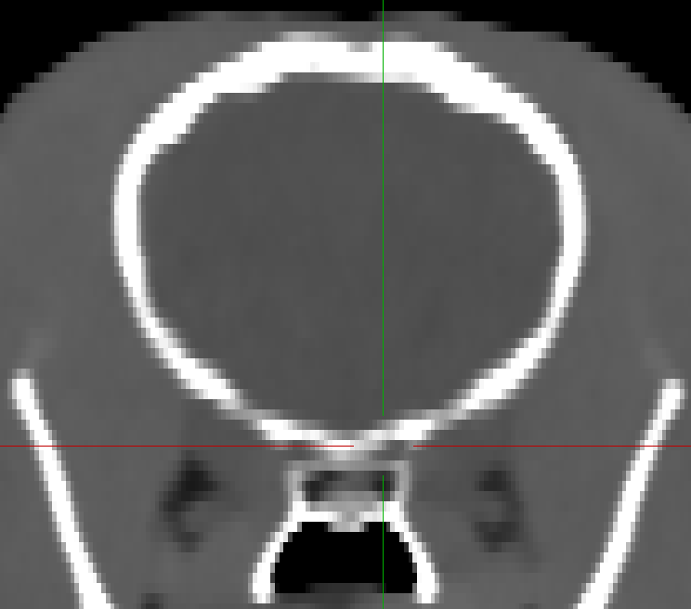

(2) In a similar way, find the middle point of skull base in sagittal position and click " SkullBase " to confirm. If the path exceeds this point during planning, it is not feasible;

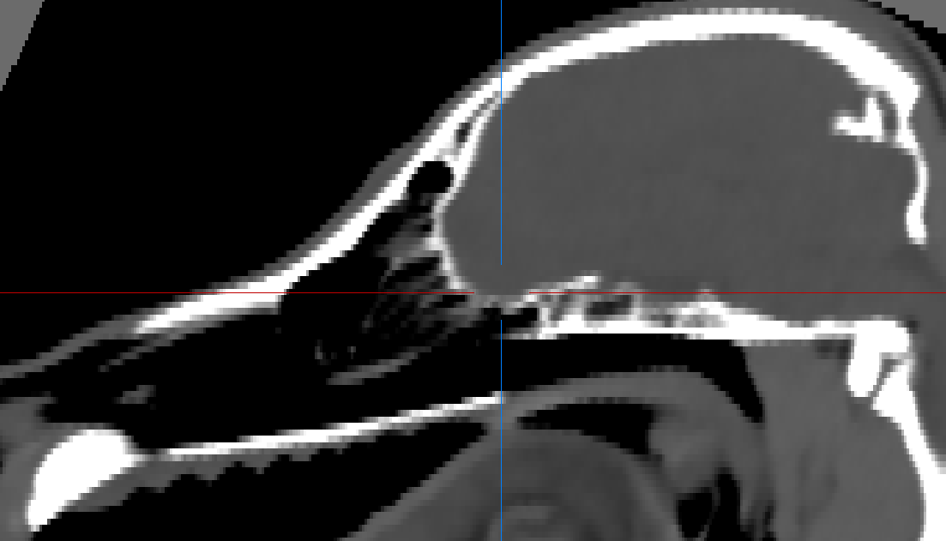

(3) Similarly, find the front point of the lower palate at the horizontal position and click "Palate" to confirm. If the path exceeds this point during planning, it is not feasible.

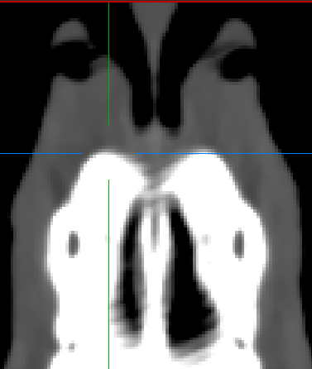

(4) If multiple points are selected, the last click to confirm shall prevail.

**Step3. Path planning**

(1) Click " PathPlan" for path planning;

(2) When traversing the feasible space, output whether the current position path is feasible after each rotation. If the feasible path is not found, reduce the reserved space and the size of surgical instruments and continue to search;

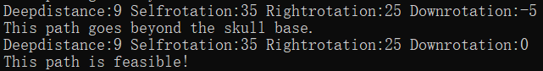

(3) Output the number of feasible paths found.



**Step4. Observe the optimal path under different indexes and output**

(1) Click " MiddlePath " to display the most centered path and generate the model to save;

(2) Click " FurtherPath " to display the farthest path from the left orbit and generate a model to save;

(3) Click " ShorterPath " to display the shortest path and generate the model for saving (the length of the shortest path is about equal to the minimum length of the required surgical instruments);

(4) Click " EasierPath " to display the minimum path of bone structure and generate a model to save;

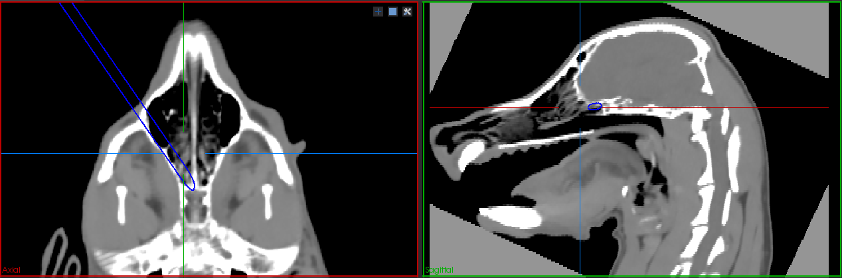

(5) Click again to generate the suboptimal path of the indicator;

(6) In the " Data Manager " interface on the left, click the box to open / close the model or image data. After selection, click the right mouse button to save and set the color;

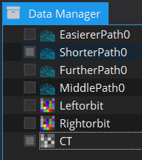

(7) Click the eye icon in the function bar, select CT data in the " Data Manager ", click " Volume Visualization" in the " Volumerendering ", and select " CT Thorax large" in the "choose an internal transfer function preset" column;



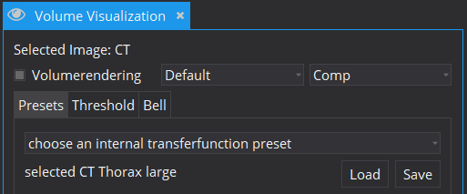

(8) Observe the surgical entrance and path in the 3D view, move the mouse to the upper right corner of the view window, click the cross icon to close the cross line, click the grid icon to zoom in / out the view window, slide the mouse wheel to zoom in / out the image, long press the left mouse button to drag up, down, left and right to rotate the image, and select "“Surface Representation" after selecting the right button of the model in " Data Manager" "Points" in the can be easily observed;

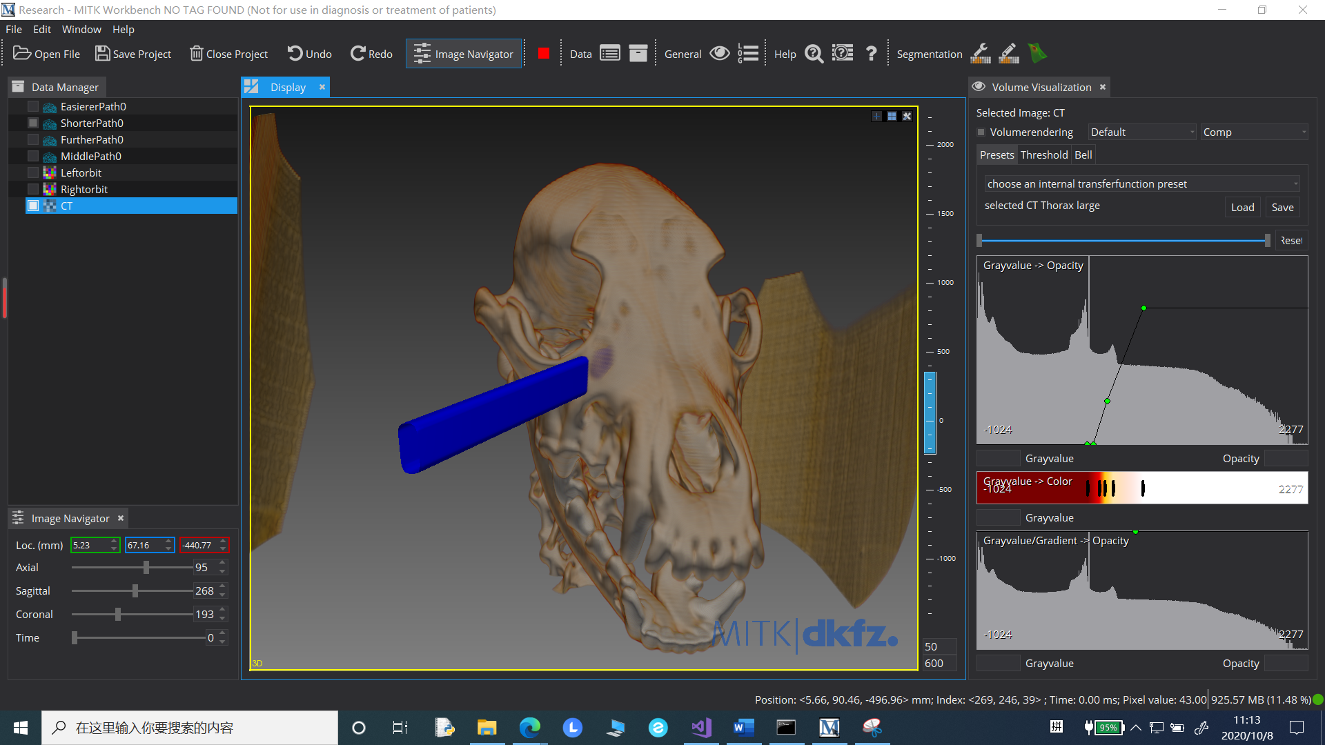

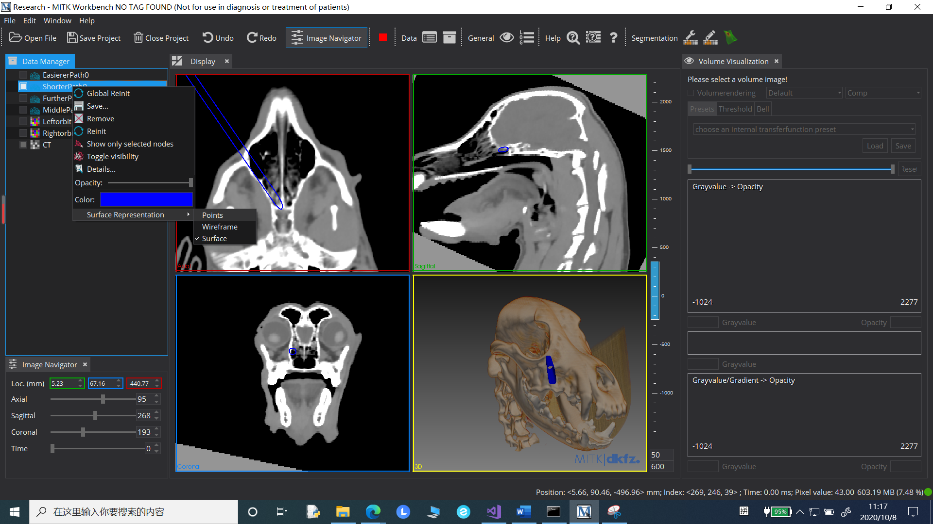

**Other. Manually set the path**

(1) Referring to the above path planning results, enter the rotation angle in the "Self rotation", "Right rotation" and "Down rotation" columns, enter the depth distance in the "Every up/mm" column, enter other parameters in the corresponding column of "Set the size of surgical instruments", and then click "ManualPath" to generate the model and display it in a roaming manner.

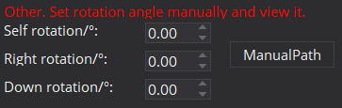

(2) The above model is saved in the "MITK-NO TAG FOUND-windows-x86_64\bin" folder ("VTK" format) for easy opening in other software or for surgical navigation;

(3) Click " Save Project " to save the current project for subsequent modification and viewing.

Appendix:

**CT data alignment and orbital segmentation using MITK**

1. Use MITK software "Open File" to read CT image data.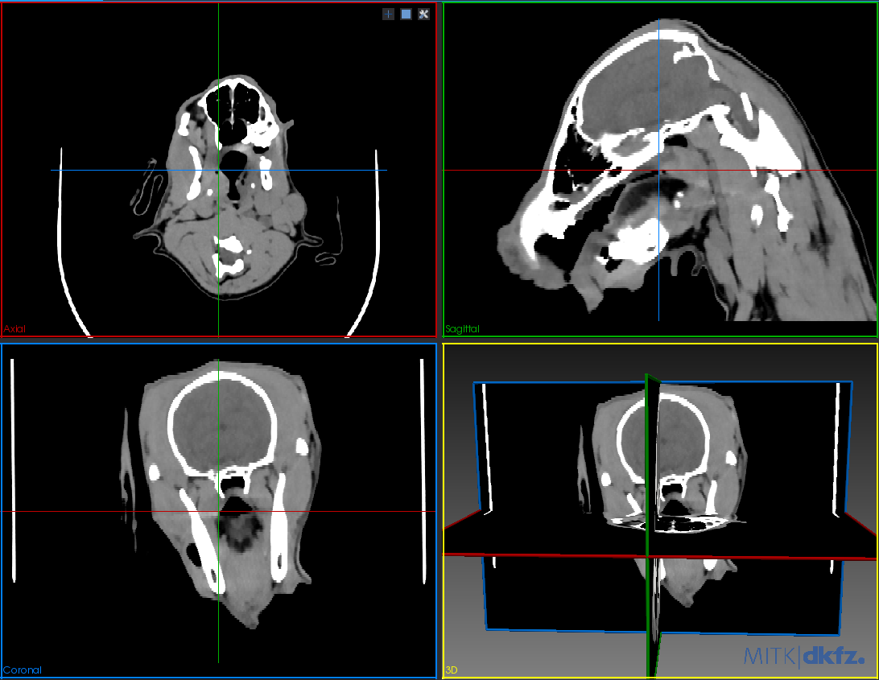

2. Click "Data Manager" to select CT data, click "New" in "Segmentation" to create a new segmented image, such as "Empty", and click "OK".

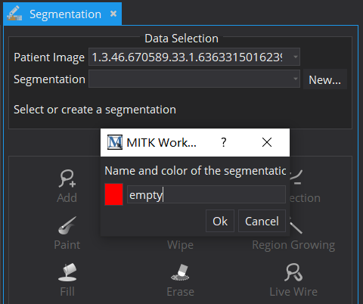

3. Click "empty" in “Data Manager”, right-click and select "Save", and select "*.nrrd" from the drop-down list to save in nrrd format.

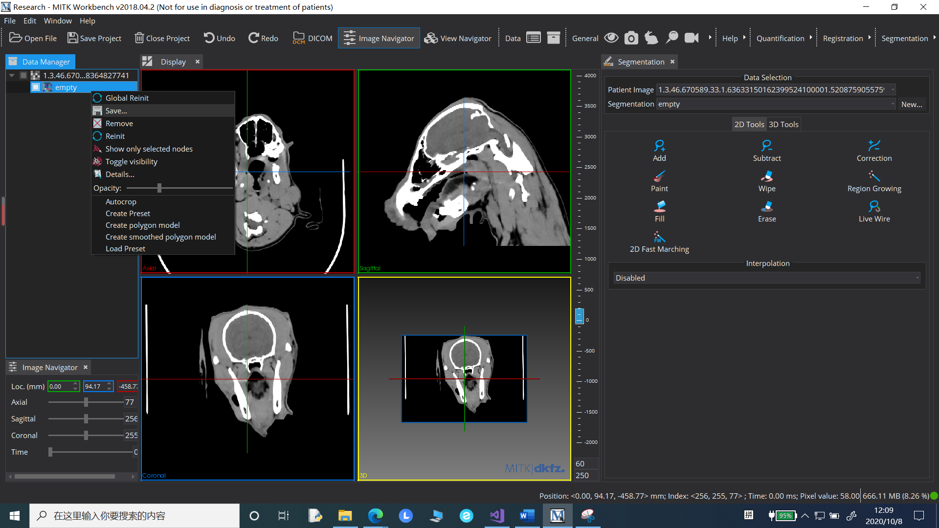

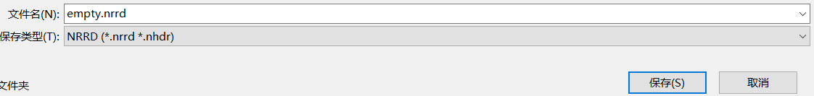

4. Close and reopen the software, read CT data and "empty.nrrd", select "empty.nrrd" in "Data Manager ", hold the left mouse button and drag it under CT data, select CT data, press the keyboard "Shift" or "Ctrl", and then select "empty.nrrd", find the palm icon in the "Registration" module and click to open the "MatchPoint Registration Manipulator".

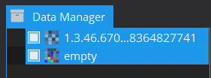

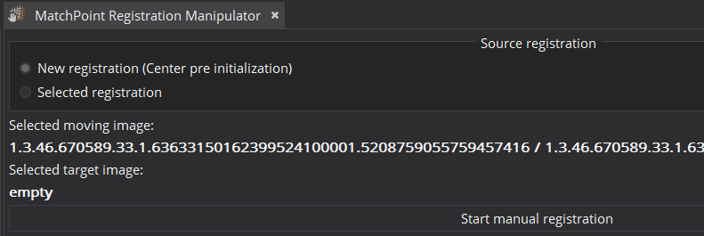

5. With CT data as "Selected moving image" and "empty.nrrd" as "Selected target image", click "Start manual registration", slide in "Rotation", or enter the value of "x (Sagittal)" to make the sagittal lower palate close to the horizontal, adjust "Y (Coral)" to make the horizontal structure symmetrical, and adjust "Z (axial) " to make the coronal optic canal clear, complete and symmetrical, click "confirm + store" and save the generated data as " CT.nrrd " in "Data Manager".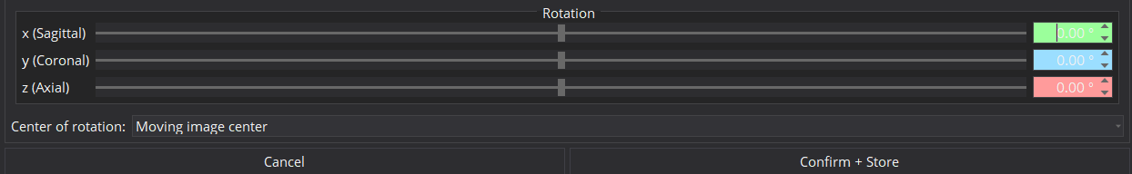

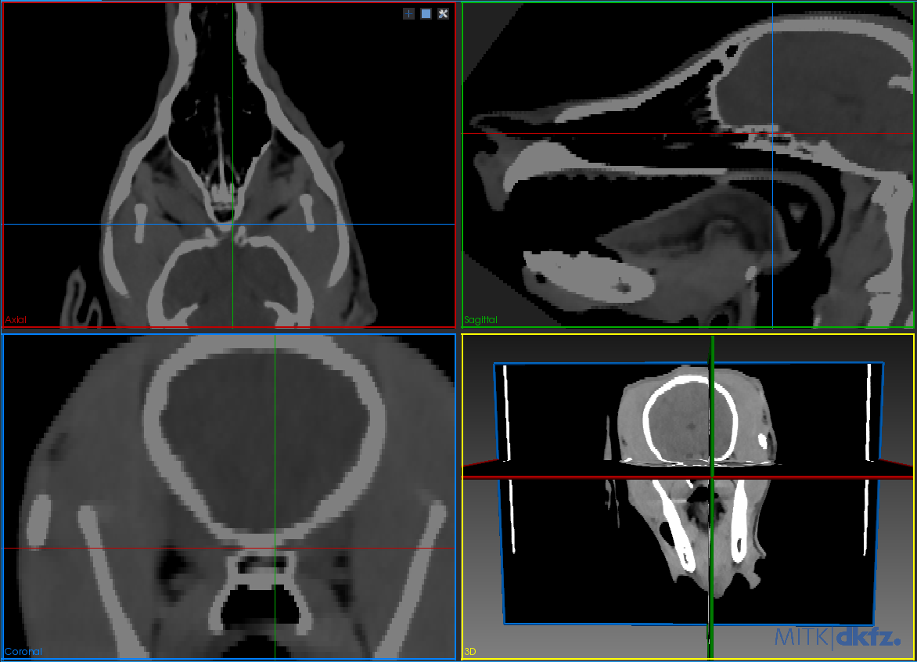

6. Close and reopen the software, read "CT.nrrd", click and select CT data in "Data Manager", click "New" in "Segmentation" to create a new left orbital segmentation image "Leftorbit", click "OK", click and select "Leftorbit" in "Data Manager", and enter the value in the lower right corner of "Display" to adjust the window width and window level for observation.

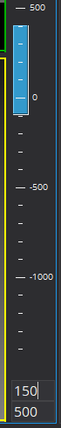

7. Click "Add" of "2D tools" in "Segmentation", and then draw the left orbital boundary in the horizontal position of "Display". You can draw two or three layers in the upper part, middle part and lower part of the orbital respectively, then change "Disabled" of "Interpolation" to "3-Dimensional", and then click "Confirm" to generate segmentation results.

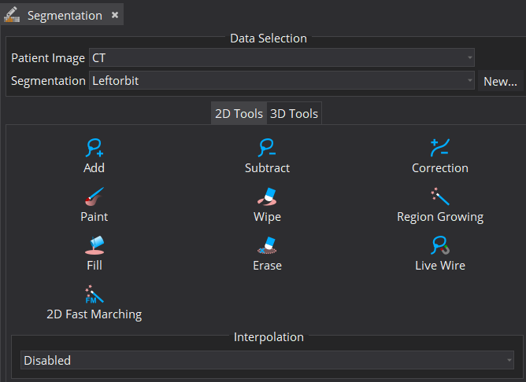

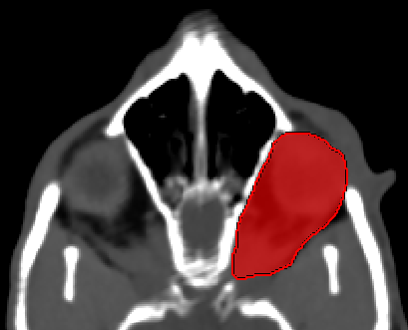

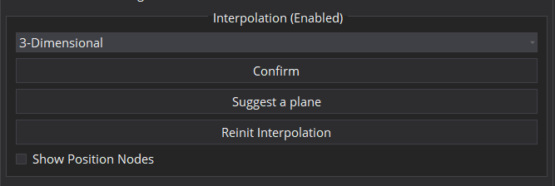

8. Click and select "Leftorbit" in "Data Manager", right click and select "Save", drop-down select "*.nrrd" to save in nrrd format, and "Leftorbit.nrrd" is the segmented image of the left orbit. Similarly, you can get "Rightorbit.nrrd".

9. Open the path planning software and read "CT.nrrd", "Leftorbit.nrrd" and "Rightorbit.nrrd" for path planning.