STANDARD OPERATING PROCEDURE
Run a discovery call
Q3 2026 Bar & Lounge Lead-Generation Campaign · La Gaudière

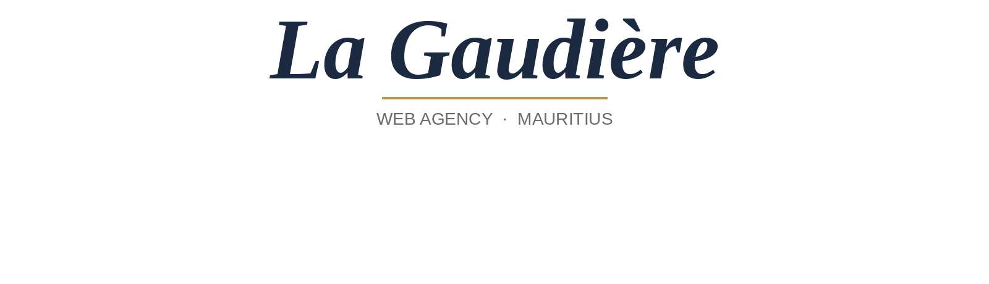
PURPOSE

The discovery call is where a Loom-watcher becomes a paying client. It's 20 minutes, opinionated, and ends with a clear next step. Skip the structure and the call drifts into a free consult; follow it and most calls close into either a Digital Presence Starter or a full website build before they end.
PROCEDURE

Inputs
- Confirmed Calendly slot with venue name and contact in the calendar invite
- Mockup Loom link, sent and viewed (check Loom analytics before the call)
- Lead tracker row open with the prospect's tier (A / B / C), source, and prior touchpoints
- Pricing one-pager PDF ready to send during or right after the call
- Quiet space, headphones, camera on
Steps
01 Minutes 0–3: the venue's real situation is on the table
Skip pleasantries fast. Ask three questions: what does the venue do, what's the slow night, and what's the goal for the next 6 months. Listen for the language they use about the problem — that's what you'll mirror back later.
02 Minutes 3–8: the mockup is walked through against their problem
Share screen, open the Figma. For each section, name the problem it solves in their words. "You said weeknights are slow — this events strip is what fixes that." Don't sell features; sell the mapping from their problem to the mockup.
03 Minutes 8–13: the scope is settled out loud
Confirm the site map (homepage, menu, events, gallery, link-in-bio). Ask three scope questions: do they need online reservations, do they want a menu CMS, do they need multilingual. Anything outside this is a v2 conversation, not v1.
04 Minutes 13–17: pricing and timeline are stated, not pitched
State the two paths plainly. Path A: full website build, MUR 45,000 starting, live in 2–3 days, SEO included. Path B: Digital Presence Starter, MUR 4,000–5,000, link-in-bio plus optimised Google Business Profile, perfect as a stepping stone. No discount talk, no hedging.
05 Minutes 17–20: the next step is concrete and timed
Pick one of three closes. Close 1 — full build: "I'll send the proposal and invoice today, kickoff Wednesday." Close 2 — Starter: "Confirm the domain you want, I'll start within 48 hours." Close 3 — not now: "I'll send the one-pager, follow up in 30 days, no pressure." Whichever close lands, send the matching artifact within 60 minutes of the call ending.
OUTPUTS

- The lead tracker is updated with call notes, scope confirmed, and outcome (Build Sold / Starter Sold / Nurture)
- Within 60 minutes: proposal + invoice sent (Build), kickoff confirmation sent (Starter), or one-pager + 30-day follow-up scheduled (Nurture)
- If a build was sold, the retainer pitch is queued for the kickoff call — not pitched on this call
- → See SOP: Produce a venue website mockup (the upstream step) and SOP: Weekly campaign run cadence (where the outcome gets reviewed)
FAQS

Q. What if they ask for a discount?
Say no, in one sentence: "Pricing is what it is — the value is in the speed and the niche fit." If price is a real blocker, offer the Digital Presence Starter as a stepping stone. Never discount the full build.
Q. What if they want to think about it?
Fine, but get a specific time. "Happy to follow up — Tuesday morning or Thursday afternoon?" Vague follow-ups die. A booked follow-up converts at roughly 4× the rate.
Q. What if they ask for references or case studies?
Until proof points exist, lean on the mockup itself: "You've already seen what your venue could look like. The work happens in 2–3 days from kickoff. If that's not enough, the Digital Presence Starter at MUR 4–5K is a low-risk way to see the work first-hand."
Q. What if the call runs over 20 minutes?
Cut at 25. Past 25 minutes the conversion rate drops. Politely say you have a hard stop, send the artifact for the close path, and book a follow-up if needed.

