Luka Spaninks

Semester 6

RB03

*Version 1*

Preface

The complete analysis phase of the project SwipeRight can be found in this document. This file will evolve over time and can always be expanded upon.

Inhoud

1. Stakeholders 3

2. Requirements 4

2.1 Functional Requirements 4

2.2 Non-functional Requirements 4

3. Use Cases 5

4. Use Case Diagram 9

5. Wireframes 10

# 1. Stakeholders

|  |  |
| --- | --- |
| Stakeholder | Description |
| Developer (me) | In this project, the developer is responsible for the product and everything involving the process. |
| Teachers | The teachers have a supporting role in this project. They give feedback and eventually grade the project. |
|  |  |

# 2. Requirements

## 2.1 Functional Requirements

|  |  |  |
| --- | --- | --- |
| N. | Description | MoSCoW |
| FR-01 | Users must get other users recommended to them based on location and preferences | Must Have |
| FR-02 | Users must be able to swipe recommended profiles to the left or right in order to accept or reject them | Must Have |
| FR-03 | Users must be able to view their own profile | Must Have |
| FR-04 | Users must be able to change preferences like distance, gender and age | Must Have |
| FR-05 | Users must be able to view matches | Must Have |
| FR-06 | Users must be able to edit their own profile | Must Have |
| FR-07 | Users must be able to chat to matches | Must Have |
| FR-08 | Users must be able to register an account | Must Have |
| FR-09 | Users must be able to login with their credentials | Must Have |
| FR-10 | Users must get a notification when they get a new match | Should Have |
| FR-11 | Users must get a notification when they get a chat message | Should Have |
| FR-12 | Users must be able to upload multiple pictures | Should Have |
| FR-13 | Users must be able to view more details on a profile | Should Have |
| FR-14 | Users must be able to send media (gifs, video’s, images & music) to matches | Should Have |
| FR-15 | Users must be able to toggle dark/light mode | Could Have |
| FR-16 | Users must be able to integrate their socials (Instagram, TikTok or Spotify) | Could Have |
| FR-17 | Users must be able to share a recommended profile | Could Have |

## 2.2 Non-functional Requirements

|  |  |
| --- | --- |
| N. | Description |
| NFR-01 | Scalability in terms of a large user base |
| NFR-02 | Security in terms of data |
| NFR-03 | Compliance with GDPR |
| NFR-04 | Transparency concerning the process, research, design and data usage |
| NFR-05 | Extensibility in terms of new features and applications |
| NFR-06 | Performance (meaning low response times and efficient data usage) |
| NFR-07 | Easy (automated) deployment and testing |
| NFR-08 | Transferability and maintainability, making it convenient for someone to continue the project |

# 3. Use Cases

|  |  |
| --- | --- |
| UC01 | Profile Recommendations |
| Actor(s) | User |
| Basic Flow | A screen displays recommended profiles to the current user based on based on location and preferences |
| Alternative Flow 1 | There is no connection to the internet, so recommendations can’t be fetched |
| Alternative Flow 2 | There are no users of the app in a specified location radius, so no recommendations are displayed to the user |
| Result | The user is able to view profiles |

|  |  |
| --- | --- |
| UC02 | Swiping Profiles |
| Actor(s) | User |
| Basic Flow | The user swipes a recommended profile to either the left or right in order to accept/reject |
| Alternative Flow 1 | There is no connection to the internet, so no data can be send or received |
| Result | The user is able to like/dislike profiles |

|  |  |
| --- | --- |
| UC03 | View Profile |
| Actor(s) | User |
| Basic Flow | The user is able to view his/her own profile |
| Result | The user views his/her own profile |

|  |  |
| --- | --- |
| UC04 | Edit Preferences |
| Actor(s) | User |
| Basic Flow | A user edits preferences like distance, gender and age on a settings interface |
| Result | The user has changed preferences which causes the recommendation system to now use these new preferences |

|  |  |
| --- | --- |
| UC05 | View Matches |
| Actor(s) | User |
| Basic Flow | A user views his/her matches |
| Alternative Flow 1 | The user does not have any matches, the system responds with a message urging the user to start swiping |
| Result | The user sees the others users that have mutually swiped right |

|  |  |
| --- | --- |
| UC06 | Edit Profile |
| Actor(s) | User |
| Basic Flow | A user wants to edit his/her profile (e.g. biography, university, location, anthem & hobbies). |
| Result | The updates have been registered by the system |

|  |  |
| --- | --- |
| UC07 | Chatting with matches |
| Actor(s) | User |
| Basic Flow | A user wants to start a chat with a match and sends a greeting message. |
| Alternative Flow 1 | The user has been unmatched, all previous chat messages are removed and none can be send anymore. |
| Alternative Flow 2 | The user unmatched someone, all previous chat messages are removed and none can be send anymore. |
| Alternative Flow 3 | There is no internet connection, the chat message is being hold in a queue until there is a connection again. |
| Result | A chat between two matches has been established |

|  |  |
| --- | --- |
| UC08 | Registering an account |
| Actor(s) | User |
| Basic Flow | A user wants to set-up an account so he/she can use SwipeRight |
| Alternative Flow 1 | The user is not yet 18+ and gets denied by the system |
| Result | The user has successfully created an account |

|  |  |
| --- | --- |
| UC09 | Logging in |
| Actor(s) | User |
| Basic Flow | A user wants to login to SwipeRight to use it |
| Alternative Flow 1 | The user has been suspended for violating the terms of service and gets denied access by the service |
| Result | The user has successfully logged in and has been granted access to SwipeRight |

|  |  |
| --- | --- |
| UC10 | New Match Notification |
| Actor(s) | User |
| Basic Flow | The user has just been matched with someone and receives a message notifying him/her of this event |
| Alternative Flow 1 | The user doesn’t have an internet connection and the notification shows when there is a connection again |
| Result | The user views a notification informing him/her that he/she has a new match |

|  |  |
| --- | --- |
| UC11 | New Message Notification |
| Actor(s) | User |
| Basic Flow | The user has just gotten a new message from one of his/her matches and receives a notification |
| Alternative Flow 1 | The user doesn’t have an internet connection and the notification shows when there is a connection again |
| Result | The user views a notification informing him/her that he/she has a new message |

|  |  |
| --- | --- |
| UC12 | Uploading Pictures |
| Actor(s) | User |
| Basic Flow | The user wants to upload pictures to his/her profile |
| Alternative Flow 1 | The images are too large (in terms of storage) and are therefore denied |
| Result | The user has successfully upload pictures to his/her profile |

|  |  |
| --- | --- |
| UC13 | More Details |
| Actor(s) | User |
| Basic Flow | When a user is viewing a recommended profile, not every single details is displayed. The user indicates he/she wants to view more details on the profile. |
| Result | The user is shown more details on a recommended profile |

|  |  |
| --- | --- |
| UC14 | Sending Media In Chat |
| Actor(s) | User |
| Basic Flow | When a user is chatting with a match, he or she wants to send an image |
| Alternative Flow 1 | The media is too large (in terms of storage) and is therefore denied |
| Result | The user has successfully send an image to a match |

|  |  |
| --- | --- |
| UC15 | Toggle Light/Dark Mode |
| Actor(s) | User |
| Basic Flow | The user prefers viewing the interface in dark mode and selects this under preferences |
| Result | The user has turned the interface to a dark color scheme |

|  |  |
| --- | --- |
| UC16 | Integrate Socials |
| Actor(s) | User |
| Basic Flow | The user wants to connect Spotify and Instagram to his profile in order to make the profile more personal |
| Result | The user’s profile now shows his/her Spotify & Instagram when being recommended to another user |

|  |  |
| --- | --- |
| UC17 | Sharing A Recommended Profile |
| Actor(s) | User |
| Basic Flow | The user wants to show off a recommended profile to his/her friends |
| Alternative Flow 1 | The user behind the recommended profile has explicitly indicated that his/her profile should not be available for sharing |
| Result | The system has generated and made available a link which can be shared to other users of SwipeRight, so they can view the profile |

# 4. Use Case Diagram

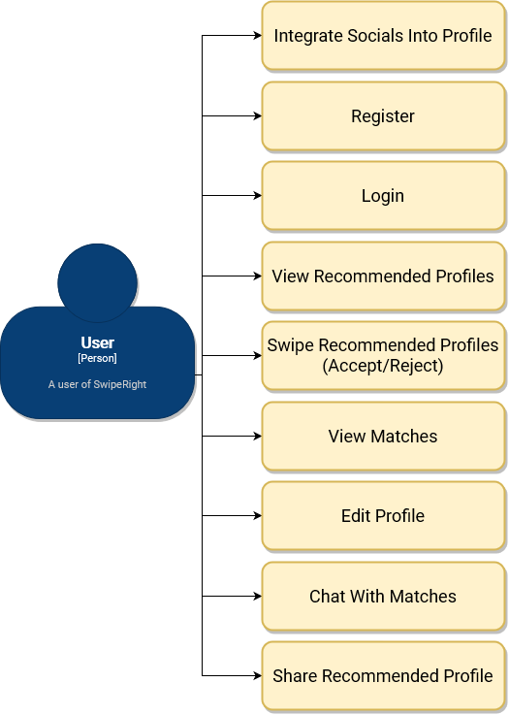

# 5. Wireframes

