Luka Spaninks

Semester 6

RB03

Preface

The complete design phase of the project SwipeRight can be found in this document. This file will evolve over time and can always be expanded upon.

Inhoud

1. Techstack 3

2. C4 Models 4

2.1 System Context 4

2.2 Container diagram 4

2.3 Component diagram 4

3. Entity Relationship Diagram 4

4. User Interface 4

4.1 Design System 4

4.1.1 Typography 4

4.1.2 Colors 4

4.2 Mockups 5

4.3 Assets 6

4.3.1 Logo 6

4.3.2 App Icons 6

4.3.3 Like & Dislike Buttons 6

4.3.4 Default Buttons 6

# 1. Techstack

|  |  |  |
| --- | --- | --- |
| Feature | Description | Motivation |
| Security | OAuth 2.0 | Secure and widely used (industry standard) |
| Server script | Go | Performant, Scalability & Nice syntax |
| Server Framework | Gin | Gin is a performant and widely used backend framework for Go. |
| Client Technology | Flutter | Flutter is a performant cross-platform technology, It’s used a lot for native development. |
| Client script | Dart | Dart is the language used in Flutter |
| Database | Apache Cassandra | Performant, Secure & highly scalable |
| Server OS | Ubuntu | Backend programs should eventually be able to run in every environment |
| Client OS | Android | In the development phase my target OS is android because it is open, it might be extended to IOS in a later stage of production. |

# 2. C4 Models

## 2.1 System Context

The idea is to work with a microservice architecture which is almost completely dependent on internal services. A system like a content delivery network should however be outsourced to an external system though. Vendors like amazon have servers everywhere in the world which helps a great deal with performance. This is a resource I unfortunately do not have access to.

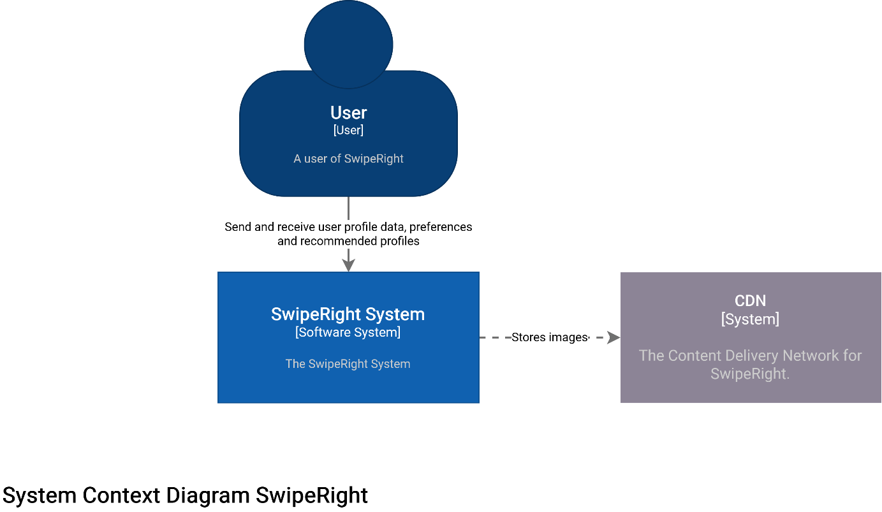

## 2.2 Container diagram

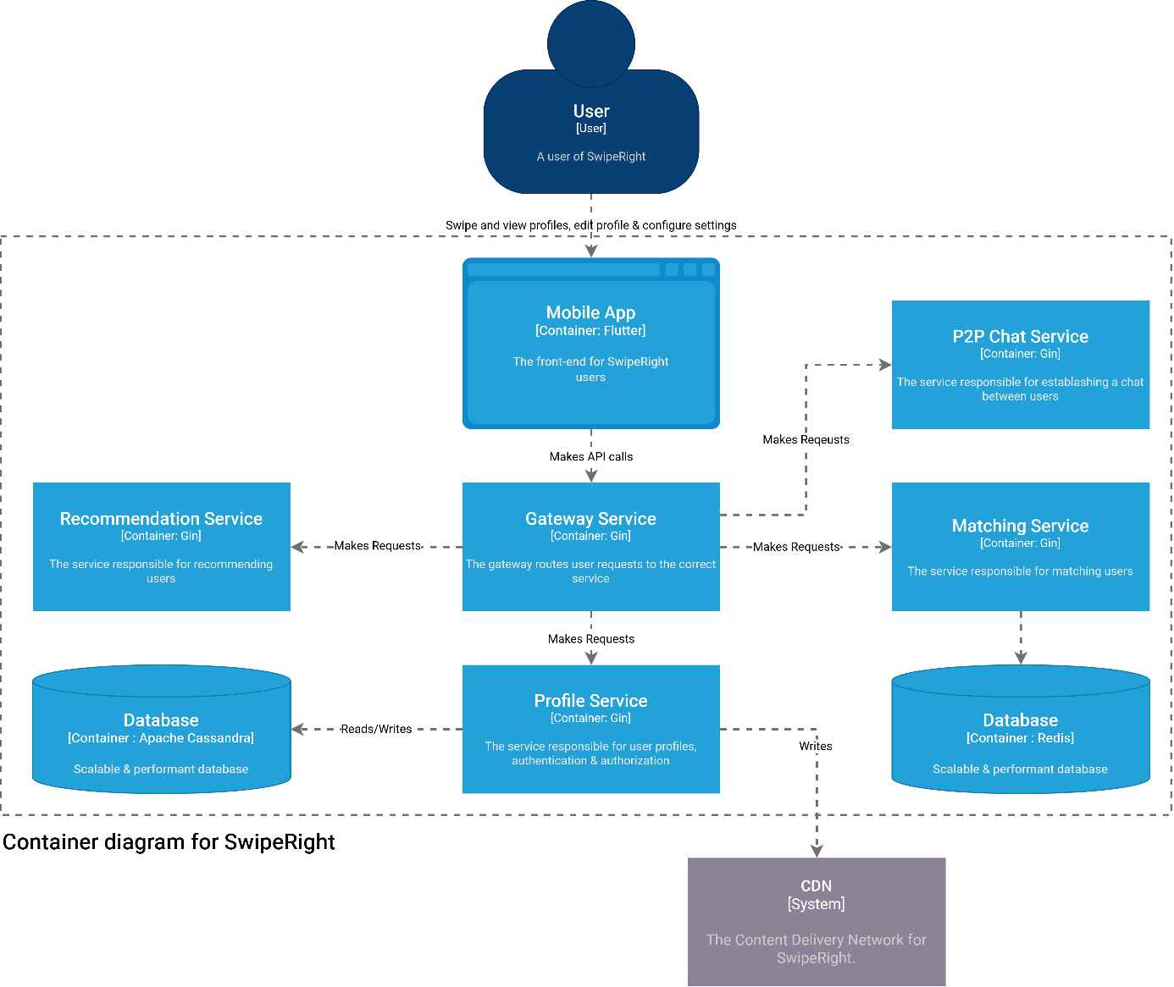

## 2.3 Component diagram

# 3. Entity Relationship Diagram

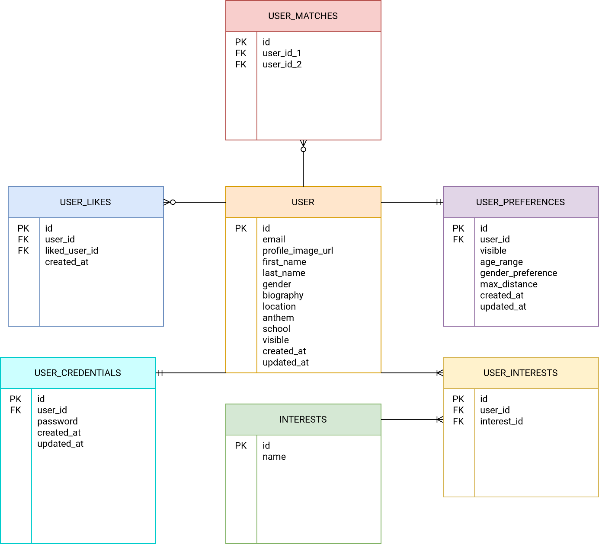

# 4. User Interface

## 4.1 Design System

### **4.1.1 Typography**

|  |  |
| --- | --- |
| **Name** | **Font** |
| Logo Font | Poppins |
| App Font | Roboto |
| |  |  | | --- | --- | | Name | **Font Size (px)** | | XS | 12 | | S | 14 | | M | 18 | | L | 20 | | XL | 24 | |  |

### **4.1.2 Colors**

|  |  |
| --- | --- |
| **Name** | **Color** |
| **Logo Gradient Top** | #FFA751 |
| **Logo Gradient Bottom** | #FFE259 |
| **App White** | #FFFFFF |
| **App Dark** | #373737 |
| **App Grey** | #CECECE |
| **App Green** | #54FF51 |
| **App Red** | #FF5151 |

## 4.2 Mockups

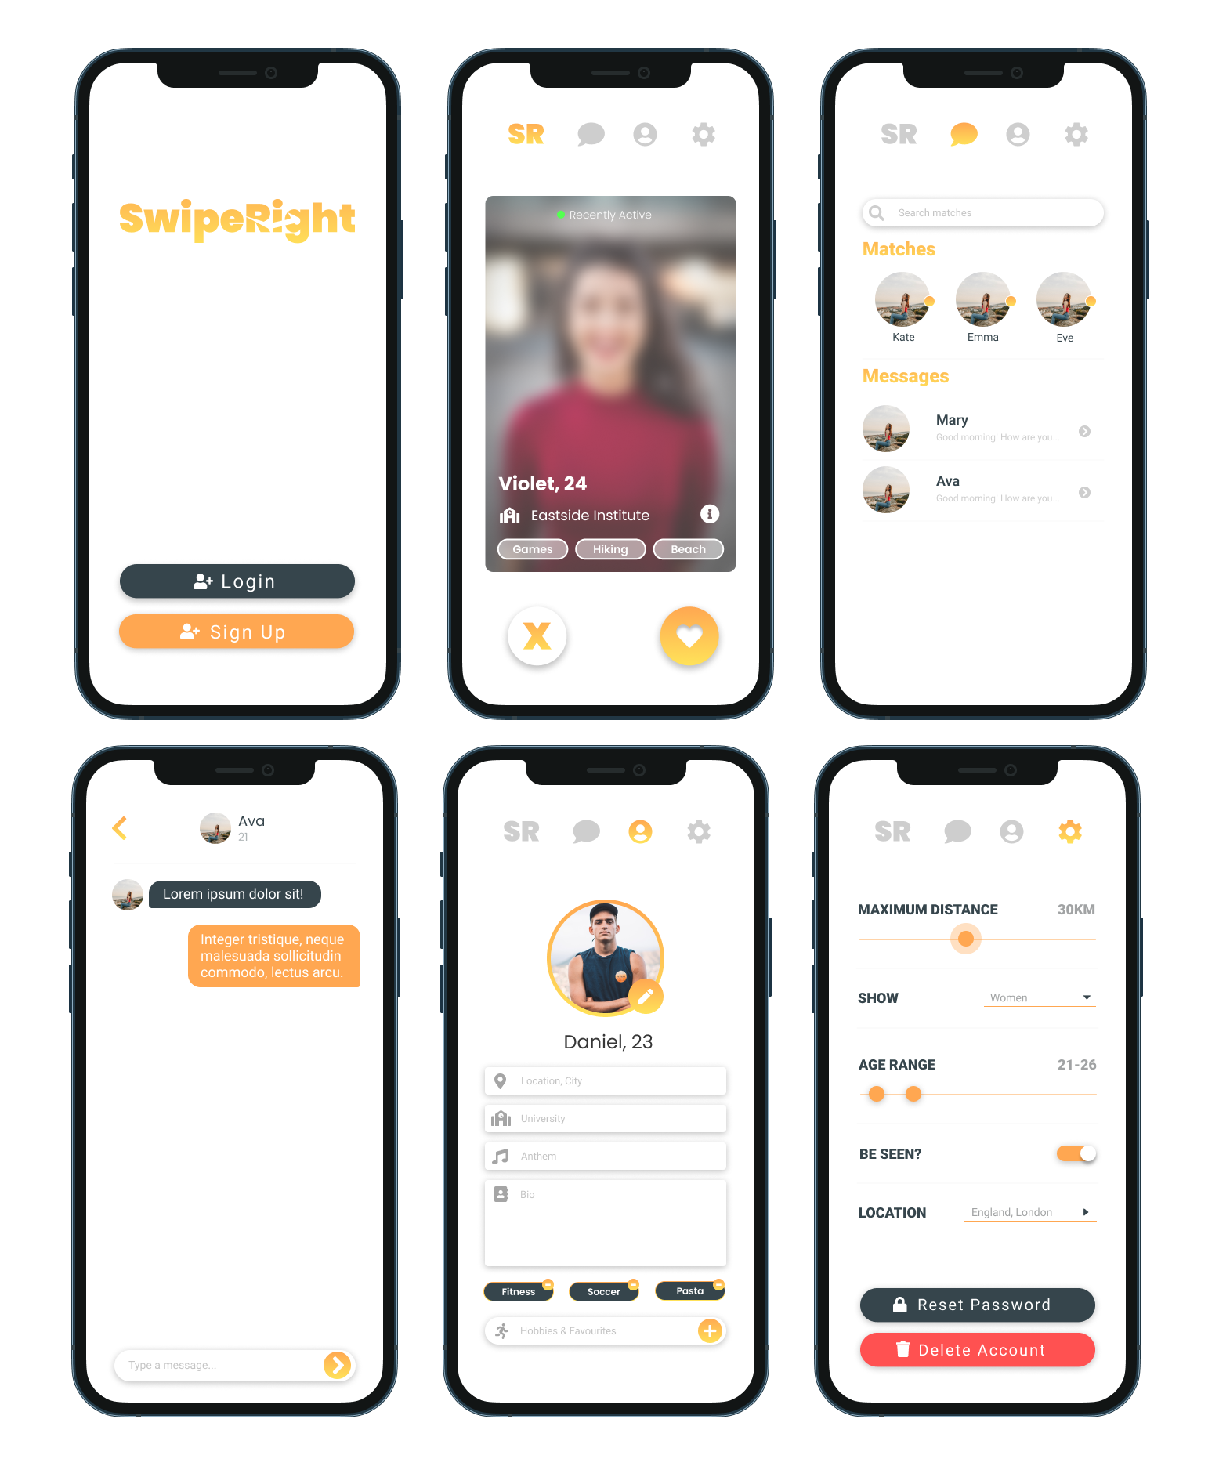

*\*\* Mockups are created with* [*Figma*](https://www.figma.com/)

*\*\*\* Pictures used are from* [*Unsplash*](https://unsplash.com/)

## 4.3 Assets

### 4.3.1 Logo



### 4.3.2 App Icons



### 4.3.3 Like & Dislike Buttons



### 4.3.4 Default Buttons

