Luka Spaninks

Semester 6

RB03

Version 1

Preface

The complete DevOps phase of the project SwipeRight can be found in this document. This file will evolve over time and can always be expanded upon.

Inhoud

Methodology 3

Source Control 4

Automation 4

Building & Testing 4

Release & Deploy 4

Monitor 4

Security 4

# Methodology

The methodology I have chosen for this project is agile. Because I need to prove 8 learning outcomes the flexibility really helps. The project planning tool I have chosen is Trello, because I am already familiar with it.

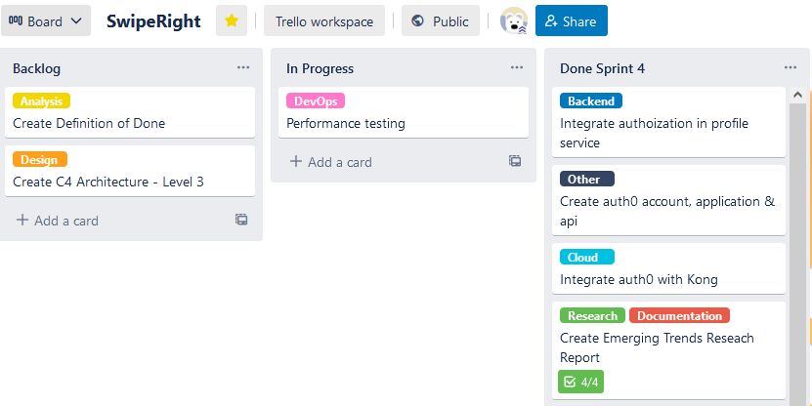

# Source Control

For source control I use the tool git in combination with a remote repository provided by GitHub. The repository is public and every item relevant to the project is stored there (monorepository). Because I am working alone on this project I decided to use git flow without the feature and hotfix branches for convenience.

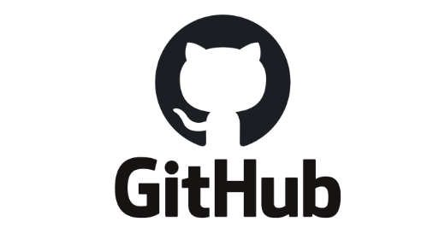

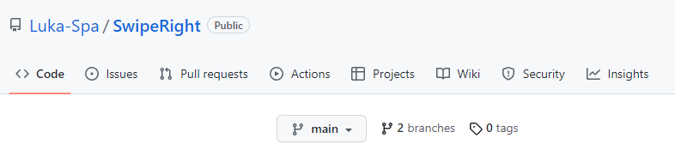

# Automation

In order to automate several components of DevOps I am using GitHub actions.

## Building & Testing

Whenever new changes are pushed to one of the branches a test and build job starts. The following is an example of what happens when the profile service is updated. The code gets tested, analyzed and the coverage gets uploaded to Codecov. Development can only be merged into main when it passes the building, tests and static code analysis

## Release & Deploy

## Monitor

# Security