Building and evaluating a cross-hazard machine-learning approach to unified lunar forecasting
Luka Takki
lukatakki123@gmail.com
Abstract
LIPAS (Lunar Impact and Predictive Analysis System) is a hybrid forecasting and decision-support system that combines machine learning with physics-based models for six lunar hazards: temperature, radiation, dust, micrometeorites, solar activity, and moonquakes. Public NASA and NOAA products, OMNI telemetry, and lunar archives feed a temporal long short-term memory network constrained by physics baselines, with results shown in a web interface for selectable lunar coordinates. Heliophysics feeds are treated as inputs adapted from solar and heliospheric measurements, not as a third forecasting method beside physics and learning.
This study aims to address three research questions: whether such a hybrid system can be developed; whether integrating hazards into one decision-support interface can improve operational usability in a simulated mission setting; and whether the locked hybrid improves predictive performance relative to replicated public baselines. A browser-prototype diagnostic first suggested a mean-skill lead against weak replicas, but that early path used a different model stack and is not the locked result; early temperature already failed a Diviner-class check. Locked studies over two 14-day windows then show modest solar gains (Window A RMSE 4.10 versus 4.66; Window B 4.99 versus 5.99) while radiation does not beat the replica (0.119 versus 0.102 in night-dominant Window A; 0.0188 versus 0.00266 in quiet dayside Window B). Temperature, moonquakes, and dust remain physics ties; micrometeorite skill is circular under blend weight zero. Qualitative comparison shows LIPAS high on coverage and usability but only moderate on validation. Mission simulation and ablation add operational and sensitivity context. LIPAS is best treated as consultative support alongside agency products, with substantial further work required.
Keywords: lunar environment ; space weather ; hybrid forecasting ; machine learning ; long short-term memory ; mission decision support
Introduction
Renewed lunar exploration plans increase the need for readable environmental information for temperature, radiation, dust, micrometeorites, solar activity, and moonquakes. Specialized models already exist for many of these hazards; most operate as separate tools, though some products span more than one hazard domain. Mission planners still need to review and adapt outputs for a given timeline. LIPAS was built to join public data and hybrid forecasts in one decision-support system rather than to replace flight-qualified agency products. Public heliophysics measurements (solar-wind, field, and event products describing Sun-driven drivers that are effectively uniform across the Moon) are adapted as inputs; they are not treated here as a third forecasting method beside physics and machine learning. The public versions used in this paper are those available for replication; full operational models are not always public.
This study aims to address three research questions: 1. Can a hybrid lunar forecasting system usefully combine machine learning and physics?
2. Does a unified multi-hazard interface improve operational usability relative to separate products?
3. Does the locked hybrid improve accuracy against selected replicated public baselines?
Because continuous co-located surface truth is not available for every hazard, evaluation uses archived measurements, engineering-model exports, and physics or catalog proxies. That limit is carried through the results and conclusion.
Methods
The methods follow the same order as the results that follow: architecture and blend, skill reporting, the separate prototype diagnostic, the two locked fourteen-day windows with replicated baselines, then the mission simulation and input ablation. Related public models and archives that supply baselines and context are summarised in the accompanying repository overview notes; the body uses author-built replicas of those public methods rather than proprietary agency software, except for the MEM 3 export.
Architecture and hybrid blend
LIPAS predicts six hazards from an 18-feature input vector. The vector joins six hazard cores with location and time context (latitude, longitude, local solar time, hour, day, month) and space-weather or surface context (solar-wind speed and density, IMF B_z, K_p,K_p is a planetary geomagnetic activity index used here as an upstream driver input. regolith depth, thermal inertia). Figure shows the data path from public feeds and lunar archives into that locked schema. Earlier draft schematics that labeled a 12-column row were incomplete; the locked production path from the second training run uses the 18-feature layout.
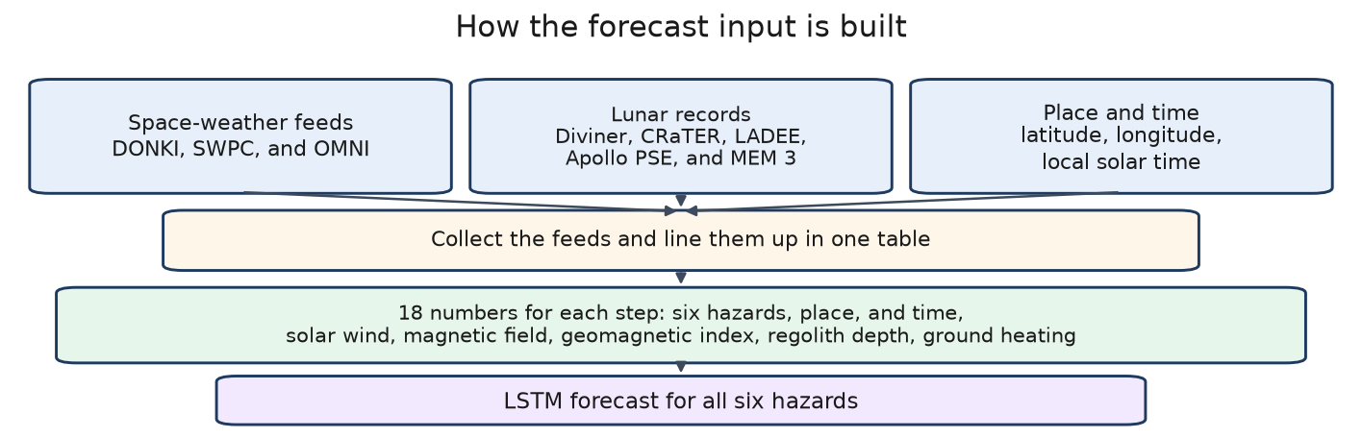
Figure. Data path into the locked 18-feature hybrid schema. Public space-weather feeds and lunar archives are normalized with site context before the temporal LSTM serve.
The model is a temporal long short-term memory (LSTM)An LSTM is a recurrent network that carries a memory state across time steps, used here for sequential residual corrections. network trained under hazard-wise hybrid blending with physics baselines. The locked blend used for the quantitative windows is
Eq.: w = [0.4, 0.05, 0, 0, 0, 0]
in hazard order solar activity, radiation, temperature, moonquakes, micrometeorites, dust. Only solar activity and radiation carry nonzero machine-learning weight. Temperature, moonquakes, micrometeorites, and dust are physics- or proxy-dominated under this lock (Fig.).
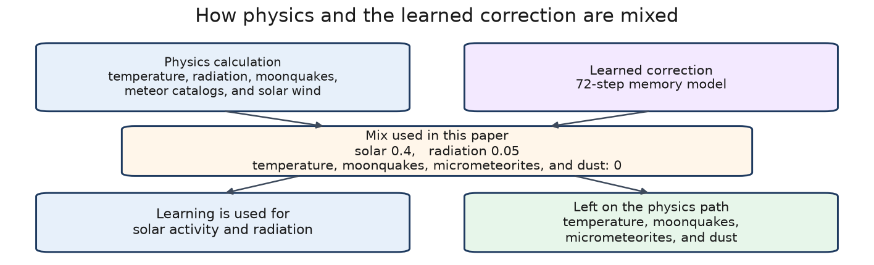
Figure. Locked hybrid blend. Physics baselines and the LSTM residual path are combined with w=[0.4,0.05,0,0,0,0]. Nonzero machine-learning weight applies only to solar activity and radiation.
A softplus-style residual update is used in later trainings. With y_phys the hazard baseline and Delta_ML the learned residual,
Eq.: yhat = y_phys + softplus(Delta_ML).
Softplus keeps residual corrections one-sided and stable. Equation the equation describes the later hybrid path; the browser prototype used a different stack (Section). Physics baselines are produced by the Python physics-estimation function that maps each hazard to its public-archive formulation; code-level names are avoided in the body.
Skill and error metrics
Within each hazard, skill is
Eq.: skill = 96 × max(0, 1 - (RMSE)/(s_h)),
where s_h is a hazard-specific scale taken from the site RMSE values for that hazard only. A skill of 96 means zero RMSE on that site for that hazard; it is not percent accuracy. Skill is never renormalized across hazards into equal heights. Locked accuracy claims also quote root-mean-square error (RMSE) and, where useful, mean absolute error (MAE):RMSE penalises large deviations more strongly; MAE reports typical absolute error. Both are computed against evaluation labels, not complete surface truth. for n paired samples with prediction yhat_j and label y_j,
Eq.: RMSE=sqrt((1)/(n)sum_j=1^n(yhat_j-y_j)^2), MAE=(1)/(n)sum_j=1^n|yhat_j-y_j|.
Physics ties and micrometeorite circular scoring are reported as such.
Prototype diagnostic (separate from locked windows)
An earlier browser-prototype study compared LIPAS against thin replicas of public tools. That path is described in Section and is not interchangeable with the locked production numbers from the second training run.
Evaluation windows and replica stack
Two 14-day locked windows are reported at the same three sites: equatorial reference (0^N, 0^E), Apollo 11, and Nobile Rim. Window A (5–18 July 2026) is night-dominant. Window B (22 July–4 August 2026) is dayside-quiet. The same locked blend and replica stack are used for both. Full numeric tables live under papers/appendix_numerical_tables/ and in QUANTITATIVE_COMPARISON_FRAMEWORK.md on the accompanying GitHub package.
Mission simulation and ablation
A short mission timeline matching the 7 h 37 min duration of the second Apollo 17 EVA, and a hazard-weight ablation study, provide operational and sensitivity context. In the ablation, the locked model is held fixed while one input at a time is replaced by its window mean (no retraining); relative RMSE changes are then compared with the locked baseline. These studies are secondary to the locked windows and are summarised only after the quantitative results.
Results
Prototype study and why early wins were large
The first quantitative pass ran in the browser prototype against relatively weak replicas of Diviner-class temperature, radiation, dust, meteor, solar, and seismic products. Under that setup the mean skill across hazards favored LIPAS (Fig.). Those early wins are not evidence that the locked hybrid beats mature agency models: the prototype appeared stronger on five hazards largely because it was scored against weak replicas rather than full agency products.
Three design choices drove the spread. First, the browser-prototype model and scoring path differ from the locked blend in Eq. the equation. Second, several replica baselines were thin proxies rather than full operational models, so the comparison favored the integrated prototype. Third, some hazard scores used circular or proxy targets, which inflate apparent skill without independent surface truth. The prototype is therefore treated as an engineering checkpoint only. The locked windows below replace it for accuracy claims.
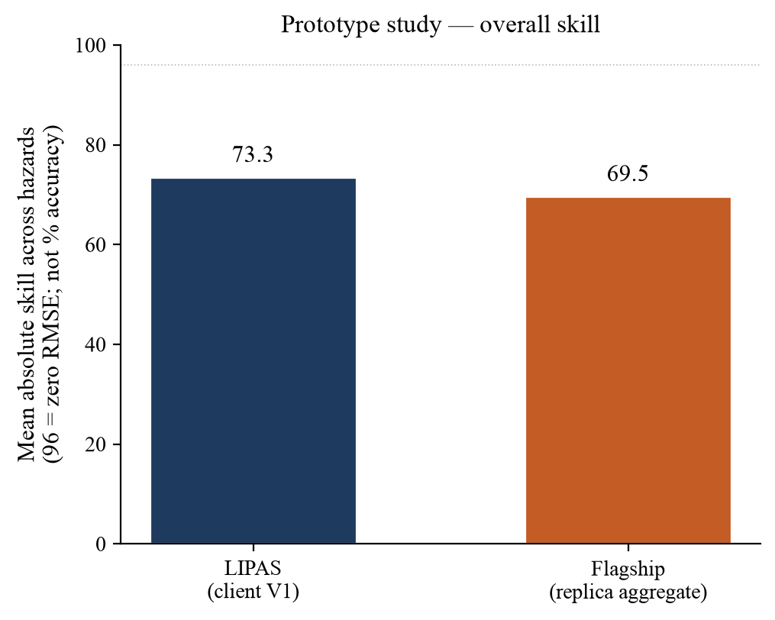
Figure. Prototype study mean skill: LIPAS (browser prototype) versus a weakly replicated public baseline aggregate. The early lead reflects weak replicas and a different model/scoring path, not the locked production result.
LIPAS versus Diviner-class temperature (prototype path)
Figure shows an early daytime temperature comparison at (0^N, 0^E) before temperature was locked to the physics path. The browser prototype overshoots the Diviner-class reference and the observed proxy near peak heating. That failure is part of why the locked blend sets temperature weight to zero and why Windows A and B report temperature as a physics tie rather than an ML win. The figure belongs to the prototype evaluation era. After this checkpoint the paper moves to the locked studies.
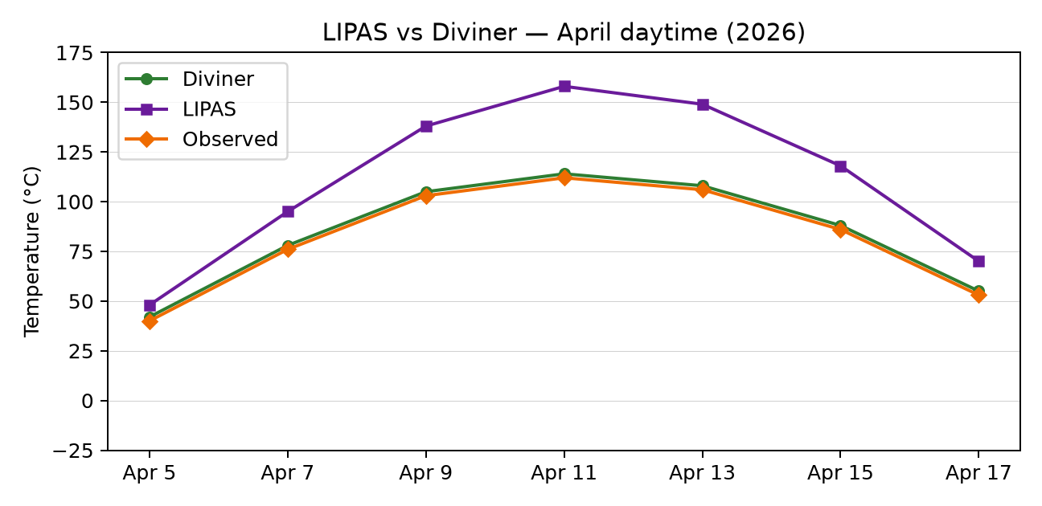
Figure. LIPAS versus Diviner-class temperature reference on the prototype daytime path at 0^N, 0^E. Prototype temperature overshoots the reference near peak heating. Locked windows use physics-led temperature under blend weight zero.
Figure does not show a temperature win for the prototype. Combined with weak replicas on other channels, that mix explains why a single mean-skill bar can still look favorable in Fig. while individual physics channels remain untrustworthy. The later locked studies therefore emphasize solar and radiation RMSE, where the replica comparison is more informative, and treat temperature as a shared physics path.
Locked Window A (night-dominant)
Window A uses the locked blend. Solar activity improves relative to the replica (RMSE 4.10 versus 4.66). Radiation does not: night-dominant RMSE is 0.119 for LIPAS versus 0.102 for the replica. Temperature, moonquakes, and dust remain physics ties. Micrometeorite skill is circular under blend weight zero and is not treated as an independent win.
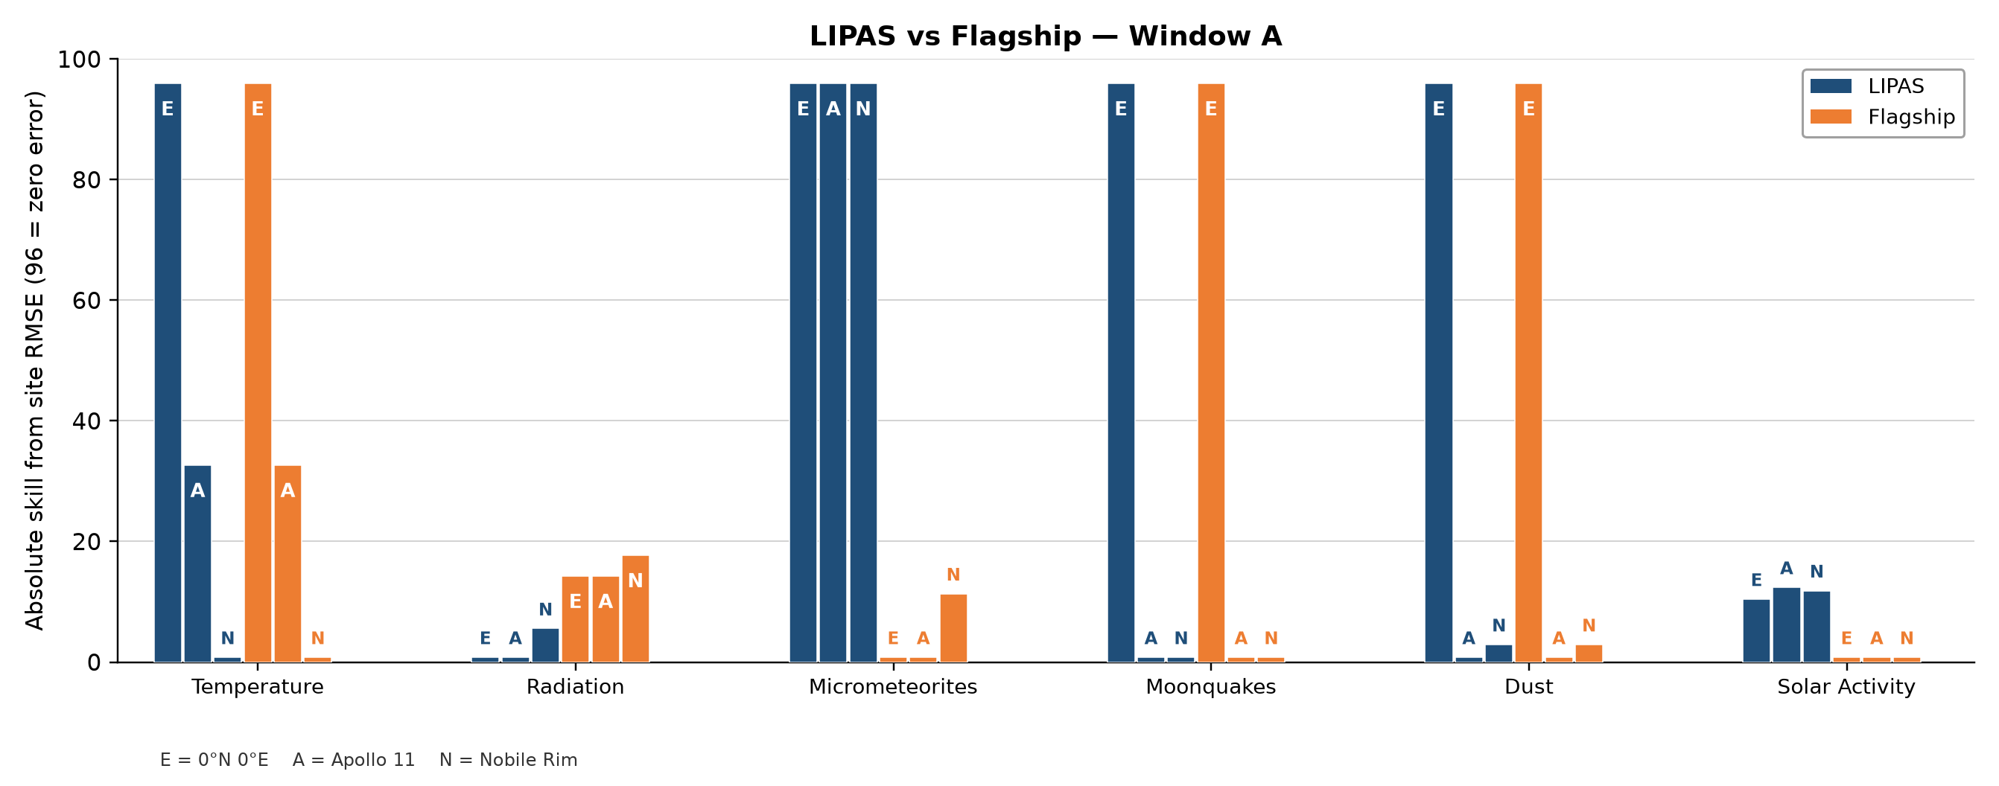
Figure. Window A locked skill by hazard and site. Within-hazard skill only; no cross-hazard height equalization. Location key: E = 0^N, 0^E; A = Apollo 11; N = Nobile Rim.
Locked Window B (dayside quiet)
Window B again shows a solar gain (RMSE 4.99 versus 5.99) while radiation remains worse than the replica under quiet dayside conditions (0.0188 versus 0.00266). Physics ties and circular micrometeorite scoring match Window A.
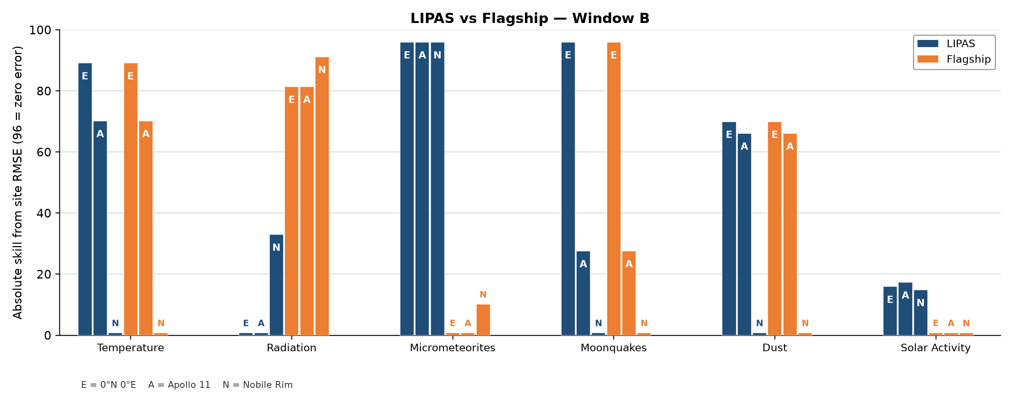
Figure. Window B locked skill by hazard and site. Same blend and replica stack as Window A. Location key as in Fig..
Qualitative comparison
A structured qualitative framework scores nine criteria (coverage, fusion, forecasting, spatial reach, real-time operations, robustness, validation, usability, openness) against DONKI, Diviner, LDEX, Apollo PSE, MEM 3, and GOES-18 (full rubric and references in Appendix B). LIPAS ranks high on multi-hazard coverage, fusion, and dashboard usability: one interface exposes six hazards and selectable lunar coordinates. Validation and robustness are only moderate because continuous co-located surface truth is missing for several hazards and because many scores rely on proxies. Specialized agency products invert that pattern: high validation inside one domain, low multi-hazard coverage.
For the research questions this means: RQ2 is supported on usability and coverage; RQ3 is only partly supported and must rest on the locked windows, not on the prototype bars; RQ1 is supported as a working hybrid architecture but not as a claim of uniform accuracy gains. Deeper interpretation of trade-offs is taken up in Section.
Mission simulation
A radiation-focused EVA at Apollo 11 lasting 7 h 37 min (matching the duration of the second Apollo 17 EVA) compared warning times from LIPAS with separate public products. The same injected storm was used on every path (precursor at T+40; rising K_p and southward IMF B_z at T+55; GOES-like proton surge at T+70), with caution at 0.095 mSv h^-1 and no-go at 0.15 mSv h^-1. The GOES-only path used proton flux alone; the combined NASA path took the earlier of that proton signal and the geomagnetic/solar-driver warnings.
LIPAS issued caution at T+45 and no-go at T+85. GOES alone reached caution at T+80 and no-go at T+105; the combined path reached caution at T+55 and no-go at T+70 (Fig.). The earlier LIPAS caution comes from upstream solar and geomagnetic drivers, not from an event the proton product cannot see. The exercise is radiation-focused: it does not show that LIPAS is safer on every hazard, and it does not replace an operator or flight-certified products.
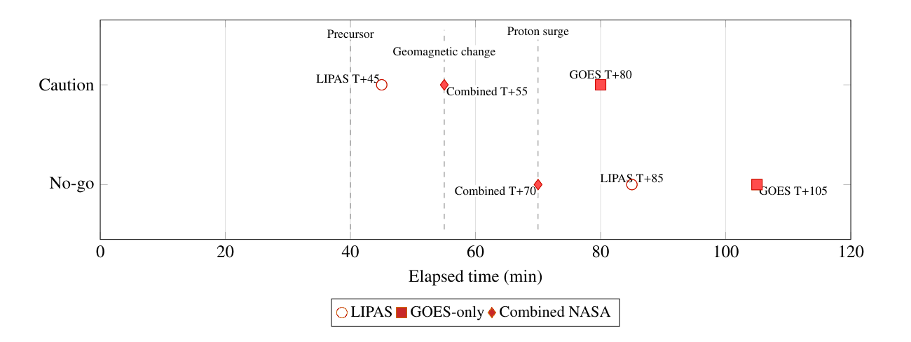
Figure. Mission-simulation decision timeline. Markers compare LIPAS, GOES-only, and combined NASA paths. Operational context only; not a substitute for locked RMSE tables.
Ablation
Under a relatively quiet portion of Window A, the locked model was held fixed while one input at a time was replaced by its window mean (no retraining). On the radiation channel, replacing the solar input raised RMSE from 0.1020 to 0.1050 (about 2.9%); setting solar and radiation together to their means raised it to 0.1068. On the solar channel, the same solar-mean replacement lowered RMSE from 3.899 to 3.290. That solar result is a sensitivity finding for this window; it does not show that live solar data are generally harmful. Zero-weight hazards remain on their physics or proxy paths under Eq. the equation.
Discussion
The studies in Section show that the usefulness of machine learning, physics-based modelling, and data integration in LIPAS depends on the hazard being forecast and on the purpose of the output. This section interprets those results, states what they do and do not show, and identifies limitations that bound the research-question answers in Section.
Combining physics and machine learning is not itself new. The contribution of LIPAS is narrower: hazard-specific weighting, uncertainty-aware blending, and cross-hazard inputs inside one lunar forecasting and decision-support system. Public heliophysics data enter as inputs to the physics and learned paths rather than as a third modelling method. The results give preliminary support for this design while showing that LIPAS should not replace specialised scientific models or be treated as a fully validated operational forecast.
The April diagnostics used the browser prototype, not the locked hybrid model, and compared it with weakly replicated baselines at a single daytime site. That comparison was designed to expose failure modes rather than to measure skill, and its scores are not pooled with the locked-model results. The temperature overshoot against a Diviner-style dayside relation near peak heating motivated keeping temperature, moonquakes, micrometeorites, and dust on the physics path. Every quantitative claim in Windows A and B, the mission simulation, and the ablation therefore rests on the locked production model from the second training run.
The ties on temperature, moonquakes, and dust follow from construction. With locked blend weights [0.4,0.05,0,0,0,0], the hybrid output on those channels is the physics path. The replicated public baselines and evaluation labels for the same channels were built from the same public archives and formulations, so identical RMSE values are expected. They show that unnecessary neural corrections were not forced where physics is already strong; they are not independent validation. Where comparison targets overlap with the construction of LIPAS, agreement partly measures internal consistency.
Solar activity provides the clearest evidence that the learned correction can add information: hybrid RMSE was lower than the replica in both windows (4.10 versus 4.66 in Window A; 4.99 versus 5.99 in Window B). The gain is modest and rests on two fourteen-day windows at three sites. Radiation did not improve: the replica had lower RMSE in Window A (0.102 versus 0.119) and in quiet dayside Window B (0.00266 versus 0.0188). Radiation should be read as a current weakness of LIPAS, not as a demonstrated strength.
Micrometeorite scores under blend weight zero are circular when the evaluation series carries the same AMS shower term as the physics path. The hybrid RMSE of 0.0 is therefore not an independent win; replica errors measure the absence of that shower term rather than a deficiency of MEM 3 as a whole. The Window B separation near the Perseids illustrates shower timing on a seasonal background; it does not validate the full NASA micrometeorite modelling framework against measured lunar impacts.
The mission simulation shows why predictive performance and operational usefulness differ. In the radiation-focused EVA scenario, LIPAS issued caution at T+45 and no-go at T+85; the GOES-only path reached caution at T+80 and no-go at T+105; the combined NASA path reached caution at T+55 and the earlier hard no-go at T+70. The earlier LIPAS caution came from upstream solar and geomagnetic drivers, not from detecting a storm that NASA products could not see. The scenario used one injected storm, fixed thresholds, and one hazard. It does not show that LIPAS is safer on every hazard, and a unified system can concentrate risk if its feeds fail.
The ablation study shows cross-hazard sensitivity inside the locked model, not causation. On a relatively quiet portion of Window A, replacing the solar input raised radiation RMSE from 0.1020 to 0.1050, while the same replacement lowered solar RMSE from 3.899 to 3.290. That solar result is a sensitivity finding for this window; it does not show that live solar data are generally harmful.
Different hazards therefore benefit from different information. Temperature, moonquakes, and dust remain physics-led by design. Solar activity shows a modest learned gain. Radiation does not. Micrometeorite behaviour is driven by explicit shower timing rather than machine learning. LIPAS is not six identical machine-learning models; it assigns influence by hazard.
Several limits bound these conclusions. Continuous co-located surface measurements do not exist for all six hazards, so targets are evaluation labels rather than complete lunar-surface truth. Except for the MEM 3 export, comparisons are author-built replicas of public methods, not runs of agency operational software. The qualitative matrix is not a ranking. The quantitative evidence covers two windows, three sites, and one locked model under relatively quiet radiation conditions.
The strongest conclusion is therefore not that LIPAS replaces specialised NASA or NOAA models. Its value is a common forecasting and decision-support layer in which physics, public heliophysics inputs, cross-hazard context, and uncertainty can be considered together, subject to substantial further validation. Mission planners remain responsible for reviewing and adapting any such outputs before operational use.
Future work
Further work should build on the locked-window, mission, and ablation findings rather than repeating those evaluations.
Radiation across activity regimes
Radiation is the highest priority because the locked hybrid did not outperform the replicated public baseline in either window. Future studies should cover quieter and stormier regimes, denser OMNI/DONKI/SWPC sampling, improved proton-flux treatment, calibrated uncertainty for alerts, and transparent comparison with combined NASA warning paths without retrospective threshold tuning.
Solar input behaviour
The solar ablation result should be repeated under stronger activity and, where feasible, with retrained rather than mean-substituted configurations, to show when live solar input helps most.
Independent labels for physics-tied channels
Temperature, moonquakes, dust, and micrometeorites should remain physics-led, but scoring needs targets independent of the physics path. Micrometeorites in particular should be assessed against observations that do not already contain the LIPAS shower term.
Validation with measured data
As Artemis and other surface or orbital measurements become available, evaluation labels should be replaced with direct measurements wherever possible. Collaboration with space agencies and research groups can strengthen validation criteria.
Operational development
Interface and mission-planner work should improve uncertainty visualisation, checklist-aligned reports, multi-hazard simulations, and tests of behaviour when data feeds fail. Usability should eventually be measured with mission personnel.
Beyond the lunar surface
Because much of the system already uses heliophysics inputs, extension to cislunar space and Earth orbit is a natural next step, with Mars as a longer-term possibility.
Throughout development, LIPAS should remain consultative decision support used alongside NASA and NOAA products, not a replacement for specialised or flight-qualified systems.
Conclusion
This research examined whether machine learning can be integrated into a unified, physics-based lunar forecasting system while retaining the physical foundations of established environmental models.
Regarding the first research question, a hybrid lunar-forecasting system can be developed by combining machine-learning and physics-based approaches in a hazard-specific way. The prototype diagnostics exposed instability in physically constrained channels and led to a locked hybrid model in which solar activity and radiation carry learned weights while temperature, moonquakes, micrometeorites, and dust remain on the physics path.
The second research question asked whether integrating multiple hazards and data sources into one decision-support system can improve operational usability. The radiation-focused mission simulation answered it only partially: LIPAS issued caution earlier than the GOES-only path by using upstream solar and geomagnetic drivers, but the combined NASA path reached the hard no-go first, and the study did not establish that LIPAS is safer than existing approaches.
The third research question asked whether the locked hybrid improves prediction performance relative to replicated public baselines. The answer is mixed. Solar activity improved modestly in both windows; radiation did not; temperature, moonquakes, and dust tied because they share a physics construction with their references; and the micrometeorite contrast under blend weight zero describes the shower term rather than independent skill.
The principal contribution of LIPAS is therefore not the replacement of existing lunar models but their integration into a single forecasting and decision-support framework. The studies show where a constrained hybrid architecture can add predictive value and where it does not yet do so, and they define the validation required before LIPAS can support lunar operations alongside NASA and NOAA products.
Acknowledgements
The author thanks Benjamin Irani-Fey for coding support during the NASA Space Apps Challenge, and thanks NASA, NOAA, and other agencies for public lunar-mission and space-weather data. The author also thanks Polygence research mentor Kyle Kennedy for support in redesigning and re-evaluating the studies, methods, and conclusions, and thanks Dr. Simon Good, Prof. Minna Palmroth, and Prof. Emilia Kilpua for support at the University of Helsinki. Any remaining errors are the author's own.
CRediT authorship contribution statement
Luka Takki: Conceptualization, Methodology, Software, Validation, Formal analysis, Investigation, Data curation, Visualization, Writing — original draft, Writing — review and editing.
Funding
This research received no specific grant from funding agencies in the public, commercial, or not-for-profit sectors.
Declaration of competing interest
The author declares that there are no known competing financial interests or personal relationships that could have appeared to influence the work reported in this paper.
Data availability
sloppypar Public NASA, NOAA, OMNI, and lunar archive products underpin the forecasts. Locked window tables, reconstructed series where noted, and figure sources are in the accompanying GitHub package under papers/appendix_numerical_tables/ and papers/elsevier/figures/. Parts of the numerical record were reconstructed from locked summary.json and CSV exports; see Appendices and. Qualitative rubric files are summarised in Appendix. Public project page: https://lipas.netlify.app. Source repository: https://github.com/Luka-bot-afk/LIPAS. Reproduction notes are at https://github.com/Luka-bot-afk/LIPAS/blob/main/papers/appendix_numerical_tables/REPRODUCTION.md. sloppypar
Code availability
Study runners, locked-model loaders, and reproduction steps are summarised in Appendix. Regenerated outputs should match the reported RMSE values when the locked blend and window definitions are used.
Declaration of generative AI and AI-assisted technologies in the writing process
The author used Cursor with Gemini assistance for drafting support, layout checks, and wording alternatives. The author checked every scientific claim against the locked study outputs, removed unsupported phrasing, and made the final edits. The scientific content, locked numbers, and conclusions remain the author's responsibility.
Appendix A. Numerical data tables
Locked Window A and Window B RMSE summaries, daily site-day rows, and related numeric exports are archived with the paper package under papers/appendix_numerical_tables/, including reported_window_rmse.md and the numerical PDF companion. Those files record the RMSE values, location keys, and blend weights used for Figs.–. Prototype comparison numbers used in Figs.– are documented in the same folder's quantitative framework note. Where a series was rebuilt from locked exports, the reconstruction is marked there rather than mixed with live telemetry.
Appendix B. Qualitative comparison framework
sloppypar The nine-criterion qualitative matrix summarised in Section is defined in full in the repository file QUALITATIVE_COMPARISON_FRAMEWORK.md (folder papers/appendix_numerical_tables/). That document lists the ordered labels from None to Very High, the sources consulted for each cell, and the comparison set (DONKI, Diviner, LDEX, Apollo PSE, MEM 3, GOES-18, and LIPAS). The criteria used in the manuscript body match that rubric: coverage, fusion, forecasting, spatial reach, real-time operations, robustness, validation, usability, and openness. Labels remain categorical; they are not converted into a numeric total or ranking score. The body reports only the interpretive outcome: LIPAS scores high on coverage and usability and only moderate on validation depth relative to specialist single-hazard archives. sloppypar
Appendix C. Locked model and blend notes
The locked production model from the second training run loads the saved_model export and applies the blend in Eq. the equation. In hazard order solar activity, radiation, temperature, moonquakes, micrometeorites, dust, the nonzero machine-learning weights are 0.4 and 0.05. Temperature, moonquakes, micrometeorites, and dust remain on physics or proxy paths under this lock.
This lock is the accuracy baseline for Windows A and B. It is distinct from the browser-prototype stack and is not an equal-weight ensemble. Skill charts drawn from this lock use within-hazard scales only (Eq. the equation). Development trees may contain alternate weight directories; the manuscript tables use only saved_model with w=[0.4,0.05,0,0,0,0].
Appendix D. Reproduction steps by study
The commands below use model directory saved_model and blend [0.4,0.05,0,0,0,0]. That model folder is distributed with the private study package; it is not part of the public repository mirror. Prototype outputs are kept separate from the locked Window A/B tables. Parallel narrative steps appear in papers/appendix_numerical_tables/REPRODUCTION.md.
Window A (night-dominant locked study)
Purpose: locked 14-day skill and RMSE at the equatorial reference, Apollo 11, and Nobile Rim (night-dominant window).
python scripts/run_14day_flagship_study.py \
--start 2026-07-05 --end 2026-07-18 --window-label A \
--out-dir logs/study_14day_window_A_night \
--model-dir saved_model \
--csv data/ingested_extended/extended_training_window_B_ready.csv

Reported solar RMSE is about 4.10 versus replica 4.66; radiation about 0.119 versus 0.102; physics ties on temperature, moonquakes, and dust; micrometeorite hybrid RMSE 0.0 (circular under the shared shower term).
Window B (dayside quiet locked study)
python scripts/run_14day_flagship_study.py \
--start 2026-07-22 --end 2026-08-04 --window-label B \
--out-dir logs/study_14day_window_B_day \
--model-dir saved_model \
--csv data/ingested_extended/extended_training_window_B_ready.csv

Reported solar RMSE is about 4.99 versus 5.99; radiation about 0.0188 versus 0.00266; the same tie and circular notes apply as in Window A.
Prototype study (browser prototype, not locked)
The prototype comparison provides historical development context (Figs.–) and is not used to overwrite locked Window A/B tables.
Mission simulation
python scripts/run_mission_sim_radiation_eva.py \
--out-dir logs/study_mission_sim_radiation_eva

In the reported run, LIPAS reaches caution near T+45 and no-go near T+85. Mission plots supply operational context rather than RMSE proof.
Ablation
python scripts/run_hazard_ablation_study.py \
--out-dir logs/study_ablation_window_A

Relative RMSE changes are compared with the manuscript ablation summary. Missing local logs are regenerated from the locked model rather than filled by hand.
Sanity check
sloppypar After a locked run, solar and radiation RMSE are checked against reported_window_rmse.md within ordinary floating-point tolerance. Printed blend weights are confirmed to equal [0.4,0.05,0,0,0,0] when the runner is called with |–model-dir saved_model|. sloppypar

