LAB4

1. Add Product Unit Test

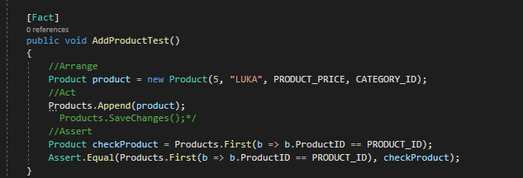

1. Delete Product Unit Test

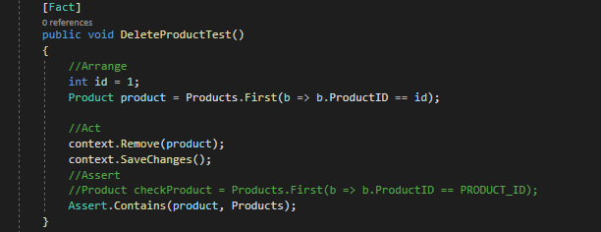

1. Get Product unit Test

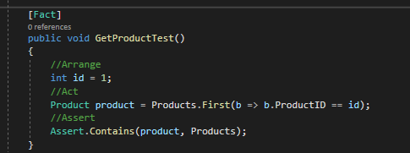

e. Changing it to use the repository pattern instead of the database.

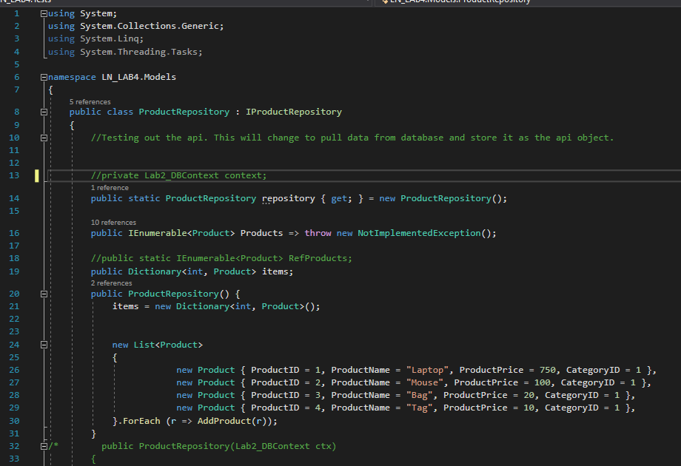

G: Take a screenshot of the top portion of the Product Controller

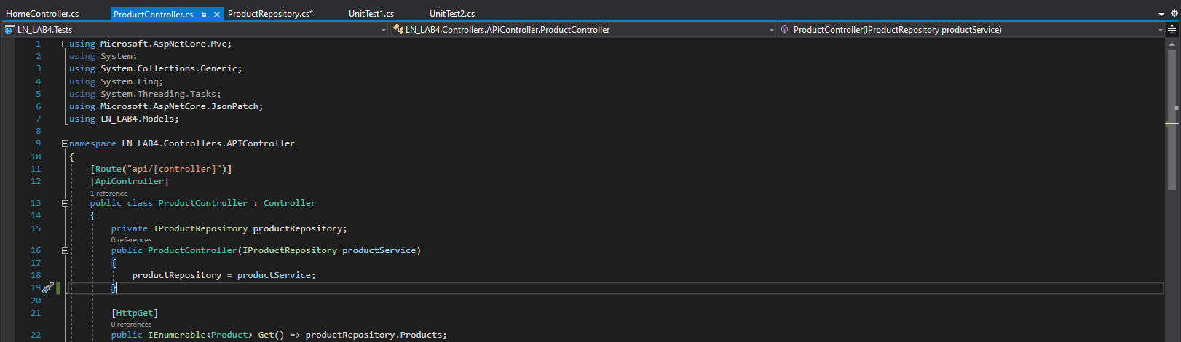

G: Take a screenshot of the top portion of the Code Repository

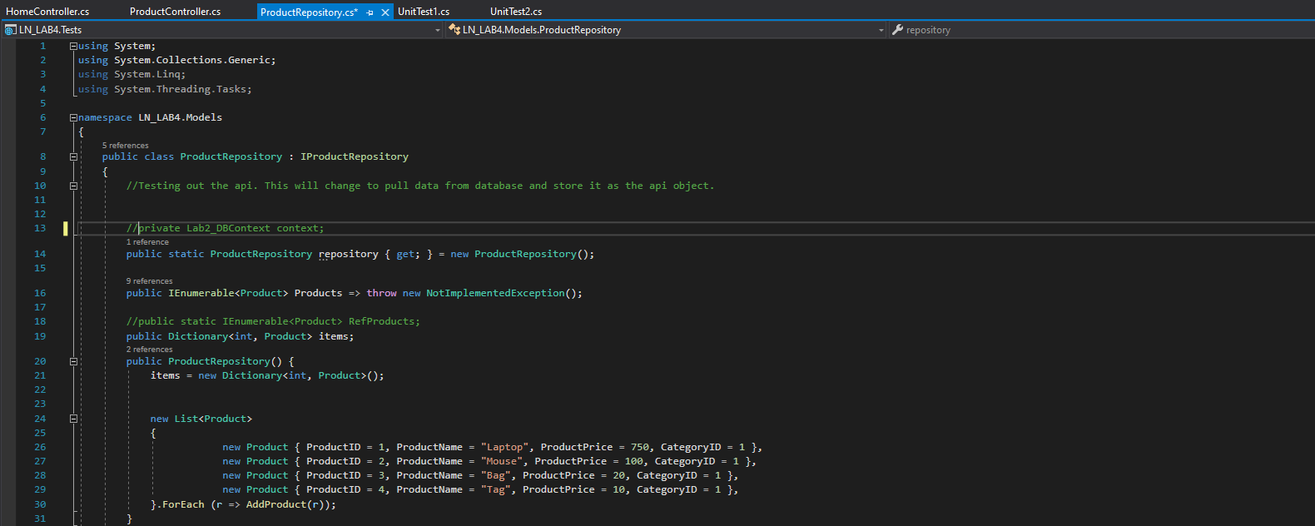

H & J: Take a screenshot of the Fake Product Repository code

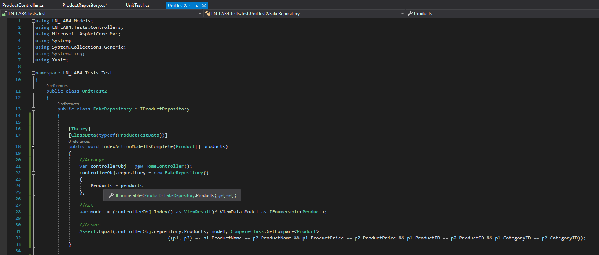

J: Create Unit Test that uses the MVC Product Controller to get a list of available

products from the Fake Product Repository.

**NOTE: I could not get this test to work.**

Final Tests

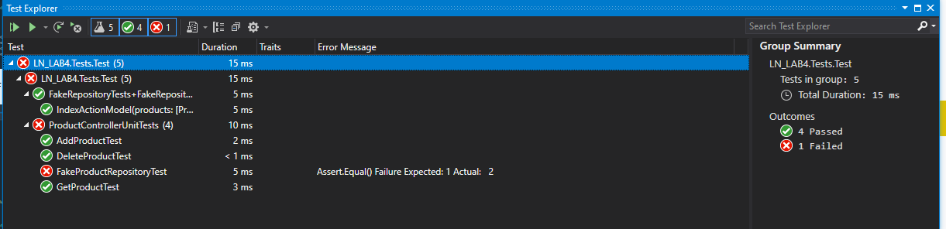

**NOTE: I could not get J test to work.**