Curriculum Vitae

I. Personal information

Name / Last name | Luka Kurnjek | 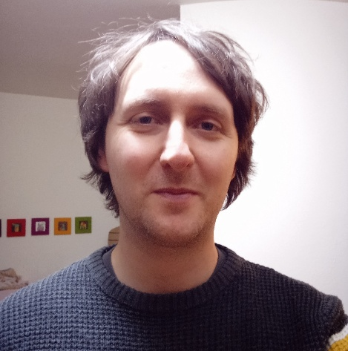
Nationality | Slovenian
Contact | https://si.linkedin.com/in/luka-kurnjek-9368b922a
Current location | Slovenia, EU
Availability  for work | 20 – 30 h/week  Can sign a contract through  my own company.

II. Language skills

 | Listening | Speaking | Reading | Writing
English (proficient) | C1 | C1 | C1 | C1
German (proficient) | C1 | C1 | C1 | C1
Certificates: Aspect College Oxford Certificate C1 (2007),
Goethe Certificate C1 (2014)

III. Computer skills

1. Technical writing and development skills | - Can explain technical subjects to broader audiences  - Am able to read and write basic code in:  Haskell, JavaScript/TypeScript, Python  - Understand smart contract developemnt on Cardano and can read and write Plinth/Aiken/MeshJS code
2. Other IT skills | - Can work with RedHat and Debian based Linux OS  - Can setup a VM (Vmware/VirtualBox), WSL or Docker  - Have some experience with Ansible  - Can work with Git and Jira/Confluence
IV. Work experience

1. Input Output Group  (IOG Education)  www.iog.io | Duration of work: August 2022 - December 2025  Description of work:  - wrote the majority of the Writing smart contracts chapter for the Mastering Cardano book (100+ pages)  - worked on Cardano smart contract and off-chain code for the Plutus pioneer program  - wrote an education course for the Lace Cardano wallet  - created several educational presentations (blockchain introduction, wallets, Cardano security)
2. Two gap years  (education and  self-growth) | Duration of period: July 2020 - July 2022  Description of work:  - learned the Haskell programming language  - learned some Python skills (PyQt, REST API)
2. Cosylab  (Control System Laboratory)  www.cosylab.com | Duration of work: January 2017 - July 2020  Description of work:  - coding automated GUI tests for Qt app in Python,  - automatizing deployment of software with Ansible  - preparing Docker images and VMs for developers  - writing user documentation and tender applications  - basic development of control system software with WinCC OA (C-like programming with OOP features)
4. Agrosphere IBG-3, Institute  (Research center Jülich, Germany) | Duration of work: February 2015 - June 2016  Type of work: DBU scholarship for environmental research  Description of work:  - geophysical imaging of subsurface earth layers  - organizing field trips for measurements  - evaluation of results in Python

V. Personality and free time activities

1. Personality | Motivated for finding a solution for my problems.  Practical in organizing my work and time schedule.  Helpful when working with other colleagues in a team.
2. Hobbies | Swimming, supping, bicycling and hiking in nature.  Reading and listening to music.
3. Interests | Like to read about blockchain technology and have an interest in educating the general public about it.

VI. Volunteer work

1. IAESTE Slovenia  (National committee  and Local committee Ljubljana)  https://iaeste.org/about | Duration of work: February 2011 - January 2015  June 2016 - September 2017  Positions held:  - coordinator for unused offers  - treasurer of local and national committee  - president of national committee Slovenia  Description of work:  - negotiations with companies for internships  - processing applications for foreign interships  - marketing and giving presentations at faculties  - organization of conferences (+200 attendees)  - leading the educational project iTECH IAESTE  - working on finances and tender applications  - arranging work permits for foreign students  - organizing summer reception activities  - leading IAESTE Slovenia (mentoring students, representing country at international meetings)

VII. Education

1. Faculty of Civil Engineering  (University of Ljubljana, Slovenia) | Date of attendance: October 2006 - September 2012  Title of qualification: Diploma engineer  Average grade: 8.82 (1-10 system with 10 being maximum)  Activities:  - designing structures, tutoring other students  - programming in Matlab and Python
2. Faculty of Mathematics and Physics  (University of Ljubljana, Slovenia) | Date of attendance: October 2012 - September 2014  Study program: Bachelor in Physics  Average grade: 9.15 (1-10 system with 10 being maximum)  Activities:  - programming in C and Python  Program duration: 3 years (finished only 1.5 years)

