# Bibliografie

|  |  |
| --- | --- |
| [1] | A. Mittal en A. Rege, „Design of digital FIR filter implemented with window techniques for reduction of power line interference from ECG signal,” in *2015 International Conference on Computer, Communication and Control (IC4)*, Indore, India, 2015. |
| [2] | F. Shirbani en S. K. Setarehdan, „ECG power line interference removal using combination of FFT and adaptive non-linear noise estimator,” in *2013 21st Iranian Conference on Electrical Engineering (ICEE)*, Ferdowsi University of Mashhad, Mashhad, Iran, 2013. |

# DSP

**Assignment worth: 15%** towards the final grade.

**Groups:** The assignment is to be completed by pairs of students.

**Description:**

1. Use MATLAB for the assignment. Record all the code you create to get your results as script and/or function files. If you use toolbox or scientific library functions, make sure that you understand what those functions are doing.

2. The assignment is about the design, implementation and use of **Notch filter**.

3. Example sampled signals are supplied: An ECG signal with interference (ecg.mat and ecg2,mat).

**Tasks: (80%)**

1. Show the sampled time domain signals with time axis in seconds of the ECG signal.

2. Calculate with MATLAB the spectrum of the signal and identify the power-line noise in the spectrum.

Research sources on pln:

[1] [2]

The transfer function of the notch filter is .

The zeros z1 and z2 are located on the unity circle at the frequency that needs to be removed. They are complex conjugate. Apply if necessary multiple notch filters in cascade.

After one notch filter all pln from the ecg2 signal is gone without too much influence on the data. Need to apply more on ecg signal

Extra questions to answer, things to add explain,… in report:

Is notch IIR, yes?

Wh­at is the time based representation?

Bode plot, impulsrespons notch filter

…

3. Give the differential equation and the direct form II representation of the notch filter(s).

Explanation diff direct form 1 and 2 and when which to use mem, bandwith

Diff equation:

Direct Form I

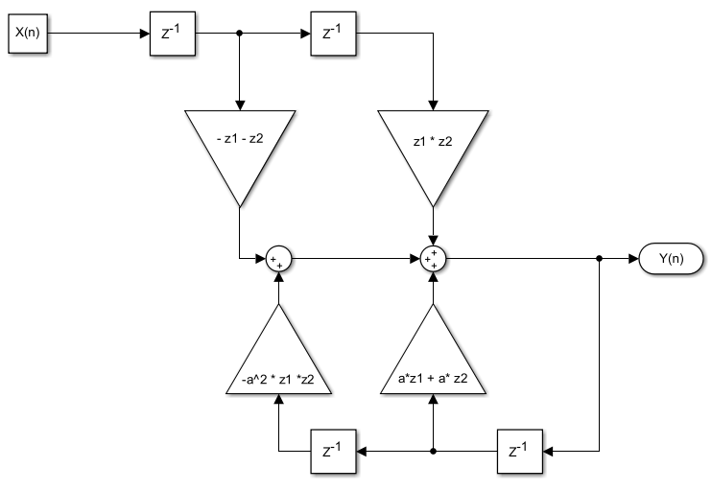

Figure 1Direct Form One for notch filter

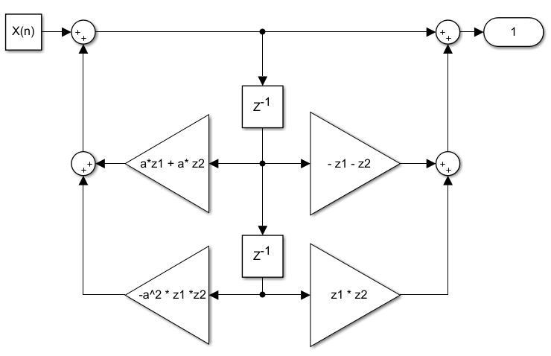

Figure 2Direct Form II of notch filter

4. Calculate with pen-paper the impulse response and the frequency response for f equal to 0, fs/4, fs/2. Check your results with the MATLAB instructions ‘freqs’ and ‘impz’.

For f equal to 0:

Impulse response:

Frequency response:

For f equal to fs/4:

Impulse response:

Frequency response:

For f equal to fs/2:

Impulse response:

0.144

Frequency response:

5. Apply the filter on the provided signal and give the time and frequency domain representation. Elaborate on your results.

(Mostly) Done

6. Design a FIR filter that removes low-frequency drift and high-frequency noise for ecg2.mat.

7. Reduce the sample frequency of ecg.mat to the lowest possible value using a rational factor. Use a IIR filter for that purpose.

**Data file:**

The data file can be loaded with MATLAB using a command such as:

**load ecg.mat or load ecg2.mat**

**Code:**

Submit to Toledo as a single zipped file (one for each group) all the code files (script and function files) that your group has used to generate your results. You need to explain in the report why specific functions have been used and show how specific argument values have been arrived at.

**Report:**

Your report should be no more than 10 pages in length, using a font no smaller than 11-point. Present a description of the process illustrated only by key lines of code and abstracts of functions. Show in the report only the key figures illustrating your results (including those specified in Tasks above). The m-files should be added to the report as an appendix. **A hard copy of the report needs to be submitted.**

**Time allocation:**

You should plan to spend no more than 20 hours each on the assignment.

**Markings:**

The markings are mentioned between brackets after each task. Additionally extra marks are given for overall report quality (introduction, conclusion, references, layout, etc.) 10% and code quality (organization, proper use of functions, commenting) 10%