**Introduction**

I have chosen to deploy **NEXTCLOUD** on Oracle VM Virtualbox with using Ubuntu 22.04.3 LTS.

**Nextcloud** is a popular open-source software platform for file synchronization and sharing. It functions like Dropbox or Google Drive but allows users to host their own cloud storage on their servers or use a third-party hosting provider.

Other technologies I used for the project are Apache and Mariadb.

**Implementation**

First I entered Oracle VM so I could use Linux.



After setting it up, I started the virtual machine.

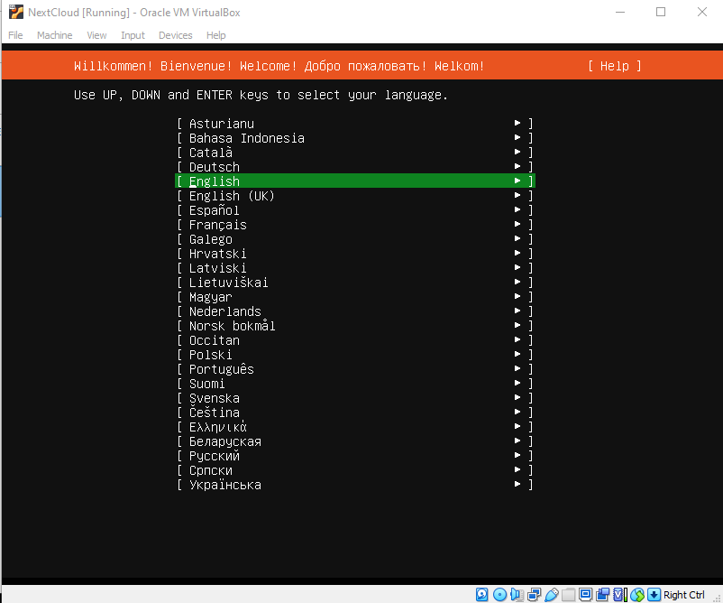

After setting it all up, first thing I did was updating the apt repository

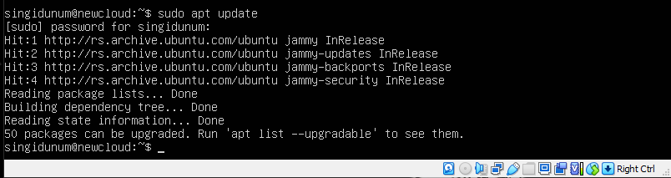

And then typed “sudo apt upgrade” to install the updates

**APACHE2**

Once it finished I started with installing apache2 which serves as the web server.

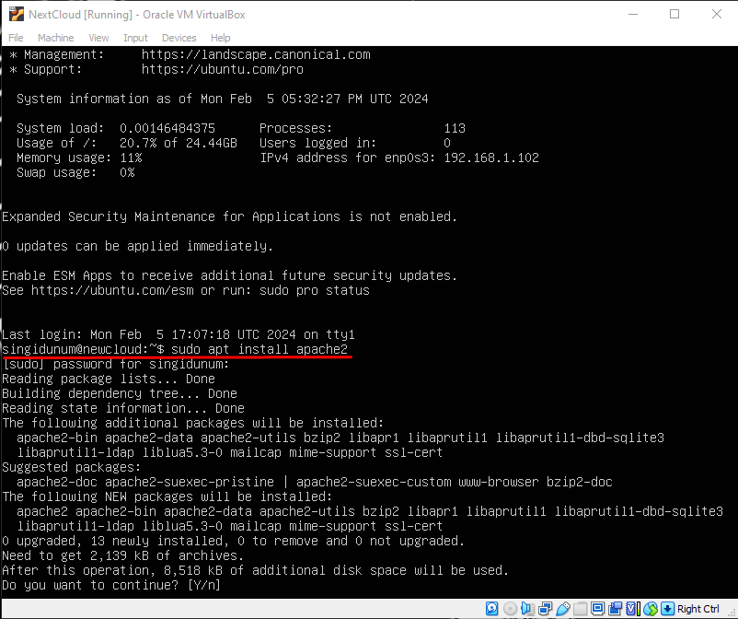

Then I configured it so it always starts when I enter the virtual machine

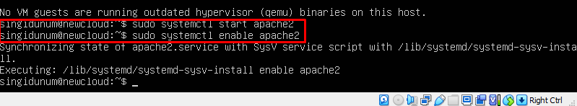

**MARIADB**

I also installed MariaDB because the **Nextcloud** also needs a database.

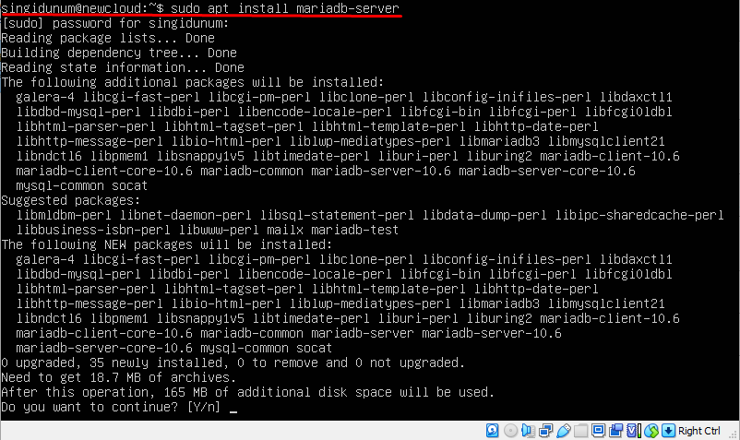

And also configured it so it starts after you start the virtual machine.

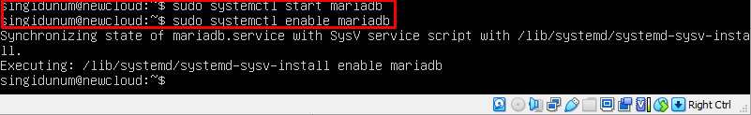

We can also check if it is started by typing “sudo systemctl status apache2/mariadb”

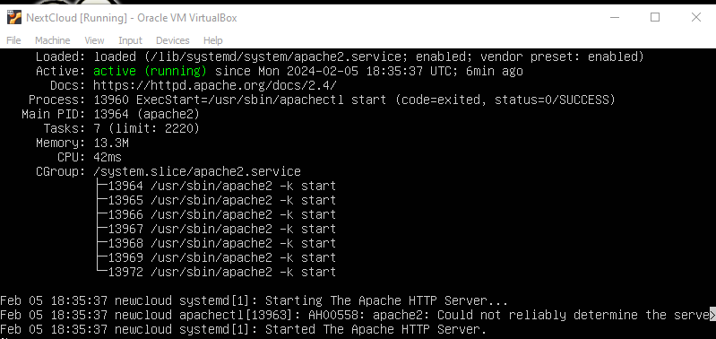

Then I logged in to MariaDB shell so I would make a database with command “sudo mysql -u root –p”

And configured it like this.

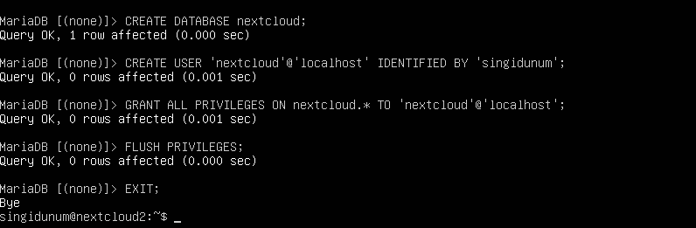

1. This creates a new database named “nextcloud”
2. Created database used named “nextcloud” with password
3. Grants all privileges to the user for the database
4. Reloads to apply changes
5. exit

**PHP**

I installed the PHP because it is necessary for my **Nextcloud**. It allows the interaction with the MariaDB and handles tasks such as user authentication, file manipulation…



**NextCloud**

Now we downloaded the **nextcloud** installation package directly from the internet onto our server with command “wget”.

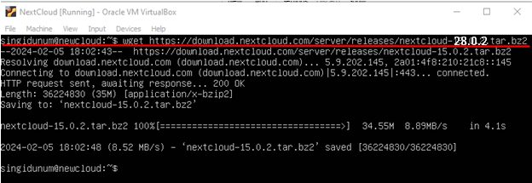

Now just to configure the PHP, we moved the **nextcloud** installation into the “/var/www/html/nextclud” directory, we also gave to the user “www-data” the ownership of files and we gave the owner with “755” code the full access.



Now we have to create a new Apache conf file for our **Nextcloud** by typing “sudo nano /etc/apache2/sites-available/nextcloud.conf” and adding in it this:

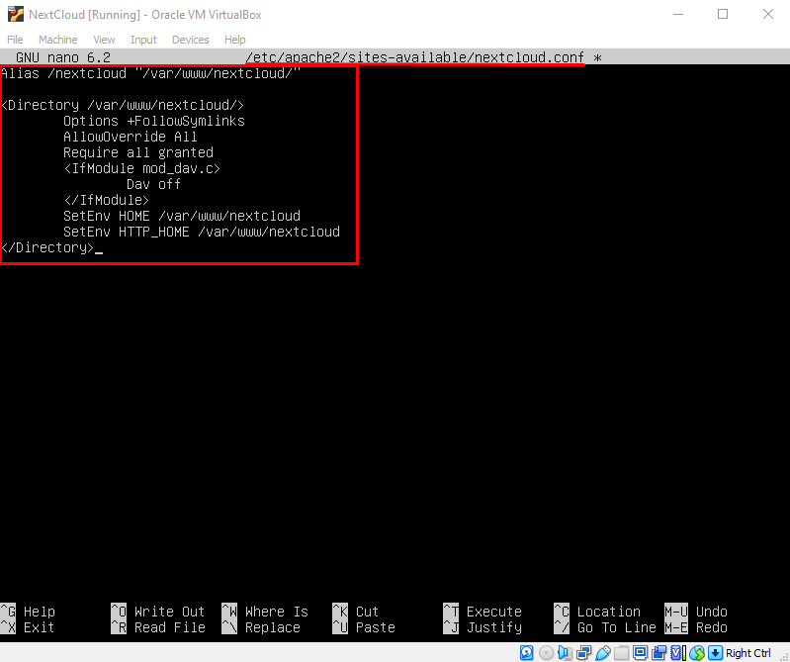

This basically creates alias for the URL path ‘/nextcloud’ which means the url will be ‘https://your_ip/nextcloud’. The directive applies conf settings to the ‘/var/www/html/nextcloud’ directory which are:

1. Allows Apache to follow symbolic links
2. Allows to override Apaches global conf settings
3. It allows access to all clients
4. Disables WebDAB module because nextCloud does not need it
5. And last two lines are so it helps ensure that Nextcloud operates correctly and uses the correct paths

Now we have to enable the nextcloud conf file in apache and eneable Apache to rewrite module which ensures that nextclouds URL rewriting function works.

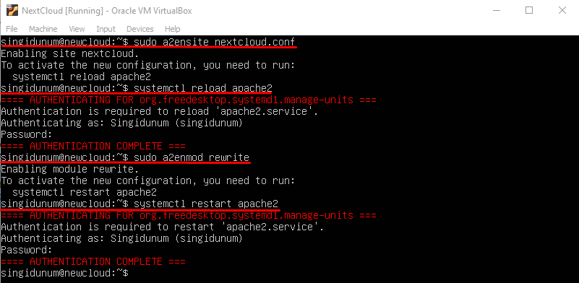

Now we can open web browser and go to <http://ip_address/nextcloud>. We can check the ip address with command “ip a”

