Assignment 1

Lukasz Filanowski 18414616

# Q1

1. The program loads the first value in arrays D1 and D2 into registers. The values from D1 and D2 are added to each other and stored in the register that array D3 was assigned. The program then loads a temporary value which terminated the program (li $v0, 10)

**SCREENSHOTS FROM GITHUB REPO: https://github.com/Lukadolla/Computer-Systems**

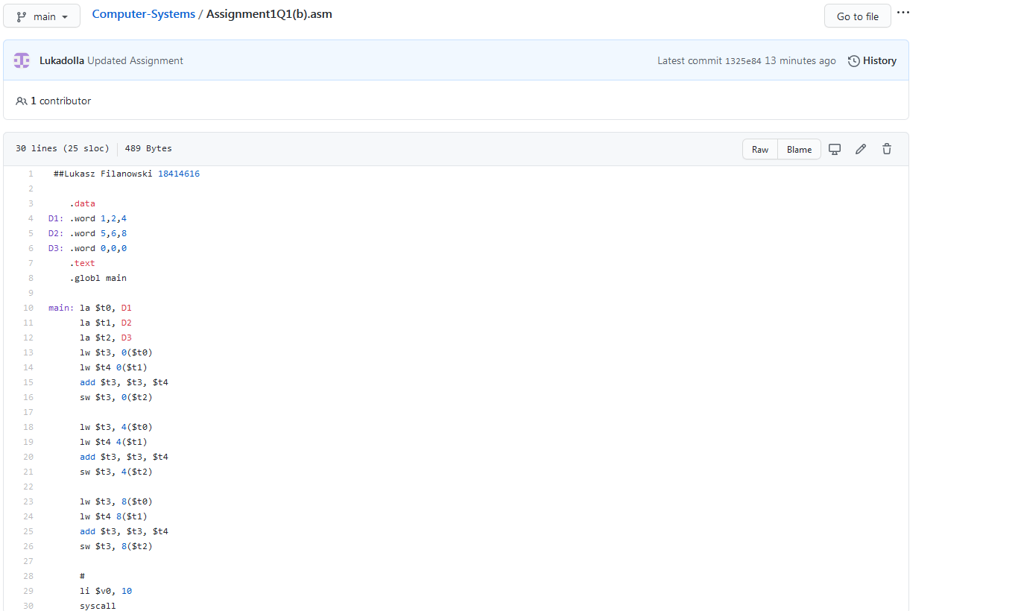

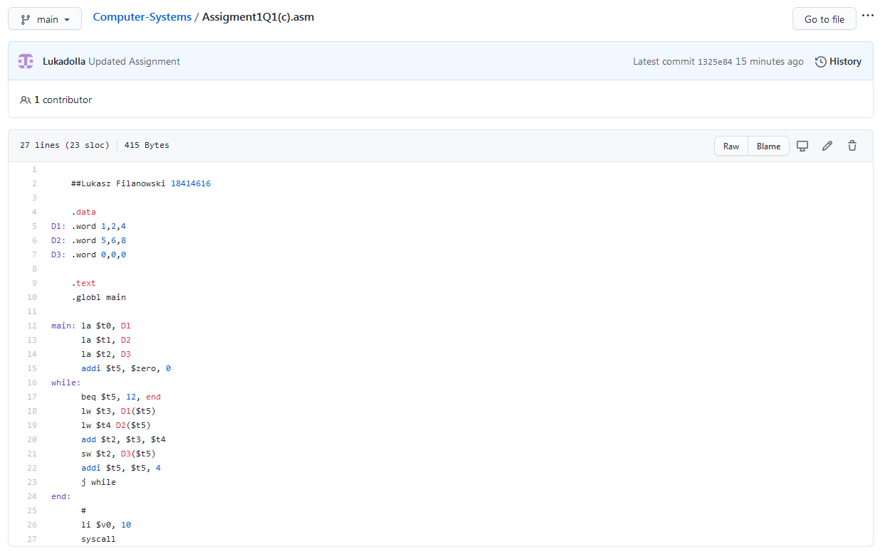

# Q2

