Assignment 2

Lukasz Filanowski 18414616

All files uploaded to Github: **https://github.com/Lukadolla/Computer-Systems**

Screenshots taken from Github

# Q1

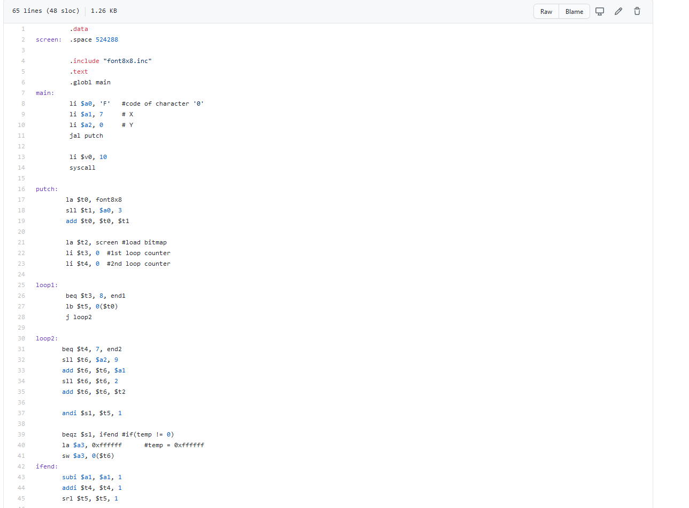

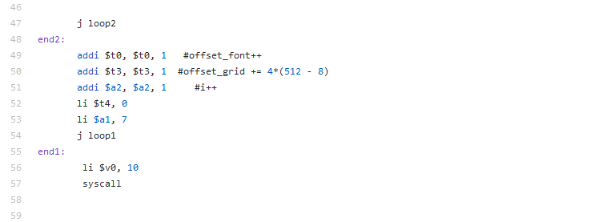

# Q2

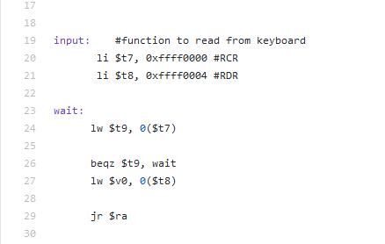

Function that reads input from the keyboard. The result is stored in register $v0. The result should then be passed into the putch function as the character to be printed where it is then displayed on the bitmap display