Assignment 3

Lukasz Filanowski 18414616

# Q1

Files uploaded to Github: **https://github.com/Lukadolla/Computer-Systems**

Screenshots taken from Github

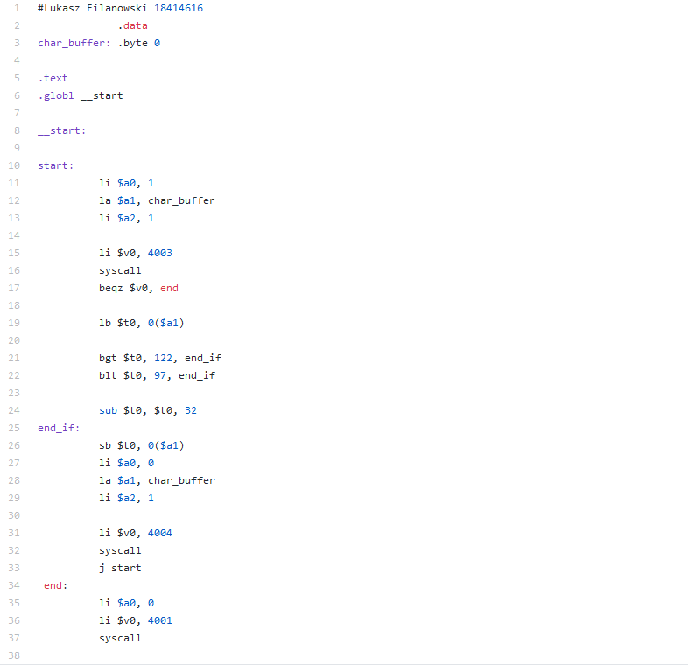

# Q2

For rotation of the string, the input string must be read in bit by bit. Then, at the specified bit n, the elements to the left and right are swapped, and then bit shifted left and right to swap the next pair of elements.