# Q1

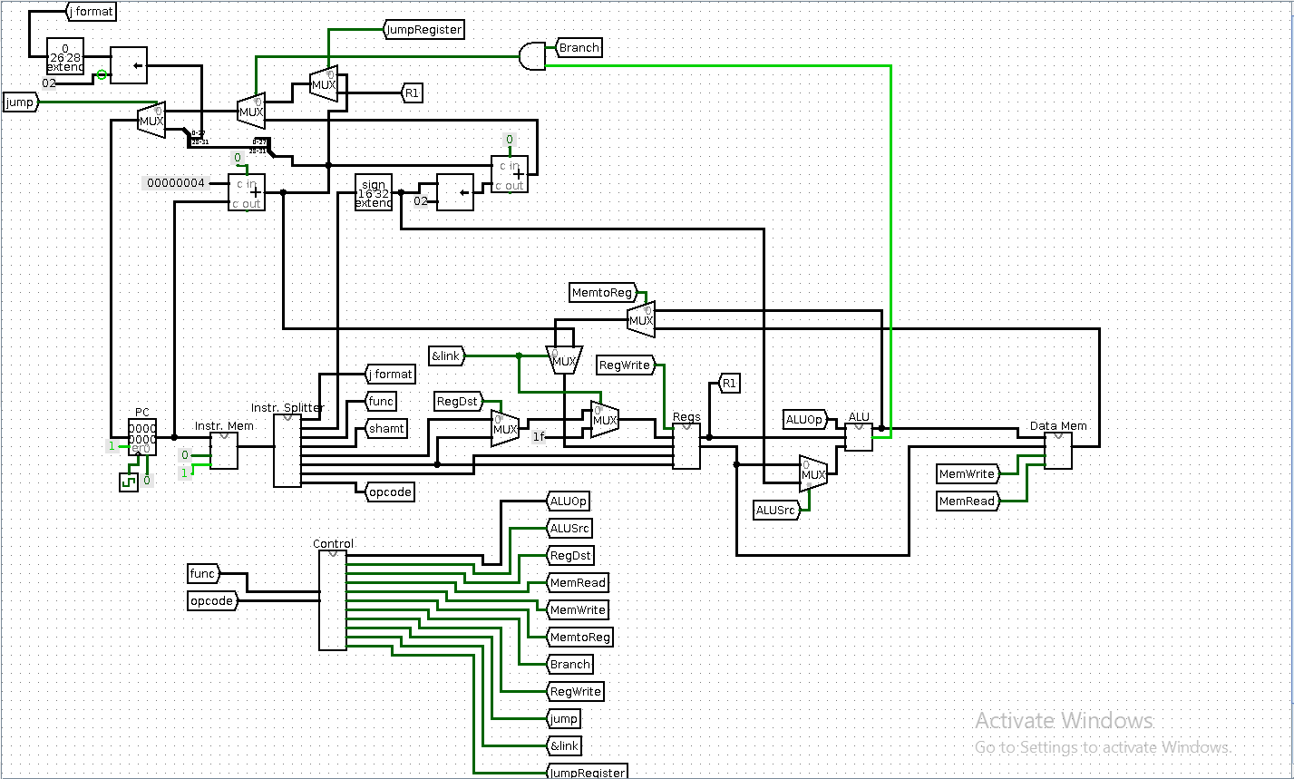

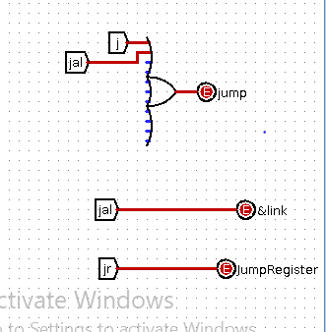

For the jr instruction, we intercept the signal before it reaches the program counter to perform the jump instruction using a logical shift left. For jump and link, the signal is processed after the instruction splitter and combined with the output from the program counter.

# Q2

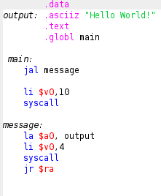

The program in question 2 loads the subroutine message into memory and executes it. When it is finished executing, the message “Hello World!” is printed to the screen and the program jumps back to the main and syscall terminates the program.