Homework #2 Due: Mar. 23, 2021

2021310001 이성우

Modify “step_f.m” file to incorporate the class label {setosa=0, versicolor=1} instead of {setosa=1, versicolor=-1} as in “for_HW2_perceptron_iris.m”. Briefly explain why your answer works. You should submit a short report (about 1~2 pages long) through LMS with the figure obtained from “for_HW2_perceptron_iris.m” and the script of “step_f.m”.

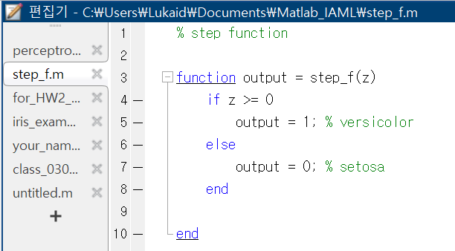

clear all

close all

%load iris_data

load iris_data.mat

X=[x(1:100,1) x(1:100,2)];

Y=y(1,1:100)';

figure(1)

hold on

plot(X(1:50,1),X(1:50,2),'ro')

plot(X(51:100,1),X(51:100,2),'bx')

xlabel('Sepal length')

ylabel('Sepal width')

%Perceptron

n_iter=1000; %# of epoch

eta=0.1; %learning rate

w=[3;3;3]; %initial value for w

for i=1:n_iter %# of epoch

for j=1:length(X)

%prediction

Yhat(j,1)=step_f(w'*[1;X(j,:)']);

%update

w=w+eta*(Y(j,1)-Yhat(j,1))*[1;X(j,:)'];

end

end

x1=4:0.1:7;

for i=1:length(x1)

x2(i)=-w(1)/w(3)-w(2)/w(3)*x1(i);

end

figure(1)

plot(x1,x2)

위에서 보는 바와 같이 step_f 의 함수, 즉, Yhat의 값을 Y의 값과 동일하게 setosa=0, versicolor=1으로 바꾼다면, 이를 fitting한 함수도 정상적으로 동작하여 다음과 같은 classifier를 보여준다.

