Dear {{Client}},

We are pleased to present the results of the recent satisfaction survey conducted among our valued customers. The survey aimed to gather feedback and insights regarding various aspects of our business.

Chart Description:

The radar chart below illustrates the satisfaction levels of customers across different categories, including price, quality, customer service, delivery, and overall experience. The chart provides a comprehensive overview of the overall satisfaction levels, enabling us to identify areas of improvement and areas where we excel.

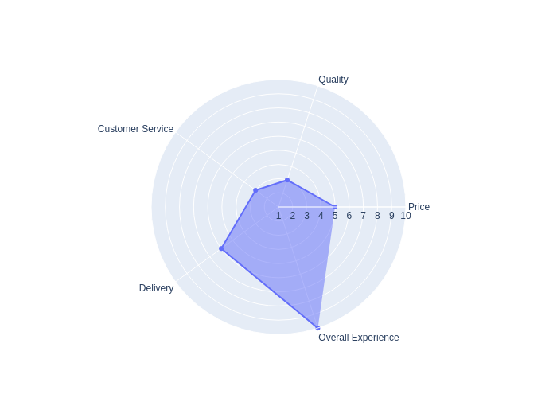

Figure 1: Radar chart showcasing customer satisfaction

Based on the survey responses, we have analyzed the data and derived valuable insights. Here are some key findings:

Price: Customers have expressed high satisfaction levels with our competitive pricing strategies, indicating that our pricing remains a significant advantage.

Quality: The feedback regarding product quality has been overwhelmingly positive, reflecting our commitment to delivering top-notch products that meet customer expectations.

Customer Service: Our customer service team has been consistently praised for their responsiveness, professionalism, and willingness to go the extra mile to assist customers.

Delivery: The survey results indicate that our customers are satisfied with the promptness and reliability of our delivery services, highlighting our strong logistics capabilities.

Overall Experience: The overall satisfaction levels reported by customers demonstrate their positive experiences with our company as a whole. We are thrilled to have such high levels of customer satisfaction across multiple touchpoints.

We sincerely thank all the participants for taking the time to provide their valuable feedback. Your insights have been instrumental in helping us enhance our services and continue delivering exceptional customer experiences.

Should you have any questions or require further information, please do not hesitate to reach out to our customer service team.

Once again, we extend our gratitude for your continued support and feedback.

Sincerely,

{{Name}}

{{Position}}

{{Company}}