# How do cybersecurity teams monitor network traffic?

Capturing packets and subsequently analyzing them is extremely demanding, both computationally and storage-wise. A single computer can generate an enormous amount of packets within a single second! That's why cybersecurity teams, such as CSIRT-MU (<https://csirt.muni.cz/>), store and analyze only **summary statistics** about the individual network connections, instead of whole packets.

The information about these connections is stored in the form of **network flows**. A simple network flow is composed of packets that share the following **five fields**: *source and destination IP address, source and destination port*, and *protocol*. This quintuple is typically extended with many other statistics, for example, duration of the flow, the total amount of packets, or the number of transferred bytes. (For detailed information, see RFC 3954 and RFC 7011.) While it may seem that this aggregation leads to losing relevant information, it's not true, as flows have **extensive applications** for network monitoring.

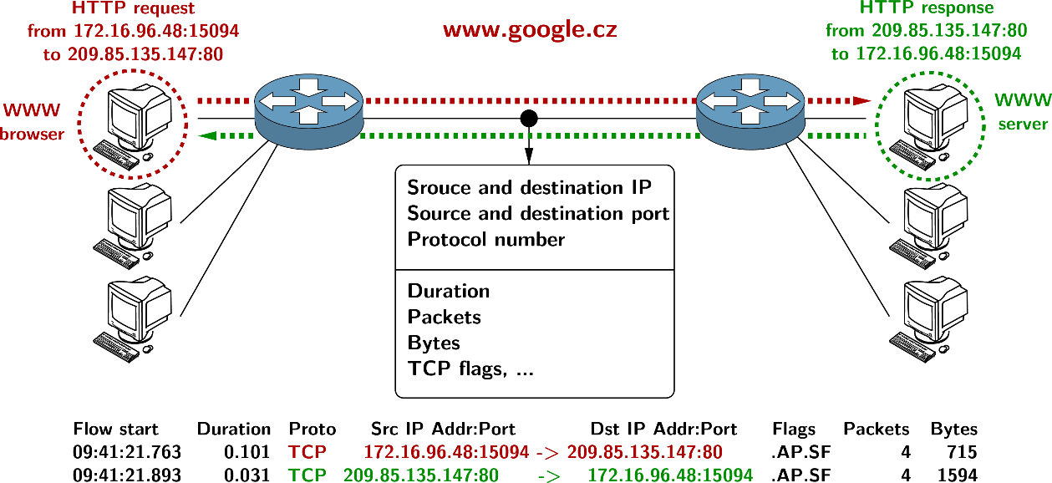As the image below shows, the flow represents a **one-way connection** when TCP is used. The situation is even simpler with UDP, in which each packet forms exactly one flow.

# Practical exercise

Now that you understand how network flows are created, will you dare to test your knowledge? You've received strips of paper that represent **individual packets** passing through the network. Each packet contains the following information:

|  |  |  |  |  |  |  |  |
| --- | --- | --- | --- | --- | --- | --- | --- |
| Number | Arrival time | Source address | Destination address | Source port | Destination port | Protocol | Bytes transferred |

Can you form **network flows** out of them? (The correct solution is on the other page.)

# Solution: The resulting flows

|  |  |  |  |  |  |  |
| --- | --- | --- | --- | --- | --- | --- |
| Start time | Duration | Source address:port | Destination address:port | Protocol | Bytes transferred | Packet numbers |
| 0.20 | 10.20 | 19.2.3.18:4020 | 125.14.55.111:80 | TCP | 440 | 1, 10, 11, 23 |
| 0.60 | 8.50 | 122.13.5.71:4000 | 125.14.55.111:80 | TCP | 360 | 2, 9, 21 |
| 0.90 | 0 | 122.13.5.71:4000 | 11.15.17.19:20200 | UDP | 110 | 3 |
| 1.60 | 8.10 | 19.2.3.18:22 | 20.20.40.44:22 | TCP | 570 | 4, 6, 16, 18, 22 |
| 1.90 | 0 | 125.14.55.111:4000 | 122.13.5.71:80 | UDP | 150 | 5 |
| 2.60 | 5.20 | 125.14.55.111:80 | 19.2.3.18:4020 | TCP | 490 | 7, 8, 17, 19 |
| 5.40 | 6.90 | 19.2.3.18:22 | 20.20.40.44:5187 | TCP | 410 | 12, 13, 24 |
| 6.40 | 0 | 122.13.5.71:4000 | 11.15.17.19:20200 | UDP | 100 | 14 |
| 6.80 | 0 | 125.14.55.111:4000 | 122.13.5.71:80 | UDP | 120 | 15 |
| 8.50 | 0 | 122.13.5.71:4000 | 11.15.17.19:20200 | UDP | 120 | 20 |

|  |  |  |  |  |  |  |  |
| --- | --- | --- | --- | --- | --- | --- | --- |
| 1. | 0.20 | 19.2.3.18 | 125.14.55.111 | 4020 | 80 | TCP | 120 |
| 2. | 0.60 | 122.13.5.71 | 125.14.55.111 | 4000 | 80 | TCP | 110 |
| 3. | 0.90 | 122.13.5.71 | 11.15.17.19 | 4000 | 20200 | UDP | 110 |
| 4. | 1.60 | 19.2.3.18 | 20.20.40.44 | 22 | 22 | TCP | 130 |
| 5. | 1.90 | 125.14.55.111 | 122.13.5.71 | 4000 | 80 | UDP | 150 |
| 6. | 2.20 | 19.2.3.18 | 20.20.40.44 | 22 | 22 | TCP | 110 |
| 7. | 2.60 | 125.14.55.111 | 19.2.3.18 | 80 | 4020 | TCP | 120 |
| 8. | 3.00 | 125.14.55.111 | 19.2.3.18 | 80 | 4020 | TCP | 140 |
| 9. | 3.40 | 122.13.5.71 | 125.14.55.111 | 4000 | 80 | TCP | 100 |
| 10. | 4.20 | 19.2.3.18 | 125.14.55.111 | 4020 | 80 | TCP | 100 |
| 11. | 4.80 | 19.2.3.18 | 125.14.55.111 | 4020 | 80 | TCP | 120 |
| 12. | 5.40 | 19.2.3.18 | 20.20.40.44 | 22 | 5187 | TCP | 150 |
| 13. | 6.00 | 19.2.3.18 | 20.20.40.44 | 22 | 5187 | TCP | 150 |
| 14. | 6.40 | 122.13.5.71 | 11.15.17.19 | 4000 | 20200 | UDP | 100 |
| 15. | 6.80 | 125.14.55.111 | 122.13.5.71 | 4000 | 80 | UDP | 120 |
| 16. | 7.10 | 19.2.3.18 | 20.20.40.44 | 22 | 22 | TCP | 100 |
| 17. | 7.40 | 125.14.55.111 | 19.2.3.18 | 80 | 4020 | TCP | 130 |
| 18. | 7.60 | 19.2.3.18 | 20.20.40.44 | 22 | 22 | TCP | 120 |
| 19. | 7.80 | 125.14.55.111 | 19.2.3.18 | 80 | 4020 | TCP | 100 |
| 20. | 8.50 | 122.13.5.71 | 11.15.17.19 | 4000 | 20200 | UDP | 120 |
| 21. | 9.10 | 122.13.5.71 | 125.14.55.111 | 4000 | 80 | TCP | 150 |
| 22. | 9.70 | 19.2.3.18 | 20.20.40.44 | 22 | 22 | TCP | 110 |
| 23. | 10.40 | 19.2.3.18 | 125.14.55.111 | 4020 | 80 | TCP | 100 |
| 24. | 12.30 | 19.2.3.18 | 20.20.40.44 | 22 | 5187 | TCP | 110 |