---

title: 'PySit2Stand: Python package for Sit-to-Stand transition detection and quantification'

tags:

- Python

- Biomechanics

- Digital Biomarkers

- Digital Medicine

- Accelerometer

- Inertial Sensors

- Wearable Sensors

- IMU

- Human Motion

- Activity Recognition

authors:

- name: Lukas Adamowicz

affiliation: 1

- name: Shyamal Patel

affiliation: 1

affiliations:

- name: Pfizer, Inc. 610 Main Street, Cambridge MA, USA 02139

index: 1

date: 31 October, 2019

bibliography: paper.bib

---

# Summary

Sit-to-stand transitions have been used to assess mobility for a broad range of conditions, such as Parkinson's Disease [@buckley:2008] and knee Osteoarthritis [@bolink:2012]. Assessments are typically performed in the clinic using timed performance tests like the timed-up-and-go [@nguyen:2015; @nguyen:2017] and chair stand tests [@guralnik:1994]. While these tools have demonstrated good psychometric properties, they have two key limitations: (1) assessments are performed episodically as they need to be administered by trained examiners, and (2) assessments performed in the clinic might not provide an adequate measure of real-world mobility. Therefore, there is a growing interest [@pham:2018; @martinez-hernandez:2019] in the use of wearable devices to detect sit-to-stand transitions that occur during daily life and quantify the quality of mobility during these transitions.

``PySit2Stand`` is an open source Python package that implements novel heuristics-based algorithms to first detect Sit-to-Stand transitions from accelerometer data captured using a single lumbar-mounted wearable device, and then provides quantitative metrics, including duration, maximum and minimum acceleration, and SPARC [@balasubramanian:2015], to assess the movement quality during each detected transition. While most previous works have focused on either in-clinic applications [@van_lummel:2013; @nguyen:2015; @nguyen:2017] or the use of multiple sensors [@nguyen:2015; @nguyen:2017], the algorithms in this package can handle data collected under free-living conditions as well as prescribed tasks (e.g. 30-second chair stand task), and it uses only the acceleration data from a single sensor on the lower back with unconstrained device orientation. The practicality of a single-accelerometer approach, which affords a long battery life and improved wearability, makes it well suited for long-term, continuous monitoring at home.

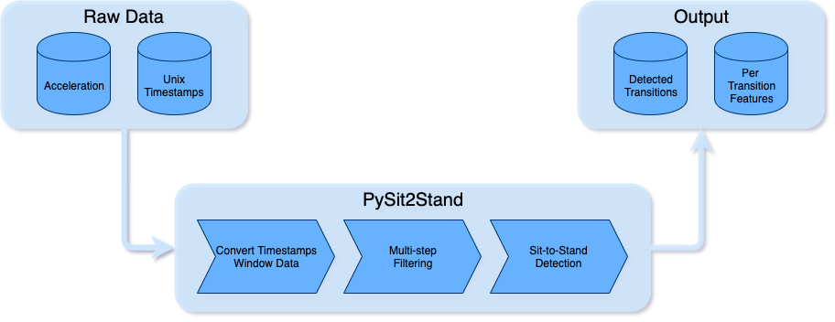

``PySit2Stand`` takes raw accelerometer data with timestamps as input and returns detected sit-to-stand transitions. Data can be windowed by full days, or parts of days can be selected for each window (e.g. window from 8:00 to 20:00). A high level interface is provided in which the user has access to all adjustable parameters, and simply provides the raw data and gets the detected transitions, with their computed features, as output. Additionally, the lower-level methods that are called during the detection are available as well for more fine-grained control.

With this framework, users maintain control over many parameters of the transition detection. Additionally, the separation of processing steps and modularity of the sub-processes allows for easy customization, if desired. This extends even to the generation of transition features, which with a custom functionality could generate additional features while still maintaining the same transition detection methods.

# Current Work

The algorithms implemented in ``PySit2Stand`` have been validated in healthy young and old adults as well as in older adults with Parkinson’s disease. Please refer to [@adamowicz:2019] for a detailed description of algorithms and results.

# Availability

``PySit2Stand`` is distributed under the MIT License and is published on PyPI, the Python Package Index, and can be installed by running the following in the terminal:

```shell-script

pip install pysit2stand # install with checking for dependencies

# or

pip install pysit2stand --no-deps # installation without checking for installed dependencies

```

PySit2Stand requires the following Python packages:

- Python >=3.6

- NumPy - [@numpy]

- SciPy - [@scipy]

- PyWavelets - [@pywavelets]

``PySit2Stand`` contains example code with sample data in its GitHub repository. Full documentation with usage examples, installation instructions, and API reference are all available at [https://pysit2stand.readthedocs.io/en/latest/](https://pysit2stand.readthedocs.io/en/latest/)

# References