# IV. Results

## Data overview

### Descriptive statistics

The variables are examined in the descriptive statistics table below:

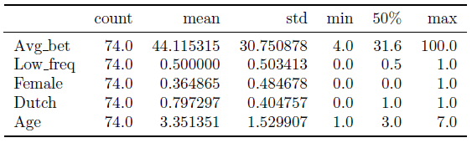

From the summary statistics, we can conclude that the amount of observation for all variables being equal to 74, the average bet ranging from a minimum of 4 to a maximum of 100. Furthermore, the data included 10 international and 17 Dutch females, with 5 international and 42 Dutch males.

(for more, visual analysis, see *figures 4, 5 and 6*)

### Pairwise correlation

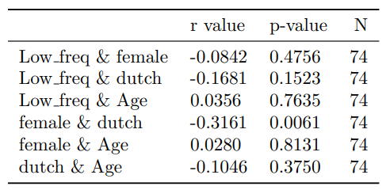

Pairwise correlation shows one statistically significant moderate in magnitude negative correlation between the gender and nationality, which is inherent to the dataset, however overall, the dataset is in order.

## Hypothesis testing

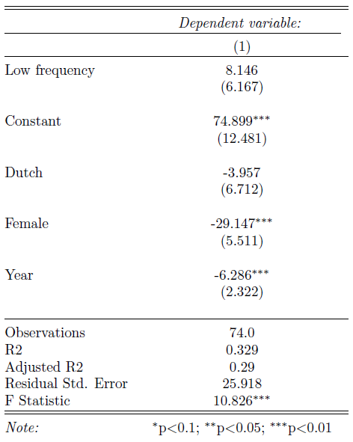

(for more extensive regression output, see *figure 1* in the appendix)

To test for hypotheses, a multiple linear regression (OLS) was used, which resulted in a model with significant independent variables followed by adjusted R-squared of 0.29 which indicates a relatively high explanatory power of the model. Additionally, robust regression was used to account for heteroscedasticity in the data.

### Hypothesis 1:

We can observe significant, and relatively large in magnitude effects year of birth on the average bet. Being older by 1 year results in 6 EU lower average bet.

However, the variable of interest – frequency, proved to be insignificant. Therefore, the alternative hypothesis 1, which states that low frequency investors will be less risk averse, is rejected.

### Hypothesis 2:

According to the significant results of gender from the regression output, being female results in 29 EU lower average bet.

Furthermore, alongside the regression, and additional a non-parametric test was used:

**Mann-Whitney U test:**

p-value: 0.00008 (Different distribution)

According to the theory, if the sample distribution is different we cannot reject the alternate hypothesis. (For visual comparison of the distributions, see *figure 2*)

Therefore, due to the significant results of the regression and the parametric test, we fail to reject hypothesis 2, which states that male risk aversion is lower than female.

# Appendix

*Figure 1:*

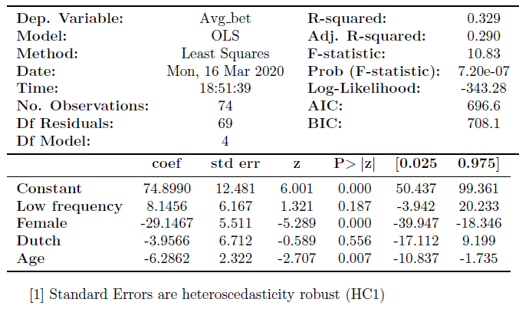

*Figure 2:*

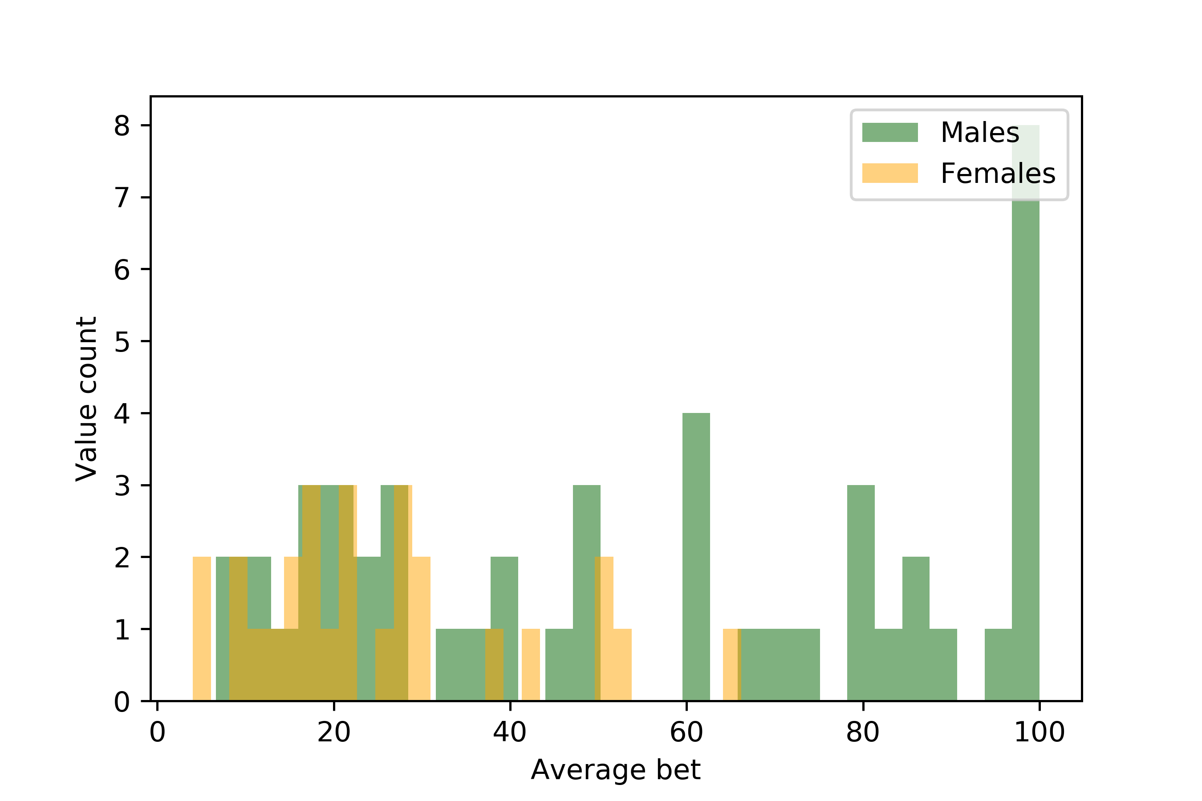

*Figures 3, 4, 5 and 6:*

