|  |  |  |  |
| --- | --- | --- | --- |
|  |  |  |  |
| LuFI_DE_CMYK LUH_Logo_srgb | | |  |
| **Manual**  How to adjust in-situ locations considered in the sea state module |  | *M. Sc.  Lukas Fröhling*  Sep 2024 |  |
|  |  |  |  |
|  | | |  |
|  |  |  |  |

# Table of Contents

[List of Figures II](#_Toc179365788)

[1 Introduction 1](#_Toc179365789)

[2 Set siteConnections via .xlsx 2](#_Toc179365790)

[2.1 How to add a new site? 3](#_Toc179365791)

[2.2 How to remove a site? 5](#_Toc179365792)

[2.3 How to change available sensors at a site? 6](#_Toc179365793)

# List of Figures

[Figure 1 - Scale factors and interpolation lines between in-situ locations 1](#_Toc179365763)

[Figure 2 – Setting site connections via symmetry matrix 2](#_Toc179365764)

[Figure 3 - siteOverview | Add new row 3](#_Toc179365765)

[Figure 4 - siteConnection | Add new site 4](#_Toc179365766)

[Figure 5 - seastateInput | Add site abbreviation to cell string 4](#_Toc179365767)

[Figure 6 - siteConnection | Remove site 5](#_Toc179365768)

[Figure 7 - seastateInput | Remove site abbreviation from cell string 5](#_Toc179365769)

# Introduction

The ***seastate module*** is a MATLAB-Toolbox that provides a real-time overview of the significant wave height in the German Bight based on data from high resolution coastal wave forecast models ([Behrens 2025](https://link.springer.com/article/10.1007/s10236-015-0825-y), [DWD OpenData](https://www.dwd.de/EN/ourservices/opendata/opendata.html)) and quality controlled in-situ measurements ([BSH - Seegang](https://www.bsh.de/DE/DATEN/Klima-und-Meer/Seegang/seegang_node.html)). The information at the in-situ locations is extracted from the grid-based data and the so-called *scaling factor* is calculated as ratio between the numerical and measuring data. The scaling information is interpolated between the in-situ locations on discretized lines, which serve as the basis for creating an interpolation matrix. However, not all locations are connected with each other; individual connections must be deselected manually. For example, a line between FN3 (NNW) and NOR (SSE) would not make sense, as there are several in-situ sites and the island of Heligoland in between (Figure 1).

|  |  |
| --- | --- |
|  |  |

Figure 1 - Scale factors and interpolation lines between in-situ locations

# Set siteConnections via .xlsx

The overview of all existing in-situ locations with information regarding latitude, longitude, water depth and installed sensors can be found here *...\10\_inputFiles\30\_siteOverview\siteOverview.xlsx*. This file is mandatory for the tool execution and must be kept up to date.

The file *siteConnections.xlsx*, which is located in the directory *...\10\_inputFiles\30\_siteOverview*, is used to set the siteConnections. The symmetry matrix shown here (Figure 2) specifies whether an interpolation line should be created between the sites (🡪 **1**) or not (🡪 **0**). Only the top-right half needs to be filled in, the rest is completed automatically. Cells that should not be changed are also password-protected. In case of fundamental changes / adjustments, the protection can be removed with the password *orExclude* (not recommended!).

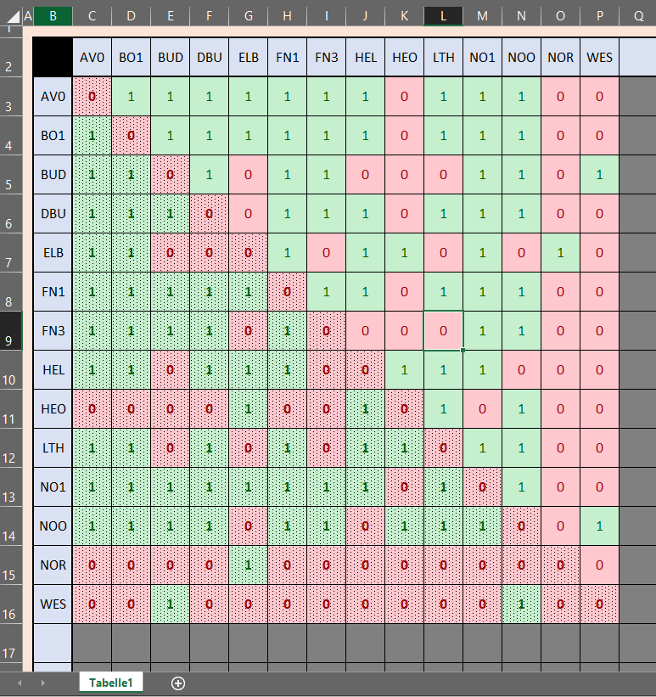

Figure 2 – Setting site connections via symmetry matrix

## How to add a new site?

If you want to add a new in-situ site to be considered in the module, adjustments at three locations are necessary:

* + - * *...\10\_inputFiles\30\_siteOverview\siteOverview.xlsx*
      * *...\10\_inputFiles\30\_siteOverview\siteConnections.xlsx*
      * *...\* *30\_execution\seastateInput.bat*
* Open *siteOverview.xlsx*, choose a suitable abbreviation for the new location (3 digits) and fill the lat, lon, depth and sensor column. Set 1 = true for available sensors and 0 = false for sensors that are not available at this site.

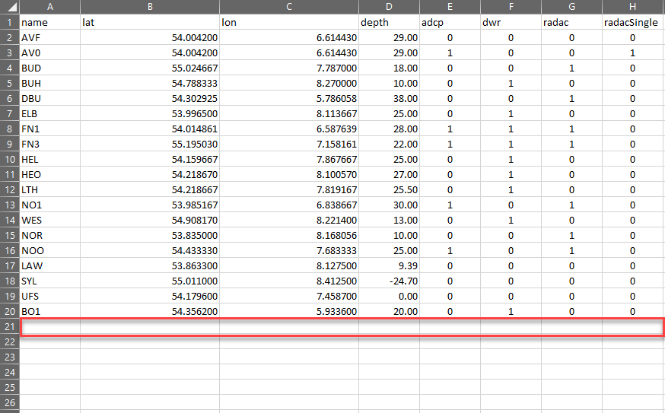

Figure 3 - siteOverview | Add new row

* Open *siteConnections.xlsx*, fill the chosen site abbreviations in first free column (Figure 4 – left), then set the corresponding connections to other sites. Set 1 for creating interpolation lines to this site and 0 for not creating an interpolation line.

|  |  |
| --- | --- |
|  |  |

Figure 4 - siteConnection | Add new site

* Open the batch file *seastateInput.bat* and add your site abbreviation as string to the insitu settings. Currently it’s the parameter *i1* (Dependent on the version of the module, could be another *i\** parameter in future versions).

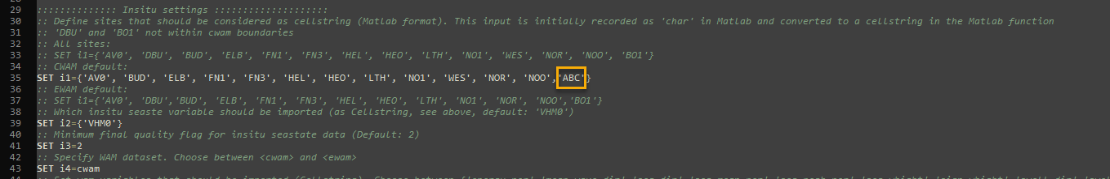

Figure 5 - seastateInput | Add site abbreviation to cell string

## How to remove a site?

If you want to remove an in-situ site from the module, adjustments at two locations are necessary:

* + - * *...\10\_inputFiles\30\_siteOverview\siteConnections.xlsx*
      * *...\* *30\_execution\seastateInput.bat*

It’s optional to also remove the site from the *siteOverview.xlsx* file. If you are sure, that the site will never used again for sensor deployment, you can also remove the corresponding row from this file.

* Open *siteConnections.xlsx* and remove the corresponding site abbreviation in Row 2. The abbreviation and connection values will be removed automatically in the bottom-left part of the matrix (Figure 6 – left). Next, you have to remove the defined sit connections in the top-right part of the matrix manually (Figure 6 – right)

|  |  |
| --- | --- |
|  |  |

Figure 6 - siteConnection | Remove site

* Open the batch file *seastateInput.bat* and remove your site abbreviation from the in-situ parameter *i1* (Dependent on the version of the module, could be another *i\** parameter in future versions).

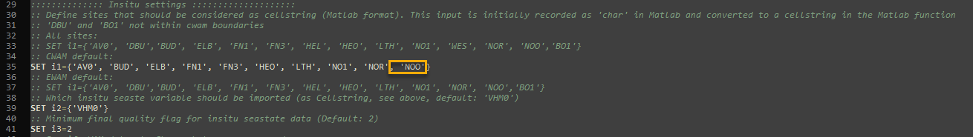

Figure 7 - seastateInput | Remove site abbreviation from cell string

## How to change available sensors at a site?

If the available sensors at a location change (e.g. no dwr available anymore, but a new radac system installed), just change the Boolean values in the corresponding columns in the file *...\10\_inputFiles\30\_siteOverview\siteOverview.xlsx.*