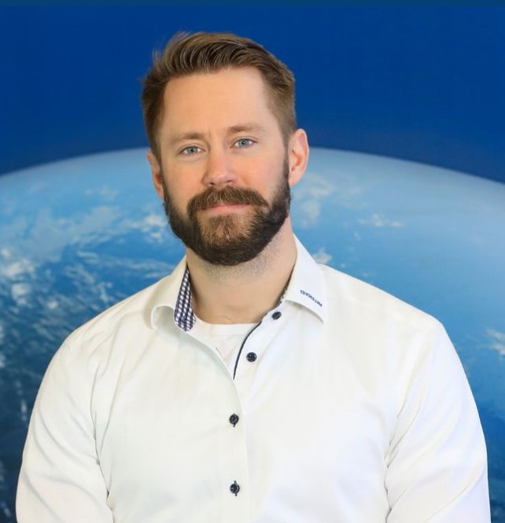

Lukas Larsson
Greater Gothenburg Area | 073-740 97 88 | lukasglarsson88@gmail.com
LinkedIn: https://www.linkedin.com/in/lukas-larsson-062163169

Business Developer & Engineer
Tech-savvy and commercially minded engineer with a strong foundation in technical sales and data-driven decision-making. Humble, collaborative, and strong work ethic.

Core Competencies
- Business Logic & Data Optimization
- Technical Sales & Scalable Service Design
- Contract Negotiation & Quality Management
- Digital Product & GTM Strategy
- Strategic Procurement

Professional Experience
• 🚀 MedTech Startup – Co-founder & Business Development (2025–Present)
- Co-developing SaaS platform to automate MedTech regulatory compliance (MDR/IVDR)
- Translating regulatory needs into product features to reduce client costs & TTM
- Developing GTM strategy for RegTech solution based on market analysis
•🔧 Valeryd AB – Business Development Manager (2023–Present)
- Increasing search visibility and product relevance with a structured data model
- Designing scalable growth concepts for long-term adaptability
- Cutting support workload through process logic
- 🏗️ Hercules Grundläggning – Site Manager (2022–2023)
- Led multi-disciplinary teams & machinery-heavy projects
- Maintained safety, legal compliance & profitability
- 🏠 Svensk Installationspartner / BHG – Product Manager & Business Developer (2017–2021)
- Created the “Installed & Ready” concept across Bygghemma
- Built installer networks, managed contracts & quality tracking
- Developed digital-first installation services across HVAC, solar & electrical
- 🌡️ Polarpumpen – Technical Sales (2014–2017)
- Closed high-volume sales on heat pumps & solar panels
- Excelled in client consultation and product matching
- 🪖 Försvarsmakten – Reconnaissance Marine, cpl (2012–2014)
- Executed strategic surveillance, intelligence gathering, and amphibious warfare.
- Forged leadership, discipline, and adaptability through missions demanding teamwork and tactical awareness.

Education
Yrgo – B.Sc. in Engineering (2020–2022)
Languages
English (Fluent) | Danish (Working Proficiency)

