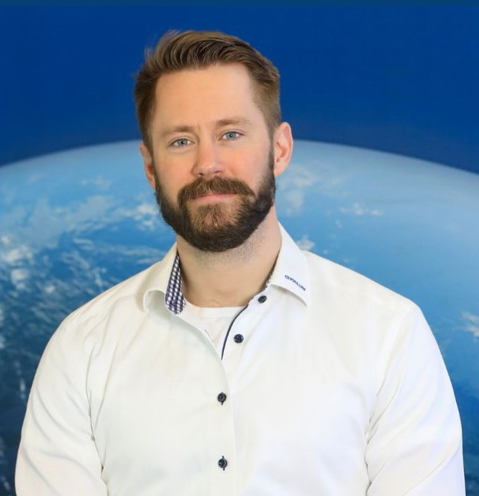

Lukas Larsson
Greater Gothenburg Area | 073-740 97 88 | lukasglarsson88@gmail.com
LinkedIn: https://www.linkedin.com/in/lukas-larsson-062163169
Yrgo – B.Sc. in Engineering (2020–2022)
Armed Forces – Reconnaissance Marine (2012-2014)
Tech stack – SQL & Python, Prompt Engineering, AI Automations
Business Developer & Engineer
Tech-savvy and commercially minded engineer with a strong foundation in technical sales and data-driven decision-making. Humble, collaborative, and strong work ethic. Fintech and AI enthusiast.
Core Competencies
- Quotation & Cost Modeling: Creating correct, competitive, and technically sound quotations, and strong understanding of cost models and economic thinking.
- Technical Sales & Application: Translating complex technical specifications and customer needs into commercially attractive solutions.
- Key Account Team Collaboration: Working closely with Key Account Managers, Project Leaders, and Procurement to secure profitability and deliver cost-effective solutions.
- Process Improvement & Proactivity: Driving continuous improvements in processes (e.g., quotation) and challenging established patterns to improve business and technology.
- Contract Management & Quality Assurance: Experience in managing contracts, quality tracking, and ensuring delivery commitment.
Professional Experience
🚀 MedTech Startup – Co-founder & Business Development (2025–Present)
- Bridged the technical-commercial gap by translating complex regulatory requirements (MDR/IVDR) into defined, marketable product features.
- Developed a Go-To-Market (GTM) strategy informed by detailed market analysis, demonstrating strong commercial foresight and market awareness.
- Focused on improving client Time-to-Market (TTM) and reducing costs, aligning with the need to find cost-effective solutions.
🔧 Valeryd AB – Business Development Manager (2023–Present)
- Applied a data-driven approach to increase search visibility and product relevance using a structured data model (Data Optimization and Business Logic).
- Reduced support workload through process logic, showcasing the drive for process efficiency and improvement.
- Designed scalable growth concepts, demonstrating a forward-leaning, proactive, and innovative approach.
🏗️ Hercules Grundläggning – Site Manager (2022–2023)
- Managed machinery-heavy projects and multi-disciplinary teams, overseeing profitability and ensuring legal/safety compliance.
🏠 Svensk Installationspartner / BHG – Product Manager & Business Developer (2017–2021)
- Developed the "Installed & Ready" concept, creating new commercial offerings and driving a digital-first service strategy (HVAC, solar, electrical).
- Built and managed installer networks, overseeing contracts and quality tracking, demonstrating strong stakeholder management and commitment to quality.
🌡️ Polarpumpen – Technical Sales (2014–2017)
- Excelled in client consultation and technical product matching (heat pumps & solar panels), demonstrating strong customer-facing technical communication.
- Consistently closed high-volume sales, showcasing results-driven performance.

