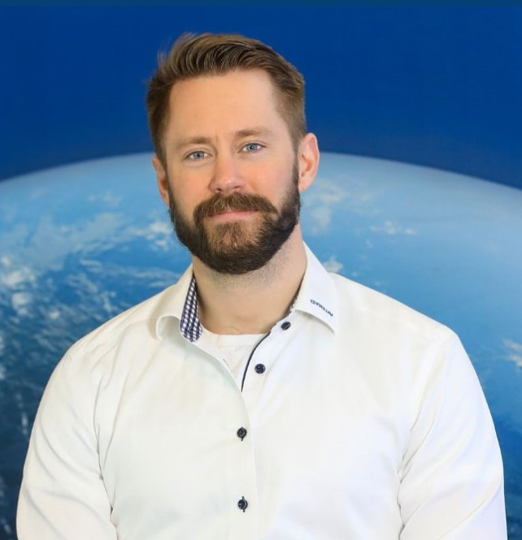

Lukas Larsson
Greater Gothenburg Area | 073-740 97 88 | lukasglarsson88@gmail.com
LinkedIn: https://www.linkedin.com/in/lukas-larsson-062163169
Introduction
Business developer and sales manager with a strong B2B track record in HVAC, ventilation, and technical solutions. Experienced driving the full sales cycle, building partner networks, and growing markets through both hands-on and strategic work.

Core Competencies
- B2B sales & full-cycle account management (HVAC, technical solutions)
- Reseller/partner network development
- Strategic business growth & market expansion
- Senior client relations & negotiation
- Operational execution, remote/hybrid work

Professional Experience
MedTech Startup – Co-founder & Business Development
2025–Present
– Leading go-to-market strategy for SaaS/regulatory product
– Designing sales framework and material for new markets

Valeryd AB – Project Manager & Technical Sales Specialist
2023–Present
– Growing sales and product portfolio for technical components
– Building and developing B2B and partner channels, optimizing sales and executive relationships
– Driving market analysis and key strategic partnerships
Hercules Grundläggning – Site Manager
2022–2023
– Managed complex projects and external client relations in technical environments
– Led multidisciplinary teams and ensured profitability, compliance and delivery
Svensk Installationspartner / BHG – Product Manager & Business Developer
2017–2021
– Rolled out “Installed & Ready” concept nationwide for Bygghemma—managed installer networks and contracts
– Developed and optimized digital installation services for HVAC, solar, and electrical solutions
– Balanced operational, commercial, and strategic business duties
Polarpumpen – Technical Sales
2014–2017
– High-volume B2B and B2C sales in HVAC and technical products
– Hands-on management of the full sales cycle, from needs analysis to closing and aftersales
– Built loyal customer base through consultative sales and service
Swedish Armed Forces – Reconnaissance Marine, Cpl
2012–2014
– Gained leadership, problem-solving, and teamwork skills under pressure

Education
Yrgo – B.Sc. in Engineering (2020–2022)

Languages
Swedish: Native
English: Fluent (oral & written)
Danish: Working proficiency

Other
B driver’s license
Used to frequent travel and remote/hybrid work environments

