# How to get the matplotlib example work in Windows

Here are the steps that finally led to the success of getting the example work.

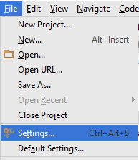

1. Open PyCharm and go to File > Settings

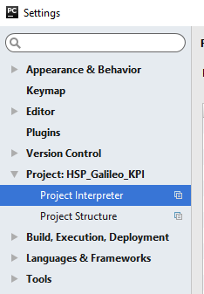

1. Then go to the Project Interpreter under your project

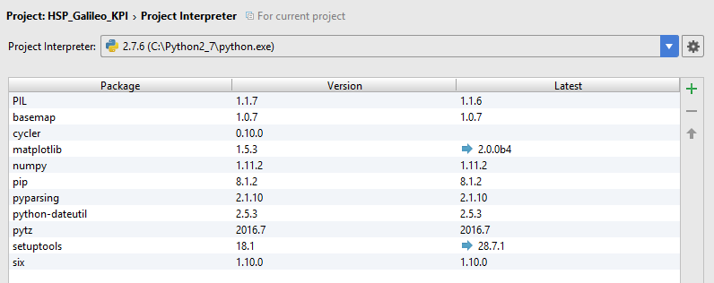

1. You need to install several packages, but first make sure you have updated pip. Then do basemap and only what is needed after that you have to install manually. You can install it via the plus on the right upper corner or you look for a windows installer that fits your python version. In my case it was 2.7.6, so most installers contain 27 in their name. Make sure the python you have installed makes an entry in the registry, that worked for me only with the 2.7.6 windows installer, not the 2.7.0 windows installer.
2. The Python code to test everything (besides three uncommented lines everything like in the online example):

**import** csv  
  
*# Open the earthquake data file.*filename = **'datasets/earthquake_data.csv'***# Create empty lists for the data we are interested in.*lats, lons = [], []  
magnitudes = []  
timestrings = []  
  
*# Read through the entire file, skip the first line,  
# and pull out just the lats and lons.***with** open(filename) **as** f:  
 *# Create a csv reader object.* reader = csv.reader(f)  
  
 *# Ignore the header row.* next(reader)  
  
 *# Store the latitudes and longitudes in the appropriate lists.* **for** row **in** reader:  
 lats.append(float(row[1]))  
 lons.append(float(row[2]))  
 magnitudes.append(float(row[4]))  
 timestrings.append(row[0])  
  
*# --- Build Map ---***from** mpl_toolkits.basemap **import** Basemap  
**import** matplotlib.pyplot **as** plt  
  
**def** get_marker_color(magnitude):  
 *# Returns green for small earthquakes, yellow for moderate  
 # earthquakes, and red for significant earthquakes.* **if** magnitude < 3.0:  
 **return** (**'go'**)  
 **elif** magnitude < 5.0:  
 **return** (**'yo'**)  
 **else**:  
 **return** (**'ro'**)  
  
  
eq_map = Basemap(projection=**'robin'**, resolution=**'l'**, area_thresh=1000.0,  
 lat_0=0, lon_0=-130)  
eq_map.drawcoastlines()  
eq_map.drawcountries()  
*# eq_map.fillcontinents(color = 'gray')  
# eq_map.bluemarble()*eq_map.drawmapboundary()  
*#eq_map.drawmeridians(np.arange(0, 360, 30))  
#eq_map.drawparallels(np.arange(-90, 90, 30))*min_marker_size = 2.25  
**for** lon, lat, mag **in** zip(lons, lats, magnitudes):  
 x, y = eq_map(lon, lat)  
 msize = mag * min_marker_size  
 marker_string = get_marker_color(mag)  
 eq_map.plot(x, y, marker_string, markersize=msize)  
  
title_string = **"Earthquakes of Magnitude 1.0 or Greater\n"**title_string += **"%s through %s"** % (timestrings[-1][:10], timestrings[0][:10])  
plt.title(title_string)  
  
plt.show()