**Play Test**

**Project – BrainFizz**

Lukas Kmitas

C00252129

Headings

**Introduction**

**Explanation for Test**

**Feedback**

**Questionnaire**

**Conclusion**



# Introduction

The goal of this play test is to improve our project by using other peoples collected feedback and then improving on them.

The game is called “BrainFizz” the theme of this game is really weird, so everything inside the game world is supposed to look strange/freaky. It is a 3D first person adventure game.

# Explanation for Test

The purpose of this test was to improve our game and as well know if people even like our game and how we can improve it to make it look awesome sticking to its theme being weird and strange.

I tested people by making a Build of the game and letting them play with no advice from me unless they say something like “where should I go” and I would give a small hint where they should be heading.

There wasn’t any time limit so when they get bored or think they are finished I let them fill out a form in docs google which has 4 general question and 4 for my component (Combat System), there was 8 more questions but they aren’t for my component.

<https://docs.google.com/forms/d/1d6z1J08f6ZaPXwyoxxrdblSETJj8Ec5l89YHDwuszXw/edit>

# Feedback

The feedback was slightly above average, most were a 4/5 overall rating of the game there was some negatives as well for some aspects of the game components going 2/4 average but for overall general of the game and for my component that I’ve made (combat system) was good as well.

**Bugfixes**

The playtest person(s) and we the game dev’s ended up discovering a lot of bugs and other stuff that it was not supposed to happen, we either end up missing or the huge lack of testing the game ourselves after we finish every feature, we just end up moving on to another feature after finishing that current feature, we play it and see if it works it works but we don’t test it to see what happens after a while for example the NPC movement if it collides with another object it ends up rotating and “walks” towards the sky not on the ground, or when I added some particle effects like the fire but if an NPC is in front of it you can still see the fire so that had to be changed. Attacking was a bit weird as well, if an hostile NPC attacks the player if its within 20 meter radius but if you are very close to it, it ends up stop attacking even though the player is clearly within that attack radius.

# Questionnaire

I’ve made a Docs in google after people finished playing the game, they do this questionnaire, there are 4 general questions and 4 questions for my specific goal for the project like the Combat system I was doing, and there were another 2 systems with 4 questions each in the questionnaire.

Four General questions

1. **How would you rate the game overall**  
   - Most answer where above average which was good for the state its was in.
2. **What was the best feature of the game, in your opinion?**  
   - the visual aspect of the game was the best thing mainly for most people, seeing the weirdness of the world, the characters walking around and the environment.
3. **What was the worst feature of the game, in your opinion?**  
   - the ability to roll made a person feel sick and there is nothing to show what the player needs to do when they start the game so they end up wandering anywhere, the quest didn’t have anything to do with the worlds story, it didn’t really bring anything to show the player why this world had this deranged look.
4. **Do you have any suggestions for improving the game?**  
   - Less invincible enemies, higher jumping and when starting the game there needs to be something that tells the player what they need to do, and as well there was absolutely no reason to have the crouching and dodging mechanics made.

Four Questions to do with combat system

1. **How easy was it to understand the combat mechanics in the game?**  
   - The combat was very easy to understand for people so everything was good at that end.
2. **How would you rate the animations overall?**  
   - It was above average 4/5 the animations I made was weird/creepy to fit the theme of the game.
3. **Explain what you like or don't like about the animations**  
   - people loves the animations having wiggly fingers for the hands of the character, and it was smooth and well made, the particle effects were really good, I’ve made Fire, Clouds and water (Ocean) were very well made.
4. **Were the weapons necessary at any time**?  
   - the weapons in the current state were absolutely useless, there isn’t any enemies to fight and somebody even mistook the passive NPC’s (like animals in the world) for enemies which they were supposed to be invincible, they are to make the world more alive, some weird looking creatures just walking around.

**Summary of Docs questions**

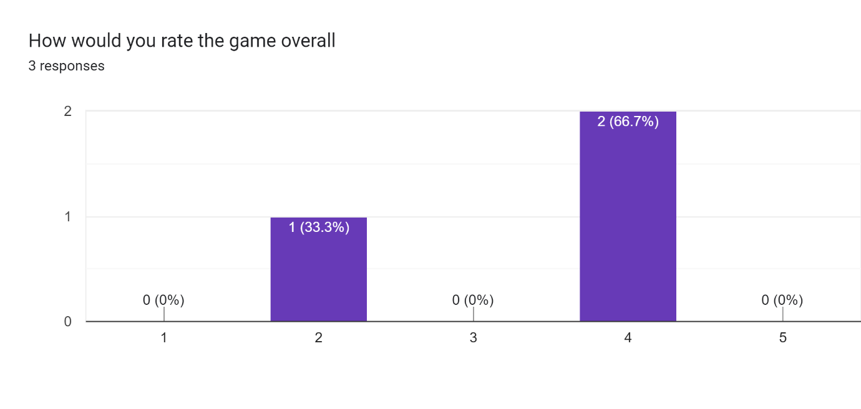

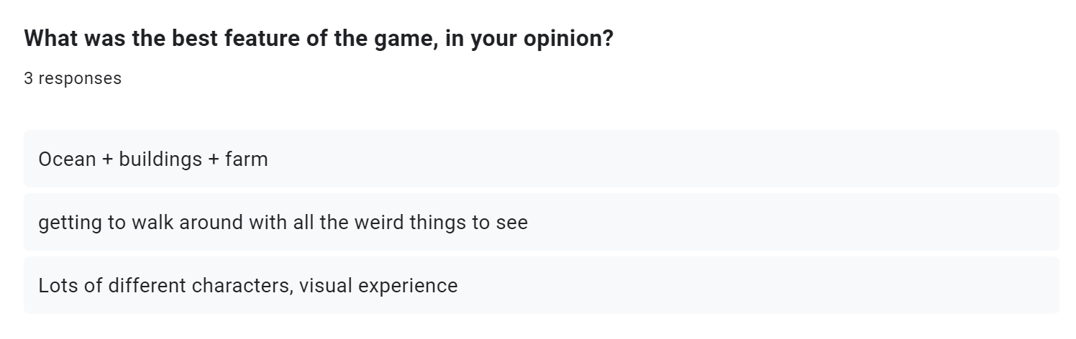

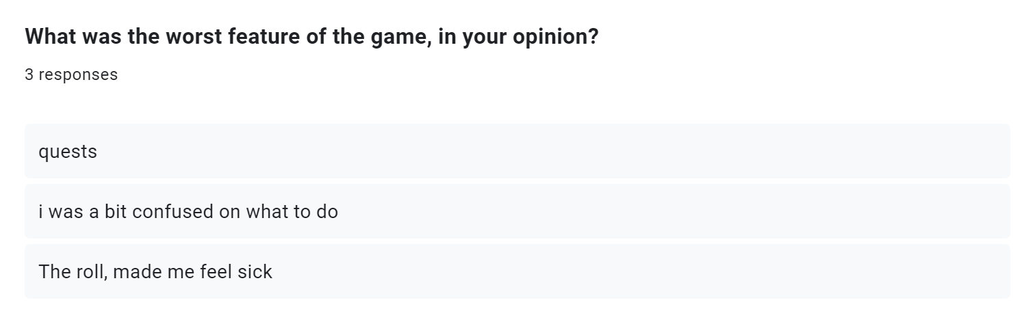

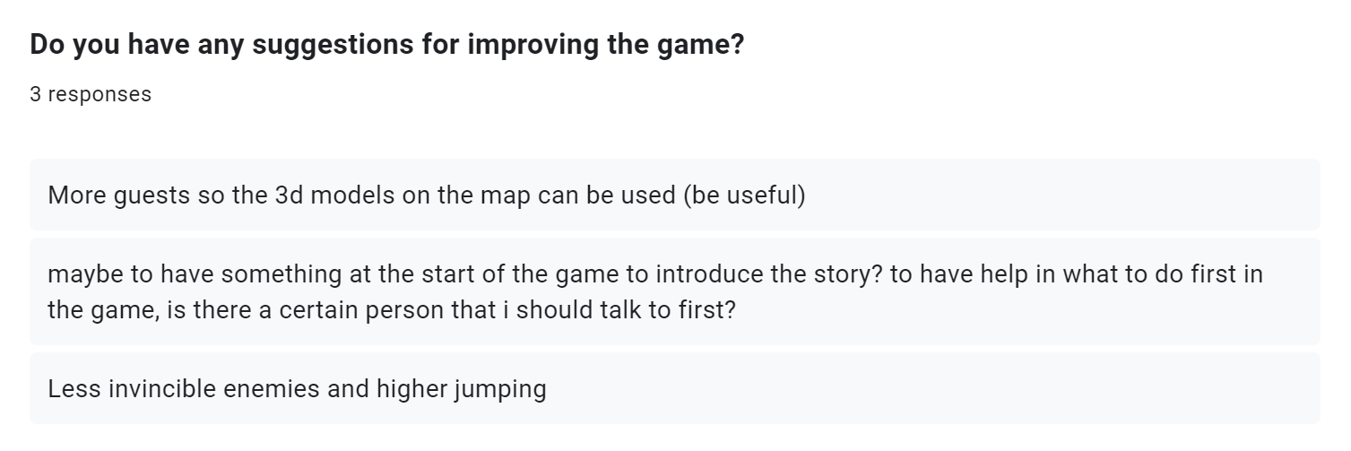

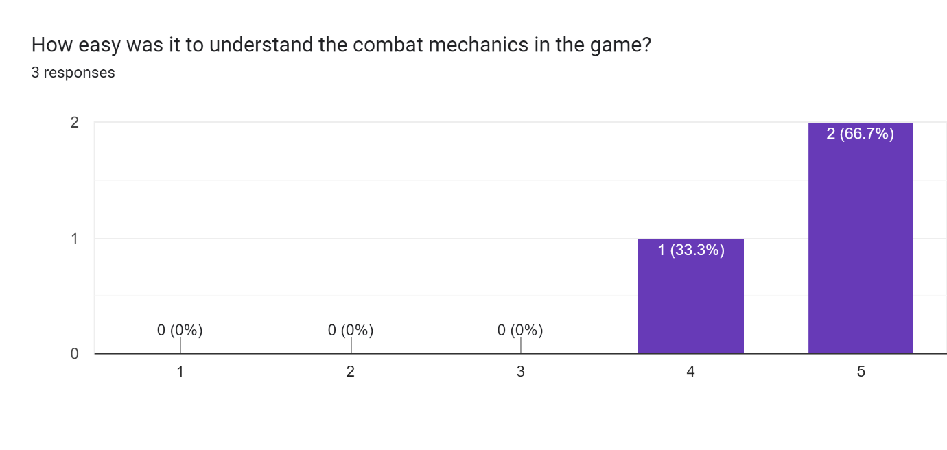

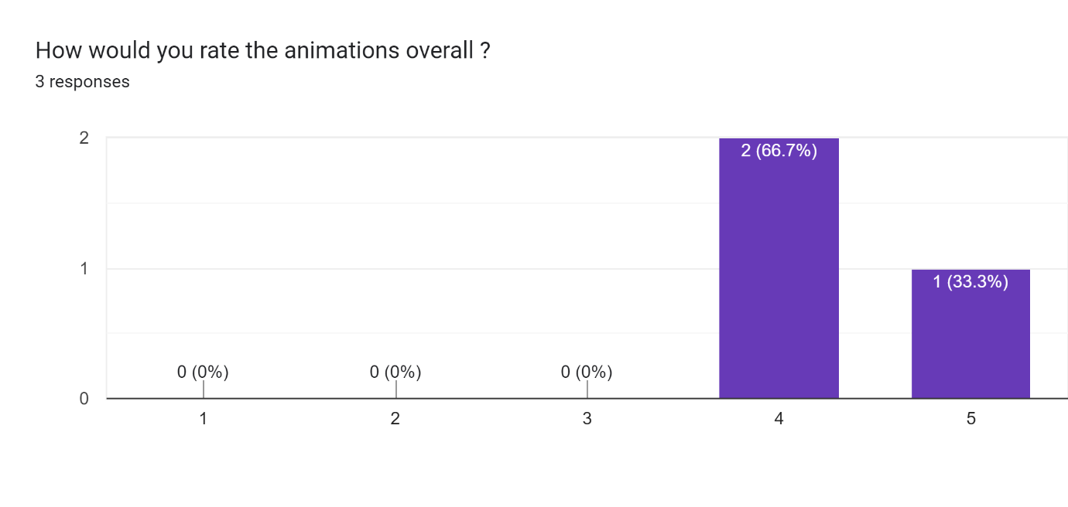

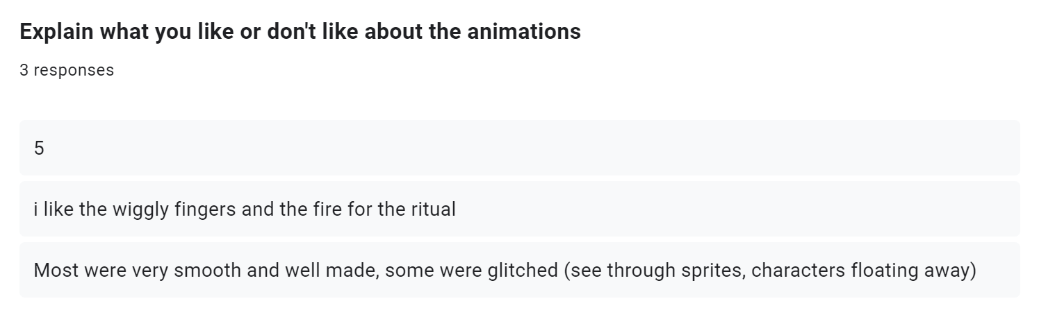

Some responses are like a number that because the questions ended up being changed after some time.

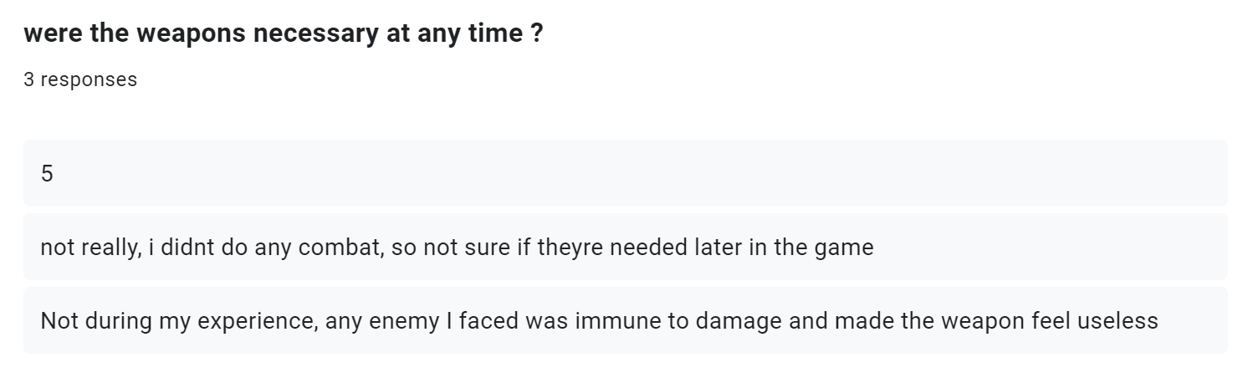

# Conclusion

So, there was a lot of improvements made and some stuff we had found out that wasn’t supposed to happen, we have discovered some bugs from watching others play the game for example the world NPC’s somehow some of them start flying up or going in very strange directions since it is a 2D texture it doesn’t really have a proper 3D body only a collider so when some change directions or maybe rotation when they hit something it no longer goes the directions its suppose to go, they even fall over and start crawling on the ground.

The world NPC’s (creatures) are now killable, since some people mistook them as enemies perhaps of their creepy looking appearance, so for evil players now you can go ahead and kill harmless, innocent baby creatures of the world.

Changes

1. World NPC’s (creatures) are now killable
2. There is an NPC that you can interact with when you start the game (can’t miss it)
3. Player starts on the boat which before it started near the shore.
4. When falling of the map world, you will respawn near the boat.
5. Stats/timing on components not looking fluent or gives unattended effects.
6. Sound was added for walking and background music.
7. The time duration of the flash of enemy’s being hit, it was way too short.