**Lab 5**

Lukas Kmitas

C00252129

**Introduction**

Kubernetes is an open-source platform designed to automate deploying, scaling, and operating application containers. Originally developed by Google, Kubernetes is now maintained by the Cloud Native Computing Foundation (CNCF). It provides a container-centric management environment, orchestrating computing, networking, and storage infrastructure on behalf of user workloads.

Kubernetes provides a powerful platform for deploying and managing containerized applications at scale, offering features for automation, scalability, reliability, and resilience. It has become the de facto standard for container orchestration in the cloud-native ecosystem.

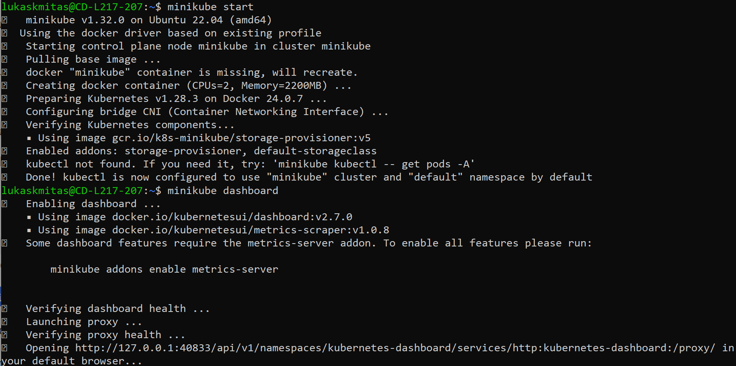

**minikube start** is a command used to launch a local Kubernetes cluster using Minikube. It initializes a virtual machine on your local system and configures Kubernetes components within it, enabling you to develop and test Kubernetes applications locally.

The command **minikube dashboard** is used to open the Kubernetes Dashboard for the Minikube cluster in a web browser. This dashboard provides a graphical user interface (GUI) for interacting with and managing the resources deployed in the local Kubernetes cluster. It offers features such as viewing cluster metrics, exploring deployed applications, and managing Kubernetes objects like pods, services, and deployments.

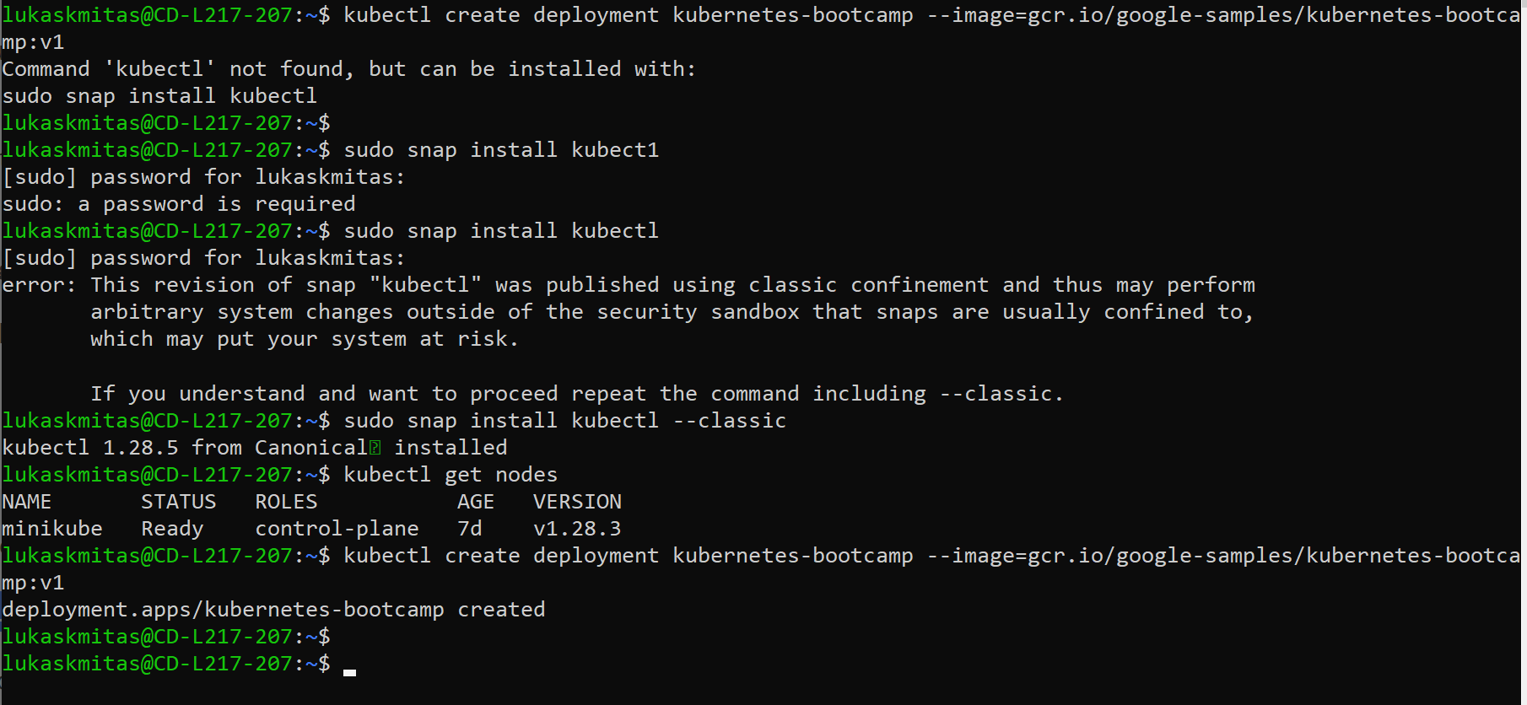

The command **kubectl create deployment kubernetes-bootcamp --image=gcr.io/google-samples/kubernetes-bootcamp:v1** is used to create a new deployment in a Kubernetes cluster.

* **kubectl**: This is the command-line interface for interacting with Kubernetes clusters.
* **create deployment**: This part of the command tells Kubernetes to create a new deployment.
* **kubernetes-bootcamp**: This is the name assigned to the deployment. You can replace it with any desired name for your deployment.
* **--image=gcr.io/google-samples/kubernetes-bootcamp:v1**: This flag specifies the Docker image to use for the deployment. In this case, it's pulling the image **gcr.io/google-samples/kubernetes-bootcamp** with the tag **v1** from the Google Container Registry (gcr.io). You can replace this image with any Docker image you want to deploy.

Overall, this command creates a deployment named **kubernetes-bootcamp** in the Kubernetes cluster, using the specified Docker image.

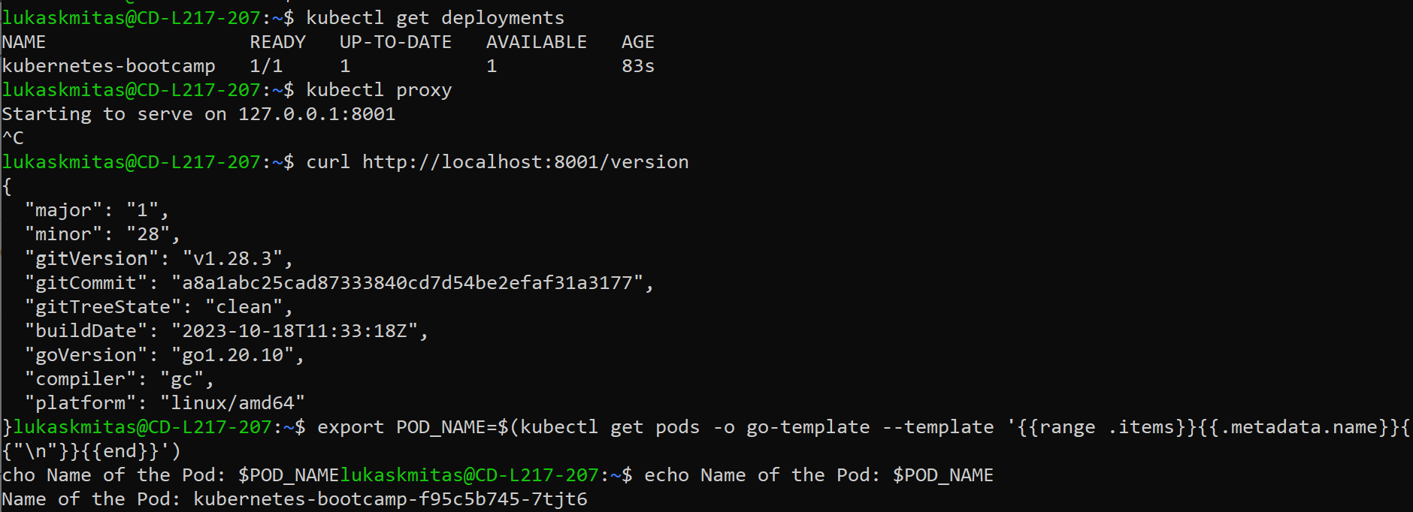

The command **kubectl get deployments** is used to retrieve information about the deployments running in the Kubernetes cluster.

* **kubectl**: The command-line interface for Kubernetes.
* **get deployments**: This part of the command specifies that you want to retrieve information about deployments.

