Student: Lukas Naehrig

Class: Info 330

Date: 5/29/2020

Assignment: 09, Milestone 3

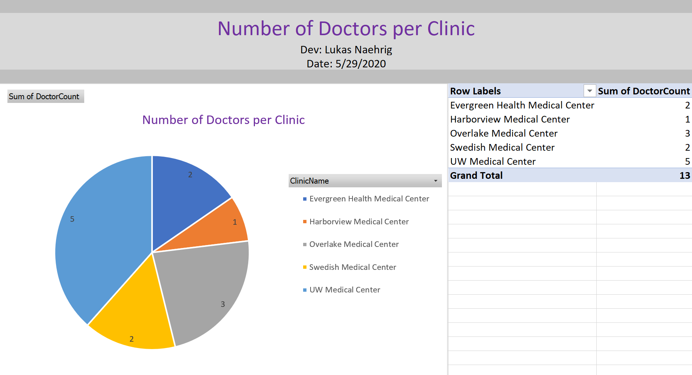Excel Report

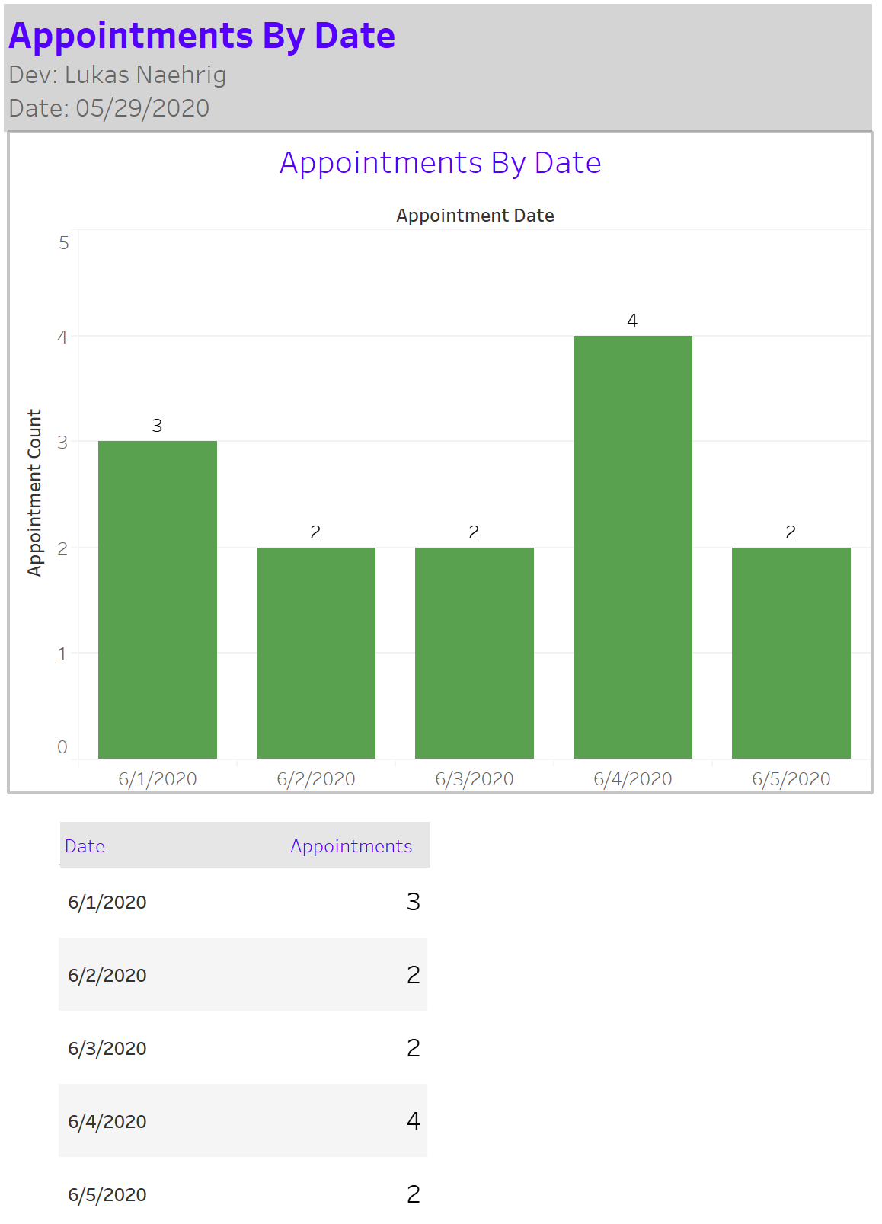Tableau Report