

Basic Functional Spec

Flashcardify

Gen Rincewind

29 July 2018

Table of Contents

Basic Functional Spec 0

Flashcardify 0

Gen Rincewind 0

29 July 2018 0

1. Overview 1

2. Scenarios 1

3. Non-Goals 2

4. Flowchart 2

5. Screen by Screen Spec 4

5.1 Deck Screen 4

5.2 Directory Screen 5

5.3 Settings Screen 6

6. Basic Overview of Actual mechanism by which the App will work. 7

# Overview

Flashcardify is a app meant to convert Chinese ebooks in epub format into Anki flashcard decks. It’s intended for students of the language Mandarin, a popular language in Mainland China i.e. the Only One the Communists allow (there is no Cantonese. Any assertions to the contrary is unpatriotic, comrade. )

**This spec is not, by any stretch of the imagination, complete.** All of the wording will need to be revised several times before it is finalized. The graphics and layout of the screens is shown here merely to illustrate the underlying functionality. The actual look and feel will be developed over time by me in Paint. Jeez I’m *advanced.* No algorithms will be discussed, that’s for later.

# Scenarios

**Joey** is a student of Genetics in college, who wants to learn Mandarin to chat with scientists in Mandarin one day, as well as live in China. He is personally interested in the language and is going through the HSK wordlists between classes, but has run up against the problem that there really isn’t anything to read. He’s already gone through the Mandarin Companion series, but that didn’t take long. He’s an avid user of Anki, and he’s prepared to invest quite a bit of time into Mandarin. Therefore, he downloaded Flashcardify and used it to transform a few simple children’s books into flash cards deck he can study daily, filtering them by HSK level – he wants to study for the tests, and isn’t so stressed about reading books. He uses the decks often.

**Sarah** is a high school student who just wants to show off to her frie nds, who is nerdy and shy, but who everybody thinks is smarter than she is. She has already downloaded a book, but she’s finding it hard to remember the words, and is getting sick of manually inputting the characters into her dictionary app. Therefore she downloaded Flashcardify and used it to transform the book into a flashcard deck. She sorted the cards in the sequence they appear in the book, and studied them for a few days.

# Non-Goals

* No flashcard functionality – too much hassle and too many additional algorithms to be implemented.
* No separate users – too much hassle
* No web syncing

# Flowchart

Connection of screens:

User starts here.

Click “create deck”

Click “create deck” button.

After deck has been created.

Navigate through directories and click on Chinese ebook.

Click on finished deck

AnkiDroid

Deck Screen – Nothing being processed.

Directory Screen

Deck Settings

Deck Screen - Processing

# Screen by Screen Spec

## Deck Screen

This is the screen the app opens on. On this screen you can see all the decks that are processing and have finished processing, and you can tap on the finished decks to open them in AnkiDroid.

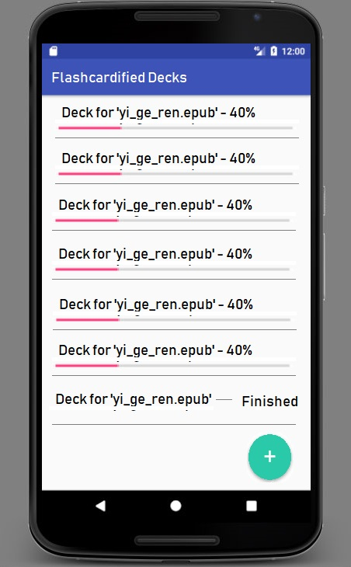

The green button leads to the Directory Structure screen, where the User can navigate to the book they want to convert.

*Open Issue: Will there be a swipe-left menu – to possibly allow users to change the settings easier.*

## Directory Screen

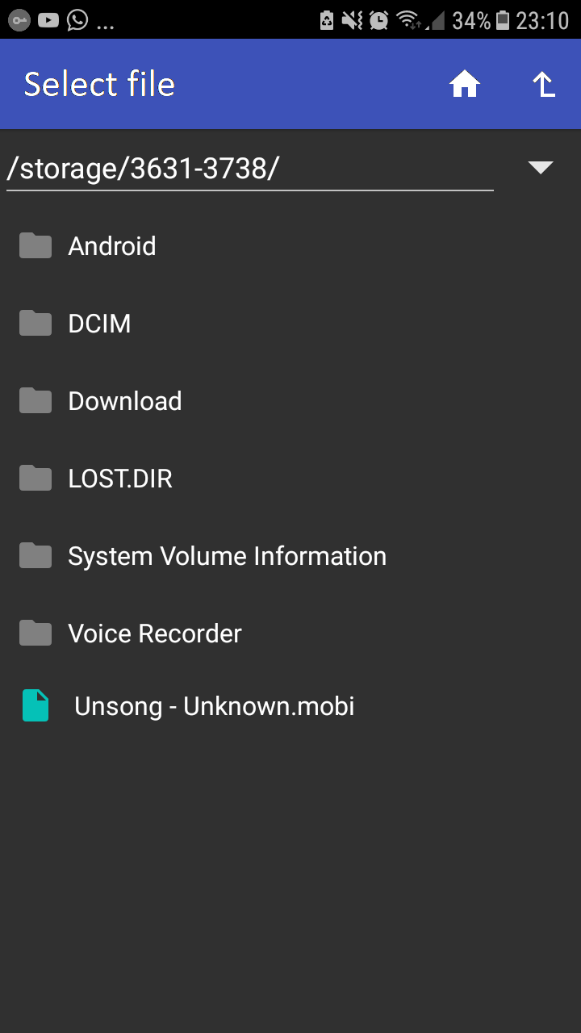

Here the user can navigate directories to select the eBook he wants to convert. The home icon goes back to the Deck Screen and the arrow goes back up a level.

When the user selects a file, it switches to the Settings Screen, where the user can select the options the created deck will have.

## Settings Screen

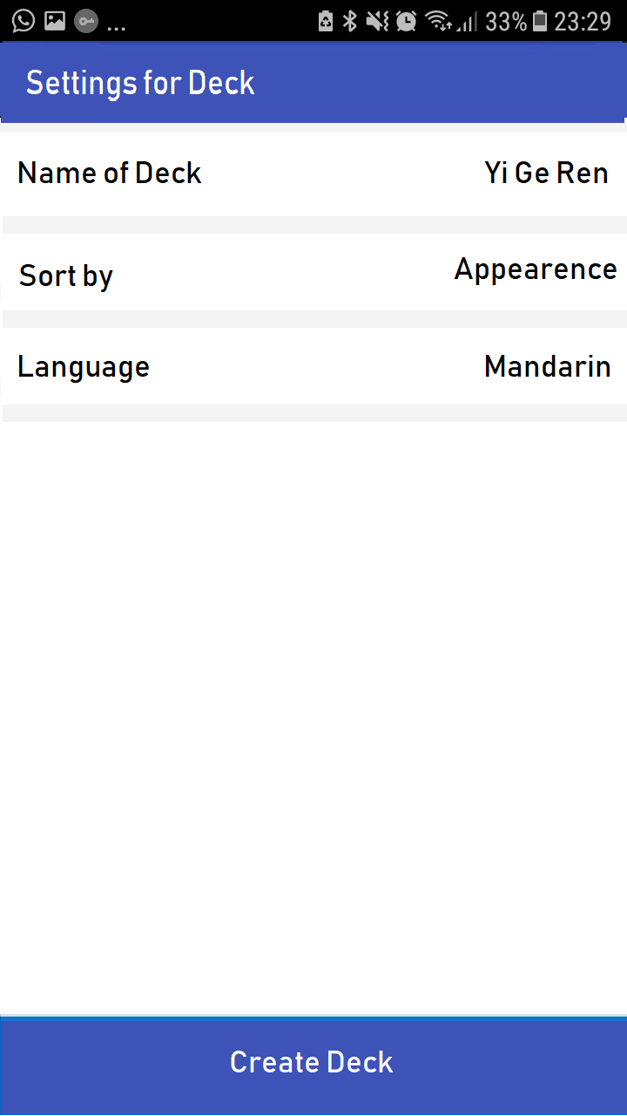

Here the user gets to adjust a few settings before the deck is created.

The settings are:

* Name of deck – what the deck will be called in Anki
* Sort by – two options:
  + Appearance: Cards will be sorted according to the sequence in which the words appear in the book.
  + Frequency: Cards will be sorted by frequency
* Language – what language the ebook is in, currently only Mandarin will be supported, but more languages could be added.

Once the user has selected his settings, he then clicks “Create deck” and is taken to the Deck Screen, and a deck is added to those being processed.

# Basic Overview of Actual mechanism by which the App will work.

The app will use an epub reader to scan in the words from the Chinese ebook, and then the words will be passed to a FSM which will then determine what the words definition is by reference to CEDICT, which will then be passed on to the ANKI deck creator. So about 4 classes will be needed for the purposes of utility.