# Ivan’s Pizzaria

Ivan is a professional drinker that loves to bake ever since his babushka baked him those muffins in 6th grade. After going to the Bakery school of Italy, he would like to open a Pizzaria in Aalborg.

Ivan can’t program but he can describe what he needs.

|  |  |
| --- | --- |
| Ivan doesn’t like: | * Sites that have navigation * Dark colors / and he hates Gray |
| Ivan likes: | * Browsing with his mobile * Single page sites * Popups |
| Ivan needs: | * A way to display his Pizzas (total of 6) * A summary of the order of the customer (all selected Pizzas, their price and total price) – maximum of 6 Pizzas per customer |

Ivan has also provided some drawings:

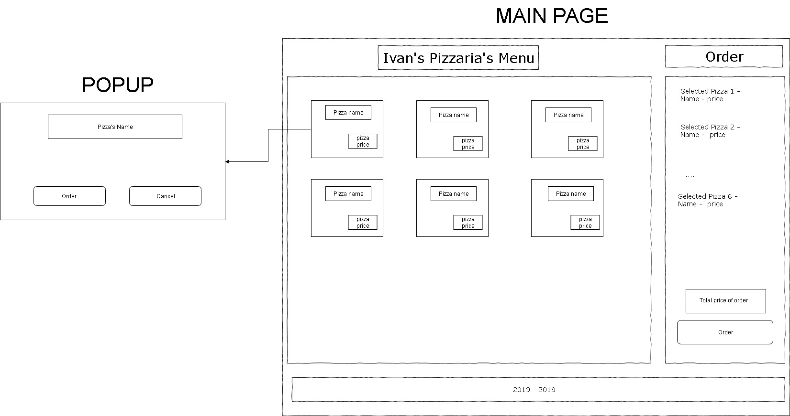

Fig 1. Ivan’s drawing (HQ image is included in the pizzabox.zip he sent)

For implementing this Ivan recommends using **Angular**, because his friends told him it is very hip, however any **other Front-end frameworks (ReactJs/VueJS)** is also OK.

Tips and Tricks:

Ivan asked Thomas, who is a friend of Ivan and a front-end magician, to share some tips and tricks to make your life easier.

Thomas mentions:

* That two very popular libraries for UI components (buttons, boxes or dialogs) are **Material** (Angular Material / React MATERIAL-UI / VueJS Material) and **Bootstrap** (ng-bootstrap/react-bootstrap/bootstrap-vue).
* That for the Layout it’s very popular to use **Flex-box layout** like (@angular/flex-layout) but a lot of people also prefer just **Bootstrap** or for simple and fast prototypes just **Media Queries.**
* That even though it is one page, it seems like there are at least 2 areas, and that they need to communicate somehow.

The assignment is to implement the store. Make a full or partial implementation and send it to ivan@saphe.dk