Loss Visibility versus Spatial Detail in industrial District-Heating Dispatch Optimisation
Lukas Ruess
Alexander Sauer
Abstract
District-heating dispatch models are simplified, yet their decision costs are seldom quantified. This study distinguishes estimation bias, the objective-value difference between formulations, from decision regret, defined as an $L_{1}$-relative forward-valued schedule gap based on each schedule’s cost when re-simulated with a high-fidelity forward model incorporating exponential heat losses, computed-friction hydraulics, and consumer differential-pressure constraints. Both are assessed through a one-phenomenon-at-a-time fidelity ladder from a copperplate model to station-resolved hydraulics. Aggregate losses in the copperplate enable exact separation of loss and topology effects. Results are computed for one real network and 135 factorially designed synthetic networks. The copperplate underestimates operating costs by 15.1% but produces schedules whose unprovisioned loss, valued at the marginal unit, adds 46.1%; loss-aware schedules provision this loss and remain hydraulically deliverable. Loss visibility, not spatial topology, explains the discrepancy. Losses account for 95.8% of the copperplate-to-baseline gap, while topology alone, with physics fixed, adds 0.25%. Across synthetic networks, losses explain a median 100.0% of the gap. The topology effect remains within $±0.6\%$ for trunk lengths of at least $5 km$ and never exceeds 2.4%. Aggregate loss adders may conceal the deficiency in one network but do not transfer across scenarios. Forward evaluation of all 174 transmission stations and service laterals using real component data adds less than 1% to the fixed schedule and finds no hydraulic violation. Spatial routing is immaterial under central generation; distributed generation remains open. Results assume fixed capacities, a fixed heating curve, and radial networks.
[orcid=0009-0005-5010-3520]
District heating ,Mixed-integer linear programming ,Model fidelity , Decision regret ,Thermal losses ,Network aggregation , Heat pump optimisation

Nomenclature
Physical effects and evaluation quantities
Symbol | Code | Status | Description
$CP$​ | T0P0 | optimised | Copperplate, no loss (decomposition control)
$CP+L$​ | T0P1 | optimised | Copperplate $+$ exogenous aggregate loss (control)
$ZN$​ | T1P1 | optimised | Zone-aggregated $+$ loss (aggregation sensitivity, Section 3.4)
$ND^{0}$​ | T2P0 | optimised | Node-resolved, no loss (topology control)
$L1$​ | T2P1 | optimised | Node-resolved $+$ trunk loss (comparison baseline)
$L2$​ | T2P2 | fwd.-eval. | $+$ temperature propagation (free-variable form degenerate)
$L3$​ | T2P3 | optimised | $+$ trunk pressure drop and pumping
$L4$​ | T2P4 | fwd.-eval. | $+$ station resolution and service laterals
$L5$​ | T2P5 | fwd.-eval. | $+$ flow-dependent station pressure drop
$L6$​ | T2P6 | optimised | $+$ transport delay
$NL$​ |  | reference | Nonlinear forward evaluator and bounded 72-hour re-solve; not a ladder rung
$b_{ℓ}$​ |  |  | Estimation bias of level $ℓ$ (optimised cost difference)
$r_{ℓ}$​ |  |  | Decision regret of level $ℓ$ (forward-evaluated difference)
$λ$​ |  |  | Loss number, annual loss / annual demand
$b$​ |  |  | Loss burden, $=λ/(1+λ)$
$L_{t}$​ |  |  | Exogenous aggregate loss supplied to $CP+L$
$κ$​ |  |  | Loss switch in the nodal balance, $\{0,1\}$
2
Sets and indices
Time steps ($|T|=8760$)
Network nodes
Pipe segments
Thermal generators
Heat pumps
Thermal storage units
Electrode boilers (power-to-heat)
PWL segment index
Subset of CHP generators
Pipes entering/leaving node $n$
Generators/heat pumps/electrode boilers/storage at node $n$
Validation time steps
Parameters
Supply/return pipe heat-transfer coefficient [W m$​^{−1}$ K$​^{−1}$]
Pipe length [m]
Pipe inner diameter [m]
Pipe cross-sectional area [m$​^{2}$]
Pipe hydraulic resistance [Pa MW$​^{−2}$]
Darcy friction factor
Fluid density [kg m$​^{−3}$]
Specific heat capacity of water [J (kg K)$​^{−1}$]
Transport delay [s] (Eq. [eq:delay_time]; $k_{p}=⌊τ_{p}/Δt⌋$ with $Δt=3600$ s)
Delay in time steps
Temperature decay factor, $∈(0,1]$
Nominal decay factor
Nominal supply temperature [$​^{∘}$C]
Nominal return temperature [$​^{∘}$C]
Nominal operating temperature [$​^{∘}$C]
Ground temperature [$​^{∘}$C]
Installed thermal capacities [MW]
Rated pipe capacity [MW]
Heat-pump minimum load fraction
Generator thermal efficiency
Storage charge/discharge efficiency
Pump efficiency
Lorenz cycle efficiency
Storage standing-loss fraction per hour
Waste-heat COP, time-varying
Default-source COP, constant
PWL segment slope and intercept (chord of $R_{p}Q^{2}$)
Heat-pump pinch-point temperature difference [K]
Electricity buy/sell price [EUR MWh$​^{−1}$]
Specific fuel cost [EUR MWh$​^{−1}$]
Heat-curtailment penalty [EUR MWh$​^{−1}$]
Carbon price [EUR t$​^{−1}$]
Demand-charge rate [EUR MW$​^{−1}$]
Storage-cycling cost [EUR MWh$​^{−1}$]
Grid emission factor [kg MWh$​^{−1}$]
Fuel emission intensity [kg MWh$​^{−1}$]
Annual scaling factor
Grid capacity, Big-M [MW]
Time-step length [h], $=1$
Number of PWL segments
Demand heterogeneity index (Appendix 9)
Cost terms
Electricity procurement net of feed-in revenue
Fuel expenditure
Heat-curtailment penalty
Carbon cost
Demand charge on peak import
Storage-cycling penalty
Solver objective
Economic operating cost (reported basis)
Variables
Generator thermal output [MW]
Heat-pump thermal output [MW]
Heat-pump waste-heat/default output [MW]
Electrode-boiler output [MW]
Pipe heat flow [MW]
Pipe thermal loss [MW]
Storage charge/discharge rate [MW]
Nodal heat demand [MW]
Curtailed heat at node $n$ [MW]
Grid import/export [MW]
CHP electrical output [MW]
Heat-pump electrical input [MW]
Electrode-boiler electrical input [MW]
Network pumping power [MW]
Annual peak grid import [MW]
Pipe pressure drop [Pa]
Pipe mass-flow rate [kg s$​^{−1}$]
Node supply temperature [$​^{∘}$C]
Pipe outlet temperature [$​^{∘}$C]
Storage state of charge [MWh]
Fuel input, heating-value basis [MW]
Grid CO$​_{2}$ emissions [kg]
Fuel CO$​_{2}$ emissions [kg]
Bilinear auxiliary, $=Q_{p,t}^{2}$ [MW$​^{2}$]
Heat-pump on/off, binary
Grid import mode, binary
Binary PWL segment selector, $\{0,1\}$ ($Q_{p,t,k}$ the flow on segment $k$ [MW])

Introduction
District-heating networks serving industrial demand are central to European decarbonisation, integrating heat pumps, combined heat and power and thermal storage in multi-source systems , and their operational optimisation relies increasingly on mathematical programming . District heating already meets a substantial share of building heat demand in mature markets and remains integral to clean-energy-system designs . Large heat pumps in particular are becoming central to its decarbonisation , which raises the economic stakes of the operational models that schedule them. How much of the network such a model represents is a design choice, and it is made along two axes: the spatial resolution at which the network appears, from a single-bus copperplate to a pipe-by-pipe graph; and the physical phenomena admitted, from a lossless energy balance to a model with pressure-coupled hydraulics, temperature propagation and transport delay.
The two extremes are well populated. Copperplate models aggregate all components and demands onto a single bus, ignoring spatial structure and thermal losses entirely, a limitation their authors acknowledge: note that “the validity of the global energy balance assumption depends on the network topology, size and the operation strategy”, without quantifying the resulting error. Full thermo-hydraulic models resolve the network pipe by pipe and capture the thermal losses that amount to 5–15 % of annual heat supply , along with pressure-dependent pumping, temperature propagation and the delays that follow from finite fluid velocity. A third complication sits across both axes: extended physics introduces nonlinear and bilinear terms incompatible with standard mixed-integer linear programming, forcing a choice between linearisation, which preserves tractability at the cost of approximation error, and native nonlinear formulations, which preserve the physics at the cost of solve time.
The working assumption in practice is that finer spatial resolution and richer physics both buy proportionate accuracy, and that the computational cost is therefore justified in proportion. No quantitative evidence establishes that proportionality, or identifies which axis delivers the return. The closest evidence comes from a neighbouring field: in electricity systems, coarse spatial resolution causes capacity-expansion models to miss intra-regional congestion and understate system cost, and the spatial aggregation choice dominates other modelling simplifications in scenario comparisons . A parallel power-systems analysis shows spatial and temporal resolution trading off against one another under a fixed computational budget , the same class of resolution-versus-physics trade this paper prices for district heating. It is natural to expect the analogue in district heating, and that expectation is worth stating precisely because this paper finds it holds only in part. Once the losses are supplied by other means, the spatial structure itself contributes little to dispatch cost, at least where all generation is co-located at a single source; whether that holds under distributed generation is left as a controlled open question. The distinction is invisible to any comparison that changes both at once, which is the first of the two limitations this study addresses.
Two features of the existing fidelity literature limit what its comparisons can conclude. First, the comparisons are confounded: moving from a copperplate or a zone-aggregated model to a node-resolved one changes the spatial representation of the network and the representation of thermal losses together, so a resulting cost difference cannot be attributed to either: the very objection that a coarse model “misses losses” is indistinguishable from “misses topology”. Second, and more fundamentally, fidelity is judged by the wrong quantity. Studies report how far the objective value of a simplified formulation departs from a detailed one, which measures the models against each other; but a planning or scheduling model is used to make a decision, and what matters is the cost of having decided with the simpler model and then operated the network. A formulation can misstate the objective yet produce a schedule that executes well, or state the objective plausibly yet schedule poorly; objective-difference comparisons cannot tell these apart. This paper addresses both: a control condition that separates loss from topology, and a decision-regret metric that separates estimation error from decision quality.

Literature review and research gap
Two strands of the district-heating literature bear on this paper: how finely a dispatch model resolves the network, and how finely it resolves the network’s physics. Neither strand has been evaluated by the quantity that matters for a scheduling model: the cost of the decisions it produces.
Reviews of district-heating modelling and optimisation document a broad methodological spectrum . Mixed-integer linear programming dominates operational district-heating optimisation , and the general-purpose frameworks in which such studies are built (oemof , PyPSA , FINE , Calliope , urbs ) are typically applied with aggregated or component-based thermal networks: losses time-invariant or absent, no hydraulic coupling, topology fixed at one level of detail, at what this paper calls the copperplate level $CP$; detailed thermo-hydraulic coupling requires additional formulations. The cost of that simplification is not quantified.
Between the copperplate and the full graph lies a continuous spectrum of spatial aggregation. compare aggregation methods on a 23-substation network and show that pipe count can be reduced by roughly an order of magnitude before production and return-temperature errors become significant; carry the approach to dynamic simulation of several thousand substations. Both establish which aggregations preserve simulation fidelity, and neither quantifies the resulting bias in dispatch-optimisation cost. The same emphasis persists in the most recent work: formalise an aggregation method with an explicit measure of the error it induces in large-scale multi-energy simulation, and show how spatial resolution shapes the outcome of regional heat-network planning. Both confirm that aggregation error is resolution-dependent, yet both judge simulated or planned quantities rather than the bias a coarse network imparts to the operational dispatch decision, and neither isolates thermal loss from spatial topology. Zone-based models aggregate demand into a handful of geographic clusters , while full-graph models resolve the network node by node from GIS data , an approach demonstrated in detailed dynamic-simulation libraries . apply full-graph optimisation to a real multi-source network, again to operate it rather than to price the cost of aggregating it. Single-node representations remain standard in national-scale analysis , and likewise reduce the thermal network of a distributed multi-energy system to a single aggregate efficiency. Bidirectional, low-temperature fifth-generation designs add flow-direction choices beyond the radial networks considered here.
Where the spectrum has been traversed, the comparison has typically confounded topology with losses: moving from a lumped to a resolved network introduces pipe losses at the same time as spatial structure, so a reported cost difference cannot be attributed to either. This confound is structural rather than incidental: the objection that a coarse model “misses losses” is empirically indistinguishable from “misses topology”. Recent full-graph studies do not resolve it, because they do not vary resolution at all: embed full-graph network expansion in an energy-hub MILP with temporally resolved heat-pump performance, formulate a full-graph design MILP with storage and conclude that temporal rather than spatial resolution dominates design quality, and treat expansion planning of existing full-graph networks under resilience constraints. Each resolves the network fully throughout, so the aggregated comparison studied here lies outside their scope. Closest to the decision-oriented view taken here, trace how the fidelity of the network model propagates into operational efficiency; but they too assess the simulated operation of a single model rather than the regret of executing a lower-fidelity schedule under a higher-fidelity one, and do not separate loss visibility from spatial topology.
Beyond topology, pipe models differ substantially in thermo-hydraulic fidelity. Steady-state thermal losses follow from the fluid–ground temperature difference and the pipe insulation, and are MILP-compatible whenever temperatures enter as fixed parameters . Pressure drop is not: the Darcy–Weisbach relation is quadratic in flow velocity and pumping power adds a cubic term, handled in the literature either by piecewise linearisation or by second-order cone relaxation ; integrate Darcy–Weisbach pressure drop with explicit pump placement in a general thermal network flow framework. instead pose the joint network configuration and design as a mixed-integer nonlinear program. Reported pumping costs span 1–5 % of thermal energy cost . This paper returns to that range, since the network studied here falls two orders of magnitude below it for reasons that are physical rather than numerical. Temperature propagation along a pipe introduces exponential and bilinear terms , validated by against industrial data to a supply-temperature mean absolute error below 0.5 K, and transport delays of one to three hours arise in long pipes . Equation-based Modelica libraries capture this thermo-hydraulic coupling for dynamic simulation . Across dispatch formulations, methods span linear, mixed-integer and nonlinear programming ; MIQCP occupies a middle ground in which quadratic constraints are handled natively while integer variables retain unit-commitment logic. demonstrate the approach for design and dispatch with multiple heat pumps at the scale of tens of consumers, but report no reference comparison isolating the cost of the piecewise-linear approximation against the native quadratic formulation. The magnitude of that linearisation error in a district-heating dispatch setting has not been published.
Two features of this literature limit what its comparisons can conclude, and both are visible in Table 1. The first is the confound above: no prior study separates the effect of representing thermal losses from the effect of representing spatial structure, so the two are never independently priced. The second is more fundamental. Fidelity is judged by comparing objective values across formulations, which measures the models against one another; but a scheduling model is used to make a decision, and what matters is the cost of having decided with the simpler model and then operated the network. A formulation can misstate its objective yet produce a schedule that executes well, or state its objective plausibly yet schedule badly, and an objective-difference comparison cannot distinguish the two. The closest prior work approaches this without closing it: report for the Verona network that simplifying thermal behaviour in a dispatch optimisation underestimates operational cost relative to a model-predictive controller using a detailed network model, and confirm the direction with a mixed-integer nonlinear MPC on a Belgian network, but neither separates topology from thermo-hydraulic fidelity nor expresses the gap as a function of observable network properties. vary the level of detail across 24 MILP formulations of a multi-energy system and identify which simplifications are cost-relevant, the controlled-comparison logic this paper adopts, but their complexity axis spans technology and part-load representation rather than network topology and thermo-hydraulics, and the building-scale system they study does not resolve pipe-by-pipe structure. review complexity management for energy-system optimisation more broadly and observe that, while temporal aggregation is well studied, spatial aggregation “has only a small community” and lacks systematic guidance.
A separate literature quantifies the dispatch value of the generation technologies studied here while leaving the network lumped. The operational role of thermal storage in these systems is surveyed by . formulate hourly annual unit commitment for German CHP plants retrofitted with heat pumps and thermal storage (methodologically close to the dispatch model used here, but representing the network as a single aggregated demand node), and optimise an industrial power-to-heat system with an accurate nonlinear component model and no network representation at all. show for the Danish market that deterministic dispatch systematically overestimates the economic value of heat-pump and electric-boiler flexibility relative to stochastic formulations. Large heat pumps are increasingly deployed in Swedish district-heating systems . Power-to-heat conversion more broadly couples the heat and electricity sectors . propose a flexibility assessment framework for district heating and cooling that incorporates network-side constraints alongside generation-side flexibility, though the published case studies do not yet vary spatial resolution as an experimental factor. None of this work treats network representation as a factor, so the interaction between topology and technology value remains open.
This paper addresses both gaps directly: a control condition that separates loss visibility from spatial resolution, and a decision-regret metric that separates estimation error from decision quality. The second is not a new idea in optimisation: it is analogous to the value of the stochastic solution , transposed from the uncertainty axis to the resolution axis. The value of the stochastic solution itself extends to multistage decision problems . The analogy is structural rather than exact: the forward valuation is an overlay under a common high-fidelity model, so, unlike the classical value of the stochastic solution, it need not be sign-definite (a loss-blind schedule can forward-evaluate as cheaper on a mispriced term). The claimed contribution lies in the transposition and the empirical finding rather than in the concept itself.
Positioning against prior model-fidelity and network-aggregation studies. No prior study isolates the loss effect from the topology effect, and none evaluates fidelity by the cost of the resulting decisions rather than by objective values. This study closes both gaps.
Study
fidelity
loss/topology
decisions
Wirtz et al. , 24 MILP variants, multi-energy |  | $×$​ | $×$​
Kotzur et al. , complexity-management review |  | $×$​ | $×$​
Larsen , Falay , network aggregation |  | $×$​ | $×$​
van der Heijde et al. , district-heating physics model | $×$​ | $×$​ | $×$​
Hering et al. , district-heating MIQCP dispatch | $×$​ | $×$​ | $×$​
This study

Contributions and research questions
The individual formulations compared here are established, and comparative fidelity studies already exist: Wirtz et al. compared MILP variants of a multi-energy system, Larsen and Falay studied network aggregation, and Kotzur et al. reviewed complexity management. The contribution lies not in the formulations themselves but in the experimental structure and the quantity evaluated, and it rests on two pillars. The first is a decision-oriented evaluation of fidelity. Each model’s dispatch schedule is re-costed under a common high-fidelity forward model to quantify decision regret and tested for physical deliverability. This evaluation is paired with a control condition, a copperplate supplied with the aggregate loss it cannot itself compute, that turns the comparison into an exact loss/topology decomposition. Together, these show that loss visibility, not spatial routing, sets the fidelity requirement; that a model can be both a biased estimator and an inadequate controller, with its estimation bias and signed forward-cost deviation pointing in opposite directions; and that a per-network loss adder that makes a copperplate appear sufficient does not transfer across networks or operating regimes, making the resolved model the transferable one. The regret idea is positioned as analogous to the value of the stochastic solution , transposed from the uncertainty axis to the resolution axis; the contribution is the transfer and the empirical finding, not the concept itself. The second pillar establishes where the fidelity threshold lies by pushing physical detail to its limit: resolving the demand side to all 174 individual transmission stations and their service laterals using real component data, with the resulting model cross-checked against a nonlinear pipe-flow solver, changes dispatch cost by less than one percent and produces essentially no change in decisions. This null result at maximal fidelity directly addresses the hydraulic-validation concern. Two further findings are reported as secondary: the spatial-routing effect is null under central generation and remains a controlled open question for distributed generation; and an a priori estimator of bias from observable network properties predicts held-out synthetic networks without refitting. The paper is organised around four research questions: the loss/topology decomposition, decision regret and deliverability, the transferability of a lumped-loss correction, and the location of the hydraulic threshold, with the two secondary questions addressed alongside.
The remainder of the paper is organised as follows. Section 2 sets out the experimental design (the fidelity ladder, the decomposition controls and the contrasts each isolates), then the two case studies, the formulations, the forward evaluator, the cost basis, the validation protocol and the computational setup. Section 3 reports and discusses the results in the order of the research questions, beginning with what the measurements can and cannot validate and ending with the limitations of the study. Section 4 concludes.

Experimental design and methodology

Experimental design: fidelity ladder and decomposition controls
This study compares a family of formulations that differ from one another in exactly one modelled phenomenon at a time, so that each pairwise contrast isolates a single effect and no comparison is confounded. The family has two parts. Four decomposition controls form a $2×2$ factorial of spatial topology against thermal loss: a copperplate with no loss ($CP$), the copperplate supplied with the aggregate loss ($CP+L$), the node-resolved network with no loss ($ND^{0}$), and the node-resolved network with trunk loss ($L1$), which is also the comparison baseline. A monotone fidelity ladder then adds, one at a time, on the same node-resolved network: temperature propagation ($L2$), trunk pressure and pumping ($L3$), station resolution with service laterals ($L4$), a dynamic flow-dependent station pressure requirement ($L5$), and transport delay ($L6$), with the fully nonlinear formulation ($NL$) as a reference that is not solved globally (evaluated forward and on bounded 72-hour re-solves). Table 2 states what each arrow isolates. Two design principles hold. First, within the four decomposition controls, each contrast changes exactly one phenomenon, so its cost difference is attributable to that phenomenon. The extended-physics levels ($L2$ to $L6$, $NL$) form a physics-evaluation framework rather than an exact one-factor-at-a-time solved ladder. Where a step also changes the representation or evaluation mode, as $L2$, $L4$, $L5$, and $NL$ do, this is stated explicitly. Second, the 174 transmission stations are present at every level; only their spatial aggregation changes, from all lumped at one point through node and zone aggregation to individually resolved, so the taxonomy is consistent across the whole family. The four controls satisfy an exact additive identity, $\text{cost}(L1)−\text{cost}(CP)=\text{loss}+\text{topology}+\text{interaction}$, where the loss main effect is $\text{cost}(CP+L)−\text{cost}(CP)$, the topology main effect is $\text{cost}(ND^{0})−\text{cost}(CP)$, and the interaction is the residual; it is an identity, not an approximation, and closes to machine precision when the four models are solved to a 0.01 % optimality gap. Two reference roles must be kept distinct. The baseline $L1$ is the detailed mixed-integer model a practitioner would actually build; every estimation-bias percentage is normalised to it. The physics reference, against which regret and physical feasibility are judged, is the forward evaluator of Section 2.4, not any solved level: even the finest solved level linearises the temperature-decay factor, so using it as ground truth would carry the same linearisation into the reference. Model-to-model differences are therefore estimation bias; only the forward evaluation speaks to decision quality.
The experimental contrasts. Within the four decomposition controls (topology $×$ loss) each arrow changes exactly one phenomenon, so those comparisons are unconfounded; the remaining steps form an extended-physics evaluation framework in which a step may change more than one thing (evaluation mode, laterals, pressure, delay), noted where it occurs.
Contrast | Isolates
$CP​→​CP+L$​ | loss visibility (no topology)
$CP​→​ND^{0}$​ | spatial topology (no loss)
$L1$ vs $CP+L,ND^{0}$ | loss $×$ topology interaction
$L1​→​L2$​ | temperature propagation
$L2​→​L3$​ | trunk pressure drop & pumping
$L3​→​L4$​ | station resolution + service laterals
$L4​→​L5$​ | dynamic (flow-dependent) station $Δp$
$L5​→​L6​→​NL$​ | transport delay; linearisation error
Where the contrasts in Table 2 name what each step changes, Table 3 gives the complete picture: every fidelity level against every phenomenon. In that grid marks a represented phenomenon and a dash its absence; A an aggregated form and exo an exogenous input; PWL, Bil and Quad a piecewise-linear, native-bilinear or native-quadratic treatment; and flat or dyn the static or flow-dependent station pressure requirement. The four decomposition controls stand to the left of the monotone $L1$ through $L6$ ladder, with the nonlinear reference $NL$ closing it on the right. The four decomposition controls, together with $L3$ and $L6$, are solved as mixed-integer linear programs to a $0.01$ % gap; the non-convex levels ($L2$, $L4$, $L5$, $NL$) are quantified with the validated forward model rather than solved. One further formulation sits outside both parts of the family. The zone-aggregated level $ZN$ resolves demand into geographic clusters rather than junctions and computes trunk loss on the aggregated graph; it is not a decomposition control, since it occupies no corner of the $2×2$, and not a ladder rung, since the ladder is defined on the node-resolved network. It is used solely to test whether the choice of zone boundary is a hidden degree of freedom in the decomposition (Section 3.4), and is reported there rather than among the bias and regret results.
Model scope grid: which phenomenon each fidelity level represents, and in what form: fwd = forward-evaluated (not in the solved dispatch), A = aggregated station, PWL/Bil/Quad the linearisation form. The solved levels $L1$, $L3$, $L6$ fix node temperatures (the free-variable form is degenerate), so $L6=L3+$ transport delay and does not inherit the station-resolved rows; temperature propagation and the station levels ($L2$, $L4$, $L5$) are forward-evaluated. The four decomposition controls ($CP$, $CP+L$, $ND^{0}$, $L1$) are separated from the zone-aggregated variant $ZN$, used only for the aggregation-sensitivity study of Section [subsec:zoneclustering].
Phenomenon | $CP$​ | $CP+L$​ | $ZN$​ | $ND^{0}$​ | $L1$​ | $L2$​ | $L3$​ | $L4$​ | $L5$​ | $L6$​ | $NL$​
Demand aggregation | 1pt | 1pt | zones | nodes | nodes | nodes | nodes | stat. | stat. | nodes | stat.
Station representation | A | A | A | A | A | A | A |  |  | A
Trunk losses ($U​LΔT$, defensible $U$) | – | exo |  | –
Service-lateral losses | – | – | – | – | – | – | – |  |  | –
Temperature propagation | – | – | – | – | – | fwd | – | fwd | fwd | – | Bil
Time-varying COP
Storage losses & $η$
Trunk pressure drop (DW) | – | – | – | – | – | – | PWL | PWL | PWL | PWL | Quad
Trunk pumping power | – | – | – | – | – | –
Station $Δp$ requirement | – | – | – | – | – | – | – | flat | dyn. | – | dyn.
Station & lateral pumping | – | – | – | – | – | – | – |  |  | –
Transport delay | – | – | – | – | – | – | – | – | –
Hourly grid emission factors

Base formulation
All levels share the objective function and component models set out below. They differ only in two places (the topology of the energy balance and the treatment of thermal losses), and it is precisely because these two enter as separable terms that the decomposition of Section 3 is exact rather than fitted.

Objective function.
The optimiser minimises total annual operating cost: electricity procurement net of feed-in revenue, fuel, heat-curtailment penalties, carbon charges, a demand charge on peak grid import, and a thermal-storage cycling penalty,
$$min Z=C^{en}+C^{fuel}+C^{dump}+C^{CO_{2}}+C^{dem}+C^{cyc}.$$
Network pumping does not appear as a separate cost term. The pump electrical power $P_{t}^{pump}$ enters the electricity balance, Eq. [eq:balance_el], and is therefore paid for through grid procurement inside $C^{en}$; it is identically zero at every level below $L3$ and is computed from Eq. [eq:pump_power] from $L3$ upward (Section 2.6). With $Δt=1$ h and $t$ indexing all 8 760 hours of the year,
Cen&=Δtt​Ptbuyλtbuy−Ptsellλtsell,&Cfuel&=Δtg,t​Fg,t λgfuel,Cdump&=Δtn,t​Qn,tdump λdump,&Cdem&=λdemfyrPpeak,CCO2&=λCO21000t​EtCO2,grid+g​Eg,tCO2,fuel,&Ccyc&=λcyc Δts,t​Qs,tch+Qs,tdis.
Here $P_{t}^{buy}$ and $P_{t}^{sell}$ [MW] are grid import and export at time $t$ and $λ_{t}^{buy}$, $λ_{t}^{sell}$ [EUR/MWh] the corresponding prices; $F_{g,t}$ [MW] is the fuel input to generator $g$ on a heating-value basis at specific cost $λ_{g}^{fuel}$; $Q_{n,t}^{dump}$ [MW] is heat curtailed at node $n$, penalised at $λ^{dump}$; $λ^{CO_{2}}$ [EUR/t] is the carbon price; $f^{yr}$ an annualisation factor; $P^{peak}$ [MW] the annual peak grid import entering the demand charge $λ^{dem}$; and $λ^{cyc}$ [EUR/MWh] the storage-cycling cost, applied to the combined charge-and-discharge throughput $Q_{s,t}^{ch}+Q_{s,t}^{dis}$ of each storage $s$.
Two elements of $Z$ depart from operator cash flow: the carbon charge $C^{CO_{2}}$ enters on a gross basis, and the cycling penalty $C^{cyc}$ is a wear-and-arbitrage deterrent rather than a cash outlay. The reported economic cost applies the standard cogeneration self-use carbon credit and excludes $C^{cyc}$, so it differs systematically from $Z$; the economic cost is used for every reported comparison. The distinction and its magnitude are set out in Section 2.5.

Energy balance, and how the controls are constructed.
The copperplate levels $CP$ and $CP+L$ enforce a single bus-level balance over all generators, heat pumps, electrode boilers and storage, with no spatial routing:
g​Qg,tth+h​Qh,t+r​Qr,t+s​Qs,tdis=Qtdem+Qtdump+s​Qs,tch+Lt⏟CP+L only ∀ t,
where $Q_{g,t}^{th}$ [MW] is the thermal output of generator $g$, $Q_{h,t}$ and $Q_{r,t}$ [MW] the heat-pump and electrode-boiler thermal outputs, $Q_{s,t}^{dis}$ and $Q_{s,t}^{ch}$ [MW] the discharge and charge of storage $s$, and $Q_{t}^{dem}$ [MW] the total network demand. The term $L_{t}$ is the exogenous aggregate loss supplied to the control condition $CP+L$ and is zero for $CP$; its calibration is given in Section 2.3.
All node-resolved levels ($ZN$, $ND^{0}$ and $L1$ through $L6$) instead enforce a nodal balance at each junction $n$, accounting for thermal losses along incoming pipes and for the spatial distribution of assets and demands:
$$\begin{align}
&\sum_{p \in \mathcal{P}_n^{\mathrm{in}}}
\bigl(Q_{p,t} - \kappa\, Q_{p,t}^{\mathrm{loss,pipe}}\bigr)
+ \sum_{g \in \mathcal{G}_n} Q_{g,t}^{\mathrm{th}}
+ \sum_{h \in \mathcal{H}_n} Q_{h,t}
+ \sum_{r \in \mathcal{R}_n} Q_{r,t}
+ \sum_{s \in \mathcal{S}_n} Q_{s,t}^{\mathrm{dis}} \notag \\
&= Q_{n,t}^{\mathrm{dem}} + Q_{n,t}^{\mathrm{dump}}
+ \sum_{s \in \mathcal{S}_n} Q_{s,t}^{\mathrm{ch}}
+ \sum_{p \in \mathcal{P}_n^{\mathrm{out}}} Q_{p,t}
\;\; \forall\, n,\, t,
\label{eq:balance_nodal}
\end{align}$$
with $P_{n}^{in}$, $P_{n}^{out}$ the pipes entering and leaving node $n$, $Q_{p,t}$ [MW] the heat flow in pipe $p$, and $Q_{p,t}^{loss,pipe}$ [MW] its thermal loss.
The switch $κ∈\{0,1\}$ is the point of the design. Equations [eq:balance_cp] and [eq:balance_nodal] differ in two respects at once (spatial resolution and loss visibility), and prior fidelity comparisons have moved both together, which is why their cost differences cannot be attributed to either. Setting the two independently generates the four corners of a $2×2$ design: $CP$ is [eq:balance_cp] with $L_{t}=0$ (neither), $CP+L$ is [eq:balance_cp] with $L_{t}$ supplied (loss, no topology), $ND^{0}$ is [eq:balance_nodal] with $κ=0$ (topology, no loss), and $L1$ is [eq:balance_nodal] with $κ=1$ (both). The cost gap $CP→L1$ therefore decomposes additively into a loss main effect, a topology main effect and their interaction, with no residual by construction. This is the control condition the confound requires, and it is the reason the decomposition in Section 3.2 closes to machine precision rather than to a fitted tolerance.
The global electricity balance and grid mutual-exclusivity constraints close the system. All electrical generators, power-to-heat units $r$, heat pumps and pumps balance against grid import, export and in-network consumption:
$$\begin{align}
P_t^{\mathrm{buy}}
&+ \sum_{g \in \mathcal{G}^{\mathrm{CHP}}} P_{g,t}^{\mathrm{el}}
= \sum_{h \in \mathcal{H}} P_{h,t}^{\mathrm{el}}
+ \sum_{r \in \mathcal{R}} P_{r,t}^{\mathrm{el}} \notag \\
&+ P_t^{\mathrm{pump}} + P_t^{\mathrm{sell}}
\quad \forall\, t,
\label{eq:balance_el} \\[4pt]
P_t^{\mathrm{buy}} &\leq M^{\mathrm{grid}}\, z_t,
\;\;
P_t^{\mathrm{sell}} \leq M^{\mathrm{grid}}\, (1 - z_t)
\;\; \forall\, t,
\label{eq:grid_bigm}
\end{align}$$
where $P_{g,t}^{el}$ [MW] is CHP electrical output, $P_{h,t}^{el}$ the heat-pump electrical input, $P_{r,t}^{el}$ the electrode-boiler input and $P_{t}^{pump}$ the network pumping power. The binary $z_{t}∈\{0,1\}$ enforces that the grid connection either imports or exports in any hour, with $M^{grid}$ a Big-M set to the grid capacity.

Thermal loss model.
For each pipe $p$, steady-state conductive losses are computed separately for the supply and return circuit. Because the supply temperature follows the heating curve rather than being optimised, the losses are fixed parameters, the simplification that keeps the formulation linear:
$$\begin{aligned}Q_{p,t}^{loss,sup}&=\frac{U_{p}^{s} L_{p} \left(T_{sup}^{nom}(t)−T_{ground}(t)\right)}{{10}^{6}}, \\ Q_{p,t}^{loss,ret}&=\frac{U_{p}^{r} L_{p} \left(T_{ret}^{nom}(t)−T_{ground}(t)\right)}{{10}^{6}},\end{aligned}$$
with $U_{p}^{s}$, $U_{p}^{r}$ [W/(m K)] the linear heat-transfer coefficients of the supply and return pipe, set by diameter and insulation class, $L_{p}$ [m] the length, $T_{sup}^{nom}$, $T_{ret}^{nom}$ [°C] the nominal temperatures prescribed by the heating curve and $T_{ground}$ [°C] the ground temperature; ${10}^{6}$ converts W to MW. Losses are identically zero for $CP$ and $ND^{0}$, enter exogenously as $L_{t}$ for $CP+L$, and are computed by [eq:loss_supply] and [eq:loss_return] for $ZN$ and $L1$ upward.
Two points about the calibration matter for what follows. First, the $U$ values are constrained to a defensible range for the pipe class rather than fitted freely: forcing the trunk-only loss to match the total inferred from the delivered-energy record by inflating terminal-pipe coefficients cannot be attributed to insulation ageing. Second, what such a multiplier would absorb is the last mile, the service laterals and substations a trunk-only model does not represent, and it is therefore placed where it physically belongs, entering only at the station-resolved level $L4$. The node-resolved levels consequently undercount the network loss by construction, and the modelled total matches the measured delivered energy to about one percent only once the laterals are added (Section 3.1); the network loss this implies is model-derived, not independently metered. This is a result rather than a defect: a quantitative statement of what a trunk-resolved model cannot see.

Heat pump.
Each heat pump $h$ either recovers industrial waste heat at a time-varying source temperature or falls back on a low-temperature source at constant performance, the thermal output being the sum of the two contributions:
$$\begin{aligned}Q_{h,t}&=Q_{h,t}^{WHR}+Q_{h,t}^{def}, \\ P_{h,t}^{el}&=\frac{Q_{h,t}^{WHR}}{{COP}_{h,t}^{WHR}}+\frac{Q_{h,t}^{def}}{{COP}_{h}^{def}}.\end{aligned}$$
The waste-heat coefficient of performance ${COP}_{h,t}^{WHR}$ is pre-computed from an analytical Lorenz-cycle model (Appendix 6.1), which avoids bilinear terms in the optimisation. That pre-computation is a deliberate scope restriction rather than an approximation of convenience, and it is revisited in the limitations: a model with endogenous COP would give the heat pump more room to respond to the network state than it has here.
Operation is bounded by a minimum load fraction $ϕ_{h}^{min}$ and the installed capacity ${\overset{‾}{Q}}_{h}$, switched by the on/off binary $u_{h,t}∈\{0,1\}$:
$$ϕ_{h}^{min} {\overset{‾}{Q}}_{h} u_{h,t}≤Q_{h,t}≤{\overset{‾}{Q}}_{h} u_{h,t} ∀ h, t,$$
so that the unit is either off or above its minimum load, preventing uneconomic part-load cycling.

Thermal storage.
The state of charge $E_{s,t}$ [MWh] of storage unit $s$ follows a discrete-time balance with self-discharge and separate charging and discharging efficiencies:
$$E_{s,t}=(1−α_{s})^{Δt/1 h} E_{s,t−1}+η_{s}^{ch} Q_{s,t}^{ch} Δt−\frac{Q_{s,t}^{dis} Δt}{η_{s}^{dis}}.$$
The coefficient $α_{s}$, the fractional standing loss per hour, represents losses of the vessel, and the exponential form makes the discretisation independent of the time step. A cyclic condition $E_{s,|T|}=E_{s,0}$ enforces energy-neutral operation over the year, preventing artificial depletion or accumulation.

Remaining assets and emissions.
Gas boiler, biomass boiler, electrode boiler and CHP follow standard linear formulations, capacity-bounded with constant efficiency, detailed in Appendix 6.2. Grid and fuel emissions are the product of energy consumed and the corresponding emission intensity,
$$E_{t}^{CO_{2},grid}=P_{t}^{buy} e_{t}^{grid} Δt, E_{g,t}^{CO_{2},fuel}=F_{g,t} e_{g}^{fuel} Δt,$$
with $e_{t}^{grid}$ [kg/MWh] the hourly marginal grid emission factor and $e_{g}^{fuel}$ [kg/MWh] the fuel-specific intensity. Both are fixed inputs: the optimiser is carbon-aware but does not optimise the emission factor itself.

Copperplate with aggregate losses
The control condition $CP+L$ is the copperplate supplied with the aggregate network loss it cannot itself compute, so that the loss/topology decomposition is exact. The loss enters exogenously, by inflating the single-node demand series; the formulation stays a linear program with the same variable count as the copperplate, and no network is added. Two calibrations of the adder are used. The first is a constant adder $L_{a}=E_{\text{loss}}/8760$, which spreads the annual network loss evenly over the year; the second is a heating-curve adder
Lb(t)=p​Up ℓpTsup(t)−Tg+p​Upr ℓpTret(t)−Tg,
which tracks the seasonal supply and return temperatures. The sums run over pipes $p$ with length $ℓ_{p}$ and supply and return heat-loss coefficients $U_{p}$ and $U_{p}^{r}$, respectively. Both are frozen before the copperplate is solved, so the copperplate never sees the reference model’s dispatch, only its aggregate loss; the two calibrations bracket the effect of the temporal loss profile and, as reported below, give the same bias and regret to within a few tenths of a percentage point. The adder is deliberately the network’s own realised loss: this is what makes $CP+L$ a best case for the lumped-loss shortcut, and the finding that even this best case does not transfer across networks (Section 3.9) is therefore conservative.

Forward evaluator and decision regret
The evaluator is a forward simulator, not an optimisation model: it takes a fixed dispatch schedule (the generation, storage and temperature trajectory a level produced) and computes the forward-evaluated (policy-dependent) cost of executing it under high-fidelity physics, reporting any physical constraint the schedule violates. Because it never optimises it has no tractability limit and contains no piecewise linearisation anywhere. Heat transport along each pipe uses the native exponential temperature decay $T_{\text{out}}=T_{\text{g}}+(T_{\text{in}}−T_{\text{g}})exp(−UL/\dot{m}c_{p})$ on both the supply and the return circuit; hydraulics use Darcy–Weisbach with a computed (Swamee–Jain) friction factor on supply and return, plus the differential-pressure requirement at the critical consumer’s substation. This is strictly a higher-fidelity reference than the finest solved level, whose temperature-decay factor is still piecewise linear, the caveat that made a solved level an unsound “ground truth” in the original submission. Cost is accounted with the model’s own conventions (energy purchase less sales, fuel, CO$​_{2}$, dump and demand charge), so that a schedule executed under the physics it was optimised for reproduces its own economic cost to within the pump and residual-loss terms the physics adds; regret then measures physics, not an accounting mismatch. Schedules from the copperplate and zone levels, which carry no node-resolved dispatch, are disaggregated to the network by the per-node demand share (with an equal-share alternative reported as a robustness check); this rule is part of the method and stated as such. Under this common evaluation, for each level $ℓ$ relative to the comparison baseline, estimation bias is defined as the difference in optimised economic cost and decision regret as the difference between the forward-evaluated costs of the two schedules. The hours and energy associated with any velocity, differential-pressure, or unmet-demand violations are also reported. This regret is a forward valuation of each schedule under the common high-fidelity model, measured against the baseline schedule’s forward-evaluated cost, not against the (uncomputed) high-fidelity optimum: it reports what a level’s own schedule is worth, valued forward, relative to the baseline, not the distance to the best schedule the finer physics would admit. It is accordingly a valuation overlay rather than a constrained recourse cost: the loss shortfall is priced at the marginal unit, not re-dispatched under commitment and ramp constraints. The evaluator is itself validated: it reproduces the baseline schedule’s economic cost as a self-consistency check, its forward losses match the model’s exported network loss to about two percent (the exponential lying slightly below the linear approximation, as expected), and its trunk pressures agree with an independent nonlinear pipe-flow solver to better than $0.007$ bar.

Fixed schedule, recomputed state, and shortfall valuation.
The mapping $M_{ℓ}$ transfers a level’s decision vector to the evaluator while holding all first stage dispatch decisions fixed exactly as produced. These decisions include generation set points, generator and heat pump commitment, storage charging and discharging, grid imports and exports, and dumped heat. The evaluator then recomputes the physical state using the high fidelity model, including network flows, node temperatures, pumping power, pipe losses, and the resulting storage state of charge. Storage bounds and the cyclic condition are checked using this recomputed state. Recomputed pumping power is priced at the electricity tariff and added to the reported cost without adjusting the fixed grid import. If recomputed native losses are lower than scheduled losses, the surplus receives no value and no additional dumping is introduced. The resulting forward cost therefore values the fixed schedule without representing a cheaper redispatch. A shortfall can remain only when the source model does not provision the full network losses. This study does not permit redispatch to cover such a shortfall. Instead, three shortfall valuation policies are applied as cost overlays rather than execution simulations (Table [tab:regret]). The marginal policy prices each MWh of shortfall at the cost of the marginal heat unit. The peak policy uses the cost of the most expensive unit dispatched during that hour. The unmet policy charges the shortfall as unserved energy. Because these policies are valuation overlays rather than executable recourse, they do not impose commitment, capacity, ramping, grid, or CHP coupling constraints. Any electricity or fuel required for a physical top up is represented only through the applicable cost per MWh and is not rebalanced within the dispatch. No other adjustment is permitted. The schedule cannot exploit the finer physics through redispatch, storage operation is not reoptimised, and any residual unmet demand is represented by penalised slack and reported in the violation columns. By fixing decisions, recomputing physical states, and applying valuation only, this procedure measures schedule quality rather than the outcome of reoptimisation.

Cost accounting: economic cost versus the solver objective
Every bias and regret figure in this paper is reported on the economic operating cost, not on the raw solver objective, and the two differ systematically. On Memmingen the objective exceeds the economic cost by $38.7$–$41.0$ % depending on the level (Table S1, Supplementary Material). Because that difference is large enough to change the apparent size of every comparison, this section states what it is and why the economic cost is the right quantity.
Two mechanisms account for it, and neither is a distortion of the dispatch. First, carbon enters the objective on a gross basis (every tonne from fuel combustion and grid import priced at the carbon price), whereas the reported cost applies the standard cogeneration self-use allocation, crediting back the emissions of combined-heat-and-power electricity that is exported rather than self-consumed. This is the avoided-emissions convention conventional in district-heating studies, and on this network it amounts to $55$–$58$ kEUR. Second, the objective carries a thermal-storage cycling penalty of $2$ EUR per MWh of throughput, worth $24$–$26$ kEUR, which shapes the solution away from physically implausible rapid cycling but corresponds to no operator cash flow. Together these reproduce the residual to within about $1.5$ kEUR per run, under one percent of the objective.
The economic cost is reported because it represents what an operator pays and is the primary operator-cost basis for the reported comparisons. Dispatch also changes emissions, storage cycling, and exports, which are accounted for separately and not folded into the bias and regret figures. Every bias and regret figure is computed directly from this economic cost, so these separate accounting terms do not enter any reported comparison. The loss/topology decomposition (Table 7) is formed from the four levels’ economic costs and closes with zero residual by construction. The objective residual, including its roughly $5.6 kEUR$ variation across levels, lies entirely outside the decomposition. The residual is not assumed to cancel; it does not enter the comparison in the first place. The copperplate’s estimation bias is $−11.8 \%$ on the raw objective and $−15.1 \%$ on the economic cost: the same finding, measured against a base that either includes or excludes terms outside the operator’s economic cost.
The carbon convention is itself a modelling decision and is stated explicitly: exported cogeneration electricity is credited with the emissions it displaces at the grid margin. The alternative gross convention shifts the magnitudes by two to three percentage points: the copperplate bias is $−12.2 \%$ rather than $−15.1 \%$, and the loss share of the gap is $97.0 \%$ rather than $95.8 \%$. It changes neither the sign of any bias or regret figure nor the loss-dominance result. Indeed, the gross basis strengthens that result because the credit is nearly identical at every level. The per-level split is released as objective_decomposition.csv, allowing either basis to be reconstructed.
One remaining concern is that the schedules are optimised using the solver objective, so aligning the objective with the reported economic cost could, in principle, shift the decomposition. This possibility is tested directly. The storage-cycling penalty is the only objective term that both differs from the economic cost and constitutes a well-posed optimisation term. The carbon self-use credit is a reporting allocation that, if placed in the objective, would reward selling electricity solely to shed attributed carbon. It is therefore excluded, and the gross-basis figures above provide the objective-consistent carbon results. Removing the cycling penalty and re-solving the four levels to the same $0.01 \%$ gap lowers every economic cost by a near-uniform $3.5 \%$: the loss share changes only from $95.8 \%$ to $95.6 \%$. The decomposition is therefore stable to the distinction between the objective and economic cost, rather than merely being arithmetically separated from it (loss_share_econobj_sensitivity.csv).

Extended thermo-hydraulic formulation
Three phenomena are added above the node-resolved baseline $L1$, each on its own rung so that no comparison changes more than one thing: temperature propagation along pipes ($L2$), trunk pressure drop and the pumping power it implies ($L3$), and transport delay ($L6$). A fourth object, the nonlinear reference $NL$, retains all three in native form and is used for forward evaluation and bounded re-solves rather than as a rung of the ladder. Piecewise-linear approximations use a binary multiple-choice representation with $K=3$ segments throughout. Both the supply and the return circuit are resolved at every level from $L3$ upward.

Pressure drop and pumping power ($L3$).
Friction in pipe $p$ follows Darcy–Weisbach, relating the pressure drop $Δp_{p}$ [Pa] to the square of the mass flow ${\dot{m}}_{p}$ [kg/s]:
$$Δp_{p}=f_{D} \frac{L_{p}}{D_{p}} \frac{8 {\dot{m}}_{p}^{2}}{ρπ^{2}D_{p}^{4}},$$
with $f_{D}$ the Darcy friction factor, $D_{p}$ [m] the inner diameter and $ρ$ [kg/m$​^{3}$] the fluid density. Because the supply and return temperatures are prescribed by the heating curve, the mass flow is linear in the pipe heat flow $Q_{p,t}$ [MW]:
$${\dot{m}}_{p,t}=\frac{{10}^{6} Q_{p,t}}{c_{p}\left(T_{sup}^{nom}(t)−T_{ret}^{nom}(t)\right)},$$
so that $Δp_{p,t}=R_{p} Q_{p,t}^{2}$ with $R_{p}$ [Pa/MW$​^{2}$] the hydraulic resistance. In $L3$ this quadratic is approximated by a multiple-choice piecewise-linear model over $K$ equal flow segments with breakpoints $0=Q^{(0)}<Q^{(1)}<…<Q^{(K)}={\overset{‾}{Q}}_{p}$. A binary $z_{p,t,k}$ selects the active segment and the flow is disaggregated onto it,
$$Q_{p,t}=\sum_{k=1}^{K}{Q_{p,t,k}}, \sum_{k=1}^{K}{z_{p,t,k}}=1, Q^{(k−1)}z_{p,t,k}≤Q_{p,t,k}≤Q^{(k)}z_{p,t,k}, z_{p,t,k}∈\{0,1\},$$
so exactly one segment carries the flow (it is these segment binaries the solver branches on, not SOS2 sets); the pressure drop is the chord of $R_{p}Q^{2}$ on the active segment,
$$Δp_{p,t}^{PWL}=\sum_{k=1}^{K}{\left(m_{k}^{(p)} Q_{p,t,k}+c_{k}^{(p)} z_{p,t,k}\right)},$$
with $m_{k}^{(p)}$ and $c_{k}^{(p)}$ the slope and intercept of the $k$-th chord of $R_{p}Q^{2}$. Its maximum approximation error is $ε_{Δp}^{max}=R_{p}{\overset{‾}{Q}}_{p}^{2}/(4K^{2})$, about $2.8$ % of the peak pressure drop at $K=3$ (Appendix 6.3). In $NL$ the quadratic enters natively.
Pumping power is the hydraulic work summed over pipes and divided by the pump efficiency,
Ptpump=10−6ηpumpp∈P​mp,t Δpp,tρ,
which is cubic in $Q_{p,t}$ and is piecewise-linearised directly in $L3$; in $NL$ it is carried by the auxiliary $W_{p,t}=Q_{p,t}^{2}$ entering as $Q_{p,t}W_{p,t}$; the auxiliary keeps the formulation quadratically constrained (a bilinear $Q_{p,t}W_{p,t}$ with the quadratic definition $W_{p,t}=Q_{p,t}^{2}$) rather than cubic, solved globally with NonConvex=2. The ${10}^{6}$ in Eq. [eq:massflow] and the ${10}^{−6}$ here reconcile the MW heat and power units with the SI $c_{p}$ [J kg$​^{−1}$ K$​^{−1}$], $Δp$ [Pa] and $\dot{m}$ [kg s$​^{−1}$] of the physical relations, matching the implementation.

Temperature propagation ($L2$).
Where $L1$ computes pipe losses from fixed nominal temperatures, $L2$ tracks the outlet temperature as the fluid travels. In steady state it decays exponentially from the inlet temperature towards the ground temperature $T_{gr}$:
$$T_{p,t}^{out}=T_{gr}(t)+\left(T_{n_{1},t}^{sup}−T_{gr}(t)\right)⋅\underset{ϕ_{p}({\dot{m}}_{p,t})}{\underset{⏟}{exp​\left(\frac{−U_{p}L_{p}}{{\dot{m}}_{p,t} c_{p}}\right)}}.$$
The decay factor $ϕ_{p}∈(0,1]$ is the fraction of the inlet temperature excess surviving to the outlet: near unity at high flow, near zero as flow approaches zero; the forward evaluator floors ${\dot{m}}_{p}$ at a small positive value so the exponent stays finite, and at zero flow $ϕ_{p}$ is taken as its limit, $0$ (full decay). Two nonlinearities follow: the exponential itself and the bilinear product $T_{n_{1},t}^{sup}ϕ_{p}$. The exponential is approximated by a PWL in $\dot{m}$ in the PWL-linearised level $L2$, and enters natively in $NL$ and the nonlinear 72-hour re-solves; the reported PWL-versus-native gap therefore combines this exponential approximation with the product approximation below, rather than cancelling it. The bilinear product likewise enters natively in $NL$; in $L2$ it is linearised by a first-order Taylor expansion about the nominal operating point,
$$\begin{align}
T_{p,t}^{\mathrm{out}} &\approx T_{\mathrm{gr}}(t)
+ \bigl(T^{\mathrm{nom}}(t) - T_{\mathrm{gr}}(t)\bigr)
\phi_{p,t}^{\mathrm{PWL}} \notag \\
&\quad + \phi_p^{\mathrm{nom}}
\bigl(T_{n_1,t}^{\mathrm{sup}} - T^{\mathrm{nom}}(t)\bigr),
\label{eq:temp_prop_lin}
\end{align}$$
with the neglected second-order cross-term bounded by $|ΔT_{max}||Δϕ_{max}|<2.5$ K (Appendix 6.4).
One property of this formulation determines how it is reported. Freeing the node temperatures makes the programme non-convex and, absent a hydraulic penalty on the resulting flow increase, degenerate: the optimiser reduces the supply temperature uniformly to its lower bound, collapsing the loss term rather than reproducing the physical decay. In the solve it does so for about $91$ % of hours, against a mean supply temperature of $85.9$ °C at the neighbouring levels. The solved objective of $L2$ is therefore not a meaningful fidelity measurement and is not used; the effect of temperature propagation is quantified instead through the forward evaluator of Section 2.4, which applies the native exponential to a fixed schedule and cannot exploit the degeneracy. $L2$ remains in the ladder as the formulation whose linearisation error is measured, not as a source of dispatch cost.

Transport delay ($L6$).
At finite velocity, heat injected at the source at time $t$ arrives downstream later. The nominal travel time through pipe $p$, with cross-section $A_{p}=πD_{p}^{2}/4$, is
$$τ_{p}=\frac{L_{p} ρ A_{p}}{{\dot{m}}_{p}^{nom}},$$
discretised to $k_{p}=⌊τ_{p}/Δt⌋$ time steps (with $τ_{p}$ from Eq. [eq:delay_time] in seconds and the hourly step taken as $Δt=3600$ s, so $k_{p}$ counts whole hours), so the heat delivered downstream is the heat injected $k_{p}$ steps earlier less the corresponding losses:
$$Q_{p,t}^{delivered}=Q_{p, t−k_{p}}−Q_{p, t−k_{p}}^{loss,pipe} ∀ p, t≥k_{p}+1.$$
Isolating delay on its own rung allows it to be separated from the linearisation error rather than confounded with it. It also produces a clean negative result, whose reason is visible in [eq:delay_time]: every trunk travel time in this network is under an hour, with the longest being about 35 minutes, so $k_{p}=0$ for every pipe and [eq:delayed_balance] collapses to the undelayed balance. $L6$ solves $L3$ plus this integer-step delay; it does not inherit the forward-only station levels $L4$ and $L5$, which lie outside the solved ladder. With $k_{p}=0$ at hourly resolution, $L6$ and $L3$ are therefore the same programme, with identical variable, binary, and constraint counts and an identical optimum to the last digit. The represented integer-step delay effect is zero at hourly resolution rather than merely small, and this is a statement about temporal resolution: at sub-hourly resolution or in a network with several additional kilometres of trunk, $k_{p}$ would not vanish. This is checked at the path level, not only per pipe: the longest source-to-consumer path, the approximately $2.8 km$ trunk to the far end, has a cumulative nominal travel time below one hour, so flooring each pipe separately does not erase a cumulative delay that would otherwise exceed the time step. The extended formulation resolves both the supply and the return circuit. Trunk pressure drop (from $L3$) follows Darcy–Weisbach, linearised as a piecewise function of flow, and the associated pumping power enters the objective at the pump efficiency taken from the installed units’ datasheets (Wilo IL-E). Every consumer additionally requires a differential pressure across its substation, set to the operator’s specified $0.6$ bar; this is the term coarser trunk-only treatments omit. The resulting pumping-energy share is small and, rather than being calibrated away, is reconciled physically by the compact network and its heavily oversized pumps; the magnitudes, and the agreement with an independent nonlinear pipe-flow solver, are reported with the results in Section 3.6.

Station-resolved hydraulics (L4, L5): test for threshold locating
The station levels are evaluated with the forward model rather than solved as additional mixed-integer dispatch levels for four reasons. First, the forward module uses the native nonlinear station pressure relation, validated against real component data and the nonlinear solver (exactly the validated nonlinear reference), whereas a mixed-integer level would re-linearise that relation and reintroduce the very linearisation this forward treatment avoids. Second, re-costing the baseline schedule under the full station physics measures the cost of executing that fixed schedule: it rises by under one percent, with no feasibility violation. This is a measurement of the fixed schedule under the finer physics, not a bound over all schedules (re-optimising under that physics could in principle yield a different schedule), but it shows the baseline schedule stays cheap and deliverable when the station detail is added. Third, it is consistent with the paper’s position that the physics reference is the forward evaluator and not further piecewise-linear levels. Fourth, station pumping is load-following (it tracks flow and hence the fixed demand), so there is little scope to re-optimise around it, and bias, regret and the forward adder nearly coincide in this case.
Temperature propagation ($L2$) is treated in the same manner for a related reason. For a prescribed plant supply temperature, downstream nodes become cooler as heat dissipates along the pipes. Representing this process requires products of temperature and mass flow, making the physics bilinear and therefore nonconvex. Treating nodal temperatures as free variables within the mixed integer formulation would be both computationally intractable and degenerate. The optimiser would gain the freedom to lower the overall temperature level. Without a hydraulic penalty, it would drive every node to a common lower bound rather than reproduce the physical temperature decay. This outcome represents temperature optimisation, which is a separate question addressed in Section 3.7, rather than temperature propagation. This study therefore isolates the propagation effect using the validated nonlinear forward reference. The evaluator fixes the plant supply temperature at the heating curve value prescribed by the schedule and propagates the native exponential temperature decay downstream. The difference relative to the fixed temperature baseline defines the temperature propagation effect. This effect is reported in Section 3.8 and isolated through the exact decomposition. Temperature propagation reduces total network losses by about 2%, corresponding to only a few tenths of a percent of total cost. Like station hydraulics, its effect therefore remains below the decision relevance threshold. Transport delay ($L6$) is a linear time shift of delivered heat and is isolated as its own level. The fully nonlinear reference (bilinear temperature propagation and quadratic pressure together) is not solved globally: the full-year mixed-integer nonlinear program is intractable (no incumbent within a day). Its distance from the linearised levels is instead characterised by the measured linearisation error and by the forward evaluator, and by bounded fixed-integer re-solves on representative 72-hour windows (Section 3.8), without asserting an unattainable full-year global solve.

Validation protocol
The network was upgraded with the heat pump, electrode boiler and thermal storage after the measurement record was collected, so validation follows a two-stage strategy after and .

Stage 1: direct network validation.
The pipe model is validated against pre-upgrade monitoring data with the new assets set to zero capacity. Following the calibration methodology of , the trunk heat-transfer coefficients $U_{p}$ are constrained to a defensible range for the pipe class; this avoids the terminal-pipe inflation that an unconstrained fit to delivered energy would require, as discussed in Section 3.1. Table 4 lists the key performance indicators and their gates, fixed ex ante from published practice before the calibration was run.
The use of these gates is deliberate. All are reported in Section 3.1, each against the formulation to which it applies. The supply-temperature MAE gates are met by the propagating formulation on the validation nodes (Table 4); what the instrumentation cannot support is the annual, point temperature field, whose far-end and corridor comparisons are dominated by a mixing-valve sensor offset and are therefore reported as diagnostics rather than as gated metrics. Retaining and reporting these diagnostics is the point rather than an oversight: they support the claim that the resolution of a model cannot be verified beyond that of its metering. The conclusions are instead anchored to annual delivered energy, for which the gate is met; the annual network loss is then model-implied (computed from the calibrated pipe model rather than measured), with delivered-energy agreement fixing the demand scale to which that loss is referenced, not the loss itself.

Stage 2: necessary-condition verification.
Dispatch of the new assets is verified against plausibility bounds rather than against measurements: the heat-pump coefficient of performance must remain within $[2.5,5.5]$, the thermal-storage state of charge within $[0.05,0.95]{\overset{‾}{E}}_{s}$, simultaneous charging and discharging are prohibited, and per-step energy closure is required. These checks are necessary but not sufficient conditions. A post-upgrade measurement campaign is therefore the natural follow-up and is identified as a limitation.

Structural sanity checks.
Two checks confirm internal consistency. The nonlinear reference with its quadratic constraints deactivated reproduces the baseline objective to within $0.01$ %; and the ordering $cost(CP)≤cost(L1)$ holds on every one of the 135 synthetic instances, the expected direction when the copperplate is a loss-free relaxation of the resolved model on the same network, though not a guaranteed inequality once features such as CHP export and unit commitment differ between the two. A departure from either check on this test set would flag a formulation error rather than a finding.
Validation targets. Gates were fixed ex ante from the values reported for comparable validations by and , before calibration. The supply-temperature gates apply to the propagating formulation only and are metering-limited; the return-temperature check tests the assumed differential-temperature parameterisation of the dispatch model rather than a resolved temperature field (Section 3.1).
Quantity | Gate | Formulation | Status
Gated
Annual delivered-energy error | $≤2$ % | MILP | met
Energy-balance closure | $≤2$ % | MILP | met
Supply-temperature MAE, mean (val. nodes, 744 h) | $≤1.5$ K | NLP | met (1.32 K)
Supply-temperature MAE, worst node (744 h) | $≤2.5$ K | NLP | met (2.27 K)
Return-temperature MAE at source | (calib.) | MILP ($ΔT$ param.) | calibration check
Far-end supply-temp MAE (annual) | (diag.) | NLP | 9.21 K (metering-limited)
Flow MAPE, source (reported, not gated) | 33.8 % | MILP
Demand MAPE, total (reported, not gated) | 29.1 % | MILP
Validation resolution bounds what fidelity can be claimed, and the Memmingen metering makes the point concretely. Its consumer sensors are billing instruments downstream of mixing valves, so they read several degrees below the primary junction temperature; intermediate node temperatures are therefore not directly testable, and even the source-to-far-end corridor match is flow-sensitive under billing-grade metering. The defensible thermal validation is therefore the annual delivered energy (matched to about one percent), from which the network loss the conclusions price is model-implied, rather than the point temperature field. The station hydraulics are validated separately against real component data and an independent nonlinear solver. The general principle is that a model resolved finer than its metering cannot have that extra detail verified: its additional resolution is asserted, not tested. This has a practical consequence and a converse. The practical consequence is that, for an operator metering at the substation or zone, the node or zone thermal level is the finest defensible level, not merely the cheapest. The converse, established in the results, is that forward-evaluating hydraulics all the way to the individual substation on the fixed schedule adds under one percent to its cost and reveals no violation, so the fidelity requirement sits below the level at which extra detail could even be validated.

Implementation
All levels are implemented in Python with Pyomo , instantiated from a single parameterised codebase through YAML configuration files, so that a fidelity level is a configuration of one model rather than a separate model. This is what makes the one-phenomenon-per-step contrasts exact: two levels differ in the terms their configuration activates and in nothing else, and a level with a phenomenon disabled reproduces the level below it to the cent. Solves use Gurobi 13.0 with identical random seeds on a 66-core, 180 GB machine, with NonConvex=2 where a quadratic formulation is involved.
Every comparison that involves a nonlinear or mixed-integer quadratic formulation is reported with a rigorous optimality bound alongside the point estimate, using the incumbent of one model and the best bound of the other so that the reported effect is conservative, together with both solver gaps. No effect smaller than the attained tolerance is claimed; where the bound does not support the point estimate this is stated, and treated as a result rather than a failure. The linear levels are solved to a $0.01$ % gap. Temperature propagation is not reported as a solved dispatch: its free-variable form is bilinear and degenerate, so it is forward-evaluated (Section 2.6) rather than optimised. Where its diagnostic MILP is solved at all it terminates only at a $0.1$ % gap, and that solve is retained as a diagnostic, not a reported cost.
Not every level is solved as a dispatch problem, and the distinction is stated wherever the levels are used. The station-resolved levels $L4$ and $L5$ are quantified with the validated forward pressure module for the reasons given in Section 2.6.1, and temperature propagation ($L2$) likewise, for the degeneracy reason given in Section 2.6. In both cases the forward evaluation reports the forward-evaluated cost of a fixed schedule under the finer physics; it is a measurement of that schedule, not a bound over all schedules the finer physics would admit. The instance count is 135 synthetic networks plus the Memmingen case, each solved through the four decomposition configurations, together with the ladder levels solved on Memmingen.

Case studies and data

Memmingen
The real case is the Memmingen district-heating network, resolved as fifteen junction nodes carrying twenty-seven metered consumer substations, supplied from a single plant that holds the whole generation portfolio: combined heat and power, gas and biomass boilers, a heat pump, an electrode boiler and thermal storage. Because all generation is co-located, Memmingen is a purely central-generation case: spatial resolution can reveal loss but not a source-routing decision. Whether that distinction matters under distributed generation is left as a controlled open question, not a factor in the synthetic factorial, which is likewise central-generation throughout. The metering is billing-grade, which is itself the point of the resolution argument: it bounds what any model of this network can be validated against. What that metering can and cannot support, and how the thermal and hydraulic models are anchored (annual delivered energy, the mixing-valve offset, and the independent nonlinear hydraulic cross-check), is set out in Section 3.1. A separate limitation applies to the portfolio: the measurements predate the heat pump, electrode boiler and storage, so the network transport physics they validate is asset-independent, but the dispatch of those units is modelled with standard component relations and plausibility-checked rather than validated against post-upgrade metering (Section 4 limitations).
The Memmingen case at a glance. All generation is co-located at the plant (central generation); the demand side resolves to 15 junction nodes, 27 metered consumer substations and 174 transmission stations.
Property | Value
Network nodes / consumer substations / stations | 15 / 27 / 174
Annual heat demand (measured / simulated) | $9.9$ / $9.8$ GWh
Model-implied annual network loss (defensible-$U$) | $≈1.2$ GWh
CHP (thermal / electric) | $0.2$ / $0.1$ MW
Gas boiler / biomass boiler | $13$ / $3.3$ MW
Heat pump / electrode boiler | $5$ / $5$ MW
Thermal storage (energy / power) | $500$ MWh / $30$ MW
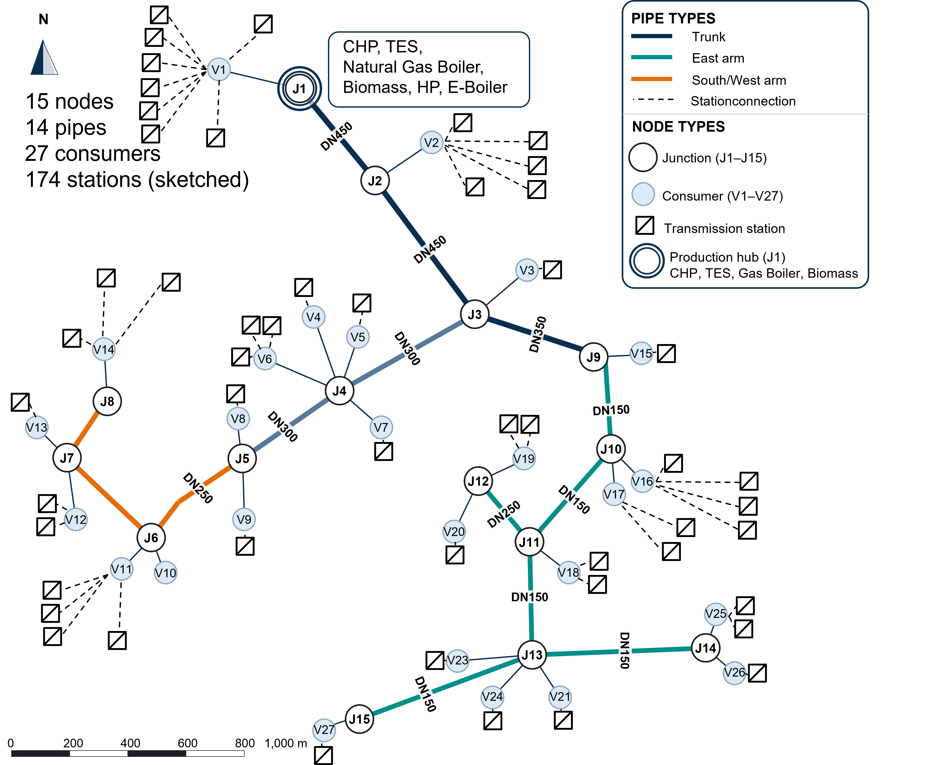
The Memmingen network: fifteen junctions (j$​_{1}$–j$​_{15}$) serving twenty-seven metered consumer substations (V$​_{1}$–V$​_{27}$) on a radial tree, with all generation (CHP, thermal storage, gas and biomass boilers, heat pump and electrode boiler) co-located at the production hub j$​_{1}$. Pipe diameters are labelled DN; the trunk and the two branch arms are distinguished by colour.
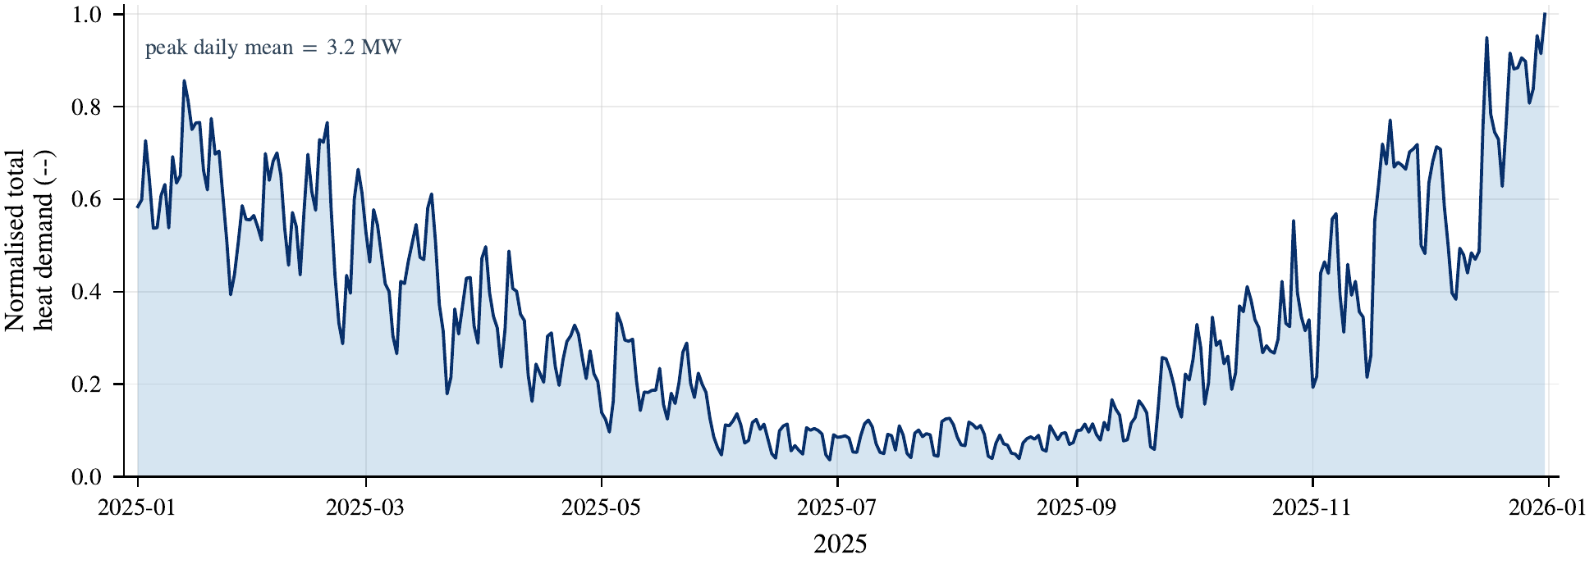
Normalised total heat demand of the Memmingen network over 2025 (cleaned consumption): the summed load of the twenty-seven consumer substations, shown as its daily mean and scaled to the annual peak. The seasonal heating profile is the exogenous demand the dispatch must serve.

Synthetic factorial
The synthetic factorial is a balanced $3×5×3×3$ family of radial networks that varies node count, trunk pipe length, demand heterogeneity and storage size. Each of the 135 networks is solved through the four decomposition controls ($CP$, $CP+L$, $ND^{0}$, $L1$) only, all with central generation; the extended Memmingen fidelity ladder, distributed generation and parameterised station-level hydraulics are not applied across the factorial. Its purpose is twofold: to test whether the loss-dominance result generalises beyond one network, and to expose the loss burden across the order-of-magnitude range of pipe lengths that drives the frozen-adder non-transfer. A stated capacity-sizing convention (rather than ad-hoc feasibility filtering) sizes the assets, and its influence on the results is reported. Full-network solves use the same 0.01 % optimality gap as the real case, so the per-network decomposition terms sit well above solver noise.
The synthetic factorial: a balanced $3×5×3×3$ grid of 135 radial networks, each solved through the same four decomposition controls ($CP$, $CP+L$, $ND^{0}$, $L1$) as Memmingen. All 135 networks use central generation; distributed generation is out of scope and left to future work.
Factor | Levels
Node count | 5, 15, 30
Trunk pipe length (km) | 1, 5, 15, 30, 50
Demand heterogeneity index | 0.1, 0.4, 0.8
Storage horizon (h) | 2, 6, 12

Results and discussion

Validation
Table [tab:validation] reports the validation outcome against the gates fixed ex ante, with each metric assessed against the formulation to which it applies. That attribution is essential when reading the table: the baseline prescribes supply temperature from the heating curve and does not propagate it along pipes, so downstream temperature metrics are structurally outside its scope and are marked as such rather than as failures.

Baseline validation
Three quantities test the formulation that produces every cost result in this paper, and all three pass. Annual delivered energy is reproduced to 1.23 % against a $2 \%$ gate. This anchors the energy scale priced by the decomposition. Network loss is the model’s computed difference between generation and delivered demand and is therefore model-implied, not measured: an independent value would require metered supply-side energy that the site does not record. Delivered-energy agreement fixes the demand scale to which that loss is referenced, rather than the loss itself. The source return temperature matches to 2.08 °C within a $2.5$ °C calibration tolerance and, more informatively, has a bias of only $−0.31$ °C. The source return sensor is the only temperature instrument in the network that does not sit downstream of a mixing valve, and the model is essentially unbiased against it. Heat-pump performance remains within its expected band, with a mean coefficient of performance of 2.99.

Temperature field: validation limitation.
The supply-temperature field belongs to the temperature-propagating formulation, and two obstacles prevent quantitative validation here. The first is formulational: the baseline does not propagate supply temperature, so its trunk drop is identically zero compared with a measured $8.2$ °C, and the far-end and corridor gates do not apply to it. The second is instrumental: for the propagating formulation, the far-end error is $9.21$ °C, with a bias of the same magnitude. Mean absolute error and bias coincide to four decimal places, so every residual has the same sign, and the magnitude lies squarely within the $5$ to $15$ °C offset associated with a three-way mixing valve. The corridor comparison shows the same signature, with a bias of $−7.73$ °C. This is consistent with a fixed sensor-location offset rather than model error. However, the primary and secondary temperatures were not measured simultaneously, so the available instrumentation cannot distinguish sensor-location bias from model error, and the temperature field is therefore not independently validated. Neither obstacle can be removed through a better pipe model, and the first is a deliberate property of the formulation used for the reported cost results.
This is the concrete form of an argument that runs throughout the paper. A model resolved more finely than its metering cannot have that additional resolution verified, and a model that does not represent a quantity cannot be tested on it. The conclusions are therefore anchored to annual delivered energy, which the measurements resolve, and hence to the model-implied network loss on which both formulations agree, rather than to a point temperature field that neither the instrumentation nor the baseline can support.

Scope of the temperature evaluation.
Two views of the temperature error are consistent. On the ex-ante validation set, comprising the held-out nodes over the 744-hour winter window for which the gates in Table 4 were fixed, the mean supply-temperature error is $1.32$ °C and the worst-node error is $2.27$ °C, both within their respective $1.5$ K and $2.5$ K gates. The $9.21$ °C figure in Table [tab:validation] instead comes from a separate, more conservative diagnostic based on the far-end node over the full annual record, without selecting a favourable window. The far end operates the mixing valve closest to fully open. Appendix 8 confirms that the earlier selection was not favourable: the all-node mean of $1.68$ °C lies between the validation-node and calibration-node group means, and two excluded nodes are the network’s best-performing.

Flow, and the per-step balance.
The source flow has a mean absolute percentage error of 33.8 %, and disaggregation by load band explains rather than excuses it. The absolute error is nearly constant across bands at roughly $12$ to $13 m^{3} h^{−1}$, so the percentage is governed by the denominator: the same physical error is $46 \%$ of a $30.9 m^{3} h^{−1}$ mean flow below one-quarter of peak load and $13 \%$ of a $102.6 m^{3} h^{−1}$ mean flow between one-half and three-quarters of peak load. Low-load hours account for $60 \%$ of the year but carry little energy, which is why a large relative error in those hours is compatible with an annual energy match of $1.23 \%$. The top band is the exception in both directions, with the largest absolute error of $25.5 m^{3} h^{−1}$ and a relative error of $23 \%$, but comprises only 56 hours; it is reported rather than absorbed into an average. The per-step energy balance, comprising generation plus net storage against delivered demand and network loss, closes to machine precision, with an annual residual below ${10}^{−3} MWh$ and every hour within tolerance. This confirms that the model’s internal conservation holds exactly. The annual demand-energy agreement of $1.23 \%$ is the separate measured comparison on which the cost conclusions rest.
A percentage error can conceal either of two different failures: a model that mistakes the level or one that fails to follow the variation. Comparing first differences separates them because a fixed offset cancels. The model tracks the flow level with a correlation of 0.91 and its day-to-day change with 0.80; for demand, the corresponding values are 0.93 and 0.89. At hourly resolution, the correlation of differences falls to $0.24$, which reflects the metering rather than the model: the record is sampled at fifteen-minute intervals and resampled to hourly resolution, so hour-to-hour differences are dominated by sampling noise. The aggregate flow error is therefore a level-and-denominator effect at low load, not a failure to reproduce how the network varies. That variation is the property on which the dispatch results depend, since cost accumulates over days and seasons rather than individual hours.

Post-upgrade assets and structural checks.
The heat pump, electrode boiler, and storage were installed after the measurement record, so their dispatch is verified against necessary conditions rather than measurements: the coefficient of performance remains within its plausible band, the storage state of charge remains within its operating limits, and simultaneous charging and discharging are prohibited. Two structural checks close the section. The nonlinear reference with its quadratic constraints deactivated reproduces the baseline objective to better than $0.01 \%$. On the economic-cost basis, the ordering $cost(CP)≤cost(L1)$ also holds for every one of the 135 synthetic instances, the expected direction for a loss-free relaxation, though not an inequality guaranteed in general. A departure from either check on this test set would indicate a formulation error rather than a finding.
Quantity | Model | Value | Bias | Scatter | Gate | Status
Annual delivered-energy error | MILP | 1.23 % | – | – | $≤$2 %
Heat-pump COP (mean) | MILP | 2.99 | -0.00 | – | $[2.5,5.5]$​
Source return-temp calibration (const. param.) | param. | 2.08 K | $−0.31$ K | 2.87 K | – | report
Energy-balance closure (annual residual) | MILP | $<{10}^{−3}$ MWh ($≈$0 %) | – | – | $≤$2 %
Flow MAPE, source | MILP
46 % low-load, 13 % mid–high | – | – | – | report
Demand MAPE, total | MILP
39 % low-load, 12 % mid–high | – | – | – | report
Flow tracking ($r_{\text{lvl}}$; $r_{Δ,\text{daily}}$) | MILP | 0.91 / 0.80 | – | h. $Δ$ 0.24 (noise) | –
Supply-temp MAE, mean (val. nodes, 744 h) | NLP | 1.32 K | – | – | $≤$1.5 K
Supply-temp MAE, worst node (744 h) | NLP | 2.27 K | – | – | $≤$2.5 K
Far-end supply-temp MAE (annual diagnostic) | NLP | 9.21 K | $+9.21$ K | 11.31 K | – | diag.
Trunk supply-temp drop MAE (diagnostic) | MILP | – (not propagated) | – | – | – | n/a
Corridor supply-temp MAE (annual diagnostic) | NLP | 8.32 K | $−7.73$ K | – | – | diag.
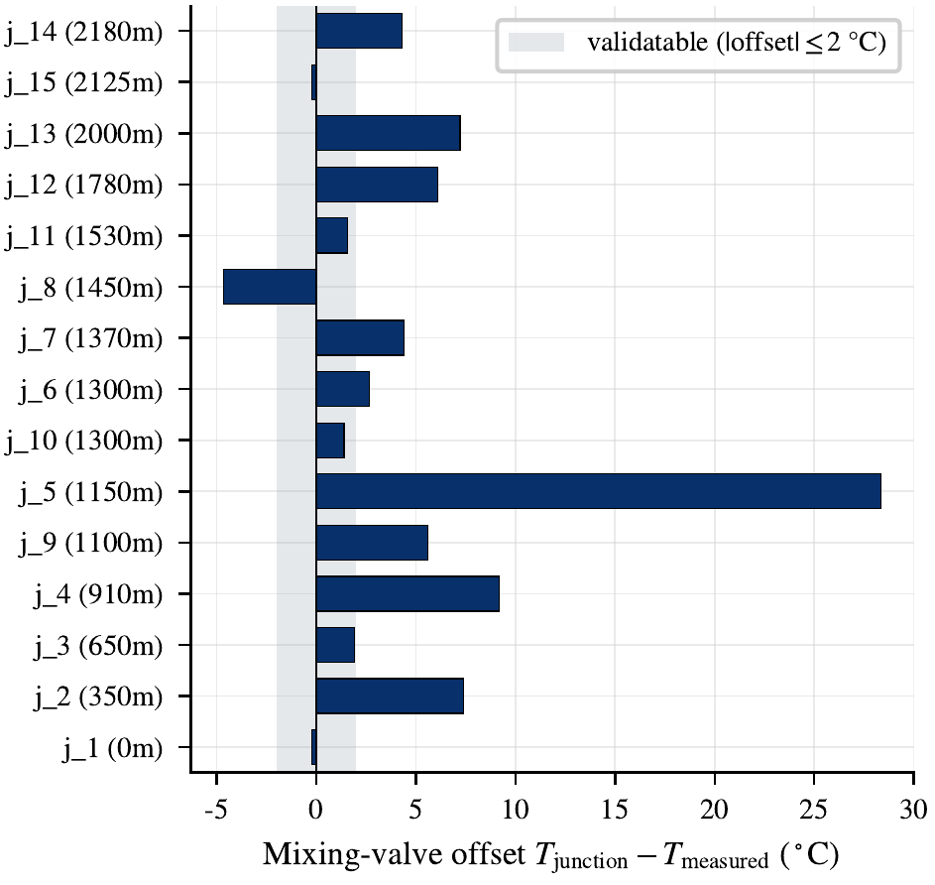
The mixing-valve offset that bounds what the temperature field can be validated against. Consumer sensors are billing instruments installed downstream of the valve, so the metered temperature sits systematically below the primary junction temperature.
Pipe losses admit two calibration approaches that require reconciliation. The first uses a global boundary-condition match and applies a single scaling factor to all heat-transfer coefficients. The second uses a branch-sequential fit and increases the coefficients of the terminal pipes to several times their nominal values until the trunk-only loss matches the total loss implied by delivered energy.
The second approach is not physically defensible. Such increases in nominal $U$-values cannot reasonably be attributed to insulation ageing. Instead, they absorb the last-mile losses from service laterals and substations that the 15-node trunk model does not represent. Because the model contains no explicit representation of these components, the calibration assigns their losses artificially to the trunk pipes.
This study therefore retains trunk heat-transfer coefficients within a defensible range and represents the residual loss through an explicit service-lateral term. This term enters only at the station-resolved level (L4). Consequently, the node-resolved levels intentionally undercount total network losses because they exclude the last mile. The model matches the total loss implied by delivered energy only after the service laterals are included. This finding is reported in Section 3.8.
Importantly, the revised calibration leaves the decomposition unchanged. The dominance of losses is therefore not an artefact of the global multiplier. This study reports in-sample and out-of-sample metrics separately because an in-sample fit alone does not constitute validation. Flow accuracy is reported as mean absolute percentage error by load band, making the fit at part load, where most operating hours occur, visible rather than obscuring it within an annual aggregate.

Estimation bias: loss visibility versus spatial resolution
On Memmingen the copperplate-to-baseline cost gap of 15.1 % ($CP$ $→$ $L1$) decomposes to machine precision into a loss main effect of 95.8 % of the gap and an interaction of -0.5 % (defensible trunk $U$; the single indefensible terminal-pipe multiplier removed). Loss visibility carries the result: a copperplate reproduces the cost level once handed the aggregate loss it cannot itself compute ($CP+L$), whereas resolving spatial topology without loss ($ND^{0}$) recovers almost none of the gap. The as-run $ND^{0}−CP$ difference of $≈$961 EUR (4.7 % of the gap) is, however, not spatial resolution alone: the copperplate and node-resolved configurations differ also in three physics parameters (return temperature, heating curve, and heat-pump coefficient of performance). Re-solving $ND^{0}$ under the copperplate’s physics isolates the topology main effect proper at only $≈$52 EUR (0.25 % of the gap), with the remaining $≈$909 EUR (4.4 %) a physics-parameter difference between the two configurations, reported on its own line in Table 7 so that it is not attributed to spatial resolution. Topology proper is thus two orders of magnitude below the loss effect: spatial resolution matters as the mechanism that makes loss endogenous, not through routing. Across the 135 synthetic networks, which are generated with identical physics across the copperplate and node-resolved variants and so carry no such confound, the same holds emphatically: loss explains a median 100.0 % of the gap and the spatial-topology main effect stays within $±$0.6 % on every network of 5 km trunk length or more, never exceeding 2.4 % even on the shortest, where the entire gap is below 6 % of cost (all solves at $≤0.1$ % optimality gap), over node counts, pipe lengths, demand heterogeneity and storage. The corrected Memmingen topology (0.25 %) sits comfortably inside this synthetic range. The $U$-calibration choice leaves the loss share essentially unchanged (inflated-$U$: 96 %; defensible-$U$: 95.8 %), so the conclusion is not an artefact of the loss calibration. Supplying the copperplate control with the hourly, heating-curve-consistent loss profile that the resolved model realises, in place of the flat annual adder, likewise moves the loss main effect only from $95.8$ to $95.5$ % of the gap (a $0.4$-percentage-point shift, and a $0.06$ % change in the $CP+L$ cost); the constant adder is retained as the primary oracle because the decomposition is insensitive to the adder’s temporal shape.
Loss$×$topology decomposition of the copperplate-to-baseline cost gap on Memmingen (economic cost; the Memmingen solves reach $≤$0.01 % gap, the synthetic factorial $≤$0.1 %). Main effects use baseline–treatment coding against $CP$: loss $=\text{cost}(CP+L)−\text{cost}(CP)$; the topology main effect is measured with physics held identical to $CP$, $\text{cost}({ND^{0}}^{*})−\text{cost}(CP)$, where ${ND^{0}}^{*}$ is the node-resolved no-loss network re-solved under $CP$’s return temperature, heating curve and heat-pump coefficient of performance. The as-run $ND^{0}$ differs from $CP$ in those three parameters as well as in topology; the resulting $\text{cost}(ND^{0})−\text{cost}({ND^{0}}^{*})=$909 EUR is a physics-parameter effect carried by the configuration rather than by spatial resolution, and is listed separately so it is not attributed to topology. Interaction is the residual and the closure is an exact algebraic identity on the optimised costs; a symmetric (Shapley) split of the small interaction changes the shares negligibly. The synthetic column, whose copperplate and node-resolved variants share physics and so carry no such confound, reports the 135-network distribution.
Term | EUR/yr | % of gap | Synthetic (135 nets)
Total gap ($CP​→​L1$) | 20,591 | 100.0 | burden 3.2–81.2 % of cost
Loss main effect | 19,737 | 95.8 | median 100.0 %
Topology main effect (physics-matched) | 52 | 0.25 | $±$0.6 % (L$≥$5 km); $≤$2.4 % at 1 km
Physics-parameter difference (config) | 909 | 4.4 | —
Interaction | -107 | -0.5 | —
Closure residual | 0.00e+00 | 0.0e+00 | (exact identity)
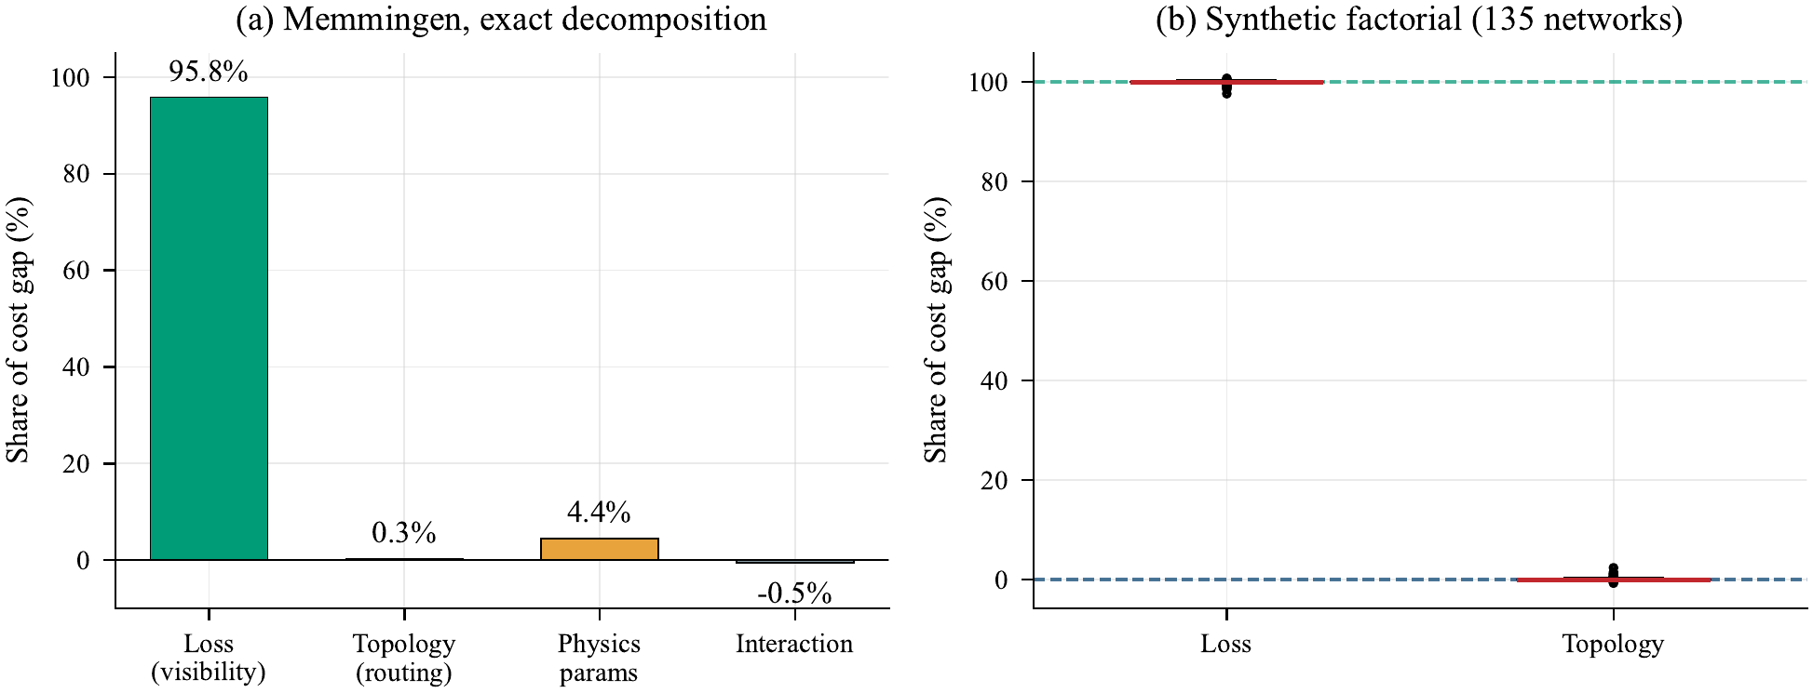
Exact decomposition of the copperplate-to-baseline cost gap for Memmingen (left) and as a distribution across the 135 synthetic networks (right). On Memmingen the topology main effect is measured with physics held identical to the copperplate; the physics-parameter difference between the copperplate and node-resolved configurations (return temperature, heating curve, heat-pump coefficient of performance) is shown separately so it is not attributed to spatial resolution. The additive identity closes to machine precision, so the terms are measured rather than fitted. The synthetic networks share physics across variants by construction and so carry no such term.

Decision regret and physical feasibility
Estimation bias and decision regret diverge sharply, and for the copperplate they carry opposite signs. Its schedule appears -15.1 % cheaper than the baseline (bias), yet re-costing that loss-ignoring schedule under the common forward physics values its unprovisioned loss at +46.1 % of the baseline (its forward-valued schedule gap): a copperplate is a biased estimator and under-provisions the network losses it never saw. The asymmetry ($|\text{regret}|>|\text{bias}|$) is mechanistic: the loss the copperplate omits must be valued, under the forward model, at the marginal or peak unit’s cost in the winter hours it never planned for, rather than avoided by optimal pre-planning. The schedules show this directly: the copperplate runs the heat pump 2 063 hours against the baseline’s 2 309 and gives it 77.9 % of production against 87.8 %: 246 fewer operating hours and ten percentage points less share, the 46 % regret being that substitution priced. Supplying the same copperplate the aggregate loss it cannot compute ($CP+L$) collapses both bias and regret to $≈\text{-0.54} \%$, but that adder is calibrated ex post on this network and does not transfer (S3.9). The loss-aware node-resolved levels ($L1$, $L3$, $L6$) reach regret $≈$ bias with no calibration, as expected, since with no ignored loss to cover the forward-minus-economic residual is a near-constant pump offset, so the decision-relevant content is the copperplate’s asymmetry rather than this near-equality. Temperature propagation ($L2$) is forward-evaluated rather than solved (Section 2.4), its free-variable form being degenerate. The sign of the copperplate regret is invariant across three shortfall-pricing schemes (valuing the shortfall at the marginal unit, at the peak unit, and penalising unmet demand at the dump price, giving $+46$/$+61$/$+832$ % regret) and across the demand-disaggregation rule ($<0.3$ pp), so it is not an artefact of either assumption. Physical deliverability is checked directly: loss-aware schedules incur zero velocity, differential-pressure or unmet-demand violations under the forward model. This is the decision-relevant reading of fidelity that model-to-model bias alone cannot give: use the simplest model for scheduling only if it is loss-aware, not a loss-blind copperplate.
Level | Bias | Regret (marginal / peak / unmet) |  |  | Viol. | Short. | HP share | HP hrs
 |  |  |  |  | (hyd.) | (MWh)
$CP$​ | -15.1 | +46.1 | +61.2 | +831.7 | 0 | 1 159 | 77.9 | 2 063
$CP+L$ (const.) | -0.6 | -0.5 | -0.5 | -0.5 | 0 | 0 | 78.2 | 2 309
$CP+L$ (curve) | -0.7 | -0.6 | -0.6 | -0.6 | 0 | 0 | 78.2 | 2 310
$ND^{0}$​ | -14.4 | +46.8 | +61.9 | +832.5 | 0 | 1 160 | 78.0 | 2 061
$L1$​ | +0.0 | +0.0 | +0.0 | +0.0 | 0 | 0 | 87.8 | 2 309
$L3$​ | +1.4 | +1.4 | +1.4 | +1.4 | 0 | 0 | 87.8 | 2 311
$L6$​ | +1.4 | +1.4 | +1.4 | +1.4 | 0 | 0 | 87.8 | 2 311
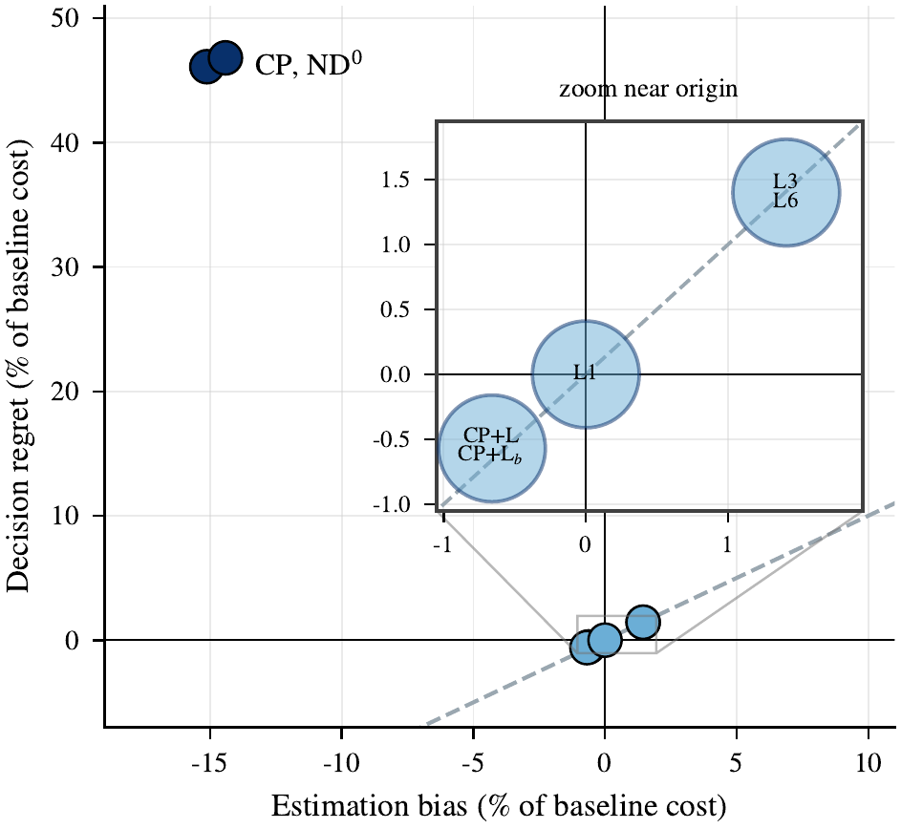
Estimation bias against decision regret for every level, as a percentage of the baseline operating cost. For the copperplate and the topology-only control the two carry opposite signs: a schedule that appears cheaper on paper leaves a large forward-valued loss shortfall. Loss-aware levels show regret approximately equal to bias.

Sensitivity to the zone aggregation
The zone-aggregated level rests on one hand-made seven-zone partition of the fifteen-node network. A partition is a modelling choice rather than a physical fact, and a different one could in principle redistribute losses and routing differently. The aggregated model was therefore re-solved across a family of alternative partitions, holding everything else fixed.
The family comprises the original partition re-run through the same aggregator, three deliberate alternatives spanning granularity (four, seven and ten zones) and a null distribution of twenty random tree-contiguous partitions, all solved to a $0.01$ % optimality gap. Every member conserves the total heat-loss capacity p​UpLp=1140.2 W/K of the node-resolved network, which is verified per configuration and confirmed by an identical realised annual loss across the family ($1257.8$–$1257.9$ MWh). Conservation requires resolving the producer as its own zone: a partition that merges the plant with downstream nodes has no incoming pipe to carry the producer zone’s internal trunk losses and silently discards them. The producer is therefore held isolated in every member, as in the original partition, and the consequence for the null is stated explicitly: each draw cuts the producer edge and then five further random edges, partitioning the remaining fourteen consumer nodes into six zones. The null therefore tests consumer-zone boundary choice at fixed producer resolution and fixed total loss, which is the comparison the question requires.
Because the delivered loss is equal across the family, the only quantity free to move is where the boundaries fall, a pure routing effect. It barely moves. The three deliberate alternatives differ from the original by at most $0.01$ % of annual cost, the twenty null draws have a standard deviation of $4$ EUR, and the full spread across all twenty-four partitions is 11 EUR, or 0.008 % of operating cost. Granularity between four and ten zones changes essentially nothing.
Set against the decomposition, this is more than a robustness check. With losses held equal, the residual is directly comparable to the spatial-topology main effect measured on the same network, and the three quantities span three orders of magnitude (Table 8).
Zone-boundary choice against the effects it must be compared with, on the copperplate-to-baseline ($CP​→​L1$) cost gap. With the total heat-loss capacity held equal across all twenty-four partitions, the residual routing effect is negligible.
Effect | Cost | % of the $CP​→​L1$ gap
Loss visibility | 19 737 EUR | 95.8
Spatial topology (resolving routing, physics-matched) | 52 EUR | 0.25
Zone-boundary choice (this subsection) | $≲$11 EUR | at solver tolerance
Choosing where to draw a zone boundary is negligible: at $≲$11 EUR the residual is three orders of magnitude below representing the loss and, like the physics-matched topology effect itself, sits at the $0.01$ % solver tolerance ($≈$13 EUR on the Memmingen cost), so no zone-partition effect is resolved above it. The aggregation is therefore not a hidden degree of freedom in the results, and the finding corroborates the decomposition from an independent direction: loss, not geometry, carries the cost.
The corollary is a practical warning worth stating. An aggregation that does not conserve the total heat-loss capacity (for instance one that merges the producer with downstream nodes and so discards the trunk pipes internal to that zone, here $10$–$18$ % of p​UpLp) shifts reported cost by up to about $6$ %, against the $0.01$ % agreement among conserving partitions. The binding requirement for a valid reduced network model is preservation of the delivered loss, not fidelity of the zone geometry. That is the same conclusion the decomposition reaches by a different route, and it is a straightforward error to make.
One parameterisation note, since two values for the same pipe appear in the released data. The aggregator uses the network’s per-pipe design heat-transfer coefficients, under which the far-east lateral carries a markedly higher value than the trunk, reflecting its older uninsulated construction. The Stage-1 validation instead calibrates a single uniform coefficient across all pipes, one free parameter, to reproduce the annual loss implied by the delivered-energy measurement. The two serve different purposes and are not intended to agree pipe by pipe: the first is the design network, the second a minimal calibration of its aggregate behaviour. All partitions compared here use the same per-pipe basis, so the comparison is unaffected.

Scope condition: the routing null is specific to central generation
One scope condition attaches to the routing null. All generation in Memmingen sits at a single node, and the synthetic factorial is built the same way (also central generation), so the null is established for centrally-supplied networks rather than for district-heating networks in general. Whether resolution matters more when generation is distributed, making which source serves which demand a live choice, cannot be answered by a radial generator that injects all heat at the primary producer: a non-root source is structurally stranded, and admitting one requires the signed-flow formulation discussed in the limitations. Distributed generation, with meshed and bidirectional topologies, is therefore left to the companion study.

Thermo-hydraulic effect, to the transmission station
Station-resolved hydraulics leave the fixed schedule almost unchanged in forward-evaluated cost. Resolving the demand side to all 174 transmission stations and their service laterals (L4), and replacing the flat station differential-pressure requirement with a flow-dependent one (L5), the total electrical pump draw (producer friction, per-station $Δp$ and service-lateral terms) peaks at $≈3$ kW against the $110.8$ kW of installed Wilo pump capacity (five parallel units), a margin of $≈108$ kW. The worst real node carries $0.10$ bar trunk $+ 0.60$ bar station $+ 0.62$ bar lateral $=1.32$ bar, leaving $2.7$ bar over its floor. These figures rest on real component data (pump datasheets, DXF-traced laterals) and agree with an independent pandapipes nonlinear solve to $<0.007$ bar on trunk pipes, a check of the trunk pressure calculation, not of the flows themselves nor of the station and lateral components, which pandapipes does not resolve (Appendix 5). Applying a $±33.8$ % deterministic flow perturbation, matched to the aggregate flow MAPE (pump power scales as flow$​^{3}$), widens the pump-energy estimate to roughly $2$–$19$ MWh yr$​^{−1}$ and the peak draw to at most $∼$7 kW; even at the upper end the $≈$108 kW capacity margin is untouched and the $L1​→​L3$ cost effect stays near $1.4$ %, so the conclusion is unchanged. The pump-energy share is therefore $∼​0.080$ % of thermal demand ($7.9 MWh$ against $≈$9.9 GWh), more than an order of magnitude below the $1$–$5$ % transmission-network literature range, reconciled by the compact network and heavily oversized pumps, not by a modelling error. Consequently adding station-level hydraulics to the fixed schedule moves its forward-valued cost by $<1$ % and reveals no evaluated hydraulic violation: even resolved to the individual substation with flow-dependent pressure, hydraulic fidelity is below the decision-relevance threshold, which bounds the value of re-optimising rather than the re-optimised schedule itself.

Robustness to a flexible supply temperature
The station-hydraulics null result and the loss-dominance finding are established with the plant supply temperature fixed by an outdoor-temperature heating curve. Because modern operators may lower the supply temperature to reduce losses, this study stress-tests both findings against that control option.
Treating the supply temperature as a free dispatch variable introduces the bilinear relation
$$Q=\dot{m}\left(T_{sup}−T_{ret}\right),$$
which makes the resulting mixed-integer formulation nonconvex and computationally intractable at the required scale. Consistent with the treatment of the nonlinear reference, the supply-temperature variation is therefore evaluated forward rather than through a new dispatch optimisation. Demand and return temperature remain fixed while the plant supply temperature is reduced. The validated forward model then recomputes network losses, mass flows, pipe velocities, and pumping power.
Lowering the supply temperature reduces trunk losses but also narrows the temperature difference. Consequently, mass flow, frictional pumping demand, and pipe velocity increase. The lowest-cost tested reduction is $17.5 K$, yielding an annual saving of $6 220 EUR {yr}^{−1}$. This corresponds to approximately $4.6 \%$ of annual operating cost when the recovered loss is valued at the marginal unit, which is its highest-priced valuation.
Two findings follow. First, the saving remains a loss effect. Its gross benefit arises from lower evaluated thermal losses and is partly offset by higher pumping costs. Loss visibility, rather than spatial routing, therefore remains the operative mechanism when the supply temperature is flexible.
Second, hydraulics determine the lowest-cost tested point. Pump energy increases from $7.9$ to $32.3 MWh$, approximately a factor of four, as the supply temperature falls. The pipe-velocity limit is first reached at the tested reduction of $20.0 K$, making this the first infeasible tested point rather than the exact continuous feasibility boundary. Hydraulics therefore shift from a negligible cost contribution under the fixed heating curve to a binding constraint under a flexible supply temperature. This boundary qualifies, but does not overturn, the station-hydraulics null result.
Forward supply-temperature sensitivity on $L1$: lowering the plant supply temperature by $ΔT_{\text{sup}}$ cuts loss cost but raises pumping. Lowest-cost tested reduction (over the swept grid) marked $​^{⋆}$; the velocity limit binds at 20 K. Loss valued at the marginal unit (its highest-priced valuation). Costs in EUR/yr.
$ΔT_{\text{sup}}$ (K) | Loss cost | Pump cost | Total | Vel. viol. | Feasible
0.0 | 83,721 | 784 | 84,505 | 0 | yes
5.0 | 81,060 | 1,012 | 82,073 | 0 | yes
10.0 | 78,381 | 1,466 | 79,847 | 0 | yes
15.0 | 76,183 | 2,224 | 78,407 | 0 | yes
17.5$​^{⋆}$ | 75,076 | 3,209 | 78,285 | 0 | yes
20.0 | 74,459 | 4,185 | 78,644 | 3 | no
25.0 | 74,059 | 5,854 | 79,913 | 33 | no

Linearisation error and transport delay, separated
Each extended phenomenon is isolated individually. Under the operating regime considered here, each has only a limited effect relative to loss visibility.

Trunk pressure and pumping.
Adding trunk pressure and pumping to the node-resolved baseline and solving the resulting model to an optimality gap of $0.01 \%$ increases annual cost by about $1.4 \%$, equivalent to approximately $1,900 EUR {yr}^{−1}$ relative to the $L1$ cost. This increment does not represent pump energy alone. Pumping consumes $7.9 MWh$, costing approximately $780 EUR {yr}^{−1}$ (Table S2, Supplementary Material). The remaining $1,100 EUR$ arises from the demand charge and the dispatch response induced by including pumping in the objective. Direct pump electricity therefore accounts for less than half of the increment, while the dispatch ordering remains unchanged.

Temperature propagation and transport delay.
Temperature propagation is evaluated forward as described in Section 2.4. Its free-variable formulation is nonconvex and degenerate because it allows the optimiser to alter the temperature level rather than isolate physical propagation. Native temperature propagation reduces total network losses by approximately $2 \%$, corresponding to only a few tenths of a percent of total cost. Transport delay, represented as a linear temporal shift, has an even smaller effect.

Solved nonlinear reference.
This study quantifies the linearisation error by solving a nonlinear reference rather than relying only on a bound. The mixed-integer schedule obtained from the piecewise-linear model is held fixed, including unit commitment and piecewise-linear segment selectors. Only the continuous variables, comprising flows, nodal temperatures, pressures, and pumping power, are reoptimised under the native physics.
The resulting model restores exponential temperature decay and the heat-loss bilinearities. It is therefore a nonconvex nonlinear programme rather than a quadratic programme. For representative winter and autumn windows of 72 hours, the nonlinear re-solves change cost by $−0.15 \%$ and $−0.33 \%$, respectively. The global solver (Gurobi, NonConvex=2) reports optimality gaps of $0.009 \%$ for the winter window and $0.025 \%$ for the autumn window, both below $0.03 \%$ and measured against valid global lower bounds.
The negative signs are informative. They show that the piecewise linearisation slightly overstates cost and that the native nonlinear physics is marginally cheaper. Both effects remain below half a percent, consistent with the exact decomposition. The friction and station-pressure terms contribute only a few hundredths of a percent and partly offset one another.

Limits of the nonlinear reference.
The corresponding full-year re-solve produces no incumbent within the available solver budget. No full-year value is therefore reported as a solved result. In addition, a low-load summer window is infeasible under the native physics when the linearised schedule is held fixed. This solver outcome is reported without assigning it a physical interpretation. It has not been established whether the result reflects genuine physical non-deliverability or a formulation or numerical issue. An irreducible infeasible subsystem analysis or a feasibility-relaxation diagnosis is left for future work.
Each effect is reported relative to its rigorous optimality bound. No point estimate is claimed when the bound cannot resolve the effect. In such cases, the conclusion is that no effect can be demonstrated at the attained tolerance. Across all extensions, the result remains consistent with the decomposition: every effect beyond loss visibility is only a fraction of the loss effect.
Extended-physics effects on dispatch cost, each isolated with the method used to quantify it. Entries are shares of total cost except the temperature-propagation row, which is a share of network loss and corresponds to a few tenths of a percent of cost. All lie far below the loss main effect, and the linearisation error is small and negative (the piecewise-linear model slightly over-states cost).
Phenomenon (step) | Effect | How quantified
Trunk pressure & pumping ($L1​→​L3$) | $+1.4$ % | solved MILP, $≤$0.01 % gap
Temperature propagation ($L1​→​L2$) | $≈−2$ % of loss | forward (native decay)
Transport delay ($L3​→​L6$) | $<0.01$ % | solved MILP, $≤$0.01 % gap ($k_{p}=0$)
Linearisation error (PWL vs native) | $−0.15/−0.33$ % | solved native, $≤$0.03 % gap (winter/autumn 72-h)

Secondary finding: generalisability and out-of-sample prediction
The decomposition generalises. Across the 135 synthetic networks the loss main effect accounts for a median 100.0 % of the cost gap and the topology main effect stays within $±$0.6 % on every network of 5 km trunk length or more, never exceeding 2.4 % even on the shortest, where the entire gap is below 6 % of cost, over the full range of node counts, pipe lengths, demand heterogeneity and storage sizes; a variance decomposition attributes essentially all of the between-network variation in the gap to loss and almost none to topology. The same data expose why the lumped-loss shortcut does not transfer. The loss burden, the share of cost the adder must reproduce, ranges from 3.2 % to 81.2 % across the factorial, driven chiefly by pipe length; a single frozen adder is by construction correct for only one point in that range, and even the most transferable choice mis-estimates the burden by a mean of 23.5 and up to 40.1 percentage points of cost when carried to another network. This is the quantitative form of the non-transfer that makes the node-resolved model, which computes the loss endogenously, the transferable one. Finally, an a-priori estimator of the cost gap from observable network properties (pipe length, node count, demand heterogeneity and storage) fitted on the synthetic networks up to 15 km trunk length (train $R^{2}≈0.999$) predicts the held-out longer networks without refitting, an extrapolation beyond the fitted range. It predicts the 30 km networks to within about seven percentage points and under-predicts at the extreme 50 km extrapolation (held-out mean absolute percentage error $≈19$ %; Table S5, Supplementary Material). This study reports the outcome as obtained. Extrapolation performance degrades at the extreme, as expected. A prediction specified before observing the outcome, whether successful or not, is more informative than a curve fitted.
The estimator above is a fitted regression on observable properties; the same physics yields a sharper, parameter-free tool. If the node-resolved model differs from a copperplate only in that it additionally generates the network loss, and cost scales with heat produced, then the burden a copperplate misses is $b=λ/(1+λ)$, where the dimensionless loss number $λ=\text{annual loss}/\text{annual demand}$ is computable a priori from the pipe geometry, heat-transfer coefficients, supply/return/ground temperatures and annual demand alone, λ=p​UpsLp(Tsup−Tg)+p​UprLp(Tret−Tg)⋅8760/(106 D), with the ${10}^{6}$ converting W to MW, representative annual temperatures, and $D$ the annual demand in MWh, without solving any optimisation. This zero-parameter curve reproduces the computed burden across all 136 points (the 135 synthetic networks and Memmingen, $λ$ spanning 0.03–1.7) with $R^{2}=\text{0.87}$ and a mean absolute error of 6.7 percentage points; a one-parameter calibration that absorbs the residual constant topology term raises this to $R^{2}=\text{0.96}$. Memmingen ($λ=\text{0.12}$) sits on the curve, its 11 % predicted burden close to the 15 % measured. The residual few points are informative rather than error: they are consistent with the omitted topology main effect and the accounting difference of Section 2.5, so the rule under-predicts by about the size of the terms it omits. It is a first-order screening heuristic, not a general cost law: it assumes heat-production cost roughly proportional to output, no commitment discontinuities, no demand-charge or CHP-export interaction, no storage-induced timing effect, and a consistent loss denominator. Under those assumptions it gives a one-line screen, plotted as a nomogram in Figure 6: a planner computes $λ$ from the network geometry and reads off whether a copperplate plausibly suffices ($λ$ small, $b≲10$ %), whether a calibrated loss adder is likely adequate, or whether node resolution is worth checking, a screening indication rather than a guarantee, since a known transferable loss adder can itself suffice, as the decomposition shows.
Balanced-design analysis of variance of the loss burden across the 135 synthetic networks (full $3×5×3×3$ factorial). Trunk pipe length dominates the between-network variance.
Factor | Share of loss-burden variance
Trunk pipe length | 95.8 %
Storage horizon | 3.2 %
Demand heterogeneity | 0.0 %
Node count | 0.0 %
Interactions + residual | 0.8 %
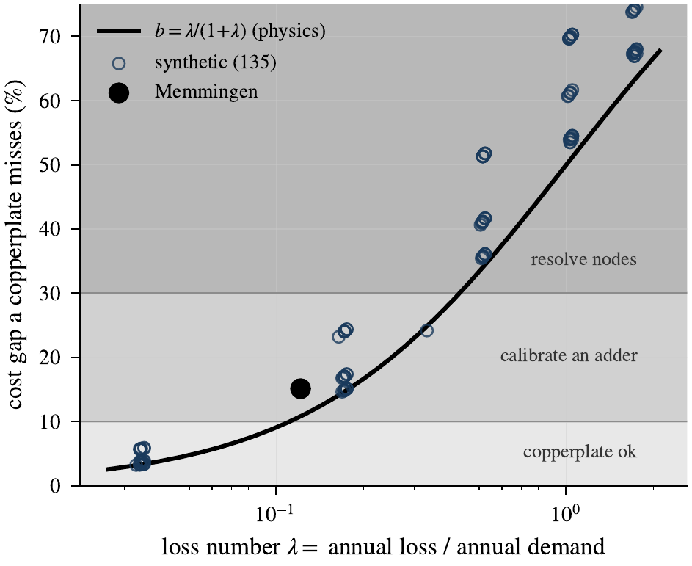
Fidelity design rule. The cost gap a copperplate misses (the loss burden) against the a-priori loss number $λ=\text{annual loss}/\text{annual demand}$. The parameter-free physics curve $b=λ/(1+λ)$ (navy) tracks the computed burden of the 135 synthetic networks (grey) and Memmingen (star) with $R^{2}=\text{0.87}$. Shaded bands are illustrative screening indications (copperplate/adder, calibrate an adder, or check node resolution) read off from $λ$ alone; the thresholds are judgmental, not validated cutoffs.
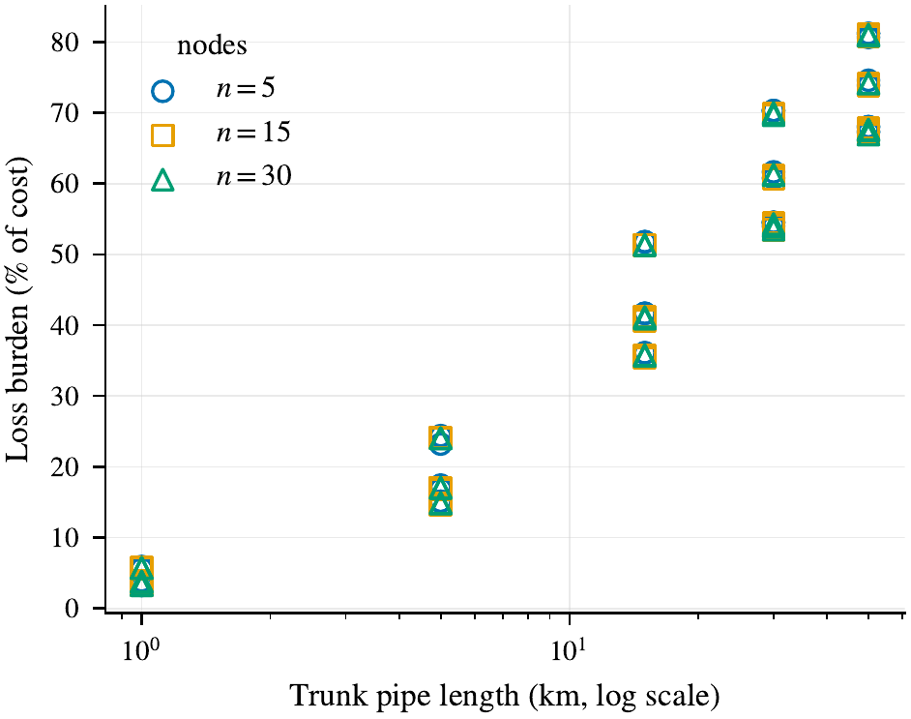
Drift of a frozen loss adder against trunk pipe length across the 135 synthetic networks. An adder calibrated on any one network mis-estimates the loss burden on others by a mean of 23.5 and up to 40.1 percentage points of cost, which is why the node-resolved model, computing the loss endogenously, is the transferable one.

Sensitivity and robustness
The decomposition is not an artefact of a single modelling choice: loss dominance survives every perturbation in Table S4 (Supplementary Material), from removing the indefensible terminal-pipe multiplier (the defensible-$U$ loss share of 95.8 % is essentially the inflated-$U$ value) through the two lumped-loss calibrations, the demand-disaggregation rule and the marginal-cost range to a flexible supply temperature. It also survives tightening the optimality gap to $0.01$ %, at which the small topology and interaction terms resolve out of solver noise to stable values (Table S3, Supplementary Material). Where a result is sensitive to an assumption, this study states this explicitly. The magnitude of last-mile losses depends on the reconstruction of the service laterals, while the value of supply-temperature flexibility depends on how the recovered loss is priced. Neither sensitivity changes the ordering on which the conclusions rest.
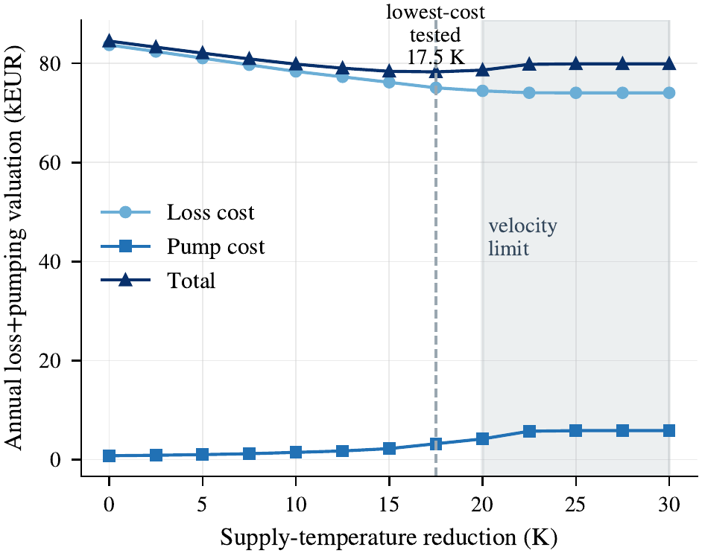
Supply-temperature flexibility. Lowering the plant supply temperature reduces thermal loss but shrinks the temperature difference, so flow and pumping rise. The lowest-cost tested reduction is 17.5 K; beyond 20 K the pipe velocity limit binds, and hydraulics change from a negligible cost into the binding constraint.

Fidelity gain versus computational cost
Table 12 reports model size and solve time for the levels that are solved. Read alongside the effects each level buys, it gives the trade-off a modeller actually faces, and the trade is unusually lopsided.
Moving from the copperplate to the node-resolved baseline multiplies the model by roughly a factor of eleven in variables and by about a factor of two in solve time, and buys the entire $15.1$ % cost gap: the whole of the estimation bias and the whole of the $46.1$ % decision regret. Every increment above that is expensive and nearly inert. Adding trunk pressure adds $368$ thousand binary variables, roughly doubling the solve time, to move dispatch cost by $1.4$ %. Adding transport delay adds no structure at all at hourly resolution and moves cost by exactly nothing. The station-resolved levels are not solved as dispatch problems, and the forward evaluation that replaces them shows why that is no loss: their effect on decisions is indistinguishable from zero.
The practical reading is that fidelity in this setting is not a smooth trade of accuracy against computation. It has one step, and the step is loss visibility. A modeller who resolves the network and computes its losses has bought essentially all of the available correction at about twice the solve time of a copperplate; a modeller who then adds hydraulics pays again and buys almost nothing. That the expensive levels are also the ones whose extra detail cannot be validated at billing-grade metering (Section 3.1) makes the case against them twice over.
Storage dispatch is indistinguishable across levels on this case: equivalent winter cycle counts and state-of-charge timing shifts under $0.2$ h from the copperplate through the pressure-resolved level. This is expected for a compact network (the longest trunk travel time is about 35 minutes, which is also why transport delay vanishes at hourly resolution) and it is the mechanism behind the identity between the delay level and the level below it. On a network with substantially longer transport times, both results would be expected to separate.
Model size and solve time for the solved levels (single-year, hourly). Temperature propagation (L2) and the station levels (L4/L5) are forward-evaluated, not solved – L2’s free-variable temperature model is a non-convex mixed-integer bilinear program and degenerate. L3 adds the pressure PWL binaries.
Level | Variables | Binaries | Constraints | Solve time
$CP$​ | 210 246 | 52 562 | 271 567 | 3 min
$CP+L$​ | 210 246 | 52 562 | 271 567 | 3 min
$ND^{0}$​ | 2 268 846 | 52 562 | 1 804 567 | 4 min
$L1$​ | 2 268 846 | 52 562 | 1 804 567 | 5 min
$L3$​ | 3 153 606 | 420 482 | 3 687 967 | 9 min
$L6$​ | 3 153 606 | 420 482 | 3 687 967 | 9 min
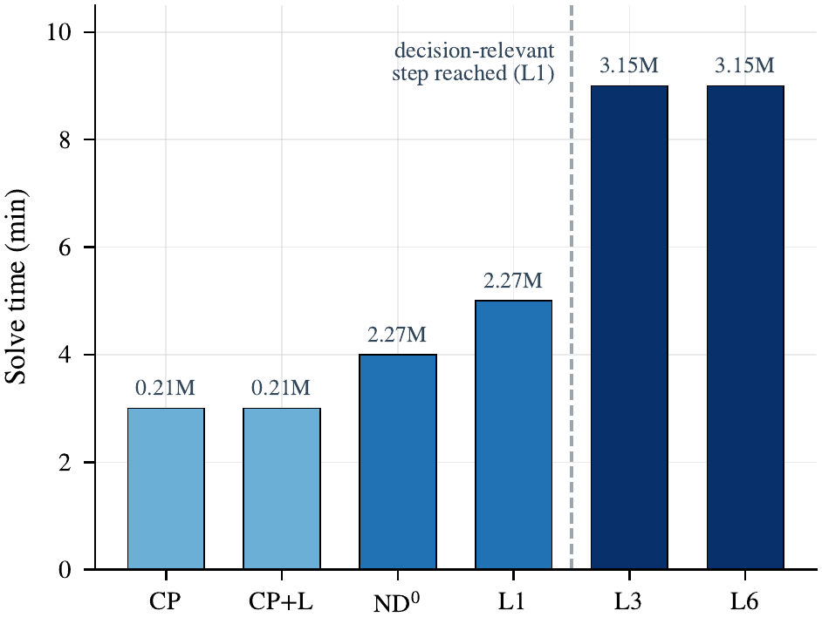
Solve time and model size across the solved levels. Bar labels give the variable count. Solve time rises from three to nine minutes along the ladder; the decision-relevant step (CP$→$L1, loss visibility) is reached at five minutes, whereas the further physics (L3, L6) nearly doubles solve time and model size while changing dispatch by under $1.4$ %.

Marginal changes in extended physics
Three of this paper’s results are nulls: station-resolved hydraulics change dispatch cost by under one percent, transport delay by exactly nothing, and the piecewise linearisation by a few tenths of a percent. A null invites two readings. Either these phenomena are genuinely inert in district-heating dispatch, or the assumptions under which they were tested closed the channels through which they would have acted. The second reading is the sceptical one; it is legitimate, and it deserves an answer more specific than a caveat.
Four assumptions each close a specific channel. A prescribed heating curve fixes the supply and return temperatures, so the optimiser cannot trade thermal loss against pumping energy, the trade in which hydraulics would acquire economic weight. Precomputed heat-pump performance makes the coefficient of performance independent of the network state, so a heat pump cannot respond to a locally depressed supply temperature by shifting its output in time or place. Fixed capacities remove siting and sizing, so spatial structure cannot express itself through where capacity is placed, only through where heat is routed. And hourly resolution discretises away every transient shorter than the time step: With $Δt=1$ h, the trunk transit time of about $35$ min gives $k_{p}=0$: sub-hourly delays are not represented on the hourly grid, and the delay step therefore shifts nothing on this network. This is the reason the measured delay effect in Table 10 lies below the solver tolerance.
The honest conclusion is therefore conditional, and stated that way throughout: within the deterministic, hourly, fixed-capacity, fixed-temperature planning regime, extended network physics adds little to a fixed schedule’s forward-evaluated cost and reveals no hydraulic violation. That regime is not a corner case. It is where the overwhelming majority of published district-heating dispatch models operate, and the practical guidance the nulls support (do not spend modelling effort on hydraulic detail before loss representation) applies wherever such models are used.
What raises this above a plausible story is that one of the four channels has been opened and measured the result. Freeing the supply temperature, the lever most likely to break the hydraulic null, does break it: pipe velocity becomes the binding constraint at a 20 K reduction and pumping energy rises by a factor of four (Section 3.7). Hydraulics move from a negligible cost to a binding constraint the moment the degree of freedom exists. That is direct evidence for the mechanism rather than an appeal to it, and it sets the expectation for the three channels left unopened: each should convert a null into a constraint rather than into a large cost term, because the physics enters dispatch as a feasibility boundary and not as a driver of the schedule.
One asymmetry is worth stating plainly because it determines how far the null results can be trusted. Relaxing these assumptions would generally give the extended physics more room to matter, although not necessarily monotonically. The null results should therefore be interpreted as conservative within the tested regime; outside that regime, they are indicative rather than guaranteed. The loss-dominance result is more robust: the decomposition is an exact algebraic identity based on the four optimised costs, and the loss term dominates empirically across all 135 synthetic networks, which span two orders of magnitude in loss burden. Its magnitude remains conditional on the tested systems, but within that regime it does not depend on any single one of the four assumptions above. This result, rather than the null results, therefore motivates the title.

Implications for modelling practice
The results translate into concrete guidance for building district-heating dispatch models. Zeroth, and most concretely: the decision can be made before any model is built. Memmingen has a loss number of $λ=0.12$ from its pipe geometry, insulation classes, temperatures and annual demand, which the design rule converts to a predicted copperplate error of 11 %, above the threshold at which a lumped representation is likely safe, a screening indication that node resolution is worth checking here, though a known transferable loss adder can still suffice. The realised error is 15 %. A planner reaches that indication from pipe lengths, insulation classes, temperatures and an annual demand figure, without solving anything. First, what a model must capture is the network loss, not the network graph. A per-node or per-link loss term recovers almost all of the bias that separating a copperplate from a node-resolved model reveals, whereas resolving the graph without losses recovers almost none of it; a modeller on a budget should spend it on loss representation before spatial detail. Second, the tempting shortcut of a single lumped loss adder is safe only where its coefficient is already known for the network and operating regime at hand: calibrated on one configuration it mis-estimates the loss on another by tens of percentage points of cost, so it is a diagnostic, not a substitute for a model that computes the loss endogenously. Third, and most practically, estimation accuracy and control adequacy are different requirements and should be stated separately. A loss-ignoring model can be used for neither (it both misprices and misschedules), but the general lesson is sharper: a model may be adequate for scheduling (small regret, deliverable) while being unfit for cost forecasting, CO$​_{2}$ accounting or tariff setting (large bias), and a modeller should say which use a given fidelity level supports rather than reporting a single “accuracy”. Fourth, fidelity should be claimed only to the resolution at which it can be validated: a model resolved below its metering cannot have its extra detail verified, so for most operators the node or zone level is the finest defensible level, not merely the cheapest. Finally, the physics beyond losses (trunk pressure, station-resolved hydraulics, and even a flexible supply temperature) changes dispatch cost by little and, evaluated forward, discloses no hydraulic violation in the setting studied; its main role is as a feasibility constraint (velocity, differential pressure) rather than a driver of the schedule, so it belongs in a model as bounds to be respected, not as detail to be optimised over.
What each fidelity level supports, stated as observations within the tested regime (fixed capacities, radial, central generation, hourly resolution) rather than universal guidelines. “Scheduling” = small regret and physically deliverable; “Estimation” = usable for cost forecasting, CO$​_{2}$ accounting and tariffs (small bias).
Model | Scheduling | Estimation
Copperplate ($CP$) | no (under-delivers loss) | no (biased)
Copperplate + loss ($CP+L$) | yes, if the loss adder is known | only where the adder transfers
Node-resolved + loss ($L1$) | yes | yes
$+$ pressure / station ($L3$–$L5$) | yes (no material gain) | yes (no material gain)

Limitations
The negative results, namely that extended physics adds little to the fixed schedule’s forward-evaluated cost, are conditional on the regime studied. Fixed capacities, a fixed heating curve, precomputed heat-pump performance, parameterised losses, and hourly resolution together limit how much the extended physics can move a dispatch decision. A setting with optimised supply temperature, sub-hourly transients, demand-side flexibility, or joint sizing could give hydraulics and temperature more room to matter, and only the first of these, a flexible supply temperature, has been bounded through forward evaluation. However, this regime is not a corner case but the standard planning setting addressed by the paper: fixed-asset dispatch on a radial, centrally supplied network at hourly resolution. The conclusions therefore apply where such models are used, while the boundaries above identify where a modeller should re-examine them. A second, data-driven limitation concerns validation. The network measurements predate the heat pump, electrode boiler, and storage. Although the transport physics validated by these data is asset-independent, the dispatch of the new units is modelled using standard component relations and checked for plausibility rather than validated against post-upgrade metering. Because the conclusions are comparative, considering bias and regret across fidelity levels for a fixed portfolio and corroborating them through the synthetic factorial, they do not depend on a measurement-accurate absolute schedule. A post-upgrade measurement campaign that directly validates the dispatch interactions would be the natural next step; no such validation is claimed here.

Uncertainty, reserves and sub-hourly operation.
The dispatch is deterministic and hourly. Price and demand are perfect-foresight time series; forecast error, reserve provision, intra-hour demand excursions and operational disturbances such as unit outages are all outside the formulation. Each of these plausibly raises the value of the physics this paper finds inert. Transport delay is a zero-timestep shift on an hourly grid and would not be at a five-minute one; thermal inertia in the pipe volume buffers exactly the sub-hourly excursions excluded here; and storage and heat-pump flexibility are worth more when they can be sold into reserve markets than when they can only arbitrage a known price curve. The results should therefore be read as establishing that extended network physics is decision-irrelevant in the deterministic hourly planning regime, the regime in which the great majority of published district-heating dispatch models operate, and not as a claim about real-time control. The direction of the bias is worth stating plainly: relaxing these assumptions would generally give the extended physics more room to matter, though not necessarily monotonically, so the nulls reported here are best read as conservative within the tested regime; the loss-dominance algebraic identity does not depend on them, though its empirical magnitude is conditional on the tested systems.
A related caution applies to the estimation-bias result in the opposite direction. show for multistage investment planning that ignoring price and demand-trajectory uncertainty, the value of the stochastic solution, biases technology selection by 27–39 %. Their setting is investment rather than dispatch and does not vary network topology, but the comparison suggests that the resolution bias quantified here and the uncertainty bias they quantify are additive rather than substitutable. A model can be wrong about the network and wrong about the future independently, and correcting one does not correct the other; addressing both within a single formulation remains open.

Demand-side flexibility.
All demands are exogenous time series and demand response is excluded. This is one of the few exclusions that could plausibly increase the topology effect rather than leave it unchanged, because spatially distributed flexibility has location-dependent value: a flexible load near the network far end can absorb local surplus without incurring the trunk losses that serving it from the plant would. Whether that is enough to lift routing above the decision threshold is untested here and is a well-posed question for a follow-up study.

Network topology class and generation siting.
Every case, real and synthetic, is a radial tree with unidirectional flow. Ring and meshed topologies are not merely a larger instance of the same problem: with pipe-flow direction fixed by the pipe list, the return-side pressure balance around a cycle forces the sum of the loop’s friction drops to be non-positive, which is infeasible for any non-zero flow. Admitting loops requires signed-flow hydraulic variables, a per-pipe direction selection that reorients each pressure drop and temperature mix, which is a distinct formulation rather than a parameter change. The same boundary limits the generation-topology moderator: the synthetic generator roots all injection at the primary producer, so the distributed-generation case is posed as a controlled open question rather than answered, and multi-source operation on a meshed network is left to the companion study. Because generation is central in every case examined, the null reported for spatial routing is established for centrally-supplied networks specifically.

The nonlinear reference.
The nonlinear reference is solved on representative 72-hour windows rather than globally. The full-year non-convex programme finds no incumbent within the solver budget, and a low-load summer 72-hour window is infeasible under native physics with the linearised schedule fixed. Both are reported as results in Section 3.8 (the second is a solver outcome whose physical-versus-numerical cause is not yet established; an IIS diagnosis is left to future work), but they do bound the claim: the solved linearisation error is established for winter and autumn operating points, and whether it remains sub-percent under shoulder-season operation with frequent on/off cycling is open. Warm-start heuristics or a reformulation of the bilinear terms are the natural routes.

One real network, and the synthetic generator’s assumptions.
The Memmingen figures come from a single industrial network; the synthetic factorial supplies external validity for the structure of the result (loss dominance, adder non-transfer, the loss-number rule) but not for the absolute magnitudes, which should not be treated as universal constants. The synthetic networks also share the assumptions of the generator that produced them: radial trees, a common heating curve, proportionally sized capacity under a stated convention. They are a controlled parametric family, not a sample of real networks, and the balanced factorial buys unambiguous attribution across the design at the cost of that representativeness.

Demand-concentration metric.
The normalised variance index used as a synthetic design factor has a narrow dynamic range on realistic tree networks, and the model-selection observations in Table 13 therefore use the Gini coefficient and top-$k$ demand share instead. An empirical mapping from either metric to the aggregation gap would require several real networks and is a natural follow-up.

Conclusions
This paper set out to determine which modelling choices actually change a district-heating dispatch decision, rather than which change a reported objective value. Therefore it separates two quantities that the fidelity literature has treated as one (estimation bias, the difference in optimised cost between formulations, and decision regret, the cost of executing a formulation’s schedule under a common forward model) on a four-cell decomposition whose controls each isolate one phenomenon, extended by a physics-evaluation framework for the finer levels. A copperplate supplied with the aggregate loss it cannot itself compute serves as a control condition, so that loss representation and spatial resolution can be switched independently and their contributions separated exactly rather than estimated. The design was applied to one industrial District-heating-network with measured data and to a complete 135-cell balanced factorial of synthetic networks.
What a simplified model must capture is loss visibility, not spatial topology. The copperplate-to-baseline cost gap decomposes to machine precision into a loss main effect of 95.8 %, while resolving spatial topology alone, with physics held constant between the copperplate and node-resolved configurations, adds a negligible 0.25 %; the same holds across the synthetic factorial, whose variants share physics by construction. The distinction is decision-relevant rather than merely book-keeping: a copperplate understates cost by 15.1 % yet carries a 46.1 % forward-valued schedule gap, representing its unprovisioned loss valued at the marginal unit, with the two effects carrying opposite signs. The schedules show why: blind to the network losses, it provisions the heat pump for a demand that is too small, running it 246 fewer hours and at a ten-percentage-point lower share, and the shortfall is then covered at the margin in winter hours it never planned for. A lumped per-network loss correction captures most of the bias, but only where its coefficient is already known: frozen and carried to another network, it mis-estimates the loss burden by tens of percentage points of cost, and even where it reproduces the cost, it still runs a materially different generation mix. Pushed to the opposite extreme, with the demand side resolved to every transmission station and its service laterals using manufacturer component data and an independent nonlinear cross-check, hydraulic detail changes the forward-valued cost of the fixed schedule by under one percent and reveals no evaluated hydraulic violation, suggesting limited re-optimisation value.
For model selection this yields a criterion that can be applied before any model is built. The share of cost a copperplate misses is $b=λ/(1+λ)$, where the loss number $λ$ is the ratio of annual network loss to annual demand and follows from the pipe inventory alone. Across all 136 networks examined (135 synthetic plus the industrial case) this parameter-free relation reproduces the computed burden with $R^{2}=\text{0.87}$, so the screening decision (copperplate, calibrated adder, or resolved nodes) is read off from $λ$ alone. Where a model must be resolved, effort belongs in the loss representation before the network graph and well before the hydraulics; and fidelity should be claimed only to the resolution at which it can be verified, which for operators metering at billing grade is the node or zone level rather than the substation.
These conclusions are bounded by the regime that produced them, and the boundaries are specific rather than decorative. They hold for radial, centrally-supplied networks with fixed capacities, a prescribed heating curve and hourly deterministic dispatch. Each of those assumptions closes a channel through which extended physics could act, so the nulls reported here are conservative within the tested regime: relaxing these assumptions would generally give the physics more room to matter, though not necessarily monotonically, as the supply-temperature study demonstrates by opening one of them and turning hydraulics from a negligible cost into the binding constraint. Ring and bidirectional topologies require a signed-flow formulation absent here; distributed generation remains an open question because every case studied is centrally supplied; and post-upgrade measurement of the new assets’ dispatch is the natural next validation step. The sharpest boundary is to the companion study: whether network resolution changes not only how a network is dispatched but where new capacity is sited, under joint dispatch-and-sizing, is a question this paper deliberately does not settle.

Acknowledgments
This work was funded by the German Federal Ministry for Economic Affairs and Energy (BMWE, reference IIC2) under grant number 03EN6057B (Verbundvorhaben eProNe; project period 2026–2028). Project management was carried out by Forschungszentrum Jülich GmbH (PT-J.ESN6). Open Access funding was enabled and organized by Projekt DEAL. The e-con AG in Memmingen provided operational data and domain expertise. The authors express their gratitude for the support provided.

Declaration of competing interest
The authors declare that they have no known competing financial interests or personal relationships that could have appeared to influence the work reported in this paper.

Data availability
The optimisation model source code (Python/Pyomo), all configuration files, the forward evaluator and all post-processing scripts are available on Zenodo under a Creative Commons Attribution 4.0 International licence. The release additionally contains the decomposition and regret analyses, the complete 135-network synthetic generator and configuration set, and the scripts producing every table and figure in this paper. The Memmingen input time series are subject to a non-disclosure agreement and are not released; anonymised summary statistics sufficient to characterise the demand and price signals are included. The synthetic networks carry no such restriction, so the entire synthetic factorial is independently reproducible.

Declaration of generative AI and AI-assisted technologies in the manuscript preparation process
During the preparation of this work, the authors used Claude Opus 5 (Anthropic) for language improvement, manuscript structuring, manuscript editing, code generation and debugging. All content was reviewed and edited by the authors, who take full responsibility for the published article.

Hydraulic cross-check against a nonlinear pipe-flow solver
As an independent check on the linearised trunk hydraulics, the same network, flows and pipe geometry were solved with pandapipes, a nonlinear steady-state pipe-flow solver, and the resulting trunk pressure drops compared pipe by pipe. The two agree to better than $0.007$ bar across the trunk, confirming that the piecewise-linear pressure model used in the optimisation is not the source of the low pumping-energy estimate; the low pumping energy follows from the network’s compactness and heavily oversized pumps (Section 2), not from a hydraulic modelling error. The station-internal and service-lateral pressure terms, which pandapipes does not resolve, are added from the manufacturer datasheets and the DXF-reconstructed lateral geometry.

Model formulation details

Heat-pump performance pre-computation
The waste-heat coefficient of performance is pre-computed from an analytical Lorenz-cycle model,
$${COP}_{h,t}^{WHR}=η_{Lorenz}⋅\frac{T_{sink,out}}{T_{sink,out}−T_{src,h}(t)+ΔT_{pp}},$$
with all temperatures in kelvin, a Lorenz efficiency of $0.6$ and a pinch-point difference of $5$ K, giving a combined approximation error of about $3.6$ %. Pre-computing rather than co-optimising the coefficient of performance keeps the formulation free of bilinear terms; it also decouples heat-pump operation from the network state, which is one of the assumptions discussed in Section 3.12 as limiting how far the extended physics can move a dispatch decision.

Linear component models

Component | Equation | Bound
Gas boiler | $Q_{g,t}^{th}=η_{g}F_{g,t}$​ | $≤{\overset{‾}{Q}}_{g}$​
Biomass boiler | $Q_{g,t}^{th}=η_{g}F_{g,t}$​ | $≤{\overset{‾}{Q}}_{g}$​
Electrode boiler | $Q_{r,t}=η_{r}P_{r,t}^{el}$​ | $≤{\overset{‾}{Q}}_{r}$​
CHP | $Q^{th}=η^{th}F$​ | $σ_{g}$ constant
Because these models are identical at every level, they cannot contribute to any level-to-level difference. This is what allows the contrasts of Table 2 to be attributed to the network representation alone.

Piecewise-linearisation error bound
For the quadratic pressure relation $Δp=RQ^{2}$ approximated over $K$ equal segments, the maximum approximation error is
$$ε_{Δp}^{max}=\frac{R{\overset{‾}{Q}}^{2}}{4K^{2}},$$
which at $K=3$ is $2.8$ % of the peak pressure drop. The resulting cost deviation is far smaller than this bound, because the optimiser compensates by adjusting the schedule rather than by violating feasibility: the approximation error manifests as a minor scheduling shift, not as a proportional cost deviation. The cost deviation itself is not estimated from this bound but measured directly, by re-solving the continuous problem under native non-linearised physics with the mixed-integer schedule fixed (Section 3.8).

$K$​ | $ε^{max}$​ | Additional variables
3 | 2.8 % | 753k
5 | 1.0 % | 998k
8 | 0.4 % | 1366k
Relative to the node-resolved baseline, binary and continuous combined.
Extrapolated at approximately 122k variables per additional segment; not simulated.

Taylor linearisation of the temperature product
The bilinear product of upstream temperature and decay factor is expanded about the nominal operating point $(T_{n_{1}}^{0},ϕ_{p}^{0})$:
$$T_{n_{1}}ϕ_{p}≈T_{n_{1}}^{0}ϕ_{p}^{0}+ϕ_{p}^{0}(T_{n_{1}}−T_{n_{1}}^{0})+T_{n_{1}}^{0}(ϕ_{p}−ϕ_{p}^{0}).$$
The neglected second-order cross-term is bounded by $|ε|≤|ΔT_{max}||Δϕ_{max}|<2.5$ K over the operating envelope. The exponential decay factor is approximated piecewise-linearly only in the PWL-linearised temperature-propagating level ($L2$); the nonlinear reference treats it natively (Section 2.4). The measured linearisation gap of $−0.15$/$−0.33$ % (Section 3.8) therefore already contains this exponential-approximation component (native versus piecewise-linear) rather than cancelling it, so the reported figure is the combined PWL-versus-native gap, not an isolated one.

Electricity selling price
The price received for exported electricity applies the spot price less a marketing spread, floored, net of a self-consumption share and a fixed fee, and cannot go negative:
$$λ_{t}^{sell}=max​\left(max\left(λ_{t}^{spot}−λ^{spread}, λ^{floor}\right)(1−h^{sell})−λ^{sell,fee}, 0\right).$$

Per-node temperature error breakdown
Table [tab:per_node_mae] reports supply-temperature error at all fourteen network nodes over a 744-hour winter window, evaluated on the temperature-propagating formulation and sorted by path length from the source. Three groups are distinguished, and the distinction matters for how the aggregate figures in Section 3.1 should be read.
Validation nodes (six) are consumer sensors whose mixing-valve offset is below $2$ °C and which took no part in the calibration; their mean error is $1.32$ °C. Calibration nodes (four) were used in the branch-sequential coefficient tuning, so their residuals are in-sample by construction; their mean is $2.32$ °C, and one node at $3.07$ °C would fail a $2.5$ °C held-out criterion. That in-sample deterioration is expected, and it is the reason a strict calibration/validation split matters. Excluded nodes (four) are set aside for measurement reasons unrelated to model quality: two exhibit mixing-valve absorption above the $2$ °C threshold and cannot be read as junction temperatures, one is a boundary-condition reference, and one serves four consumers with a $20.9$ °C intra-node spread, so no single junction reference exists.
The mean across all fourteen nodes is $1.68$ °C, between the validation-node mean of $1.32$ °C and the calibration-node mean of $2.32$ °C. The validation nodes are therefore not systematically the best-performing ones (two of the excluded nodes are in fact the best in the network), so the group means are not an artefact of favourable node selection.

@ l c c c c c @ Node & Path [m] & Role & MAE [$​^{∘}$C] & Bias [$​^{∘}$C] & In gate?
j$​_{2}$ & 350 & excl. & 2.99 & $+2.98$ & No
j$​_{3}$ & 650 & excl. & 0.58 & $+0.07$ & No
j$​_{4}$ & 910 & excl. & 0.37 & $−0.18$ & No
j$​_{9}$ & 1100 & val. & 0.87 & $+0.41$ & Yes
j$​_{5}$ & 1150 & excl. & 2.35 & $+1.51$ & No
j$​_{6}$ & 1300 & cal. & 1.62 & $−1.62$ & No
j$​_{10}$ & 1300 & val. & 2.27 & $+1.78$ & Yes
j$​_{7}$ & 1370 & cal. & 3.07 & $+2.53$ & No
j$​_{8}$ & 1450 & cal. & 2.29 & $+1.00$ & No
j$​_{11}$ & 1530 & val. & 1.41 & $+0.71$ & Yes
j$​_{12}$ & 1780 & val. & 0.69 & $−0.29$ & Yes
j$​_{13}$ & 2000 & val. & 1.09 & $−1.02$ & Yes
j$​_{15}$ & 2125 & val. & 1.58 & $−0.24$ & Yes
j$​_{14}$ & 2180 & cal. & 2.31 & $+1.02$ & No
& 1.32 & &
& 2.32 & &
& 1.57 & &
& 1.68 & &
In-sample residual on a calibration node; would exceed a $2.5$ °C held-out criterion.

Demand heterogeneity index
With $d_{n}$ the share of total annual demand at node $n$, the normalised variance index is
dn=t​Qn,tdemn​t​Qn,tdem, HI=NN−1n=1Ndn−1N2.
The index maps monotonically to the Gini coefficient on tree topologies but compresses the realistic range: the industrial case has $HI=0.05$ against a Gini of $0.41$. The synthetic values $0.1$, $0.4$ and $0.8$ correspond approximately to Gini ranges of $0.15$–$0.25$, $0.40$–$0.55$ and $0.70$–$0.85$. Because of that compression, the model-selection observations in Table 13 are expressed in terms of the Gini coefficient and the top-$k$ demand share rather than this index.
55 natexlab H. Lund, S. Werner, R. Wiltshire, S. Svendsen, J. E. Thorsen, F. Hvelplund, B. V. Mathiesen, generation district heating (4GDH): Integrating smart thermal grids into future sustainable energy systems, Energy 68 (2014) 1–11. doi:10.1016/j.energy.2014.02.089. A.-J. Perea-Moreno, D. Muñoz Rodríguez, Q. Hernandez-Escobedo, E. Salmerón-Manzano, F. Manzano-Agugliaro, Worldwide scientific landscape on district heating systems, Energy Efficiency 19 (2026) 19. doi:10.1007/s12053-026-10419-4. S. Werner, District heating and cooling in Sweden, Energy 126 (2017) 419–429. doi:10.1016/j.energy.2017.03.052. H. Lund, P. A. Østergaard, P. Sorknæs, S. Nielsen, I. R. Skov, M. Yuan, J. Z. Thellufsen, B. V. Mathiesen, S. M. Benson, A. Jentsch, X. Zhang, S. Werner, R. Wiltshire, B. Möller, N. Duic, District heating in clean energy systems, Nature Reviews Clean Technology 1 (2025) 532–546. doi:10.1038/s44359-025-00076-8. A. David, B. V. Mathiesen, H. Averfalk, S. Werner, H. Lund, Heat roadmap Europe: Large-scale electric heat pumps in district heating systems, Energies 10 (2017) 578. doi:10.3390/en10040578. M. Wirtz, L. Kivilip, P. Remmen, D. Müller, generation district heating: A novel design approach based on mathematical optimization, Applied Energy 260 (2020) 114158. doi:10.1016/j.apenergy.2019.114158. S. Frederiksen, S. Werner, District Heating and Cooling, 1st ed., Studentlitteratur, Lund, Sweden, 2013. M. M. Frysztacki, J. Hörsch, V. Hagenmeyer, T. Brown, The strong effect of network resolution on electricity system models with high shares of wind and solar, Applied Energy 291 (2021) 116726. doi:10.1016/j.apenergy.2021.116726. B. A. Frew, M. Z. Jacobson, Temporal and spatial tradeoffs in power system modeling with assumptions about storage: An application of the POWER model, Energy 117 (2016) 198–213. doi:10.1016/j.energy.2016.10.074. B. Talebi, P. A. Mirzaei, A. Bastani, F. Haghighat, A review of district heating systems: Modeling and optimization, Frontiers in Built Environment 2 (2016) 22. doi:10.3389/fbuil.2016.00022. T. Fang, R. Lahdelma, Optimization of combined heat and power production with heat storage based on sliding time window method, Applied Energy 162 (2016) 723–732. doi:10.1016/j.apenergy.2015.10.135. S. Hilpert, C. Kaldemeyer, U. Krien, S. Günther, C. Wingenbach, G. Pleßmann, The Open Energy Modelling Framework (oemof) – a new approach to facilitate open science in energy system modelling, Energy Strategy Reviews 22 (2018) 16–25. doi:10.1016/j.esr.2018.07.001. T. Brown, J. Hörsch, D. Schlachtberger, : Python for power system analysis, Journal of Open Research Software 6 (2018) 4. doi:10.5334/jors.188. L. Welder, D. S. Ryberg, L. Kotzur, T. Grube, M. Robinius, D. Stolten, Spatio-temporal optimization of a future energy system for power-to-hydrogen applications in Germany, Energy 158 (2018) 1130–1149. doi:10.1016/j.energy.2018.05.059. S. Pfenninger, B. Pickering, : A multi-scale energy systems modelling framework, Journal of Open Source Software 3 (2018) 825. doi:10.21105/joss.00825. TUM-ENS, J. Dorfner, urbs: A linear optimisation model for distributed energy systems, Software, GitHub repository, 2016. URL: https://github.com/tum-ens/urbs. H. V. Larsen, B. Bøhm, M. Wigbels, A comparison of aggregated models for simulation and operational optimisation of district heating networks, Energy Conversion and Management 45 (2004) 1119–1139. doi:10.1016/j.enconman.2003.08.006. B. Falay, G. Schweiger, K. O’Donovan, I. Leusbrock, Enabling large-scale dynamic simulations and reducing model complexity of district heating and cooling systems by aggregation, Energy 209 (2020) 118410. doi:10.1016/j.energy.2020.118410. M. Vrain, T. Wissocq, N. Lamaison, V. Dussartre, N. Lhuillier, R. Girard, An aggregation method to model district heating networks in large-scale multi-energy simulations, Energy 334 (2025) 137384. doi:10.1016/j.energy.2025.137384. L. A. Cassetti, F. Fattori, A. Dénarié, G. Muliere, M. Pozzi, G. Spirito, M. Motta, Impact of spatial resolution in modelling decarbonized district heating networks, Energy 334 (2025) 137357. doi:10.1016/j.energy.2025.137357. B. van der Heijde, M. Fuchs, C. Ribas Tugores, G. Schweiger, K. Sartor, D. Basciotti, D. Müller, C. Nytsch-Geusen, Dynamic equation-based thermo-hydraulic pipe model for district heating and cooling systems, Energy Conversion and Management 151 (2017) 158–169. doi:10.1016/j.enconman.2017.08.072. R. Bavière, L. Giraud, M. Vallée, C. Paulus, Presentation, validation and application of the DistrictHeating Modelica library, in: Proceedings of the 11th International Modelica Conference, Versailles, France, 2015, pp. 79–88. doi:10.3384/ecp1511879. M. Vesterlund, A. Toffolo, J. Dahl, Optimization of multi-source complex district heating network, a real case study, Energy 126 (2017) 53–63. doi:10.1016/j.energy.2017.03.018. D. Connolly, H. Lund, B. V. Mathiesen, Smart Energy Europe: The technical and economic impact of one potential 100 % renewable energy scenario for the European Union, Renewable and Sustainable Energy Reviews 60 (2016) 1634–1653. doi:10.1016/j.rser.2016.02.025. P. Gabrielli, M. Gazzani, E. Martelli, M. Mazzotti, Optimal design of multi-energy systems with seasonal storage, Applied Energy 219 (2018) 408–424. doi:10.1016/j.apenergy.2017.07.142. S. Buffa, M. Cozzini, M. D’Antoni, M. Baratieri, R. Fedrizzi, generation district heating and cooling systems: A review of existing cases in Europe, Renewable and Sustainable Energy Reviews 104 (2019) 504–522. doi:10.1016/j.rser.2018.12.059. L. Trentmann, A. Ceruti, B. Schweiger, H. Spliethoff, What district heating share is optimal for a municipality? a holistic approach including supply temperatures, Energy Conversion and Management 357 (2026) 121434. doi:10.1016/j.enconman.2026.121434. A. Ceruti, J. Lambert, H. Spliethoff, Integrating renewable energy and thermal storage in district heating networks: A design optimization approach, Energy Conversion and Management 345 (2025) 120323. doi:10.1016/j.enconman.2025.120323. J. Vieth, J. Westphal, A. Speerforck, Optimal district heating network expansion planning with resilience considerations, Energy 358 (2026) 141350. doi:10.1016/j.energy.2026.141350. P. Friedrich, T. Huynh, S. Niessen, Optimizing district heating operations: Network modeling and its implications on system efficiency and operation, Smart Energy 18 (2025) 100175. doi:10.1016/j.segy.2025.100175. C. Bordin, A. Gordini, D. Vigo, An optimization approach for district heating strategic network design, European Journal of Operational Research 252 (2016) 296–307. doi:10.1016/j.ejor.2015.12.049. M. Blommaert, Y. Wack, M. Baelmans, An adjoint optimization approach for the topological design of large-scale district heating networks based on nonlinear models, Applied Energy 280 (2020) 116025. doi:10.1016/j.apenergy.2020.116025. S. K. K. Hari, A. Zlotnik, S. Srinivasan, K. Sundar, M. Ewers, Optimization of district heating network parameters in steady-state operation, Journal of Thermal Science and Engineering Applications 17 (2025) 011001. doi:10.1115/1.4066908. T. Mertz, S. Serra, A. Henon, J.-M. Reneaume, A MINLP optimization of the configuration and the design of a district heating network, Energy 117 (2016) 450–464. doi:10.1016/j.energy.2016.07.106. D. Maldonado, P. Schönfeldt, H. Torio, F. Witte, M. Füting, Validation of a calibrated steady-state heat network model using measured data, Applied Thermal Engineering 248 (2024) 123267. doi:10.1016/j.applthermaleng.2024.123267. G. Schweiger, P.-O. Larsson, F. Magnusson, P. Lauenburg, S. Velut, District heating and cooling systems – framework for Modelica-based simulation and dynamic optimization, Energy 137 (2017) 566–578. doi:10.1016/j.energy.2017.05.115. T. Ommen, W. B. Markussen, B. Elmegaard, Comparison of linear, mixed integer and non-linear programming methods in energy system dispatch modelling, Energy 74 (2014) 109–118. doi:10.1016/j.energy.2014.04.023. D. Hering, A. Xhonneux, D. Müller, Design optimization of a heating network with multiple heat pumps using mixed integer quadratically constrained programming, Energy 226 (2021) 120384. doi:10.1016/j.energy.2021.120384. D. Quaggiotto, J. Vivian, A. Zarrella, Management of a district heating network using model predictive control with and without thermal storage, Optimization and Engineering 22 (2021) 1897–1919. doi:10.1007/s11081-021-09644-w. J. Jansen, F. Jorissen, L. Helsen, Mixed-integer non-linear model predictive control of district heating networks, Applied Energy 361 (2024) 122874. doi:10.1016/j.apenergy.2024.122874. M. Wirtz, M. Hahn, T. Schreiber, D. Müller, Design optimization of multi-energy systems using mixed-integer linear programming: Which model complexity and level of detail is sufficient?, Energy Conversion and Management 240 (2021) 114249. doi:10.1016/j.enconman.2021.114249. L. Kotzur, L. Nolting, M. Hoffmann, T. Groß, A. Smolenko, J. Priesmann, H. Büsing, R. Beer, F. Kullmann, B. Singh, A. Praktiknjo, D. Stolten, M. Robinius, A modeler’s guide to handle complexity in energy systems optimization, Advances in Applied Energy 4 (2021) 100063. doi:10.1016/j.adapen.2021.100063. E. Guelpa, V. Verda, Thermal energy storage in district heating and cooling systems: A review, Applied Energy 252 (2019) 113474. doi:10.1016/j.apenergy.2019.113474. E. Mollenhauer, A. Christidis, G. Tsatsaronis, Increasing the flexibility of combined heat and power plants with heat pumps and thermal energy storage, Journal of Energy Resources Technology 140 (2018) 020907. doi:10.1115/1.4038461. J. V. M. Walden, M. Bähr, A. Glade, J. Gollasch, A. P. Tran, T. Lorenz, Nonlinear operational optimization of an industrial power-to-heat system with a high temperature heat pump, a thermal energy storage and wind energy, Applied Energy 344 (2023) 121247. doi:10.1016/j.apenergy.2023.121247. M. G. Nielsen, J. M. Morales, M. Zugno, T. E. Pedersen, H. Madsen, Economic valuation of heat pumps and electric boilers in the Danish energy system, Applied Energy 167 (2016) 189–200. doi:10.1016/j.apenergy.2015.08.115. H. Averfalk, P. Ingvarsson, U. Persson, M. Gong, S. Werner, Large heat pumps in Swedish district heating systems, Renewable and Sustainable Energy Reviews 79 (2017) 1275–1284. doi:10.1016/j.rser.2017.05.135. G. Schweiger, J. Rantzer, K. Ericsson, P. Lauenburg, The potential of power-to-heat in Swedish district heating systems, Energy 137 (2017) 661–669. doi:10.1016/j.energy.2017.02.075. L. Riedl, S. Zwickl-Bernhard, L. Kranzl, H. Kauko, C. Schifflechner, A framework for flexibility assessment of district heating and cooling systems, Applied Energy 416 (2026) 127973. doi:10.1016/j.apenergy.2026.127973. J. R. Birge, F. Louveaux, Introduction to Stochastic Programming, Springer Series in Operations Research and Financial Engineering, 2nd ed., Springer, New York, 2011. doi:10.1007/978-1-4614-0237-4. L. F. Escudero, A. Garı́n, M. Merino, G. Pérez, The value of the stochastic solution in multistage problems, TOP 15 (2007) 48–64. doi:10.1007/s11750-007-0005-4. J. Kuś, Ł. Mika, M. Żurawski, Validation strategies for district heating network models, Energies 18 (2025) 5012. doi:10.3390/en18185012. M. L. Bynum, G. A. Hackebeil, W. E. Hart, C. D. Laird, B. L. Nicholson, J. D. Siirola, J.-P. Watson, D. L. Woodruff, Pyomo – Optimization Modeling in Python, 3rd ed., Springer, 2021. doi:10.1007/978-3-030-68928-5. A. Kök, J. Hachez, L. Kranzl, S. Kumar, J. Dalgren, Beyond perfect foresight: Sequential investment optimization for district heating capacity expansion, Energy Conversion and Management 357 (2026) 121433. doi:10.1016/j.enconman.2026.121433. L. Ruess, calion v1.0.0 — district heating dispatch optimization framework, 2026. URL: https://doi.org/10.5281/zenodo.21219368. doi:10.5281/zenodo.21219368.

