Graphene Sensing Code Documentation

# Interface

## Tab Control

### Errors

The errors tab is where all of the errors are displayed for any instrument. Oftentimes, when an error is occurring the problem may be that the instrument is not correctly connected, or is not correctly configured.

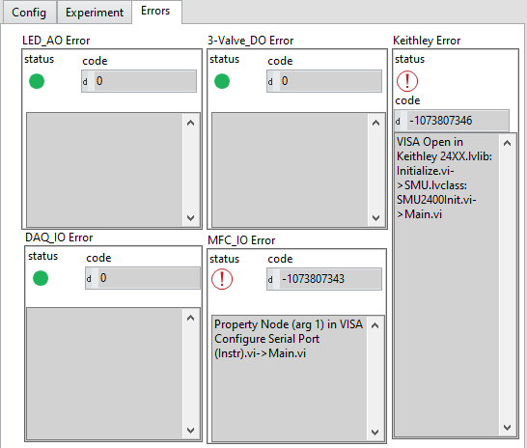

### Experiment

This tab contains the settings that might be changed during the experiment, as well as the controls for certain devices.

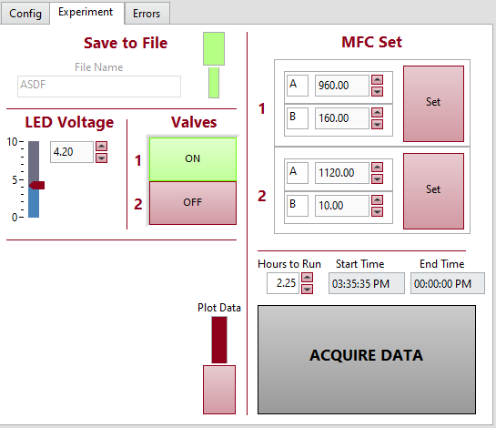

#### Save to File

The save to file section includes 2 controls, an input for the filename, and a switch to confirm that the user wants to save to file. When the program is acquiring data, these inputs will be greyed out.

File Name: The inputted text will be part of the name of the saved file that will go to the Data folder. The full file name will be the date and time that the file was created, followed by the information of whether the file is saving the DAQ or Keithley data, followed by the inputted text.

For example,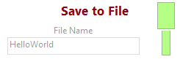if run at 11:59:42 PM on December 31, 1999, then the file would be saved as 1999_12_31-23_59_42DAQHelloWorld.tdms.

TDMS is a file format that can be opened as a spreadsheet, and records the data, as well as the name and time of the data acquisition.

#### LED Voltage

The LED Voltage section controls the Voltage being supplied to the LED. Both the numeric control and the slider will control the LED, so the user may select an exact voltage by typing in, or quickly change the voltage by using the slider.

#### Valves

The Valves section controls the valves through digital outputs. They can be turned either on or off.

#### MFC Set

The MFC Set section allows the user to control the Massw Flow Controllers through the interface. This interface contains the name of the MFCs, as well as the value to be written to them, and finally a set button to set the MFCs to the inputted value.

#### Acquire Data

This tab is the main controller of the software. Using the Hours to Run numeric controller, you can set how long you would like the software to run for (between 0.25 -> 10 hours). Once the Acquire Data button is pressed, you will no longer be able to change the Save to File settings, and the start and end times will be set to inform the user of the progress.

### Config

