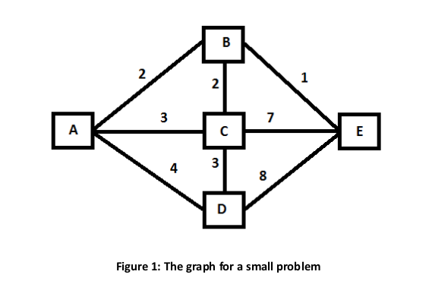
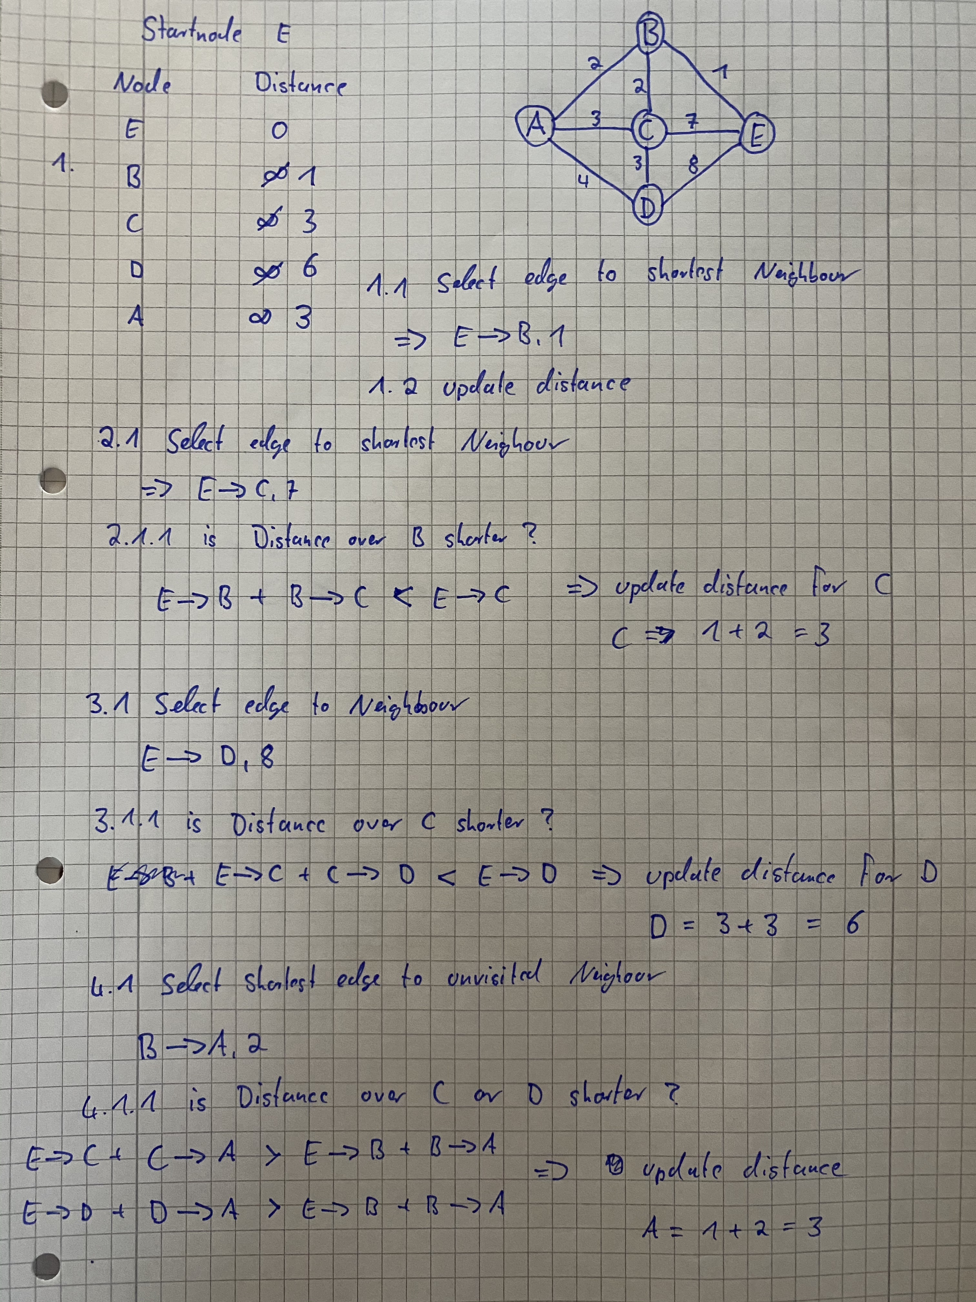
Learning Systems – Assignment 4 Dynamic Programing
Lukas Schnittcher Ernest Pokropek
Report


