Learning Systems – Assignment 2 Fuzzy Logic
Lukas Schittcher Ernest Pokropek
Report

1. What is the AND-Operator in Fuzzy Logic?
The AND-Operator is represented by a Min-value function which returns the minimal value of a list of numbers. For example: 0.3 & 0.5 & 0.1 => Min(0.3 , 0.5, 0.1) = 0.1

2. What is the OR-Operator in Fuzzy Logic?
The OR-Operator is represented by a Max-value functiont which retunrs the maximum value of a list of numbers. For example: 0.3 || 0.5 || 0.1 => Max(0.3 , 0.5, 0.1) = 0.5
The following Fuzzy-Rule:

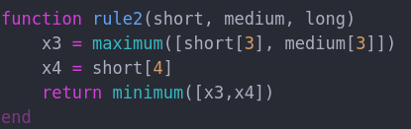
is represented with the following function:
The Accuracy is 78%.
Fuzzy-Decision with hand
=>

