Report – Sepsis Data
  - Compiled by Lukas Steininger

Description of Dataset

Overview
The dataset contains 15.214 entries, with 32 recorded parameters for each entry. The parameters describing the case are as follows: the column “case:concept:name” specifies the case itself, “concept:name” identifies the event that occurred, “time:timestamp” records the time at which the event took place and “org:group” names the organisational unit that logged the event. Furthermore, the column “lifecycle:transition” specifies in which state the event is. However, all 15.214 entries hold the value “complete”, which simply states that every activity is completed.

Additionally, there are 27 more parameters. They are described in the following table. 22 of these parameters are only filled out when a patient is registering in the ER (activity ER Registration). It can be assumed that these columns are part of an admission questionnaire in the emergency room.

Category | Number of Attributes | Description | Only when registering
SIRS Criteria | 5 | Attributes indicating the presence or absence of criteria for Systemic Inflammatory Response Syndrome (SIRS). | Yes
Diagnostics Availability | 11 | Attributes indicating whether a specific diagnostic test (e.g., urinary culture, thorax X-ray) has been performed or is available. | Yes
Key Lab Values | 3 | Numerical values for key lab markers: leucocytes, C-reactive protein (CRP), and lactic acid.
Symptoms & Condition | 4 | Attributes focusing on the presence or absence of symptoms or patient condition (e.g., organ dysfunction, low blood oxygen level). | Yes
Infection Suspected | 1 | A single attribute indicating whether a clinical infection is suspected. | Yes
Primary Diagnosis | 1 | A single attribute concerning the final or working diagnosis.
Patient Age | 1 | A numerical attribute recording the age of the patient.
IV Therapy Status | 1 | An attribute indicating whether the patient is currently receiving Intravenous (IV) therapy. | Yes

Statistics on Activities and Cases
The dataset contains 1050 unique cases which are marked using combinations of up to three letters and 16 unique activities. These 16 events include five different release types, three events stating that a certain lab value is available, two events informing about admission to other stations, four events concerning the ER and two events informing that the patient is receiving IV therapy.

Activities
Most of the performed activities, around 53%, are one of the three events signalling that a lab value is available. Since these blood markers play a vital role in identifying and monitoring sepsis, it makes sense that these are performed most frequently. Figure 1 shows how often each of the activities is performed.

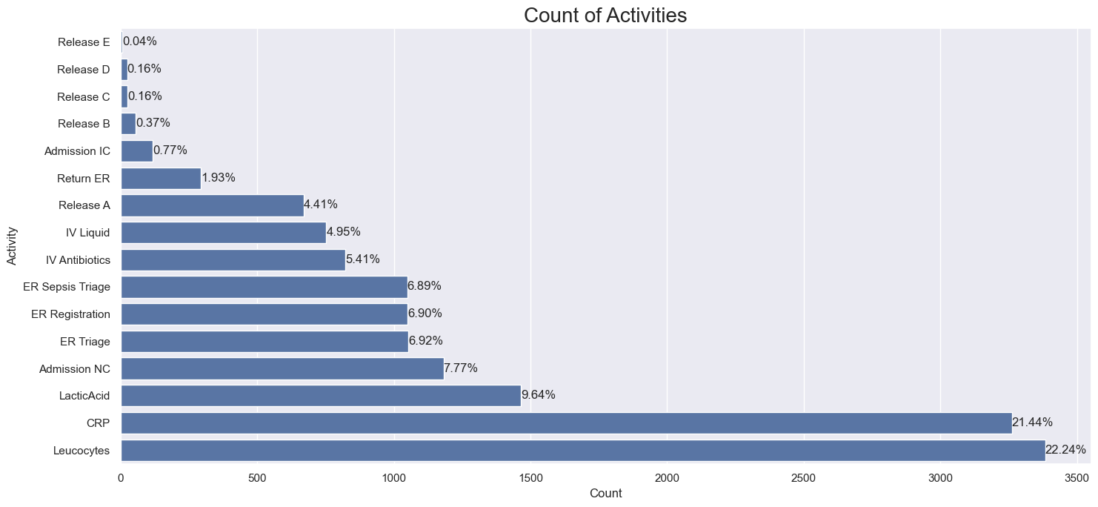
Figure 1: Absolute and relative count of activities in the dataset.

Of the 1050 cases in the dataset, almost all of them start with a registration in the ER as can be seen in Figure 2. The end of a case, however, is not as straight forward. The most frequent ending activity is Release A, with the other dedicated types of releases being in 4th, 9th, 11th and 13th place. As it can be seen in Figure 2, around 54% of cases do not end with one of these dedicated endings, but with other event, like the return to the ER for instance. Seeing that 14 of 16 activities can be the final activity in a trace, it can be said, that this process is likely complicated.
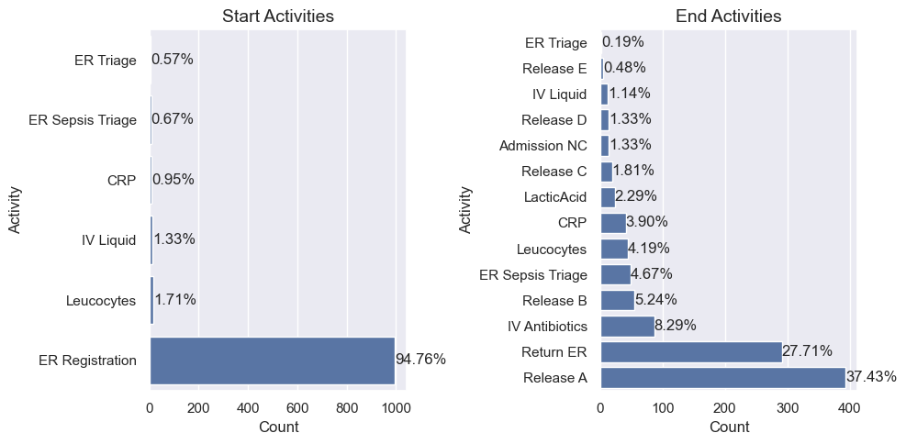
Figure 2: Absolute and relative count of start and end activities in the dataset.
Figure 3 shows the number of reworks for activities, given there are any. The number of reworks for a given activity show the number of cases in which the activity appeared twice or more. Repeating the lab activities in a case is highly plausible, since Sepsis progression in a patient can necessitate repeated measurements. Repeated admission to the IC or NC (intensive care and normal care) also seems possible.

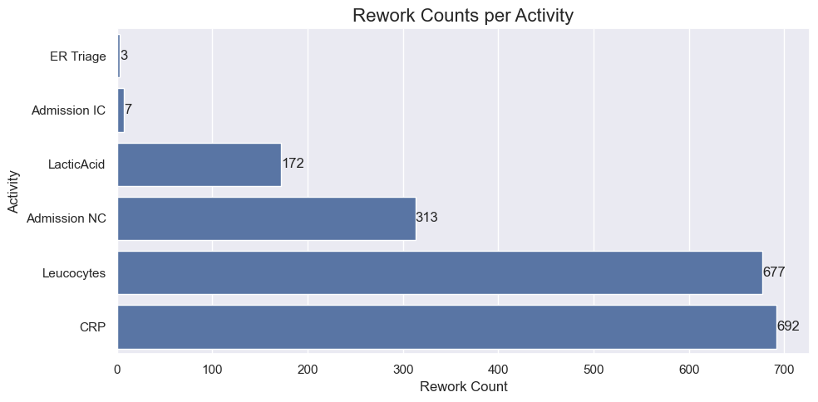
Figure 3: Rework counts per Activity. Number of Cases in which the activities are repeated at least once.

Cases
The duration of the cases has a very big range. The shortest case has a duration of 2 minutes (case “Q”), the longest case on the other hand takes 422 days and approx. 8 hours (case “HG”). On average, a case takes about 28 days and 11 hours. The median duration, however, is 5 days and 8 hours. Figure 3 shows the distribution of the case duration in days. The distribution is heavily right skewed due to the extreme outliers.

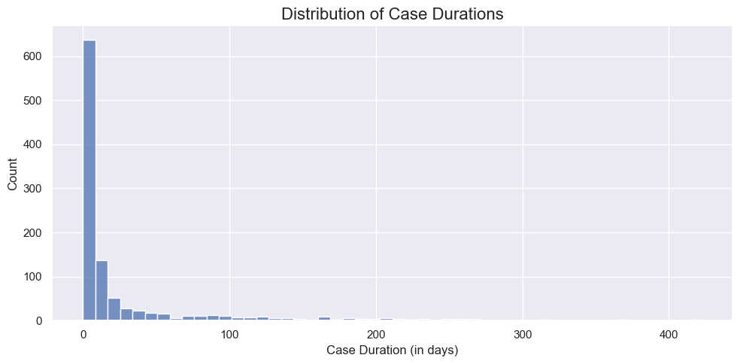
Figure 4: Distribution of all case durations, in days
Closer inspection of the longest case gave some insights into why there might be such a big number of extreme outliers. The case “HG” started on the 13th of December 2013 and ended with a “Release A”-event on the 18th of December 2013. However, the final event (“Return ER”) in the case was triggered on the 8th of February 2015, more than a year after the initial release. While cases can be continued after some time due to readmission, a continuation of the same case after that much time seems highly implausible. Therefore, it can be assumed, that more outliers of that kind exist.

Process Insights

Variants
The log contains a total amount of 846 different variants (unique sequence of activities), of which the most common variant makes up 3.33% of all traces. Around 10% of the traces can be explained by the top five variants. Table 1 describes these five variants in both their composition and their frequency.

However, most of the traces are comprised of 784 unique variants, making the log highly heterogenous. This can partly be explained by the circumstance that the flow of a patient can be rather unique itself, with some patients circling back and forth between the same few activities. On the other hand, the system does not seem to be optimal, given the fact that dedicated “Release” events make up less than half of the final events in a trace, lab values can be the first event in a trace etc.

Table 1: Top five Variants in the data set, making up approx. 10% of all cases.
Variant | Activities | Cases
Variant 1 | Er Registration  ER Triage  ER Sepsis Triage | 35 cases (3.35%)
Variant 2 | ER Registration  ER Triage  ER Sepsis Triage  Leucocytes  CRP | 24 cases (2.29%)
Variant 3 | ER Registration  ER Triage  ER Sepsis Triage  CRP  Leucocytes | 22 cases (2.1%)
Variant 4 | ER Registration  ER Triage  ER Sepsis Triage  CRP  Lactic Acid  Leucocytes  IV Liquid  IV Antibiotics | 13 cases (1.24%)
Variant 5 | ER Registration  ER Triage  ER Sepsis Triage  Leucocytes  CRP  Lactic Acid | 11 cases (1.05%)

Map view of process

Figure 4 shows a visualisation of the process. n the variants with at least two traces, all traces but one go through “ER Registration”, “ER Triage” and “ER Sepsis Triage”. This is displayed using the case coverage metric in each activity. Key activities in this process are the measurement of CRP and leucocyte values, denoted by their abundance in the event log. These measurements build the bases for treatment decisions or discharge.

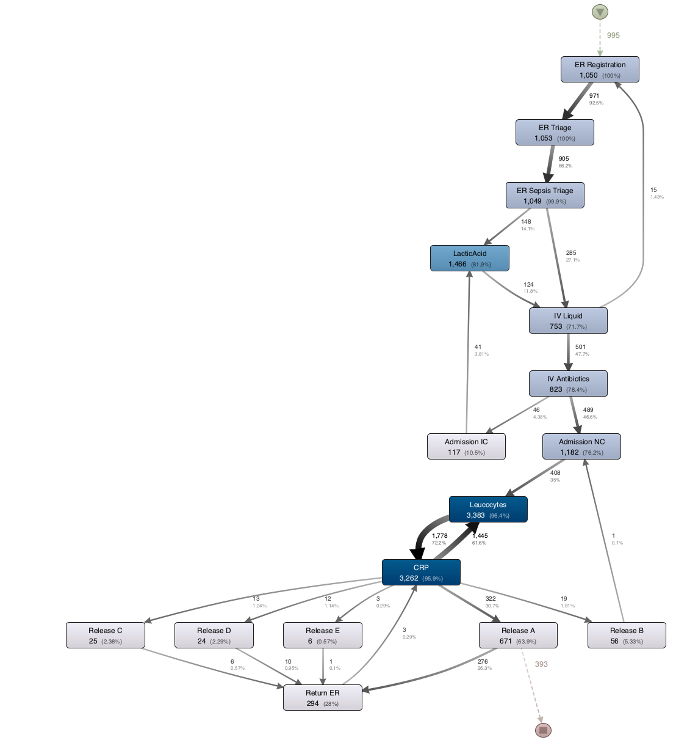
Figure 5: Map views of the process created in Disco. This map view was created using 100% Activities and 0% Paths.

Using the dotted chart in Figure 6, we can see the progression of the events over the time relative to the case (time since case start). For a better overview, the activities are categorised into six groups: “ER Activities”, “Admission”, “IV Treatment”, “Lab Tests”, “Return ER” and “Release”. Within the first hour of the case, patients usually go through the ER triages (i.e., ER Activities), different lab tests and IV treatments. Admissions to NC or IC usually appear after a few hours. Between the time of ten hours and 100 hours, repeated lab values are tested, additionally some patients receive more IV treatments. Patients are released via release events after a few days (100 hours). Return of the patients to the ER happens mostly after a few weeks/months.

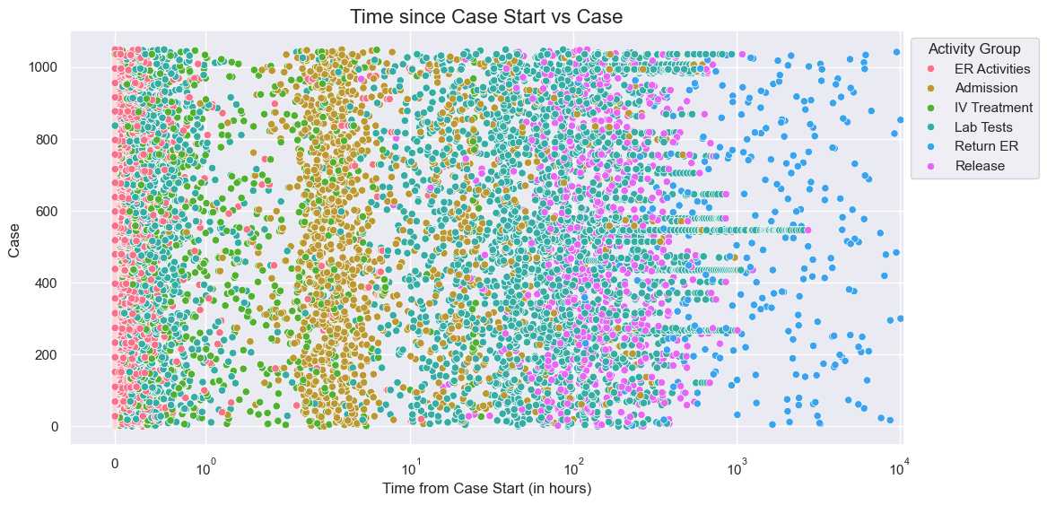
Figure 6: Dotted Chart of the log scaled time from the case start for each case.

