# Workflow

* Git
  + Branches
    - Main
    - (Optional) Dev
    - Feature

1. Auth => Together
2. Chat...

# Functionality

* Design
  + Material Design
  + Material Icons
  + (Optional) Tailwind CSS
  + 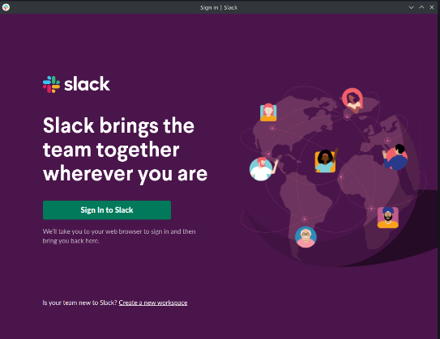Mockup 1:1 Slack
    - Theme dark
    - (Optional) Light theme
* Logo
* Login
  + Create account (Firestore)
    - Form validation (Onsubmit)
      * First name
      * Last name
      * Email
      * Password (Min length, strong pw)
    - User feedback = Popups (Snack bar/Dialog)
  + Firebase Auth
    - (Optional) Email verifier
  + Guest login (Redirect to Dashboard)
    - Name (required)
    - Name always shown on messages with => (Guest)
  + Footer (Imprint/Legal Notice)
    - (Optional) GitHub
* Chat
  + Header
    - Burger (Toggle Nav)
    - Search bar
      * Filter messages for all channels
    - User profile
      * Avatar (Name + profile image)
      * Account
        + Edit details

Name + email

Profile picture (Upload)

* + - * + Delete account
      * Logout => Login page
    - (Optional) Support
  + Nav (Left)
    - Channels (Dropdown)
      * Add channel
      * Menu icon
        + Edit channel
        + Delete channel
    - Direct message (Dropdown)
  + Home = # welcome channel (HARDCODED)
    - Custom welcome message/information for user
* Chat function
  + Post message
    - (Optional) upload files (img, etc)
    - (Optional) format message (Like word) => Library
  + Edit message
    - Only the user who created the message
    - Dialog if user is not authorized
  + Delete message
    - Only the user who created the message
    - Dialog if user is not authorized
  + (Optional) Show thread